**ESE JULY 2023**

**What are the two different ways of sending data when the send primitive is invoked?**

When invoking the send primitive for inter-process communication (IPC), there are two primary ways of sending data:

1. **Blocking Send:**
   * **Description:** In a blocking send operation, the sending process is blocked until the receiving process acknowledges the receipt of the data. This means that the sender will wait until the receiver is ready to receive the data before it can proceed with its execution.
   * **Use Case Example:** In a client-server architecture, if a client sends a request to the server using a blocking send, it will wait until the server processes the request and acknowledges receipt before continuing.
2. **Non-blocking Send:**
   * **Description:** In a non-blocking send operation, the sending process continues its execution without waiting for the receiver to acknowledge or process the data. The send operation returns immediately, allowing the sender to proceed with other tasks while the data is transmitted in the background.
   * **Use Case Example:** In scenarios where responsiveness is crucial, such as real-time systems, a non-blocking send allows a process to send data and continue its work without being delayed by the transmission process.

**Define the following blocking/non-blocking and**

**synchronous/asynchronous primitives:**

**a. Synchronous primitives b. Asynchronous primitives C. Blocking**

**primitives d. Non-blocking primitives**

**a. Synchronous Primitives:**

* **Definition:** Synchronous primitives refer to operations that occur in a predetermined order, and the caller typically waits for the operation to complete before proceeding. In a synchronous operation, the flow of control is predictable and sequential.
* **Example:** A synchronous function call, where the calling process waits for the called function to complete before continuing its execution.

**b. Asynchronous Primitives:**

* **Definition:** Asynchronous primitives involve operations that can initiate and complete independently of the caller's execution. The caller doesn't necessarily wait for the operation to finish but may be notified later through callbacks or events.
* **Example:** Asynchronous messaging, where a process can send a message and continue its work without waiting for an immediate response.

**c. Blocking Primitives:**

* **Definition:** Blocking primitives are operations that cause the calling process to wait until the operation completes. The flow of control is paused, and the process remains in a blocked state until the requested action is finished.
* **Example:** A blocking I/O operation, where a process waits for data from a file or network before proceeding.

**d. Non-blocking Primitives:**

* **Definition:** Non-blocking primitives allow the calling process to continue its execution without waiting for the operation to complete. The operation may proceed in the background, and the caller can check later for completion or results.
* **Example:** Non-blocking I/O, where a process initiates an I/O operation and continues with other tasks without waiting for the operation to finish, checking for completion later.

**What is a distributed program? What areThe different models of process communication? Explain each one in details.**

**Distributed Program:** A distributed program is a type of computer program designed to run on multiple interconnected computers within a network. These programs are designed to achieve a common goal by dividing tasks among different machines, and they typically communicate and coordinate with each other to accomplish their objectives. Distributed programming is essential for building scalable, fault-tolerant, and efficient systems.

**Models of Process Communication in Distributed Systems:**

1. **Message Passing:**
   * **Description:** In this model, processes communicate by exchanging messages. Messages can contain data, instructions, or requests. Communication can be either synchronous or asynchronous. Synchronous message passing involves the sender waiting for a response, while asynchronous message passing allows the sender to continue its work without waiting.
   * **Example:** Remote Procedure Call (RPC) is a form of synchronous message passing, while message queues represent asynchronous message passing.
2. **Shared Memory:**
   * **Description:** In shared memory communication, processes communicate by reading from and writing to shared regions of memory. Multiple processes can access and modify the shared data, and proper synchronization mechanisms (e.g., locks) are required to avoid conflicts.
   * **Example:** Multithreading within a single program, where threads share a common address space.
3. **Remote Procedure Call (RPC):**
   * **Description:** RPC is a model that allows a program to cause a procedure (subroutine) to execute in another address space (commonly on a remote machine) as if it were a local procedure call, hiding the complexities of the distributed nature of the system.
   * **Example:** Java RMI (Remote Method Invocation) and gRPC (Google Remote Procedure Call) are examples of RPC frameworks.
4. **Socket Programming:**
   * **Description:** Processes communicate over a network using sockets, which provide an endpoint for sending or receiving data. Sockets can be either connection-oriented (e.g., TCP) or connectionless (e.g., UDP).
   * **Example:** Web applications use socket programming for communication between a client's browser and a server using protocols like HTTP over TCP.
5. **Publish-Subscribe Model:**
   * **Description:** In the publish-subscribe model, processes subscribe to specific events or messages. When an event occurs, the publisher notifies all subscribers without them explicitly requesting the information. This is often used in event-driven architectures.
   * **Example:** MQTT (Message Queuing Telemetry Transport) is a popular protocol for publish-subscribe communication in IoT applications.
6. **Distributed Objects:**
   * **Description:** Distributed objects involve the exchange of objects between processes in a distributed system. Each process has a local representation of the object, and method invocations on the local object can result in remote procedure calls.
   * **Example:** Common Object Request Broker Architecture (CORBA) and Java RMI provide frameworks for distributed object communication.

**What is Group communication? Give any two key applications of group communication in distributed systems.**

**Group Communication:** Group communication in distributed systems involves the coordination and information exchange among a predefined set of processes, known as a group. These processes collaborate to achieve common goals, share information, and ensure consistency across the distributed environment. Group communication is essential for building reliable and fault-tolerant distributed systems.

**Two Key Applications of Group Communication in Distributed Systems:**

1. **Replicated Services:**
   * **Description:** Replicated services involve having multiple instances (replicas) of a service or application running on different nodes within a distributed system. Group communication mechanisms ensure that these replicas stay synchronized by allowing them to exchange messages and coordinate their actions.
   * **Key Application Benefits:**
     + **Fault Tolerance:** If one replica fails due to a crash or other issues, the remaining replicas can continue to provide the service without interruption. This enhances system reliability.
     + **Load Balancing:** Group communication enables load balancing by distributing client requests among the available replicas. This ensures efficient utilization of resources.
   * **Example Scenario:** Consider a web service replicated across multiple servers. Group communication allows these servers to share updates, ensuring that they provide consistent responses to client requests.
2. **Consensus Algorithms:**
   * **Description:** Consensus is a fundamental problem in distributed computing where a group of processes must agree on a common decision, even in the presence of failures. Group communication plays a crucial role in facilitating the exchange of messages among processes to reach a consensus on a particular value or outcome.
   * **Key Application Benefits:**
     + **Distributed Decision Making:** Consensus algorithms enable distributed processes to agree on a common decision, such as the value of a variable or the order of events, despite the possibility of individual process failures.
     + **Atomic Commitment:** In the context of distributed transactions, group communication ensures that all processes involved agree to either commit or abort the transaction, maintaining consistency across the system.
   * **Example Scenario:** Imagine a distributed database system where nodes need to agree on whether to commit or abort a transaction. Group communication ensures that all nodes reach a consensus on the outcome, preventing inconsistencies in the database.

**Multicast Communication:**

* **Description:** Multicast communication involves the efficient dissemination of information from one sender to multiple receivers within a group. It enables a single sender to send a message to a selected subset of processes, often referred to as a multicast group.
* **Key Application Benefits:**
  + **Scalable Communication:** Multicast reduces the network load compared to unicast (point-to-point) communication, making it more scalable for scenarios with many receivers.
  + **Efficient Broadcasting:** Ideal for scenarios where information needs to be broadcasted to a specific audience rather than the entire network.
* **Example Scenario:** In a distributed online gaming application, the game server could use multicast communication to send updates about game events (e.g., player movements, scores) to all players within a specific game session. This optimizes the use of network resources and ensures that only relevant players receive the updates.

**What are the two criteria must be met by a causal ordering**

**Protocol? Explain with proper justification**

A causal ordering protocol in distributed systems aims to establish a consistent and causal relationship among events or messages. Two key criteria must be met by a causal ordering protocol:

1. **Partial Ordering of Events:**
   * **Explanation:** Events in a distributed system need to be partially ordered based on their causal relationship. This means that if event A causally precedes event B (i.e., A influences or triggers B), then A should be ordered before B in the causal order. However, events that are concurrent or independent should not be strictly ordered with respect to each other.
   * **Justification:** Partial ordering captures the causality among events while allowing for concurrency, reflecting the fact that events may occur independently and should not be strictly ordered unless there is a causal relationship.
2. **Consistent Global View:**
   * **Explanation:** The protocol should ensure that all processes in the distributed system have a consistent global view of the events. In other words, the partial ordering of events should be agreed upon by all processes, providing a unified perspective on the causal relationships.
   * **Justification:** Consistency in the global view is crucial to avoid inconsistencies or misunderstandings among processes. All processes should agree on the causal relationships among events to maintain a coherent understanding of the system's behavior.

**Example Justification:** Consider a distributed system with multiple processes exchanging messages. If process P1 sends a message M1, and process P2 receives M1 and subsequently sends message M2, there is a causal relationship between M1 and M2. A causal ordering protocol should ensure that all processes agree that M1 causally precedes M2. However, if another process, P3, sends a message M3 concurrently with M1, these two messages may be considered concurrent in the causal order since there is no causal relationship between them.

**Write a bully Election algorithms and explain it with the Help**

**example.**

The Bully Election Algorithm is a leader election algorithm used in distributed systems where processes need to elect a coordinator or leader. The algorithm ensures that the process with the highest priority becomes the leader. If the current leader fails, other processes can initiate a new election to choose a new leader.

**Bully Election Algorithm:**

1. **Initiation:**
   * Any process can initiate an election by sending an Election message to all processes with higher priorities.
2. **Election Message:**
   * Upon receiving an Election message, a process checks its own priority. If it has a higher priority, it responds with an Answer message and starts a sub-election.
3. **Sub-Election:**
   * The process that initiates the sub-election sends Election messages to processes with higher priorities. If no higher-priority process responds, it becomes the coordinator.
4. **Coordinator Status:**
   * The coordinator periodically sends a KeepAlive message to inform other processes about its status. If a process doesn't receive KeepAlive messages from the coordinator, it assumes the coordinator has failed and can initiate a new election.

**Example:** Let's consider a scenario with five processes (P1 to P5) and their respective priorities. Higher priority values indicate higher priority.

* P1 (Priority 5)
* P2 (Priority 3)
* P3 (Priority 8)
* P4 (Priority 2)
* P5 (Priority 6)

**Execution:**

1. Process P3 detects the failure of the current coordinator or decides to initiate an election.
2. P3 sends Election messages to P1, P2, P4, and P5 since they have higher priorities.
3. P1, P2, and P5 respond with an Answer message, indicating they have higher priorities.
4. P3 realizes that P5 has the highest priority among the respondents, so it gracefully steps down.
5. P5 becomes the coordinator and sends KeepAlive messages to inform others about its status.

If the current coordinator (P5) fails, any process that doesn't receive KeepAlive messages from P5 can initiate a new election, and the process with the highest priority among the remaining ones will become the new coordinator.

The Bully Election Algorithm ensures that the process with the highest priority is elected as the coordinator, and the system remains resilient to coordinator failures.

**Explain the Lamport s distributed mutual exclusion algorithm in**

**terms of**

**a. Requesting the critical section**

**b. Executing the critical**

**section and**

**C. Releasing the critical section**

The Lamport's Distributed Mutual Exclusion Algorithm is designed to ensure that multiple processes in a distributed system can access a critical section without interference. Let's break down the algorithm into the requested components:

a. **Requesting the Critical Section:**

* When a process wants to enter the critical section, it sends a request message to all other processes, including a timestamp representing its logical clock value.
* The logical clock ensures that each request is assigned a unique timestamp and helps in determining the order of requests.

b. **Executing the Critical Section:**

* Upon receiving a request, a process compares the timestamp of the incoming request with its own. The process with the lowest timestamp gets priority.
* If there's a tie in timestamps, the process with the lower process ID is given priority.
* Once a process wins the election, it can enter the critical section and perform its operations.

c. **Releasing the Critical Section:**

* After a process finishes executing the critical section, it broadcasts release messages to inform other processes that it's done.
* This allows other processes to update their information and possibly enter the critical section based on their requests and priorities.

**Example:** Let's consider three processes, P1, P2, and P3. P1 wants to enter the critical section.

a. P1 sends a request message with a timestamp to P2 and P3.

b. P2 and P3 receive the request and compare timestamps. Suppose P2 has a lower timestamp; it grants permission to P1. P1 enters the critical section.

c. After P1 completes its critical section execution, it sends release messages to P2 and P3, allowing them to potentially enter the critical section based on their requests and timestamps.

**What are the different model of deadlocks? Explain any three**

**models.**

Deadlocks are situations where a set of processes are blocked because each process is holding a resource and waiting for another resource occupied by some other process. There are different models of deadlocks, depending on how the resources and processes are represented and managed. Here are three common models of deadlocks:

* Single-resource model: In this model, each process has a unique identifier and can request one resource at a time. The system maintains a resource allocation graph, where each node represents a resource and each edge represents a request or release operation. [A deadlock occurs when there is a circular dependency among the requests, meaning that each process is waiting for a resource that is held by another process in the cycle1](https://rcet.org.in/uploads/academics/rohini_47859940100.pdf).
* Multiple-resource model: In this model, each process has a unique identifier and can request multiple resources at once. The system maintains a set of resources and a set of processes, where each resource has an identifier and each process has an identifier. [A deadlock occurs when there is a circular dependency among the requests, meaning that each process is waiting for one or more resources that are held by other processes in the cycle1](https://rcet.org.in/uploads/academics/rohini_47859940100.pdf).
* Communication model: In this model, each process has a unique identifier and can send or receive messages from other processes. The system maintains a message queue for each process, where messages are stored until they are delivered or discarded. [A deadlock occurs when there is no message in transit between any pair of processes in the set, meaning that all processes are waiting for messages from other processes in the set](https://rcet.org.in/uploads/academics/rohini_47859940100.pdf)[2](https://www.geeksforgeeks.org/distributed-system-types-of-distributed-deadlock/).

I hope this helps you understand the different models of deadlocks. If you have any further questions, please feel free to ask me 😊…

**What are the types of data indexing in P2P networking^ Explain with example**

Data indexing is a technique for organizing and locating data in a distributed system, such as a peer-to-peer (P2P) network. There are different types of data indexing, depending on how the data is mapped to the nodes or peers in the network, and how the queries are handled. Here are some examples of data indexing in P2P networking:

* Centralized indexing: This type of indexing uses one or a few central servers to store references or indexes to the data on many peers. For example, the Domain Name System (DNS) is a centralized index that maps domain names to IP addresses. [Some early P2P networks, such as Napster, also used a central directory lookup to find files shared by other peers](https://www.ic.unicamp.br/~celio/peer2peer/hybrid-systems/data-indexing-in-peer04.pdf)[1](https://www.ic.unicamp.br/~celio/peer2peer/hybrid-systems/data-indexing-in-peer04.pdf).
* Local indexing: This type of indexing indexes the data at various peers being scattered across other peers throughout the P2P network. To access the indexes, a structure is used in the P2P overlay to access the indexes. [For example, Chord is a distributed hash table (DHT) that maps keys to values using a hash function and stores them in multiple nodes](https://www.ic.unicamp.br/~celio/peer2peer/hybrid-systems/data-indexing-in-peer04.pdf)[1](https://www.ic.unicamp.br/~celio/peer2peer/hybrid-systems/data-indexing-in-peer04.pdf).
* Distributed indexing: This type of indexing requires each peer to index only its local data objects and remote objects need to be searched for. This form of indexing is typically used in unstructured overlays in conjunction with flooding search or random walk search. [For example, Pastry is another DHT that supports complex queries using relational operators and text retrieval techniques](https://www.ic.unicamp.br/~celio/peer2peer/hybrid-systems/data-indexing-in-peer04.pdf)[1](https://www.ic.unicamp.br/~celio/peer2peer/hybrid-systems/data-indexing-in-peer04.pdf).

I hope this helps you understand the types of data indexing in P2P networking. If you have any further questions, please feel free to ask me 😊.

**What are the different distributed computing models? Explain with suitable diagram.**

[**https://www.ques10.com/p/2108/explain-distributed-computing-models-with-diagra-1/**](https://www.ques10.com/p/2108/explain-distributed-computing-models-with-diagra-1/)

**What is the global state of the distributed system? How to design the**

**efficient method to design recording the global state of the distributed**

**system?**

[**https://www.cs.uic.edu/~ajayk/Chapter4.pdf**](https://www.cs.uic.edu/~ajayk/Chapter4.pdf)

The global state of a distributed system is a collection of the local states of the processes and the channels. A global state computed along a consistent cut is correct. [The global state of a consistent cut comprises the local state of each process at the time the cut event happens and the set of all messages sent but not yet received1](https://www.geeksforgeeks.org/chandy-lamports-global-state-recording-algorithm/).

[To design an efficient method to record the global state of a distributed system, one possible approach is to use Chandy-Lamport’s global state recording algorithm](https://www.geeksforgeeks.org/chandy-lamports-global-state-recording-algorithm/)[2](https://ics.uci.edu/~cs230/lectures20/distrsyslectureset3-win20.pdf). This algorithm uses a special message called MARKER to trigger each process to record its own state and the messages it sends and receives. The MARKER travels across all communication channels and causes each process to update its local state accordingly. The final global state is obtained by concatenating all local states recorded by each process.

[Another possible approach is to use DPREU or DPRRU algorithms](https://www.geeksforgeeks.org/chandy-lamports-global-state-recording-algorithm/)[3](https://www.ijert.org/global-state-recognition-algorithms-in-distributed-systems), which are based on dynamic programming and reduce the number of messages exchanged between processes. These algorithms use a data structure called DP-Tree, which stores information about each process and its neighbors in a hierarchical manner. The DP-Tree allows processes to query their neighbors without sending any messages, thus saving communication overhead. The final global state is obtained by traversing the DP-Tree from root to leaf.

I hope this helps you understand how to design an efficient method to record the global state of a distributed system. If you have any further questions, please feel free to ask me 😊…

**Construct with neat diagrams and give example of different forms of**

**communication, such as persistent asynchronous, persistent synchronous,**

**transient asynchronous, receipt based transient synchronous, delivery**

**based transient synchronous, and response based transient synchronous**

**communication**

1. **Persistent Asynchronous Communication:**
   * **Description:** In persistent asynchronous communication, the sender does not wait for an immediate response from the receiver. The message is sent, and the sender continues its execution without blocking.
   * **Example:** Sending emails is an example of persistent asynchronous communication. The sender sends an email, and the system doesn't wait for an immediate response.
2. **Persistent Synchronous Communication:**
   * **Description:** In persistent synchronous communication, the sender waits for an immediate response from the receiver before proceeding with further actions.
   * **Example:** Making a synchronous HTTP request in a web application is an example. The client sends a request, waits for the server's response, and then continues based on the received response.
3. **Transient Asynchronous Communication:**
   * **Description:** Transient asynchronous communication involves the sender not waiting for an immediate response. However, there might be mechanisms for later acknowledgment or notification of delivery.
   * **Example:** Publishing a message to a message queue (e.g., using RabbitMQ or Apache Kafka) is an example. The sender publishes a message and doesn't wait for subscribers to receive it immediately.
4. **Receipt-Based Transient Synchronous Communication:**
   * **Description:** In receipt-based transient synchronous communication, the sender waits for an acknowledgment (receipt) from the receiver to confirm the successful delivery of the message.
   * **Example:** Sending a text message with delivery receipts enabled. The sender waits for a receipt to confirm that the message has been delivered to the recipient's device.
5. **Delivery-Based Transient Synchronous Communication:**
   * **Description:** In delivery-based transient synchronous communication, the sender waits for the actual delivery of the message to the recipient.
   * **Example:** Sending a letter through postal mail. The sender waits for the physical delivery of the letter to the recipient.
6. **Response-Based Transient Synchronous Communication:**
   * **Description:** In response-based transient synchronous communication, the sender waits for a response or reply from the receiver before proceeding.
   * **Example:** Making a synchronous Remote Procedure Call (RPC). The client sends a request to the server, waits for the server to process and respond before continuing its execution.

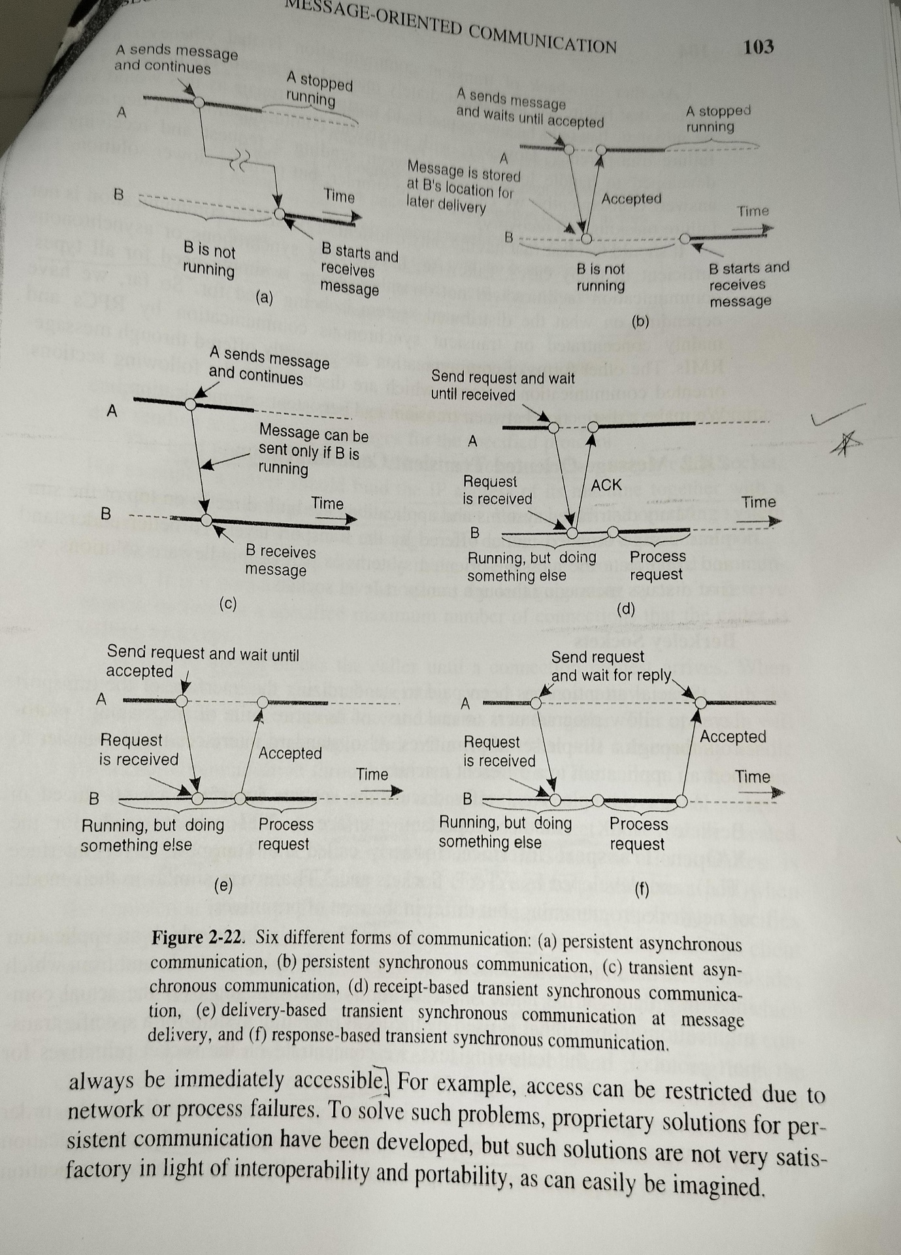

**Why is it difficult to keep the synchronized system of physical clocks in**

**distributed system? Justify your answer with appropriate examples.**

Keeping a synchronized system of physical clocks in a distributed system is challenging due to various factors, including network delays, clock drift, and the asynchronous nature of distributed communication. Let's explore these challenges with examples:

1. **Network Delays:**
   * **Challenge:** The time it takes for a message to travel between nodes in a distributed system is variable and influenced by network delays. These delays can be unpredictable and may lead to discrepancies in clock synchronization.
   * **Example:** Consider two nodes, A and B, in a distributed system. If A sends a synchronization message to B, the time it takes for the message to reach B will be influenced by factors like network congestion and routing changes. This variability in transit time introduces uncertainty in clock synchronization.
2. **Clock Drift:**
   * **Challenge:** Physical clocks on different nodes may have different clock rates due to hardware variations, temperature changes, or other factors. Over time, these differences can result in clock drift, causing clocks to deviate from the true time.
   * **Example:** Two servers with slightly different clock rates will gradually drift apart. Even if they are initially synchronized, the difference in clock rates will lead to a growing time gap between them.
3. **Asynchronous Communication:**
   * **Challenge:** Asynchronous communication, where processes operate independently and exchange messages without waiting for each other, introduces challenges in maintaining synchronized clocks. Processes may not be aware of the time it takes for a message to be transmitted, making it difficult to establish accurate synchronization.
   * **Example:** In a messaging system, if Process A sends a message to Process B and continues its execution without waiting for a response, the clocks of A and B may not be perfectly synchronized due to the asynchronous nature of the communication.
4. **Faults and Failures:**
   * **Challenge:** Distributed systems are susceptible to faults and failures, and maintaining synchronized clocks becomes more challenging when nodes can become unavailable or experience transient issues.
   * **Example:** If a node in a distributed system fails and later recovers, its clock may have drifted during the downtime. Resynchronizing the recovered node with the rest of the system can be challenging, especially if the failure duration is significant.
5. **Uncertainty in Timestamps:**
   * **Challenge:** Assigning accurate timestamps to events in a distributed system is challenging due to the uncertainty introduced by network delays and clock drift. This uncertainty affects the consistency and reliability of timestamps.
   * **Example:** In a distributed database, if events are timestamped based on local clocks, querying the database using these timestamps may yield inconsistent or inaccurate results due to variations in clock synchronization.

Hello, this is Bing. I can help you with your question about why it is difficult to keep the synchronized system of physical clocks in distributed system. Here is a summary of what I found:

* [Physical clock synchronization is the process of aligning the clocks of computers or nodes in a distributed system to a common reference point, such as Universal Coordinated Time (UTC)](https://www.geeksforgeeks.org/clock-synchronization-in-distributed-system/)[1](https://www.geeksforgeeks.org/clock-synchronization-in-distributed-system/).
* [It is difficult to keep the synchronized system of physical clocks in distributed system because of several challenges, such as](https://www.geeksforgeeks.org/clock-synchronization-in-distributed-system/)[1](https://www.geeksforgeeks.org/clock-synchronization-in-distributed-system/)[2](https://www.geeksforgeeks.org/synchronization-in-distributed-systems/):
  + Information dispersion: Distributed systems store information on machines, which may have different clock settings and sources. Gathering and harmonizing this information to achieve synchronization presents a challenge.
  + Local decision realm: Distributed systems rely on localized data for making decisions. As a result, when it comes to synchronization, we have to make decisions with information from each node, which makes the process more complex.
  + Mitigating failures: In a distributed environment, it becomes crucial to prevent failures in one node from causing disruption in synchronization. If one node fails or crashes, the other nodes may not be able to communicate or coordinate with it.
  + Temporal uncertainty: The existence of clocks in distributed systems creates the potential for time variations. Different nodes may have different clock drifts and skew, which can affect the accuracy and consistency of data exchange and task execution.

[Some examples of difficulties that arise when synchronizing clocks in distributed systems are3](https://www.thecode11.com/2022/06/physical-clock-and-logical-clock-in-distributed-system.html):

* Getting two systems agree upon time: Two clocks hardly ever agree. Quartz oscillators oscillate at slightly different frequencies. This creates an ever-widening gap in perceived time. This is called as clock drift. At one point of time, the difference between the two clocks is called as clock skew.
* Synchronizing multiple nodes: If there are multiple nodes involved in a distributed system, they may have different clock settings and sources. This makes it harder to achieve consensus and coordination among them.
* Handling network delays: Network delays can affect the speed and reliability of communication between nodes. If there are network failures or congestion, the messages may not reach their destination or may arrive out of order.

I hope this helps you understand why it is difficult to keep the synchronized system of physical clocks in distributed system. If you have any other questions, please feel free to ask me 😊

**Explain the Ricart Agrawala algorithm with respect to requesting the**

**critical section, executing the critical section and releasing the critical**

**section. Give the correctness of Ricart Agrawala algorithm for achieving**

**mutual exclusion.**

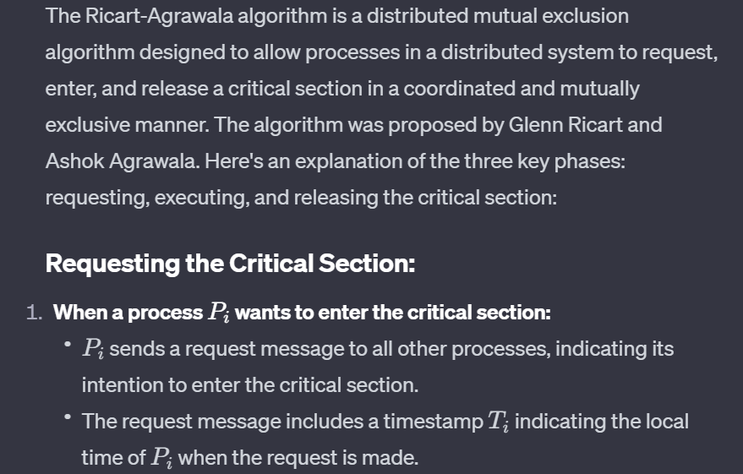

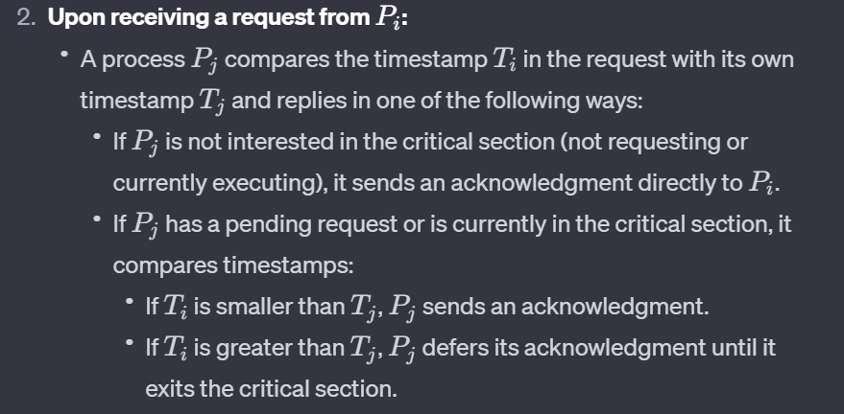

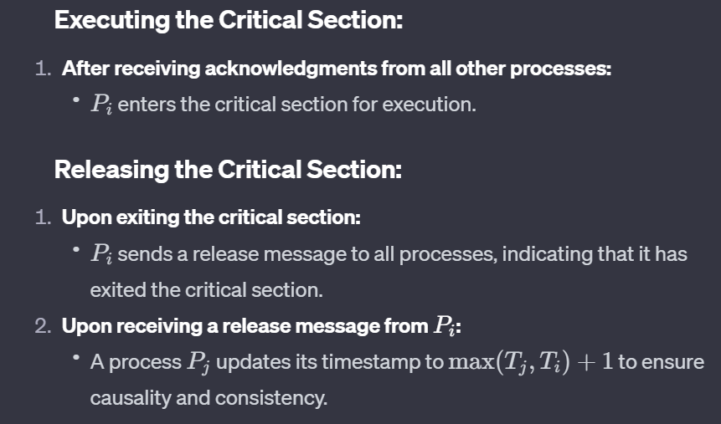

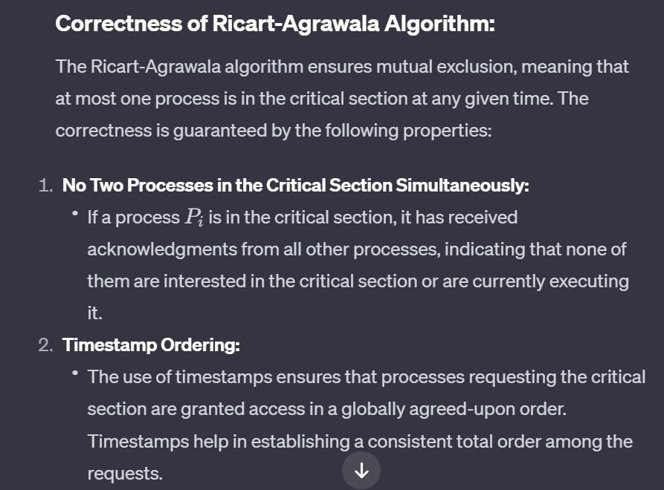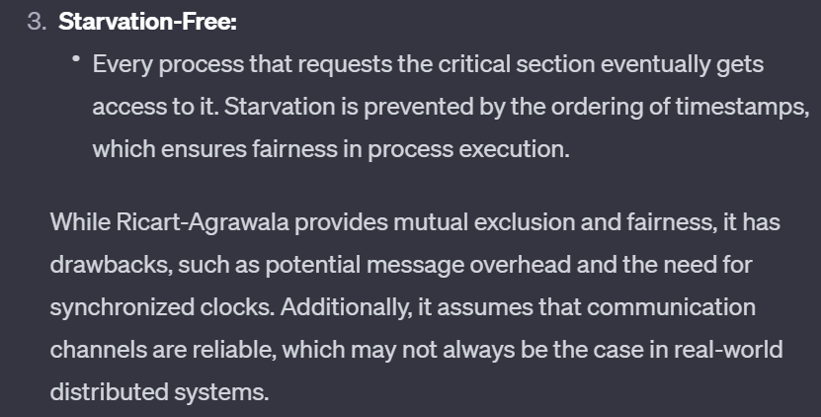

[The Ricart-Agrawala algorithm is an optimization of Lamport’s Distributed Mutual Exclusion Algorithm and follows a permission-based approach to ensure mutual exclusion in a distributed system](https://www.geeksforgeeks.org/ricart-agrawala-algorithm-in-mutual-exclusion-in-distributed-system/)[1](https://www.geeksforgeeks.org/ricart-agrawala-algorithm-in-mutual-exclusion-in-distributed-system/)[2](https://rcet.org.in/uploads/academics/regulation2021/rohini_92724486041.pdf). Here’s how it works:

[**Requesting the Critical Section**: When a site S_i wants to enter the critical section, it sends a timestamped REQUEST message to all other sites1](https://www.geeksforgeeks.org/ricart-agrawala-algorithm-in-mutual-exclusion-in-distributed-system/)[2](https://rcet.org.in/uploads/academics/regulation2021/rohini_92724486041.pdf). [When a site S_j receives a REQUEST message from site S_i, it sends a REPLY message to site S_i if and only if](https://www.geeksforgeeks.org/ricart-agrawala-algorithm-in-mutual-exclusion-in-distributed-system/)[1](https://www.geeksforgeeks.org/ricart-agrawala-algorithm-in-mutual-exclusion-in-distributed-system/)[2](https://rcet.org.in/uploads/academics/regulation2021/rohini_92724486041.pdf):

* Site S_j is neither requesting nor currently executing the critical section.
* [In case Site S_j is requesting, the timestamp of Site S_i’s request is smaller than its own request](https://www.geeksforgeeks.org/ricart-agrawala-algorithm-in-mutual-exclusion-in-distributed-system/)[1](https://www.geeksforgeeks.org/ricart-agrawala-algorithm-in-mutual-exclusion-in-distributed-system/)[2](https://rcet.org.in/uploads/academics/regulation2021/rohini_92724486041.pdf).

[**Executing the Critical Section**: Site S_i enters the critical section if it has received the REPLY message from all other sites1](https://www.geeksforgeeks.org/ricart-agrawala-algorithm-in-mutual-exclusion-in-distributed-system/)[2](https://rcet.org.in/uploads/academics/regulation2021/rohini_92724486041.pdf).

[**Releasing the Critical Section**: Upon exiting, site S_i sends REPLY messages to all the deferred requests1](https://www.geeksforgeeks.org/ricart-agrawala-algorithm-in-mutual-exclusion-in-distributed-system/)[2](https://rcet.org.in/uploads/academics/regulation2021/rohini_92724486041.pdf).

**Correctness of Ricart Agrawala Algorithm for Mutual Exclusion**: The Ricart-Agrawala algorithm achieves mutual exclusion. [The proof is by contradiction](https://www.geeksforgeeks.org/ricart-agrawala-algorithm-in-mutual-exclusion-in-distributed-system/)[2](https://rcet.org.in/uploads/academics/regulation2021/rohini_92724486041.pdf). Suppose two sites S_i and S_j are executing the critical section concurrently and S_i’s request has higher priority than the request of S_j. Clearly, S_i received S_j’s request after it has made its own request. Thus, S_j can concurrently execute the critical section with S_i only if S_i returns a REPLY to S_j (in response to S_j’s request) before S_i exits the critical section. [However, this is impossible because S_j’s request has lower priority](https://www.geeksforgeeks.org/ricart-agrawala-algorithm-in-mutual-exclusion-in-distributed-system/)[2](https://rcet.org.in/uploads/academics/regulation2021/rohini_92724486041.pdf). [Therefore, the Ricart-Agrawala algorithm achieves mutual exclusion](https://www.geeksforgeeks.org/ricart-agrawala-algorithm-in-mutual-exclusion-in-distributed-system/)[2](https://rcet.org.in/uploads/academics/regulation2021/rohini_92724486041.pdf).

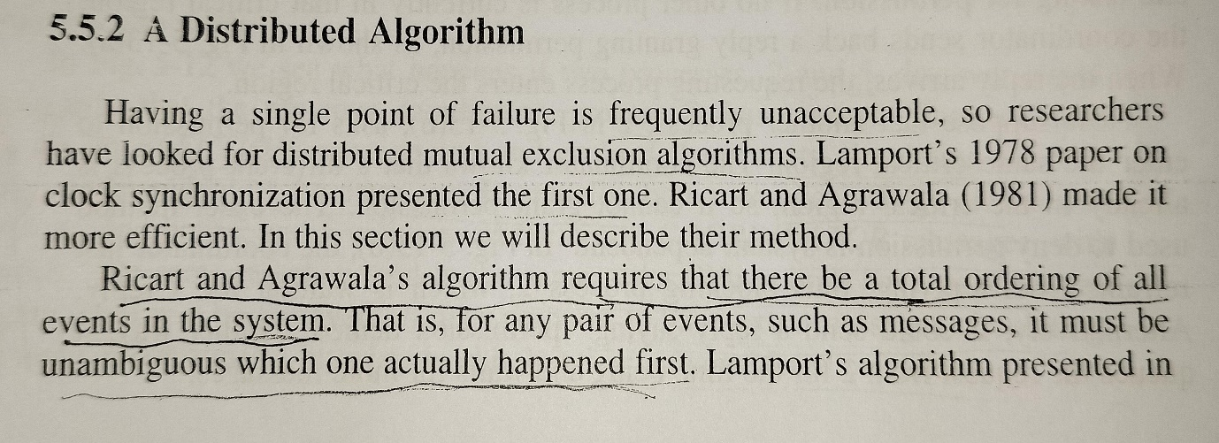

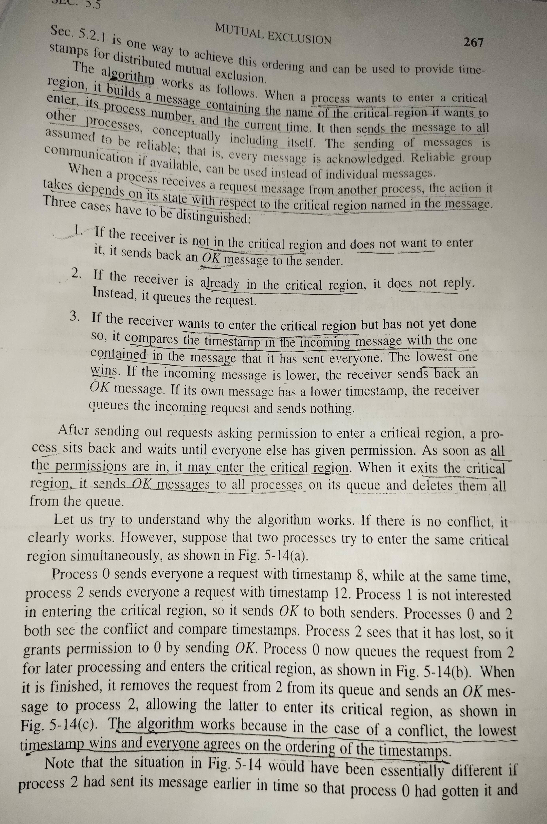

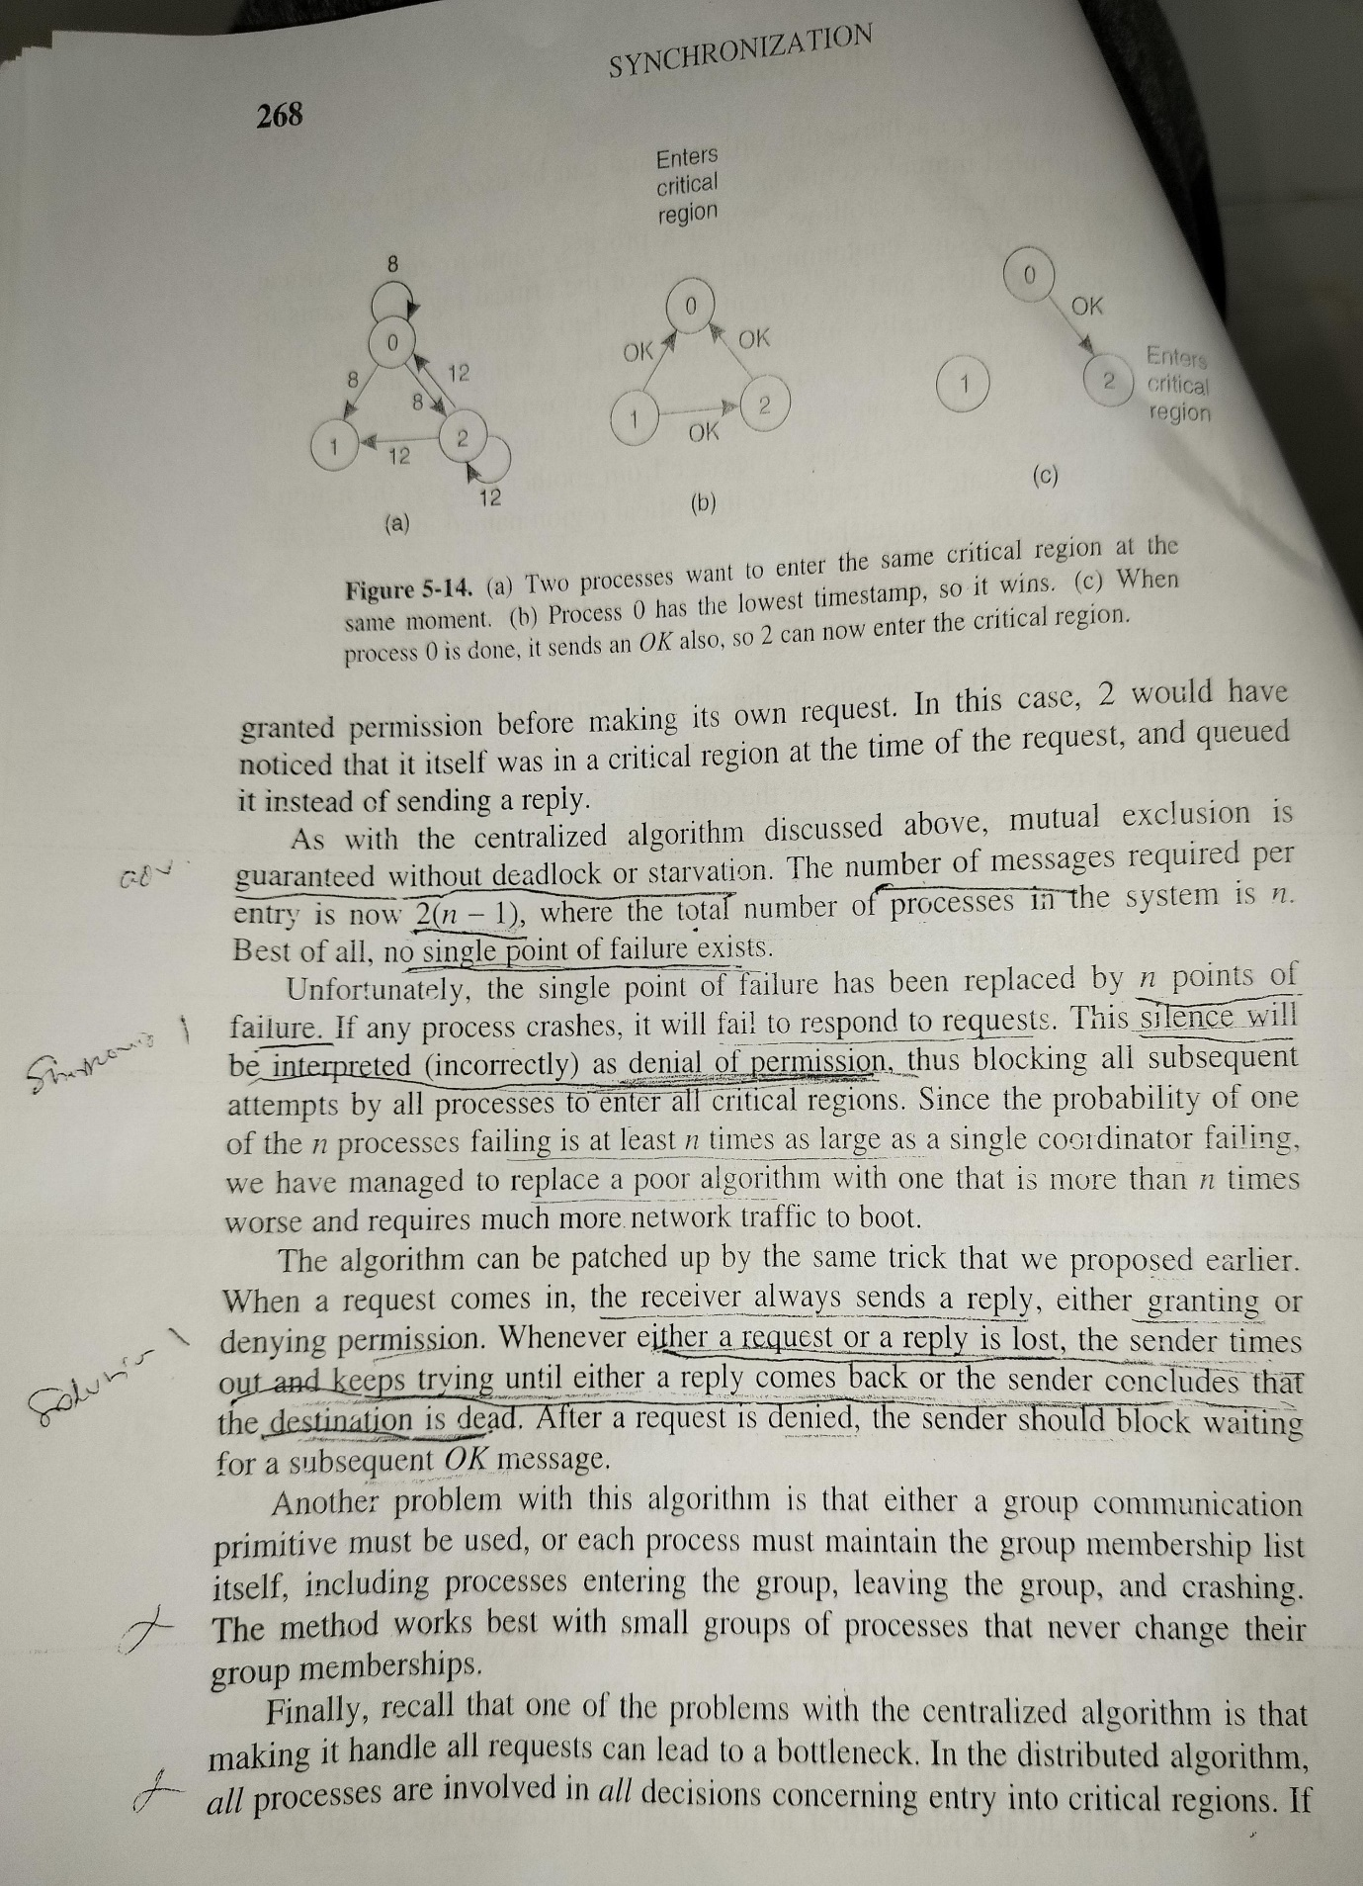

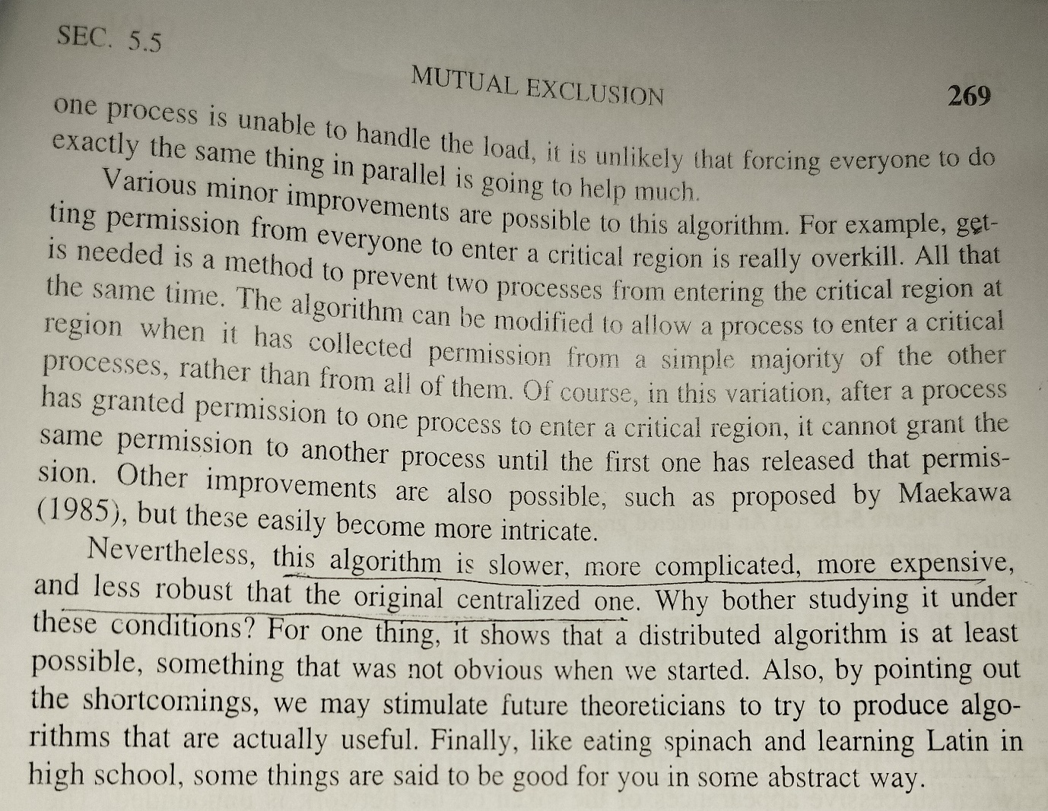

**What is deadlock in distributed systems? Explain the Knapps**

**classification of distributed deadlock detection algorithm.**

[A deadlock in a distributed system is a situation where a set of processes are blocked because each process is holding a resource and waiting for another resource occupied by some other process](https://www.geeksforgeeks.org/distributed-system-types-of-distributed-deadlock/)[1](https://www.geeksforgeeks.org/distributed-system-types-of-distributed-deadlock/). [Deadlocks in distributed systems are similar to deadlocks in centralized systems, but handling them in distributed systems is more complex because the resources, the processes, and other relevant information are scattered on different nodes of the system1](https://www.geeksforgeeks.org/distributed-system-types-of-distributed-deadlock/).

[Knapp’s classification categorizes distributed deadlock detection algorithms into four classes2](https://rcet.org.in/uploads/academics/rohini_76495739696.pdf)[3](https://rcet.org.in/uploads/academics/regulation2021/rohini_35497506669.pdf):

1. **Path-pushing algorithms**: These algorithms detect deadlocks by maintaining an explicit global wait-for graph (WFG). Each site sends its local WFG to all neighboring sites. [The procedure is repeated until some site has a sufficiently complete picture of the global state to announce deadlock or to establish that no deadlocks are present2](https://rcet.org.in/uploads/academics/rohini_76495739696.pdf)[3](https://rcet.org.in/uploads/academics/regulation2021/rohini_35497506669.pdf).
   * [Examples: Menasce-Muntz, Gligor and Shattuck, Ho and Ramamoorthy, Obermarck2](https://rcet.org.in/uploads/academics/rohini_76495739696.pdf)[3](https://rcet.org.in/uploads/academics/regulation2021/rohini_35497506669.pdf).
2. **Edge-chasing algorithms**: These algorithms verify the presence of a cycle in a distributed graph structure by propagating special messages called probes, along the edges of the graph. [The formation of a cycle can be detected by a site if it receives the matching probe sent by it previously2](https://rcet.org.in/uploads/academics/rohini_76495739696.pdf)[3](https://rcet.org.in/uploads/academics/regulation2021/rohini_35497506669.pdf).
   * [Examples: Chandy et al., Choudhary et al., Kshemkalyani–Singhal, Sinha–Natarajan algorithms2](https://rcet.org.in/uploads/academics/rohini_76495739696.pdf)[3](https://rcet.org.in/uploads/academics/regulation2021/rohini_35497506669.pdf).
3. **Diffusion computation-based algorithms**: These algorithms use echo algorithms to detect deadlocks. The deadlock detection computation is diffused through the WFG of the system. [If this computation terminates, the initiator declares a deadlock](https://www.geeksforgeeks.org/distributed-system-types-of-distributed-deadlock/)[2](https://rcet.org.in/uploads/academics/rohini_76495739696.pdf)[3](https://rcet.org.in/uploads/academics/regulation2021/rohini_35497506669.pdf).
   * [Examples: Chandy–Misra–Haas algorithm for one OR model, Chandy–Herman algorithm](https://www.geeksforgeeks.org/distributed-system-types-of-distributed-deadlock/)[2](https://rcet.org.in/uploads/academics/rohini_76495739696.pdf)[3](https://rcet.org.in/uploads/academics/regulation2021/rohini_35497506669.pdf).
4. [**Global state detection-based algorithms**: These algorithms exploit the fact that a consistent snapshot of a distributed system can be obtained without freezing the underlying computation2](https://rcet.org.in/uploads/academics/rohini_76495739696.pdf)[3](https://rcet.org.in/uploads/academics/regulation2021/rohini_35497506669.pdf).

I hope this helps you understand deadlock in distributed systems and Knapp’s classification of distributed deadlock detection algorithms. If you have any other questions, please feel free to ask me 😊.

**Explain the models of deadlocks on distributed systems?**

In distributed systems, deadlocks can occur when multiple processes or nodes are unable to proceed because each is holding resources while waiting for others to release the resources they need. Deadlock models in distributed systems help us understand the conditions under which deadlocks may arise. Here are three common models:

1. **Resource Allocation Graph Model:**
   * **Description:** The Resource Allocation Graph is a graphical representation of the allocation and request of resources in a distributed system. Nodes represent processes, and edges represent resource requests or allocations. This model is based on the conditions necessary for a deadlock: mutual exclusion, hold and wait, no preemption, and circular wait.
   * **Key Conditions:**
     + Mutual Exclusion: Resources that cannot be shared.
     + Hold and Wait: A process holds a resource and waits for others.
     + No Preemption: Resources cannot be forcibly taken from a process.
     + Circular Wait: There is a circular chain of processes waiting for resources.
   * **Example:** If process P1 holds resource R1 and requests resource R2, while process P2 holds resource R2 and requests resource R1, a circular wait occurs, leading to a potential deadlock.
2. **Wait-for Graph Model:**
   * **Description:** The Wait-for Graph model focuses on the relationships between processes waiting for resources. Nodes represent processes, and directed edges represent a waiting relationship. A cycle in the graph indicates a potential deadlock.
   * **Key Condition:**
     + Circular Wait: A cycle in the wait-for graph.
   * **Example:** If process P1 is waiting for a resource held by P2, P2 is waiting for a resource held by P3, and P3 is waiting for a resource held by P1, a circular wait-for graph occurs, signaling a potential deadlock.
3. **State Transition Model:**
   * **Description:** The State Transition Model describes the possible states and transitions of processes in a distributed system. Processes can be in different states such as running, blocked, or terminated, and transitions occur based on events like acquiring or releasing resources.
   * **Key Conditions:**
     + Circular Waiting: Processes are in a circular waiting state.
     + No Preemption: Resources cannot be forcibly taken from a process.
   * **Example:** Consider two processes, P1 and P2, and two resources, R1 and R2. If P1 holds R1 and requests R2 while P2 holds R2 and requests R1, the system may reach a state where neither process can proceed, leading to a deadlock.

These models help in identifying the conditions and scenarios that may lead to deadlocks in distributed systems. Understanding these models is crucial for designing deadlock prevention, avoidance, and detection mechanisms to ensure the reliability and performance of distributed applications.

**What are the challenges in Peer to Peer system design? How to resolve**

**these challenges using appropriate examples?**

[Peer-to-Peer (P2P) systems face several challenges due to their decentralized nature1](https://cacm.acm.org/magazines/2010/10/99498-peer-to-peer-systems/fulltext)[2](https://link.springer.com/chapter/10.1007/978-3-540-30566-8_2). Here are some of the key challenges:

1. [**Efficiency**: P2P systems need to ensure efficient searching and matching of resources across the network](https://cacm.acm.org/magazines/2010/10/99498-peer-to-peer-systems/fulltext)[3](https://greenice.net/3-key-challenges-peer-peer-marketplace-development-solve-technology/).
2. [**Security**: Providing overall security in a P2P network is difficult as each system is independent and contains its own data](https://cacm.acm.org/magazines/2010/10/99498-peer-to-peer-systems/fulltext)[4](https://www.tutorialspoint.com/Peer-to-Peer-Computing).
3. [**Data Backup**: It is challenging to backup data as it is stored in different computer systems and there is no central server](https://cacm.acm.org/magazines/2010/10/99498-peer-to-peer-systems/fulltext)[4](https://www.tutorialspoint.com/Peer-to-Peer-Computing).
4. [**Manageability**: The decentralized nature of P2P systems raises concerns about manageability](https://cacm.acm.org/magazines/2010/10/99498-peer-to-peer-systems/fulltext)[1](https://cacm.acm.org/magazines/2010/10/99498-peer-to-peer-systems/fulltext).
5. [**Performance Guarantees**: Ensuring performance guarantees in P2P systems is a significant challenge](https://cacm.acm.org/magazines/2010/10/99498-peer-to-peer-systems/fulltext)[2](https://link.springer.com/chapter/10.1007/978-3-540-30566-8_2).

To address these challenges, various solutions have been proposed:

1. [**Efficient Searching and Matching**: Centralized and decentralized approaches can be used to help buyers and sellers find each other as easily and as fast as possible](https://cacm.acm.org/magazines/2010/10/99498-peer-to-peer-systems/fulltext)[3](https://greenice.net/3-key-challenges-peer-peer-marketplace-development-solve-technology/). [For example, Uber uses a centralized, location-based search approach for efficient matching of drivers and riders3](https://greenice.net/3-key-challenges-peer-peer-marketplace-development-solve-technology/).
2. [**Security**: Security can be enhanced by adopting new distributed technologies, such as IPFS and Blockchain, which follow a full P2P model](https://cacm.acm.org/magazines/2010/10/99498-peer-to-peer-systems/fulltext)[5](https://www.mdpi.com/2076-3417/11/21/10012).
3. **Data Backup**: Data replication strategies can be used to ensure data availability and reliability. For instance, in a P2P file sharing system, multiple copies of the same file can be stored at different peers to ensure data availability even if some peers go offline.
4. **Manageability**: Management issues can be addressed by designing proper protocols and algorithms for tasks such as resource discovery, routing, and load balancing.
5. [**Performance Guarantees**: Performance can be improved by using efficient algorithms and protocols, and by optimizing resource allocation and task scheduling](https://cacm.acm.org/magazines/2010/10/99498-peer-to-peer-systems/fulltext)[2](https://link.springer.com/chapter/10.1007/978-3-540-30566-8_2).

These are just a few examples of the challenges and potential solutions in P2P system design. [The specific challenges and solutions can vary depending on the specific requirements and constraints of the P2P system](https://cacm.acm.org/magazines/2010/10/99498-peer-to-peer-systems/fulltext)[3](https://greenice.net/3-key-challenges-peer-peer-marketplace-development-solve-technology/)[2](https://link.springer.com/chapter/10.1007/978-3-540-30566-8_2).

**Explain the data indexing and overlays with the help of examples.**

Sure, let’s start with **data indexing**:

[Data indexing is a technique used in distributed systems to organize and locate data efficiently](https://www.bing.com/aclk?ld=e8HcLaX_-YBgiKz6hTY77djTVUCUy0KXnqvbRZ6TYsRgoIj6dK9tsxr05RKVAhTXjsmKW4uLYSKnFUe-yIoQx5vSln0swGtTGbqsEHC7J_tVtJzIB5BGO6Gwhgc81NKN99Q1E3vC-lPGOXunwsEQwJV6J6j3CrPnWdU85WAxESM9S1853q&&rlid=e1f5f8e74acc1cd363949d65e28eeab7)[1](https://dzone.com/articles/faster-indexing-and-query-global-vs-local-indexing)[2](https://www.codewithc.com/efficiently-indexing-high-dimensional-data-in-distributed-systems-the-ultimate-guide/). [There are two main types of indexing models in distributed systems](https://dzone.com/articles/faster-indexing-and-query-global-vs-local-indexing)[1](https://dzone.com/articles/faster-indexing-and-query-global-vs-local-indexing):

1. **Local Indexes**: In this model, each node in the cluster indexes the data it locally holds. This optimizes for fast indexing. [However, as the data ingest increases, index maintenance locally competes with the incoming workload, and as the cluster gets larger (more nodes), the scatter-gather hits the query latency](https://dzone.com/articles/faster-indexing-and-query-global-vs-local-indexing)[1](https://dzone.com/articles/faster-indexing-and-query-global-vs-local-indexing).
2. **Global Indexes**: In this model, an index is maintained that spans across all nodes in the cluster. This allows for efficient querying as the index provides a global view of the data. [However, maintaining and updating a global index can be challenging, especially in large-scale distributed systems](https://dzone.com/articles/faster-indexing-and-query-global-vs-local-indexing)[1](https://dzone.com/articles/faster-indexing-and-query-global-vs-local-indexing).

Now, let’s move on to **overlays**:

[An overlay network is a virtual network that is built on top of another network](https://dzone.com/articles/faster-indexing-and-query-global-vs-local-indexing)[3](https://en.wikipedia.org/wiki/Overlay_network). [Nodes in an overlay network are connected by virtual or logical links, each of which corresponds to a path, perhaps through many physical links, in the underlying network](https://dzone.com/articles/faster-indexing-and-query-global-vs-local-indexing)[3](https://en.wikipedia.org/wiki/Overlay_network).

[For example, distributed systems such as peer-to-peer networks are overlay networks because their nodes form networks over existing network connections](https://dzone.com/articles/faster-indexing-and-query-global-vs-local-indexing)[3](https://en.wikipedia.org/wiki/Overlay_network). [Another example is the Internet, which was originally built as an overlay upon the telephone network3](https://en.wikipedia.org/wiki/Overlay_network).

[In summary, data indexing and overlays are fundamental concepts in distributed systems that enable efficient data retrieval and network organization, respectively](https://dzone.com/articles/faster-indexing-and-query-global-vs-local-indexing)[1](https://dzone.com/articles/faster-indexing-and-query-global-vs-local-indexing)[3](https://en.wikipedia.org/wiki/Overlay_network).

**What is RMI ?? How to apply parameter passing techniques like passing object by value or by reference in RMI with suitable diagram**

**Remote Method Invocation (RMI):**

RMI, or Remote Method Invocation, is a Java API that facilitates communication between objects in different Java Virtual Machines (JVMs). It enables objects in one JVM to invoke methods on objects residing in another JVM, potentially on a different host. RMI is a powerful tool for building distributed applications where components can seamlessly communicate across a network.

**Parameter Passing in RMI:**

In RMI, the correct passing of parameters during remote method calls is crucial for the proper functioning of distributed applications. Two main techniques are employed: Passing by Value and Passing by Reference.

1. Passing by Value:

* **Explanation:**
  + When an object is passed by value in RMI, a copy of the object is serialized (converted into a byte stream) and sent to the remote JVM.
  + The remote JVM then deserializes the object, reconstructing it on the server side.
  + Importantly, any modifications made to the object on the server side do not affect the original object on the client side.
* **Use Case:**
  + This method is suitable for scenarios where you want to transmit the current state of an object but do not want changes on the server side to impact the client's local instance.

2. Passing by Reference:

* **Explanation:**
  + If the object being passed implements the **java.rmi.Remote** interface, it is passed by reference.
  + Instead of sending a copy of the object, RMI sends a stub (proxy) for the object to the client.
  + The stub acts as a proxy, forwarding any method calls made on it to the actual remote object on the server.
* **Use Case:**
  + This method is beneficial when you want the client to interact with the remote object as if it were a local object. Method calls on the stub are transparently forwarded to the remote object, allowing seamless communication.

**Example:**

Let's consider an example where we have a **Calculator** object hosted on a remote server, and a client wants to perform addition using RMI:

1. **Passing by Value:**
   * The client sends the values to be added as parameters by value. Copies of the values are sent to the server.
   * The server performs the addition and returns the result. Changes to the values on the server do not affect the client.
2. **Passing by Reference:**
   * The client receives a stub for the **Calculator** object, which is a remote reference.
   * The client invokes the **add** method on the stub as if it were a local method.
   * The stub forwards the method call to the actual **Calculator** object on the server, performs the addition, and returns the result.

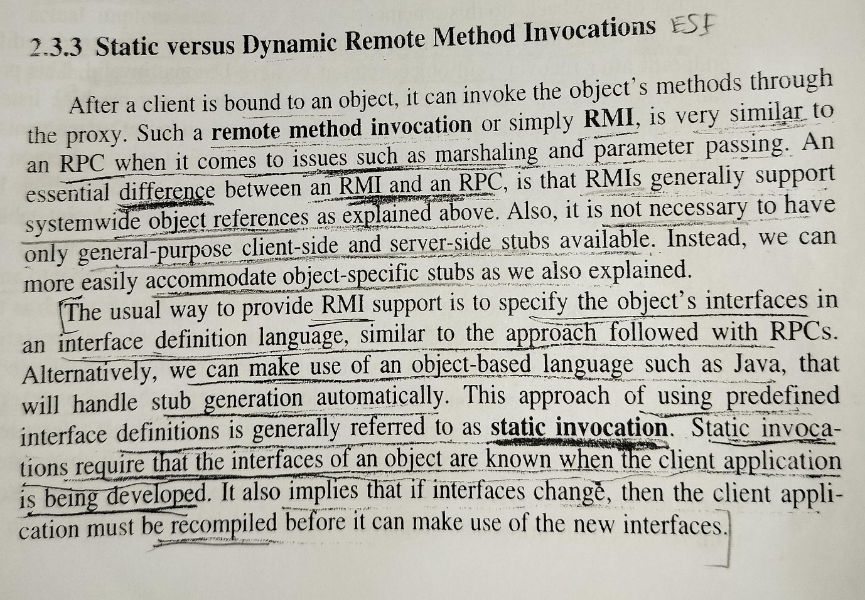

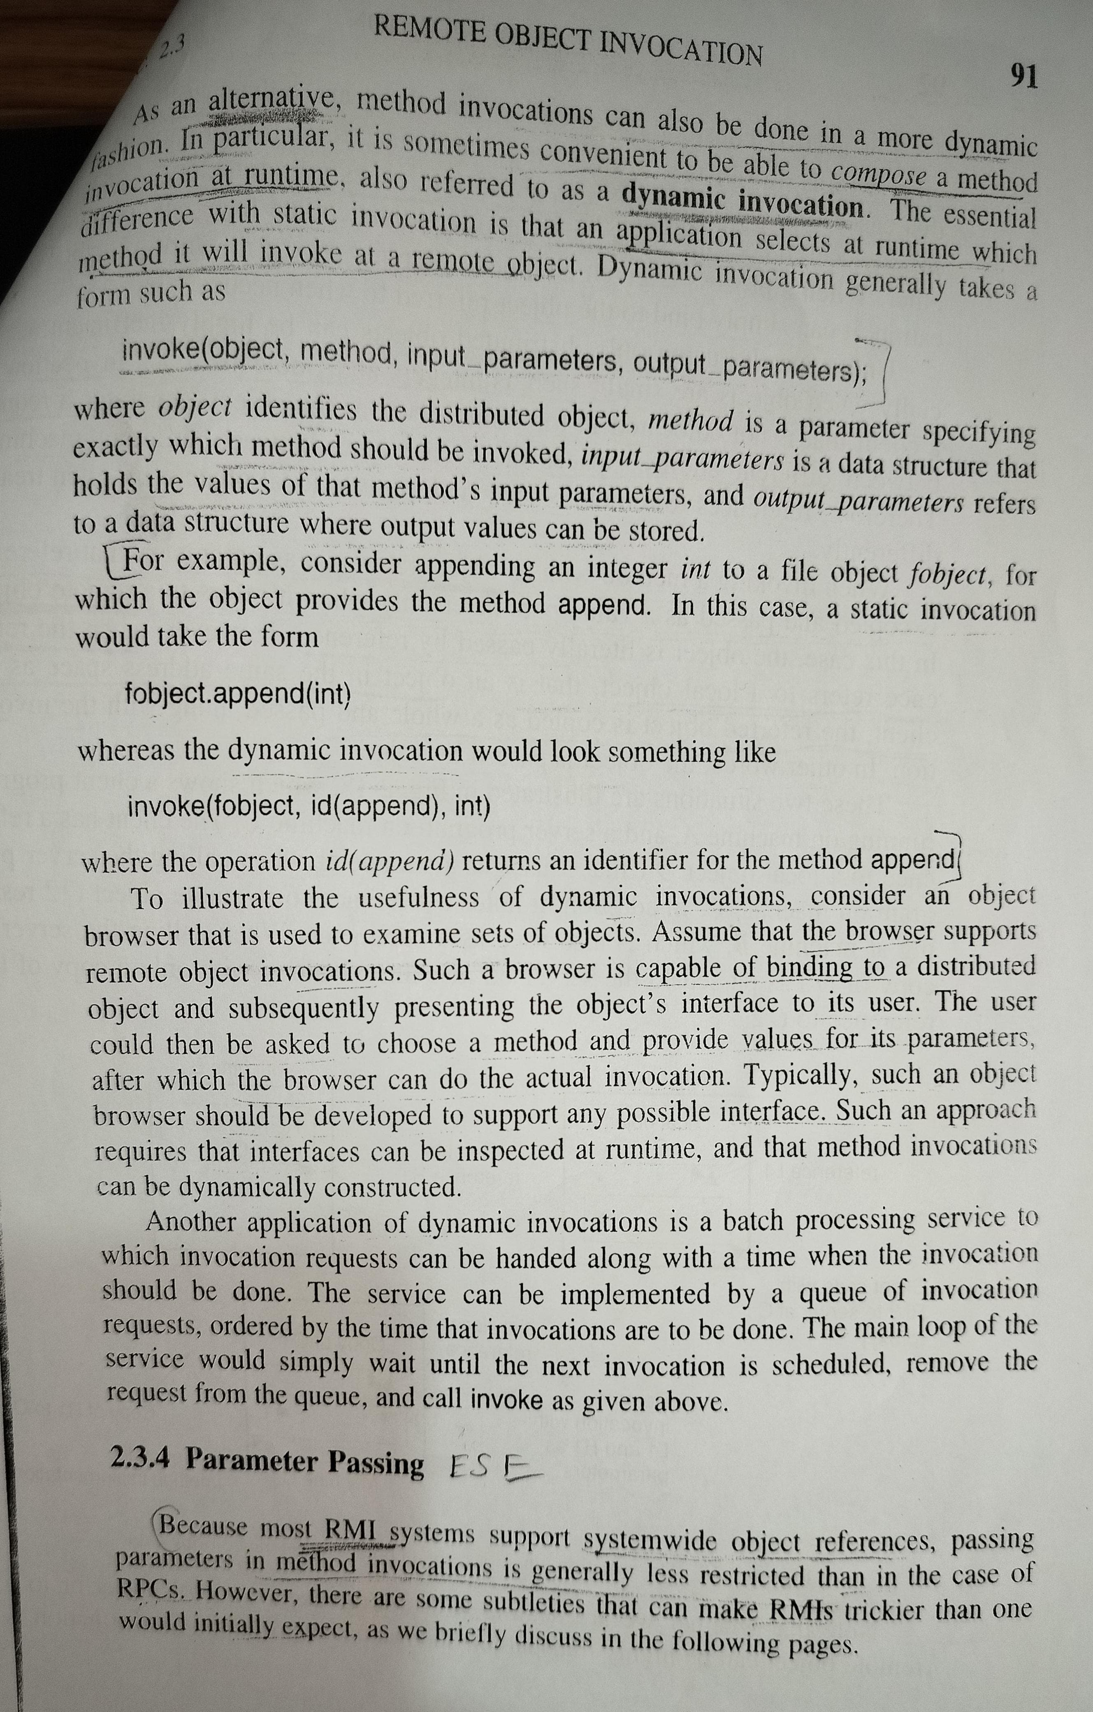

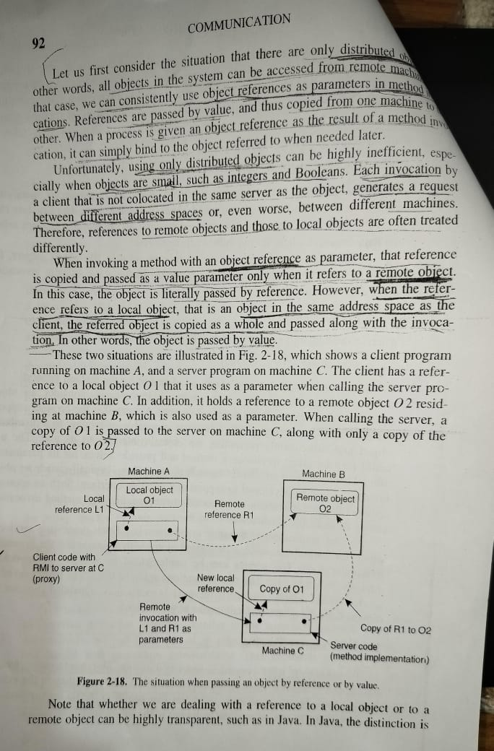

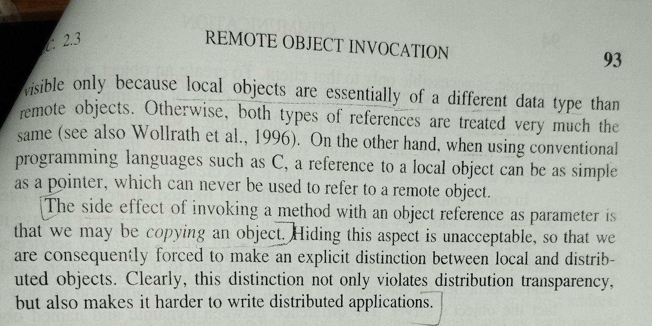

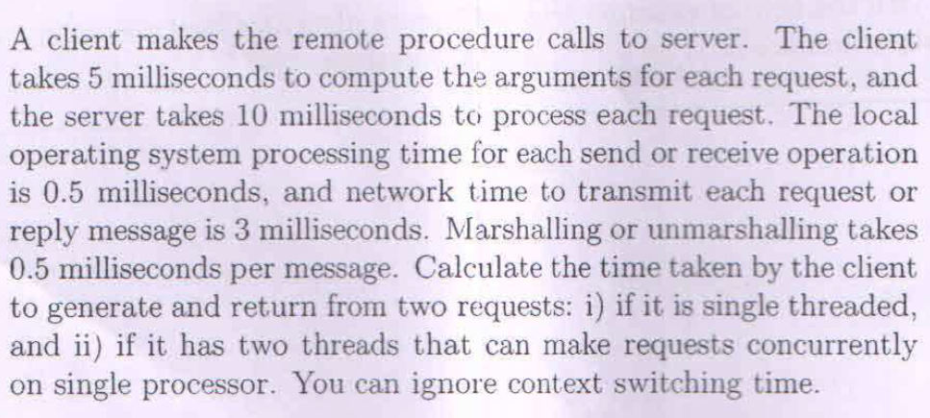

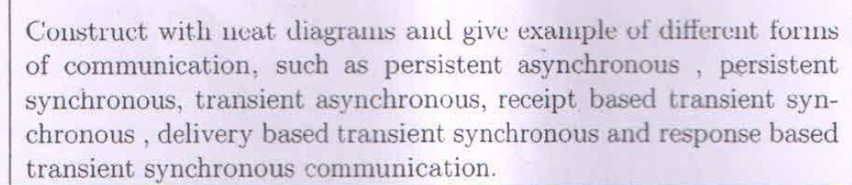

**What are different reasons for code migration explain in detail. Explain with diagram how client dynamically configure the server**

[Code migration is the process of moving programming code from one system to another1](https://www.ques10.com/p/24012/what-is-code-migration-what-are-the-reasons-for-mi/). [It can involve moving from one version of a language to a newer version, moving to a different programming language, or migrating to an entirely new platform or operating system1](https://www.ques10.com/p/24012/what-is-code-migration-what-are-the-reasons-for-mi/). Here are some reasons for code migration:

1. [**Performance Improvement**: Modern programming languages often have better efficiency than legacy languages](https://www.ques10.com/p/24012/what-is-code-migration-what-are-the-reasons-for-mi/)[2](https://www.edx.org/learn/code-migration). [Therefore, migrating code can lead to more efficient execution](https://www.ques10.com/p/24012/what-is-code-migration-what-are-the-reasons-for-mi/)[1](https://www.ques10.com/p/24012/what-is-code-migration-what-are-the-reasons-for-mi/)[2](https://www.edx.org/learn/code-migration).
2. [**Load Sharing in Distributed Systems**: Long-running processes can be migrated to idle processors to improve system-wide performance](https://www.ques10.com/p/24012/what-is-code-migration-what-are-the-reasons-for-mi/)[1](https://www.ques10.com/p/24012/what-is-code-migration-what-are-the-reasons-for-mi/)[3](https://cs.gmu.edu/~setia/cs707/slides/code-migration.pdf).
3. [**Client-Server Systems**: If large quantities of data need to be processed, it is better to ship the data processing component to the client](https://www.ques10.com/p/24012/what-is-code-migration-what-are-the-reasons-for-mi/)[3](https://cs.gmu.edu/~setia/cs707/slides/code-migration.pdf). [This leads to more efficiency in execution](https://www.ques10.com/p/24012/what-is-code-migration-what-are-the-reasons-for-mi/)[1](https://www.ques10.com/p/24012/what-is-code-migration-what-are-the-reasons-for-mi/)[3](https://cs.gmu.edu/~setia/cs707/slides/code-migration.pdf).
4. [**Software System Changes**: Migrating to a completely different programming language could be caused by porting to a new software system or implementing a different relational database management system (RDMS)](https://www.ques10.com/p/24012/what-is-code-migration-what-are-the-reasons-for-mi/)[1](https://www.ques10.com/p/24012/what-is-code-migration-what-are-the-reasons-for-mi/).
5. [**Platform or Operating System Changes**: Migrating to an entirely new platform and/or operating system (OS) changes not only the programming language, but also the machine code behind the language](https://www.ques10.com/p/24012/what-is-code-migration-what-are-the-reasons-for-mi/)[1](https://www.ques10.com/p/24012/what-is-code-migration-what-are-the-reasons-for-mi/).

[As for how a client dynamically configures a server, one common method is through the Dynamic Host Configuration Protocol (DHCP)4](https://www.geeksforgeeks.org/dynamic-host-configuration-protocol-dhcp/)[5](https://www.geeksforgeeks.org/how-dhcp-server-dynamically-assigns-ip-address-to-a-host/). Here’s a simplified sequence of events:

1. [When a client device connects to the network, it sends out a DHCPDISCOVER message to the DHCP server](https://www.ques10.com/p/24012/what-is-code-migration-what-are-the-reasons-for-mi/)[6](https://www.howtogeek.com/404891/what-is-dhcp-dynamic-host-configuration-protocol/).
2. [The DHCP server responds with a DHCPOFFER message, which includes network configuration parameters such as IP addresses, subnet masks, and gateway addresses](https://www.ques10.com/p/24012/what-is-code-migration-what-are-the-reasons-for-mi/)[4](https://www.geeksforgeeks.org/dynamic-host-configuration-protocol-dhcp/)[5](https://www.geeksforgeeks.org/how-dhcp-server-dynamically-assigns-ip-address-to-a-host/).
3. [The client device receives the DHCPOFFER and sends a DHCPREQUEST message back to the server to request the offered address](https://www.ques10.com/p/24012/what-is-code-migration-what-are-the-reasons-for-mi/)[5](https://www.geeksforgeeks.org/how-dhcp-server-dynamically-assigns-ip-address-to-a-host/).
4. [The server acknowledges the request with a DHCPACK message, completing the configuration](https://www.ques10.com/p/24012/what-is-code-migration-what-are-the-reasons-for-mi/)[5](https://www.geeksforgeeks.org/how-dhcp-server-dynamically-assigns-ip-address-to-a-host/).

Unfortunately, I can’t provide a diagram here, but I hope this explanation helps you understand code migration and dynamic client-server configuration. If you have any further questions, please feel free to ask me 😊.

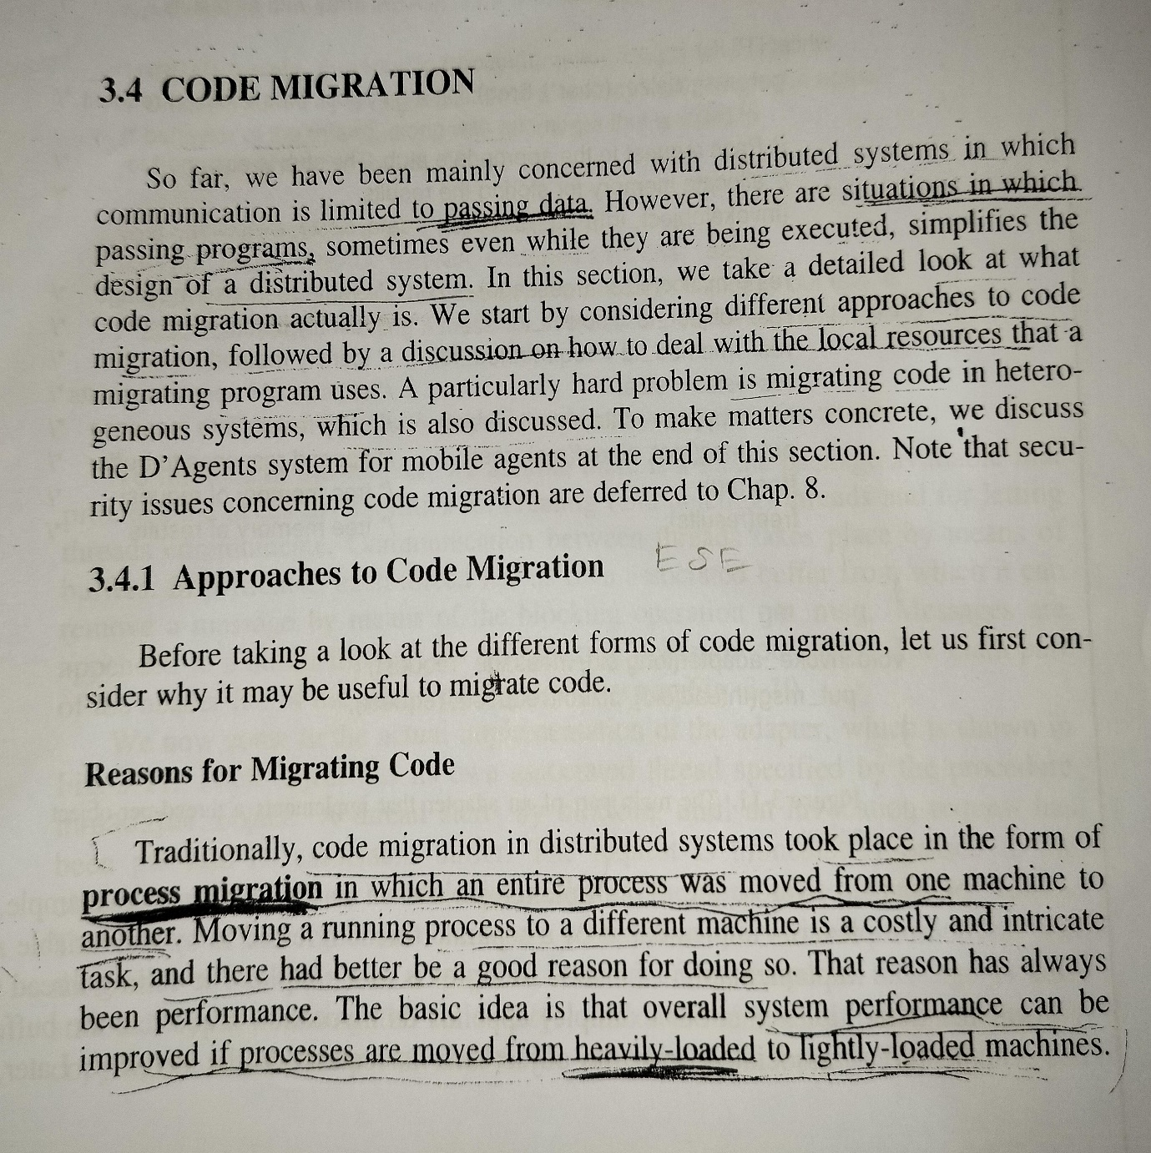

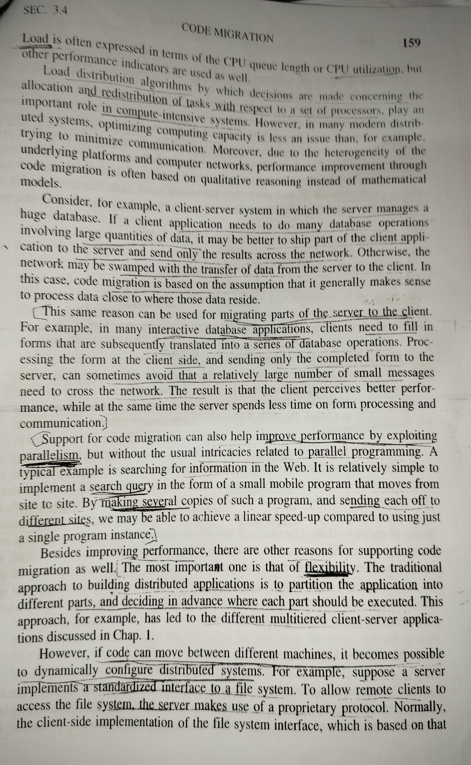

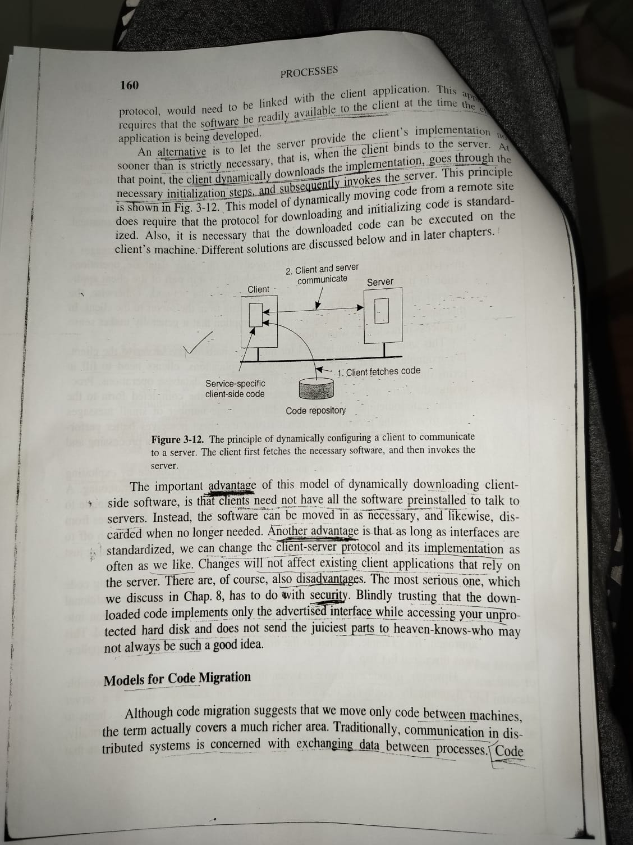

**What is global state of a distributed system ? with the help of a diagram explain the distributed snapshot algorithm**

[The global state of a distributed system is a collection of the local states of the processes and the channels1](https://ics.uci.edu/~cs230/lectures20/distrsyslectureset3-win20.pdf). [A global state computed along a consistent cut is correct1](https://ics.uci.edu/~cs230/lectures20/distrsyslectureset3-win20.pdf). [The global state of a consistent cut comprises the local state of each process at the time the cut event happens and the set of all messages sent but not yet received1](https://ics.uci.edu/~cs230/lectures20/distrsyslectureset3-win20.pdf).

[The distributed snapshot algorithm, also known as the Chandy-Lamport algorithm, is used to capture a consistent global state of a distributed system](https://ics.uci.edu/~cs230/lectures20/distrsyslectureset3-win20.pdf)[2](https://www.geeksforgeeks.org/chandy-lamports-global-state-recording-algorithm/). Here’s how it works:

1. [Any process in the distributed system can initiate this global state recording algorithm using a special message called MARKER](https://ics.uci.edu/~cs230/lectures20/distrsyslectureset3-win20.pdf)[2](https://www.geeksforgeeks.org/chandy-lamports-global-state-recording-algorithm/).
2. [This MARKER traverses the distributed system across all communication channels and causes each process to record its own state](https://ics.uci.edu/~cs230/lectures20/distrsyslectureset3-win20.pdf)[2](https://www.geeksforgeeks.org/chandy-lamports-global-state-recording-algorithm/).
3. [In the end, the state of the entire system (Global state) is recorded](https://ics.uci.edu/~cs230/lectures20/distrsyslectureset3-win20.pdf)[2](https://www.geeksforgeeks.org/chandy-lamports-global-state-recording-algorithm/).

Unfortunately, I can’t provide a diagram here, but I hope this explanation helps you understand the global state of a distributed system and the distributed snapshot algorithm. If you have any further questions, please feel free to ask me 😊.

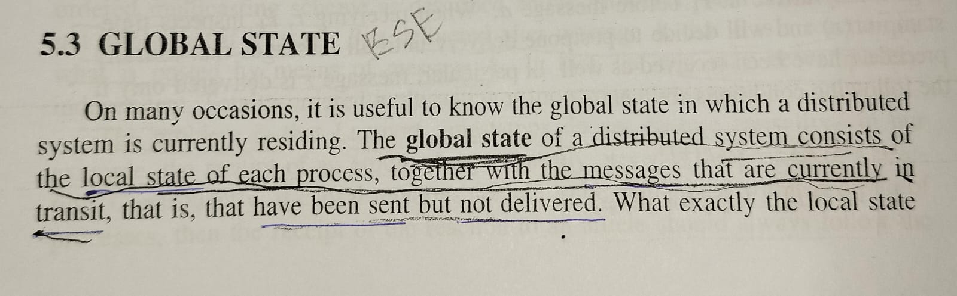

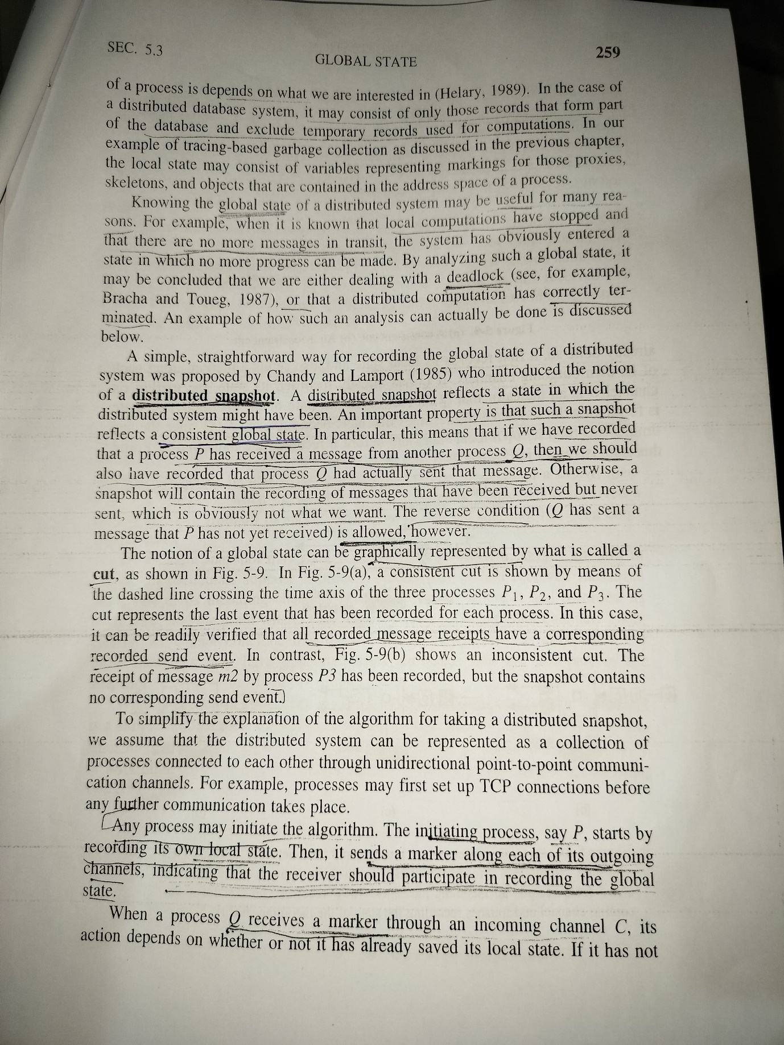

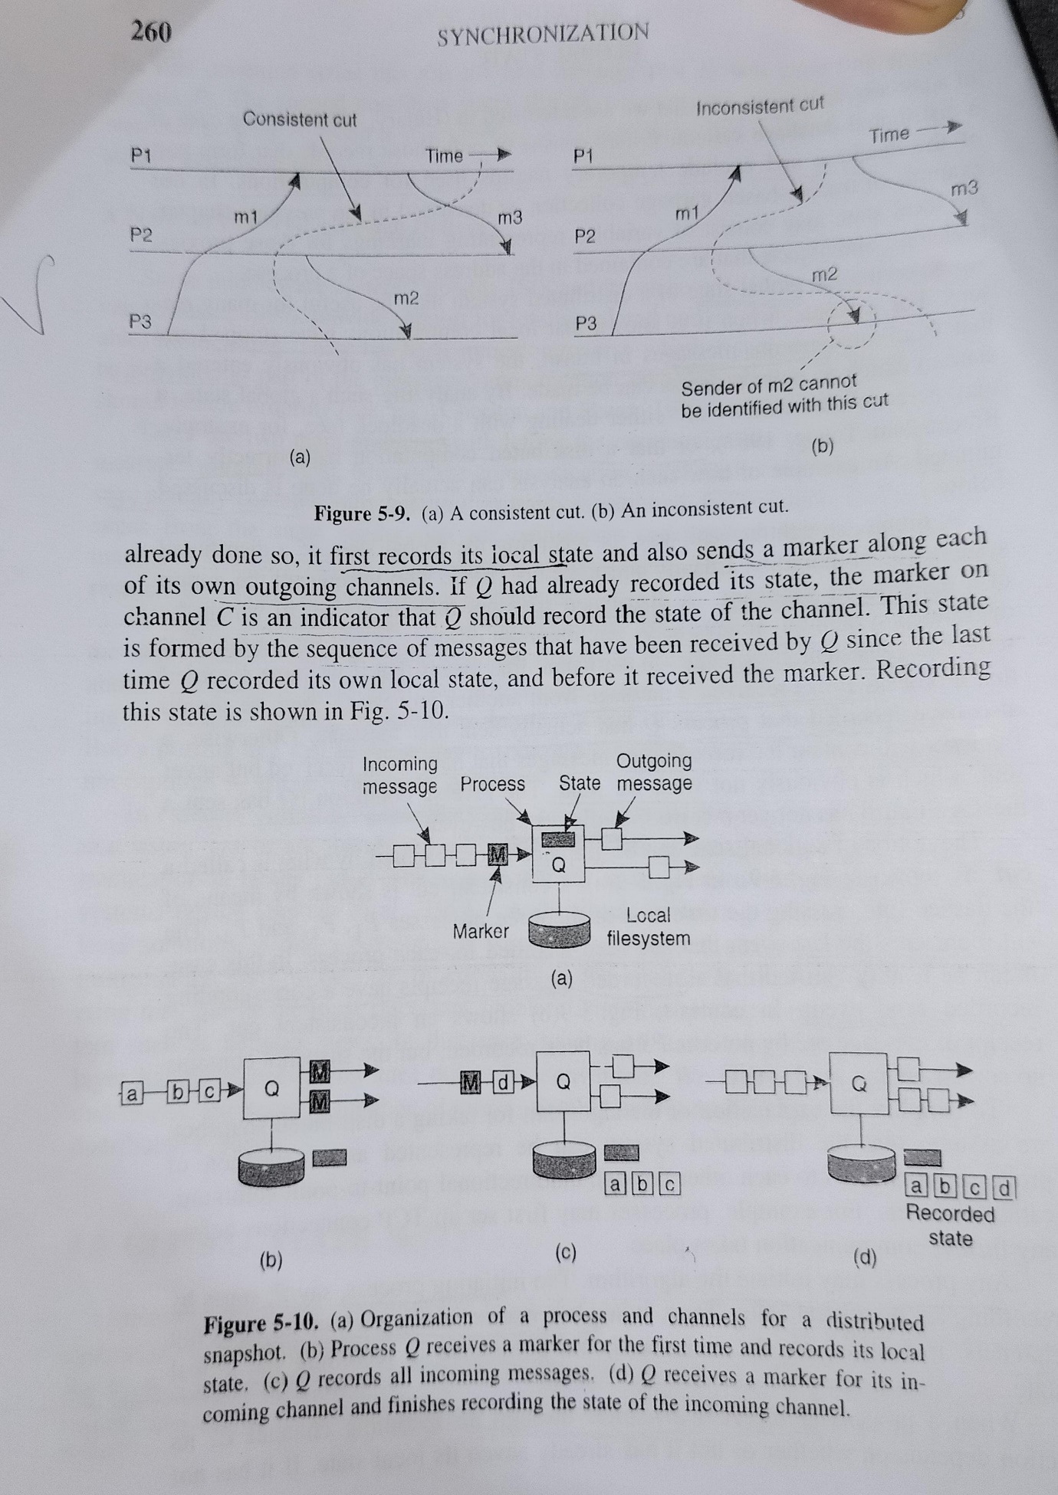

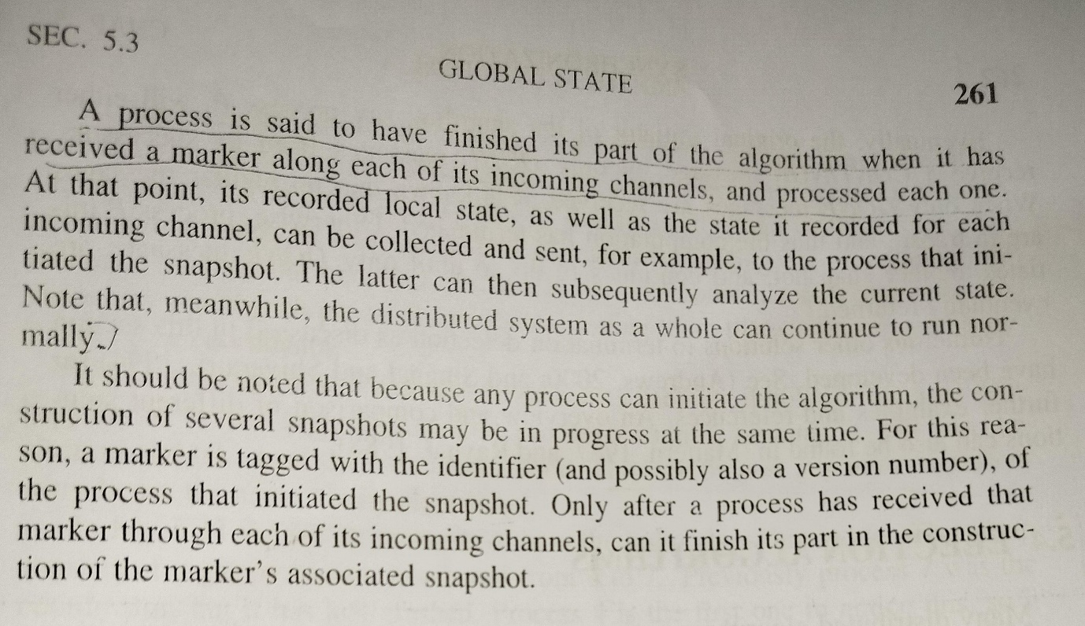

**Explain how election is done when any particular system crashes using bully algorithm and ring based algorithm.**

In distributed systems, when a process (often referred to as a coordinator or leader) crashes or is otherwise unable to perform its duties, an **election algorithm** is used to select a new coordinator. Two common algorithms for this purpose are the **Bully algorithm** and the **Ring algorithm**. Let’s explore how each of these algorithms operates:

### Bully Algorithm

The Bully algorithm is based on the principle that the process with the highest identifier (ID) should be the coordinator. [Here’s how the election process works using the Bully algorithm1](https://www.geeksforgeeks.org/bully-algorithm-in-distributed-system/):

1. **Detection**: A process detects that the coordinator is not responding.
2. **Election Message**: The detecting process sends an election message to all processes with higher IDs.
3. **Wait for Response**: The detecting process waits for a response from these processes.
4. **Coordinator Election**:
   * If no response is received within a certain time frame, the detecting process assumes that all higher ID processes are down and elects itself as the new coordinator.
   * If a response is received, the responding process with the highest ID takes over the election process and repeats steps 2 and 3.
5. **Victory Message**: Once a process has determined that it is the highest active process, it sends a victory message to all processes with lower IDs to announce itself as the new coordinator.

### Ring Algorithm

The Ring algorithm is used in systems organized in a logical or physical ring. It assumes unidirectional communication between processes. [Here’s how the election process works using the Ring algorithm](https://www.geeksforgeeks.org/bully-algorithm-in-distributed-system/)[2](https://www.geeksforgeeks.org/election-algorithm-and-distributed-processing/):

1. **Coordinator Failure Detection**: A process detects that the coordinator has failed.
2. **Election Message**: The detecting process creates an election message containing its own ID and sends it to the next process in the ring.
3. **Passing the Message**: Each process that receives the election message adds its ID to the message and passes it to the next process in the ring.
4. **Receiving Own ID**: When a process receives an election message containing its own ID, it knows that it has made a full circle.
5. **Election Completion**:
   * The process with the highest ID in the election message is elected as the new coordinator.
   * The winning process sends a message around the ring to inform all other processes of the election result.

Both algorithms ensure that a new coordinator is elected in the event of a failure. The Bully algorithm is straightforward and effective in systems where every process can communicate with every other process. The Ring algorithm is suitable for systems arranged in a ring topology, where each process communicates only with its immediate neighbor.

[For more detailed information on these algorithms, including their advantages, disadvantages, and suitability for different types of distributed systems, you can refer to the resources provided1](https://www.geeksforgeeks.org/bully-algorithm-in-distributed-system/)[2](https://www.geeksforgeeks.org/election-algorithm-and-distributed-processing/). These resources will give you a comprehensive understanding of the algorithms and their practical applications in real-world distributed systems.

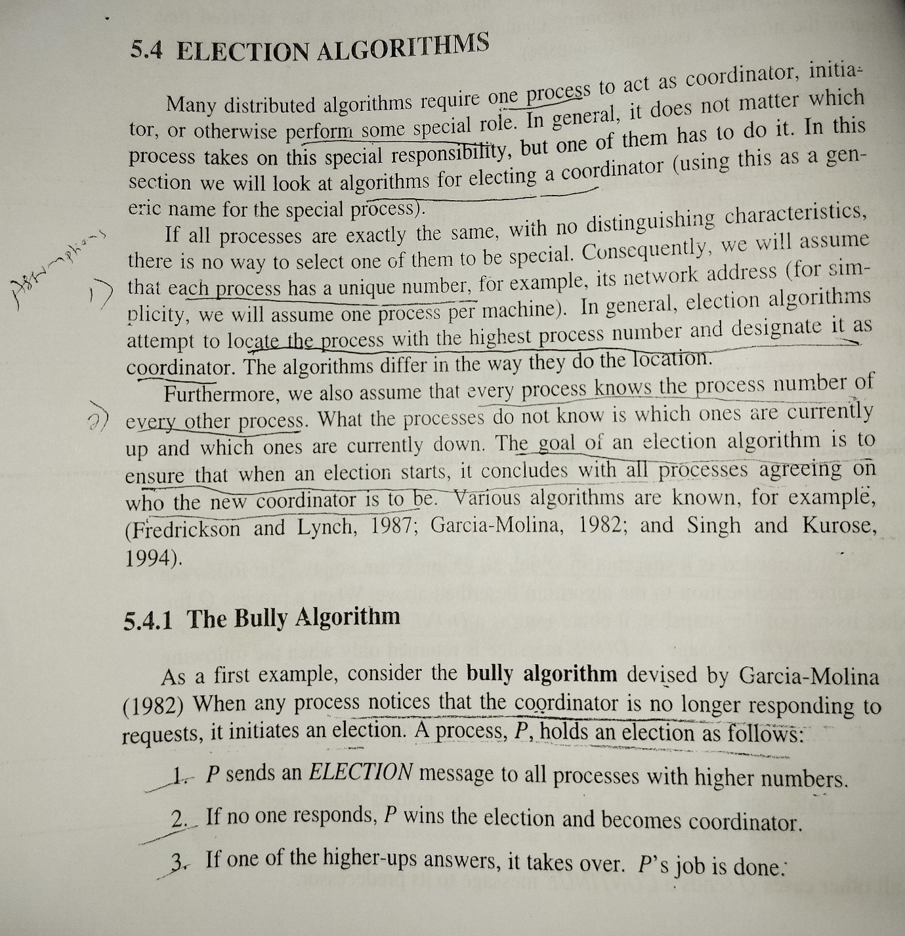

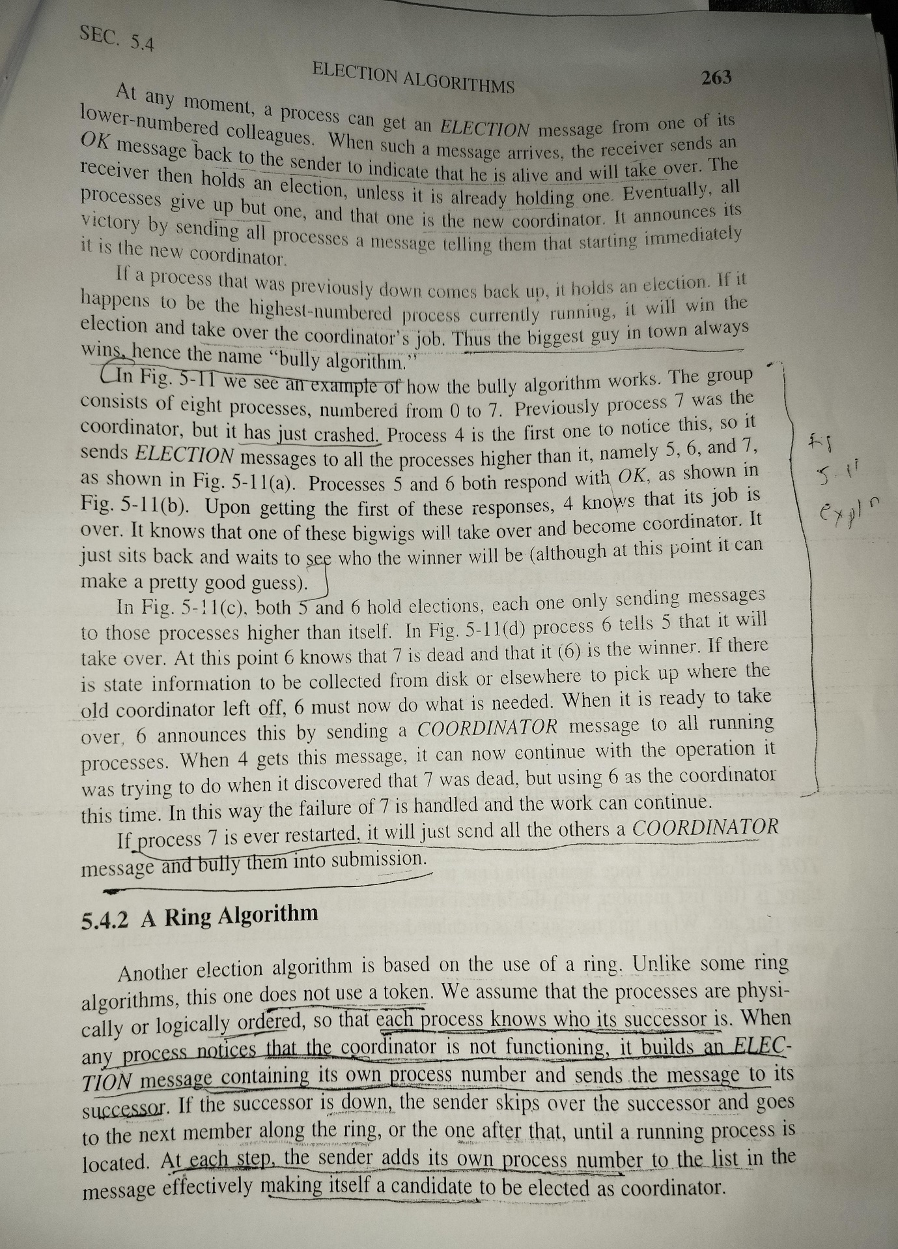

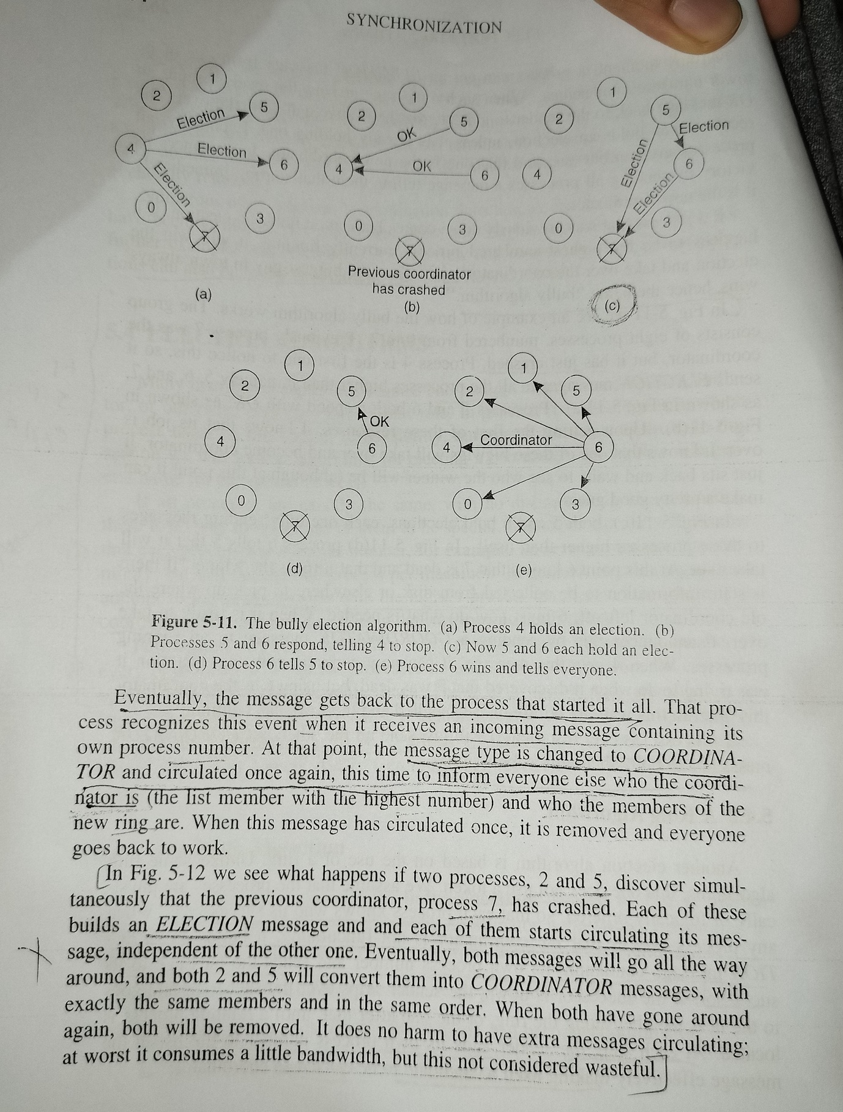

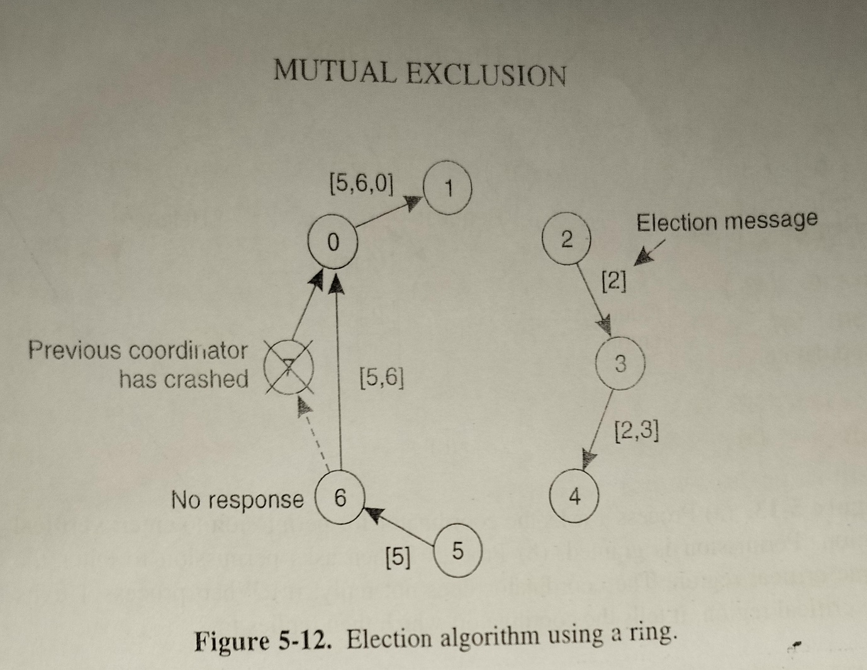

**Explain the working of distributed mutual exclusion algorithm.**

[Distributed mutual exclusion is a critical requirement in distributed systems where only one process is allowed to execute the critical section (CS) at any given time1](https://www.cambridge.org/core/books/abs/distributed-computing/distributed-mutual-exclusion-algorithms/F819BE611EE98FD80D4DF2A6237F79DA)[2](https://www.cs.uic.edu/~ajayk/Chapter9.pdf). In a distributed system, shared variables (semaphores) or a local kernel cannot be used to implement mutual exclusion. [Message passing is the sole means for implementing distributed mutual exclusion](https://www.cambridge.org/core/books/abs/distributed-computing/distributed-mutual-exclusion-algorithms/F819BE611EE98FD80D4DF2A6237F79DA)[1](https://www.cambridge.org/core/books/abs/distributed-computing/distributed-mutual-exclusion-algorithms/F819BE611EE98FD80D4DF2A6237F79DA)[2](https://www.cs.uic.edu/~ajayk/Chapter9.pdf).

[There are two main types of distributed mutual exclusion algorithms: token-based and non-token-based](https://www.cambridge.org/core/books/abs/distributed-computing/distributed-mutual-exclusion-algorithms/F819BE611EE98FD80D4DF2A6237F79DA)[3](https://www.geeksforgeeks.org/mutual-exclusion-in-distributed-system/).

**Token-Based Algorithms**: A unique token is shared among all the sites. [If a site possesses the unique token, it is allowed to enter its critical section](https://www.cambridge.org/core/books/abs/distributed-computing/distributed-mutual-exclusion-algorithms/F819BE611EE98FD80D4DF2A6237F79DA)[3](https://www.geeksforgeeks.org/mutual-exclusion-in-distributed-system/).

[**Non-Token-Based Algorithms**: A site communicates with other sites to get their permission to enter the critical section](https://www.cambridge.org/core/books/abs/distributed-computing/distributed-mutual-exclusion-algorithms/F819BE611EE98FD80D4DF2A6237F79DA)[3](https://www.geeksforgeeks.org/mutual-exclusion-in-distributed-system/). [An example of a non-token-based algorithm is Lamport’s Distributed Mutual Exclusion Algorithm](https://www.cambridge.org/core/books/abs/distributed-computing/distributed-mutual-exclusion-algorithms/F819BE611EE98FD80D4DF2A6237F79DA)[4](https://www.geeksforgeeks.org/lamports-algorithm-for-mutual-exclusion-in-distributed-system/). In this algorithm:

* [A site S_i sends a REQUEST message to all other sites to get their permission to enter the critical section4](https://www.geeksforgeeks.org/lamports-algorithm-for-mutual-exclusion-in-distributed-system/).
* [When a site S_j receives the REQUEST message from site S_i, it returns a REPLY message to site S_i](https://www.cambridge.org/core/books/abs/distributed-computing/distributed-mutual-exclusion-algorithms/F819BE611EE98FD80D4DF2A6237F79DA)[4](https://www.geeksforgeeks.org/lamports-algorithm-for-mutual-exclusion-in-distributed-system/).
* [A site S_i can enter the critical section if it has received the message with timestamp larger than (tsi, i) from all other sites and its own request is at the top of request_queuei](https://www.cambridge.org/core/books/abs/distributed-computing/distributed-mutual-exclusion-algorithms/F819BE611EE98FD80D4DF2A6237F79DA)[4](https://www.geeksforgeeks.org/lamports-algorithm-for-mutual-exclusion-in-distributed-system/).
* [When a site S_i exits the critical section, it removes its own request from the top of its request queue and sends a RELEASE message to all other sites](https://www.cambridge.org/core/books/abs/distributed-computing/distributed-mutual-exclusion-algorithms/F819BE611EE98FD80D4DF2A6237F79DA)[4](https://www.geeksforgeeks.org/lamports-algorithm-for-mutual-exclusion-in-distributed-system/).
* [When a site S_j receives the RELEASE message from site S_i, it removes the request of S_i from its request queue4](https://www.geeksforgeeks.org/lamports-algorithm-for-mutual-exclusion-in-distributed-system/).

[These algorithms ensure that mutual exclusion is achieved in a distributed system](https://www.cambridge.org/core/books/abs/distributed-computing/distributed-mutual-exclusion-algorithms/F819BE611EE98FD80D4DF2A6237F79DA)[3](https://www.geeksforgeeks.org/mutual-exclusion-in-distributed-system/)[4](https://www.geeksforgeeks.org/lamports-algorithm-for-mutual-exclusion-in-distributed-system/). [However, they come with their own set of challenges such as dealing with failures, ensuring fairness, and reducing message complexity](https://www.cambridge.org/core/books/abs/distributed-computing/distributed-mutual-exclusion-algorithms/F819BE611EE98FD80D4DF2A6237F79DA)[3](https://www.geeksforgeeks.org/mutual-exclusion-in-distributed-system/)[4](https://www.geeksforgeeks.org/lamports-algorithm-for-mutual-exclusion-in-distributed-system/). If you have any further questions, please feel free to ask me 😊.

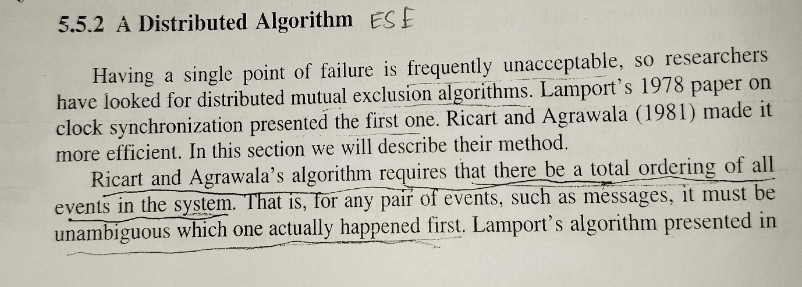

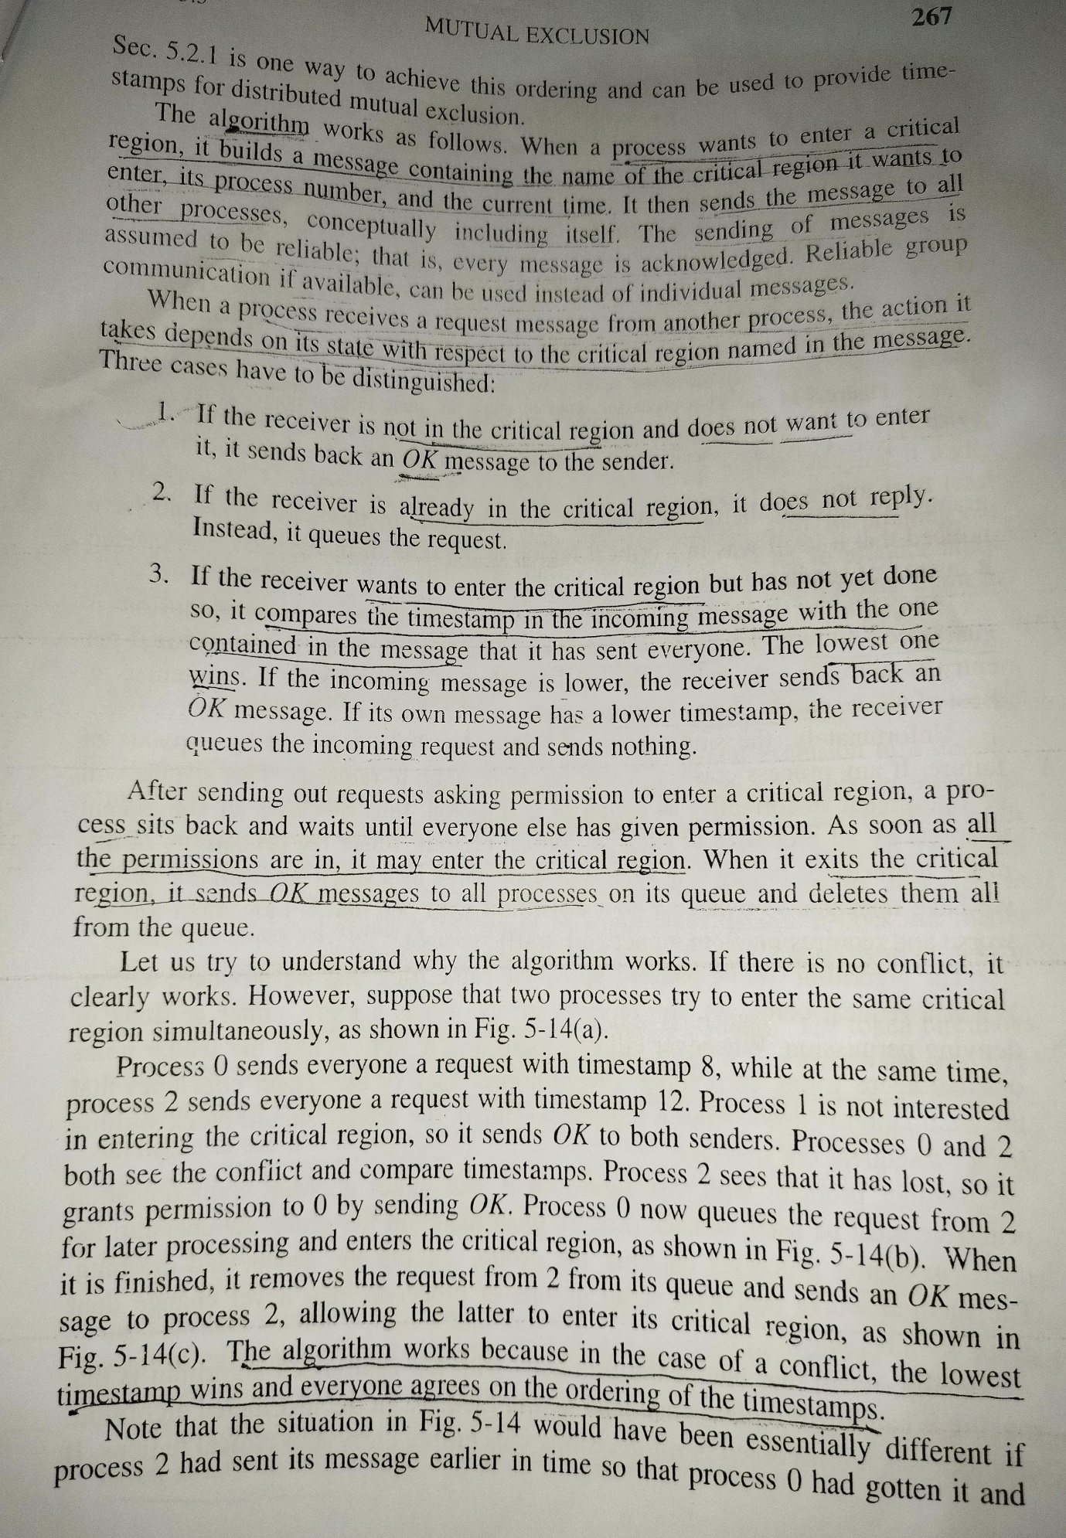

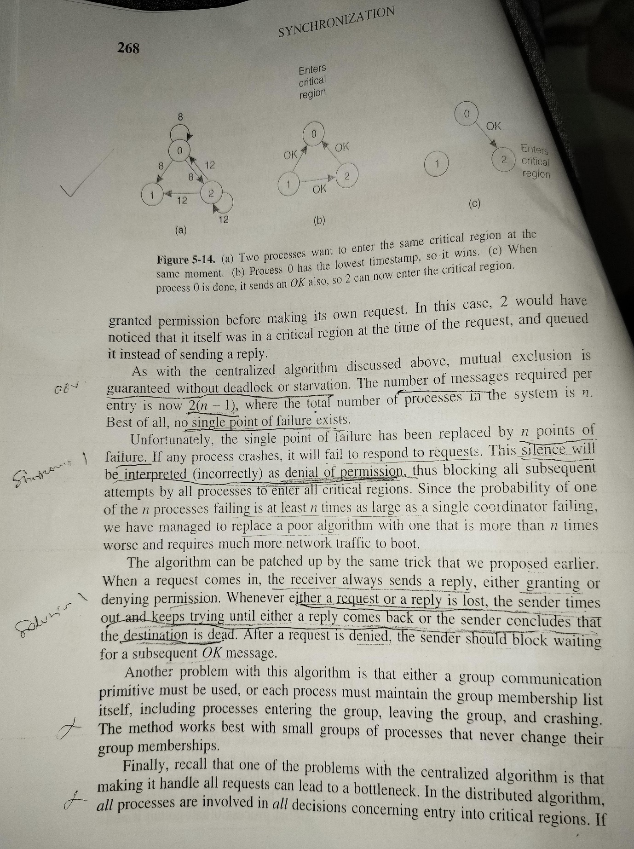

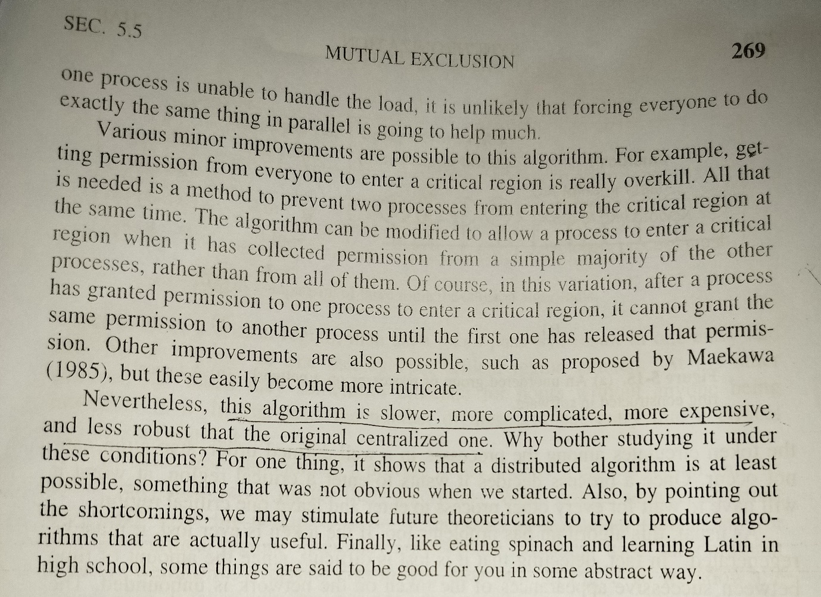

**Give me advantages and disadvantages of distributed mutual exclusion algorithm**

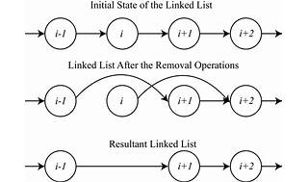

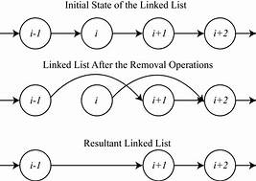

Explore

Distributed mutual exclusion algorithms are essential for ensuring that only one process at a time can access a shared resource in a distributed system. Here are some advantages and disadvantages of these algorithms:

### Advantages:

* [**Concurrency Control**: They prevent race conditions by ensuring that only one process can enter its critical section at a time1](https://www.geeksforgeeks.org/mutual-exclusion-in-distributed-system/).
* [**Fairness**: Most algorithms are designed to provide fair access to the shared resource, ensuring that every process gets a chance to enter the critical section](https://www.geeksforgeeks.org/mutual-exclusion-in-distributed-system/)[2](https://www.geeksforgeeks.org/maekawas-algorithm-for-mutual-exclusion-in-distributed-system/).
* [**Scalability**: They can be used in large-scale distributed systems without significant issues](https://www.geeksforgeeks.org/mutual-exclusion-in-distributed-system/)[2](https://www.geeksforgeeks.org/maekawas-algorithm-for-mutual-exclusion-in-distributed-system/).
* [**Fault Tolerance**: Some algorithms are designed to recognize failures and continue functioning without disruption1](https://www.geeksforgeeks.org/mutual-exclusion-in-distributed-system/).
* [**No Central Coordinator**: Algorithms like Lamport’s do not require a central coordinator, which avoids a single point of failure3](https://www.geeksforgeeks.org/lamports-algorithm-for-mutual-exclusion-in-distributed-system/).

### Disadvantages:

* [**Complexity**: Implementing mutual exclusion in distributed systems is more complex due to the lack of shared memory and a common physical clock1](https://www.geeksforgeeks.org/mutual-exclusion-in-distributed-system/).
* [**Message Overhead**: Some algorithms, like Lamport’s, require a significant number of messages to be exchanged, which can lead to high network traffic3](https://www.geeksforgeeks.org/lamports-algorithm-for-mutual-exclusion-in-distributed-system/).
* [**Synchronization Delay**: The time taken to achieve mutual exclusion can be affected by message transmission times, leading to delays3](https://www.geeksforgeeks.org/lamports-algorithm-for-mutual-exclusion-in-distributed-system/).
* [**Failure Handling**: The failure of one process can halt the progress of the entire system in some algorithms3](https://www.geeksforgeeks.org/lamports-algorithm-for-mutual-exclusion-in-distributed-system/).
* [**Contention**: High levels of contention for the shared resource can make the algorithm inefficient as it may take several rounds of communication to resolve conflicts4](https://www.tutorialspoint.com/lamportis-algorithm-for-mutual-exclusion-in-distributed-system).

These algorithms play a crucial role in the design of distributed systems, and their selection should be based on the specific requirements and constraints of the system in question. [For more detailed information on distributed mutual exclusion algorithms, you can refer to the resources provided](https://www.geeksforgeeks.org/mutual-exclusion-in-distributed-system/)[1](https://www.geeksforgeeks.org/mutual-exclusion-in-distributed-system/)[3](https://www.geeksforgeeks.org/lamports-algorithm-for-mutual-exclusion-in-distributed-system/)[5](https://www.cs.uic.edu/~ajayk/Chapter9.pdf)[4](https://www.tutorialspoint.com/lamportis-algorithm-for-mutual-exclusion-in-distributed-system)[6](https://www.tutorialspoint.com/mutual-exclusion-in-a-distributed-system)[2](https://www.geeksforgeeks.org/maekawas-algorithm-for-mutual-exclusion-in-distributed-system/).

**What are the reasons for replication? Explain strict data-centric consistency model.**

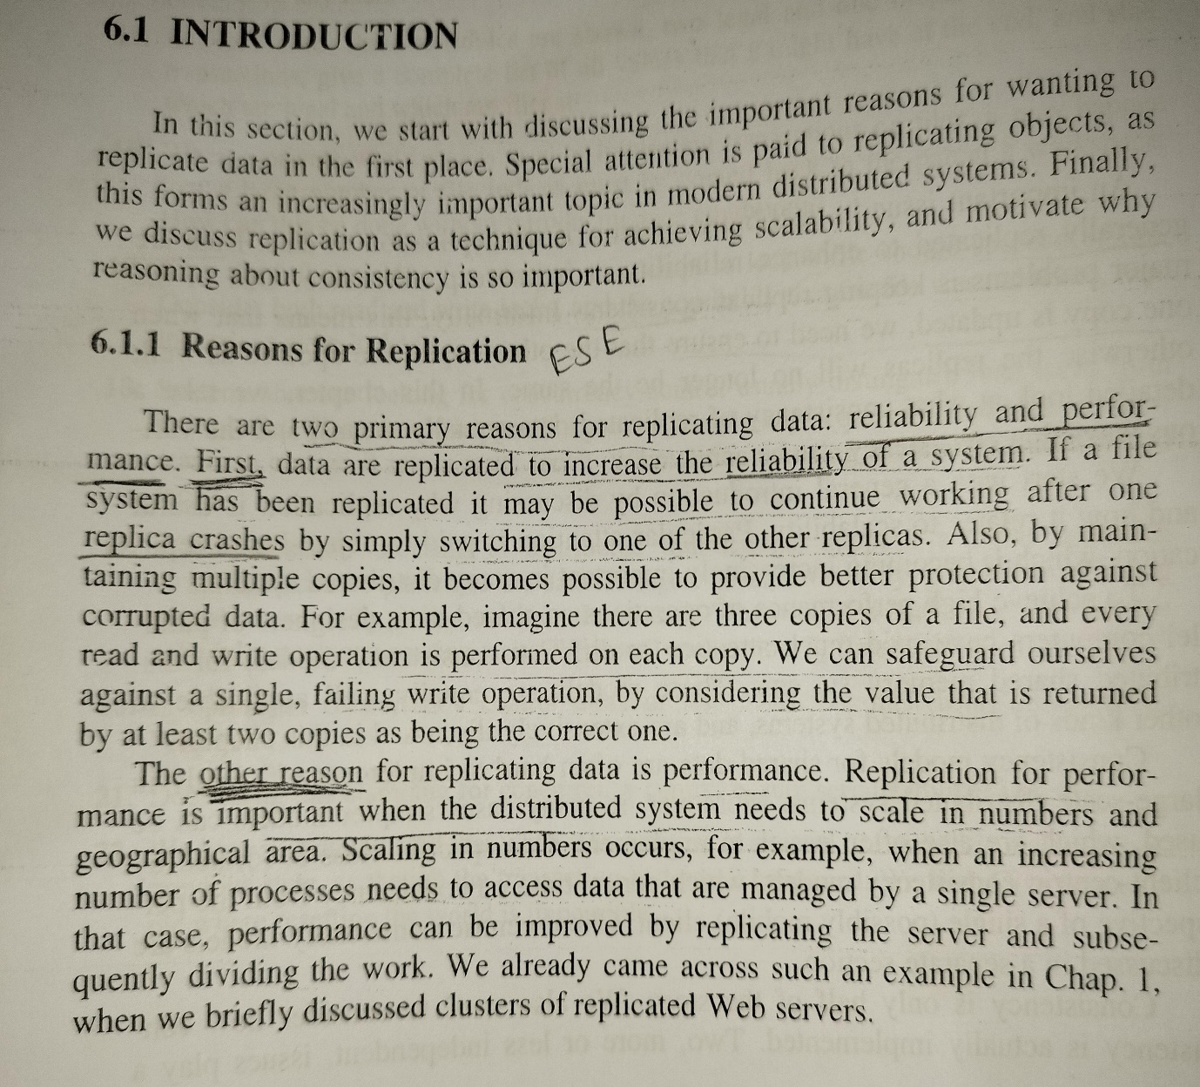

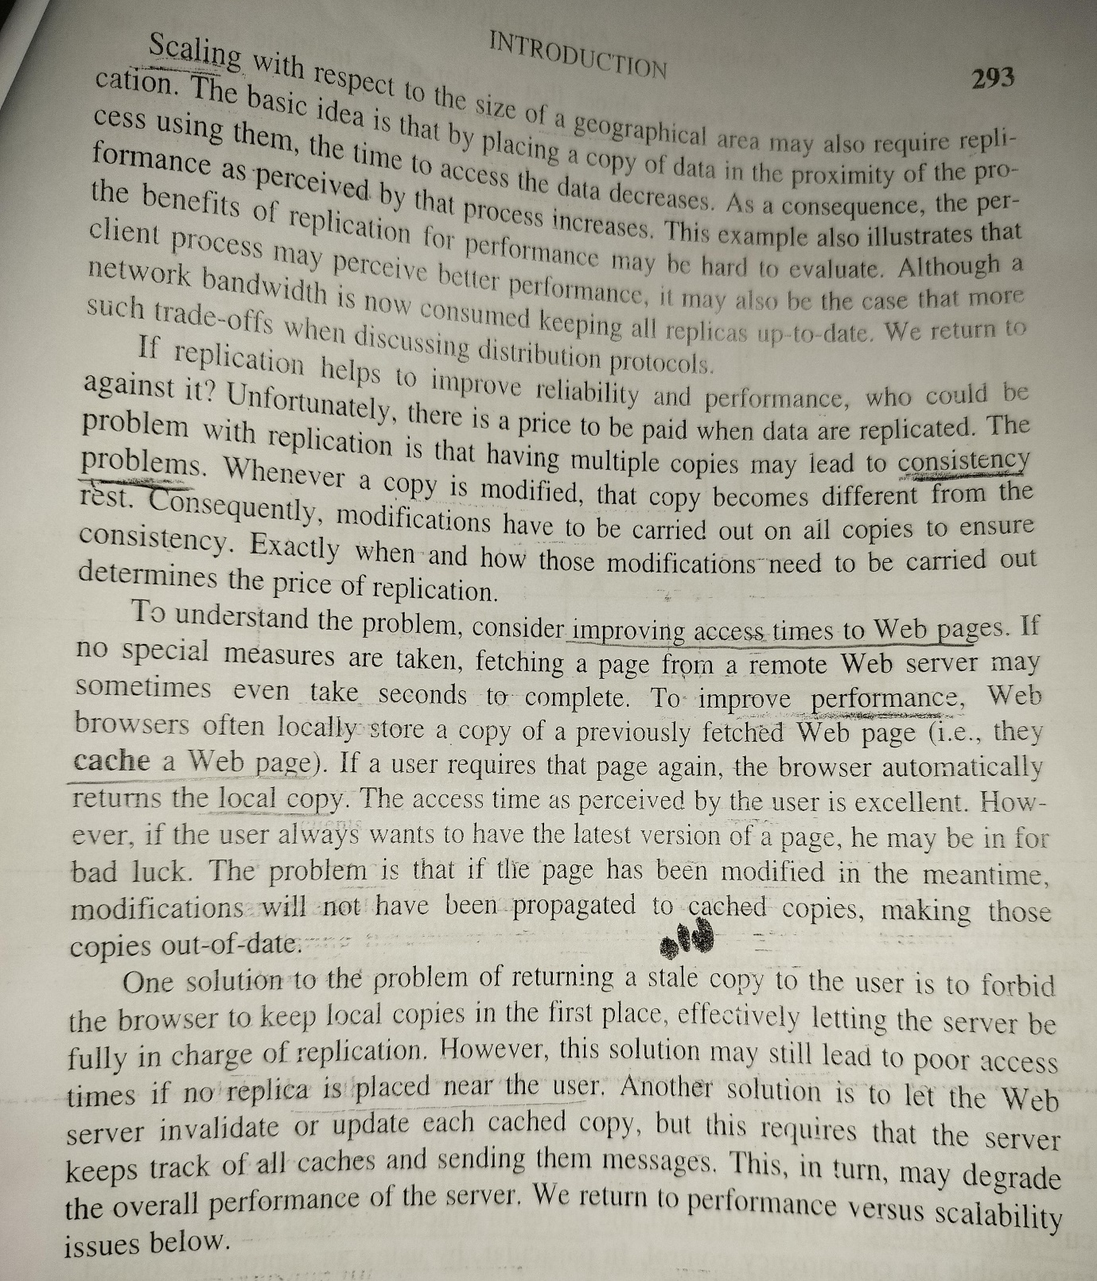

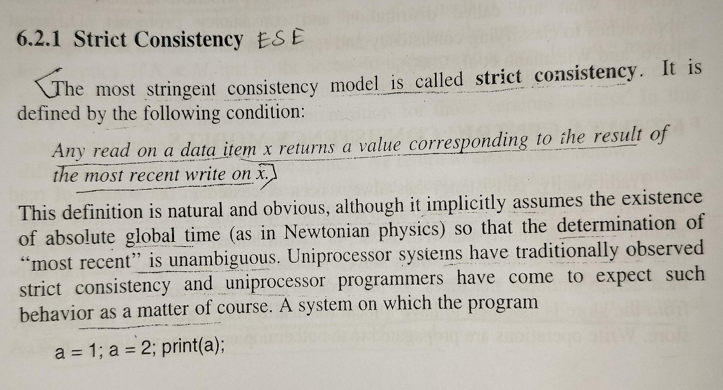

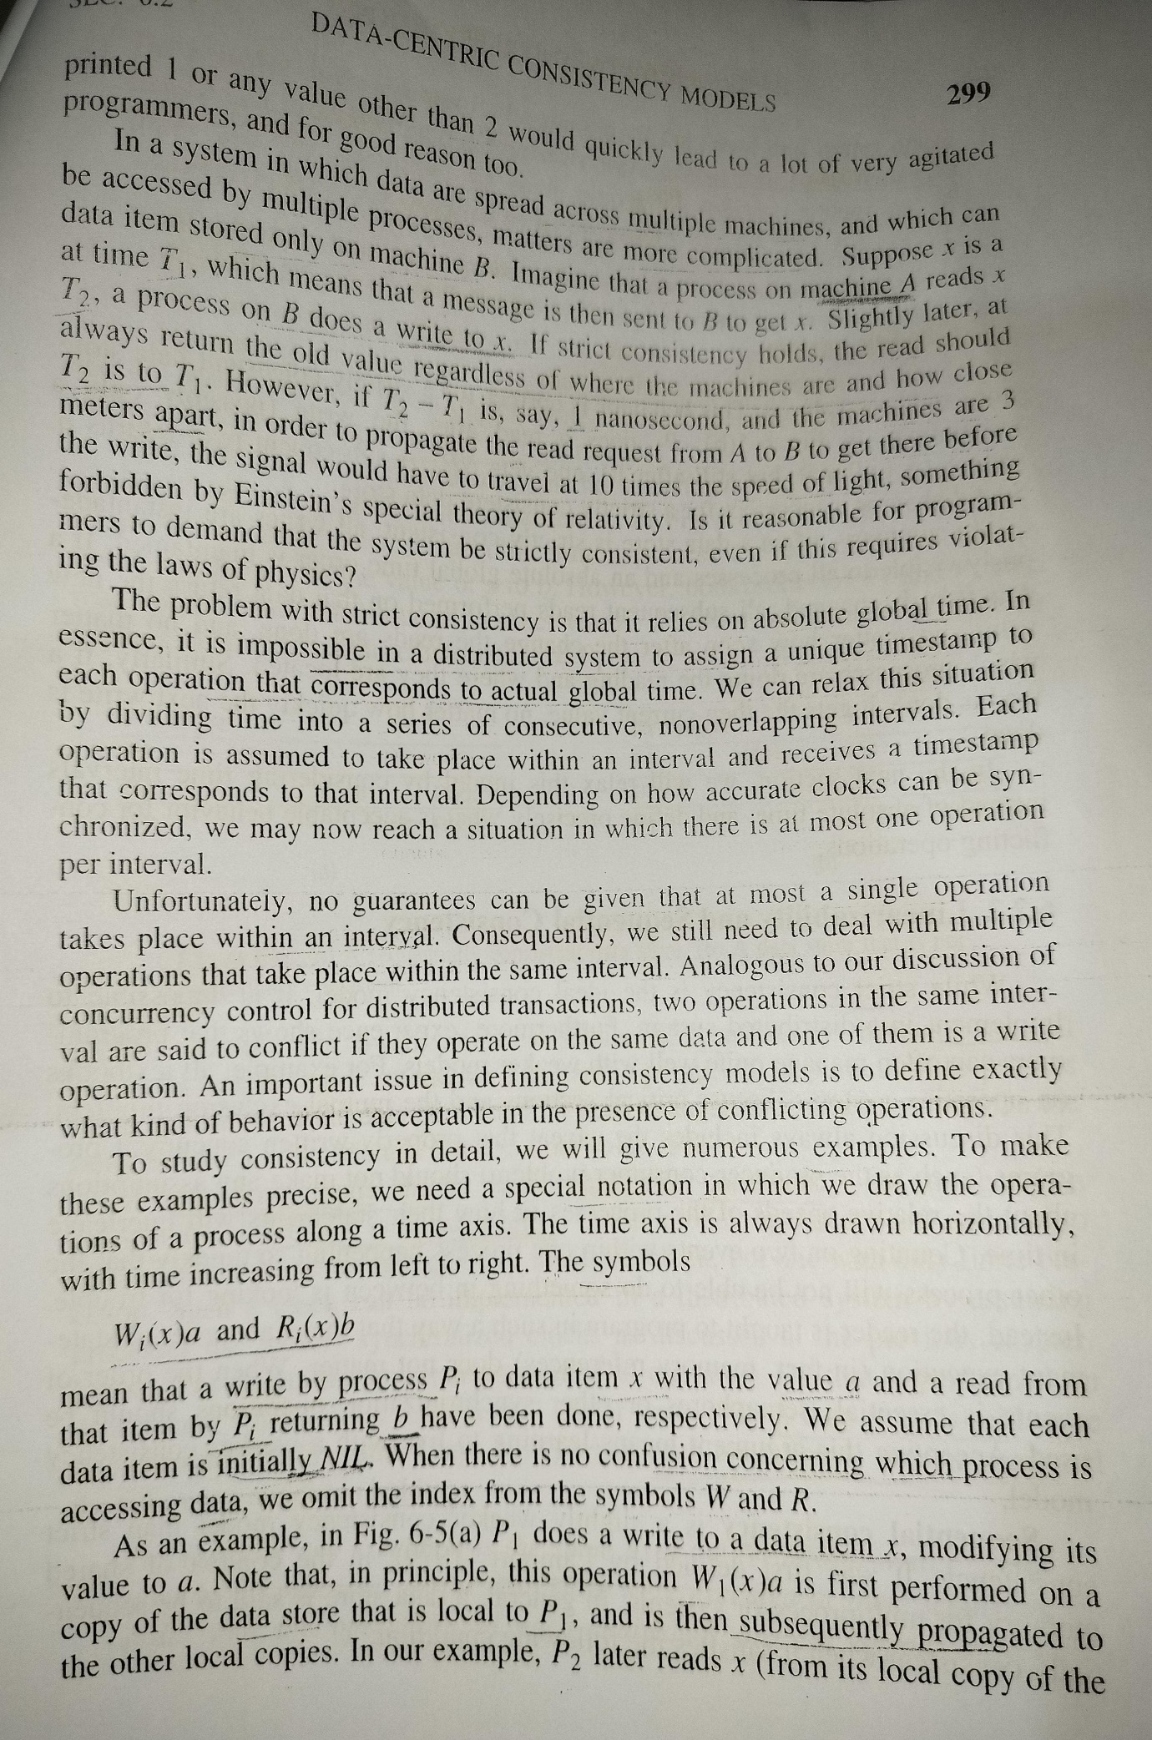

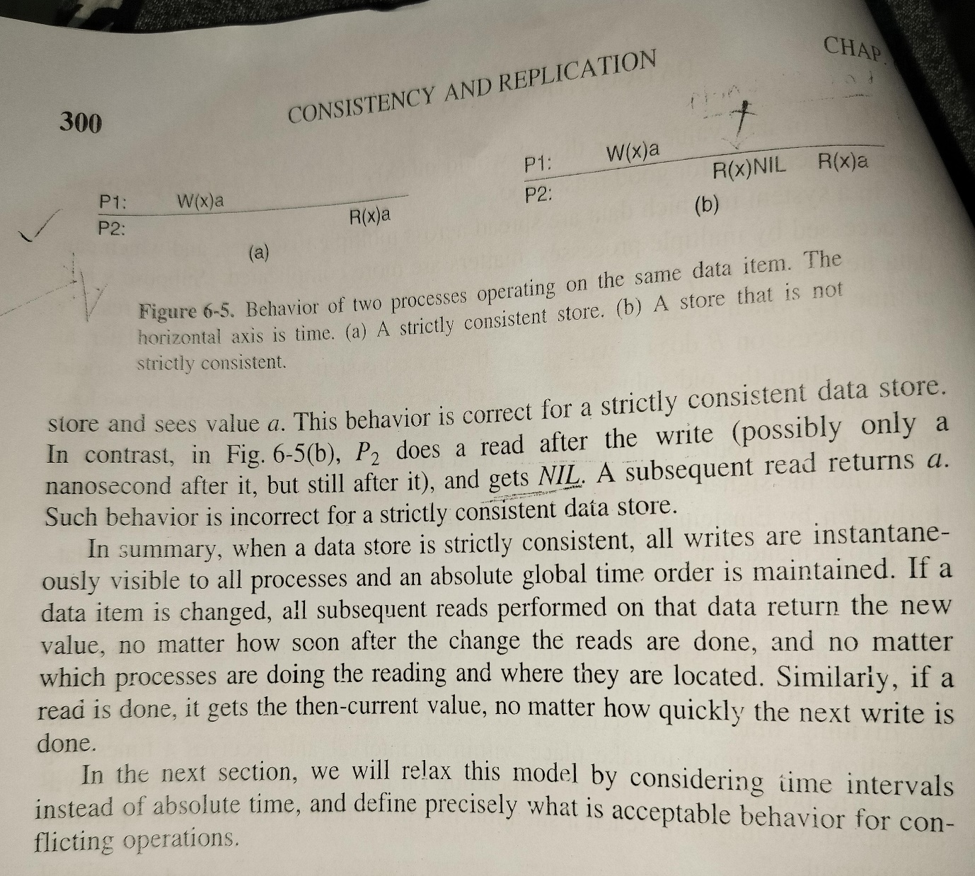

**Reasons for Replication:**

Replication is the process of creating and maintaining copies of data or services in multiple locations, typically distributed across a network. There are several reasons for adopting replication in distributed systems:

1. **Improved Availability:**
   * Replication enhances system availability by providing alternative access points. If one replica is unavailable due to network issues or node failures, clients can still access other replicas.
2. **Fault Tolerance:**
   * Replication helps in creating fault-tolerant systems. If one replica becomes unavailable or experiences a failure, other replicas can continue to serve requests, ensuring uninterrupted operation.
3. **Load Balancing:**
   * Distributing replicas across multiple nodes allows for load balancing. Incoming requests can be distributed among replicas, preventing any single node from being overwhelmed with requests.
4. **Reduced Latency:**
   * Placing replicas closer to users or clients can reduce latency. Users can access data or services from a nearby replica, leading to faster response times and improved user experience.
5. **Scalability:**
   * Replication supports system scalability. As the demand for resources or services increases, additional replicas can be deployed to handle the increased load, providing a scalable and efficient solution.
6. **Disaster Recovery:**
   * Replication aids in disaster recovery by ensuring that data or services are available even in the event of a catastrophic failure or natural disaster affecting a specific location.
7. **Consistency and Performance Trade-Off:**
   * Replication allows for tuning the trade-off between consistency and performance. Systems can be configured to prioritize consistency by ensuring that all replicas are updated before responding to clients, or to prioritize performance by allowing some replicas to be slightly out-of-date.

**Strict Data-Centric Consistency Model:**

The strict data-centric consistency model is a type of consistency model in distributed systems that emphasizes strong consistency guarantees. In this model:

1. **Consistency:**
   * All replicas of the data are consistent with each other at all times. Any read operation on any replica will return the most recent write.
2. **Synchronization:**
   * Strict synchronization is maintained between replicas. Before a write is acknowledged, it must be replicated to all other replicas.
3. **No Read Stale Data:**
   * Clients always read the most up-to-date data. There is no allowance for reading stale or outdated information.
4. **Linearizability:**
   * The model is often associated with linearizability, a property that ensures that the system's behavior appears as if all operations are executed instantaneously at some point between their invocation and response.
5. **Complexity and Overhead:**
   * Achieving strict data-centric consistency often involves significant complexity and overhead. Synchronization mechanisms, such as two-phase commit protocols or consensus algorithms, may be used to ensure consistency.
6. **Use Cases:**
   * This model is suitable for applications where data consistency is of utmost importance, such as financial systems, databases, or systems dealing with critical data.
7. **Trade-Off with Performance:**
   * While providing strong consistency guarantees, the strict data-centric consistency model can come with a trade-off in terms of performance. Synchronization and coordination among replicas may introduce delays.
8. **Challenges with Scalability:**
   * Ensuring strict consistency across a large number of replicas can pose challenges in terms of scalability, especially as the number of nodes in the system grows.

**Explain Berkeley's Algorithm and averaging algorithm used for clock synchronization with examples**

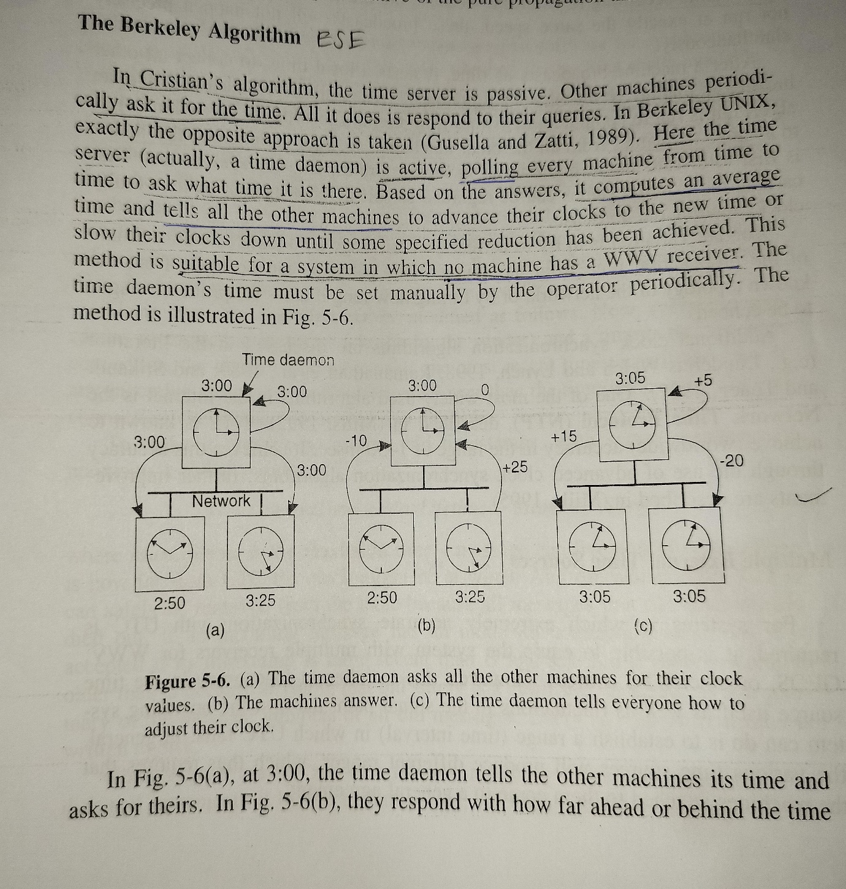

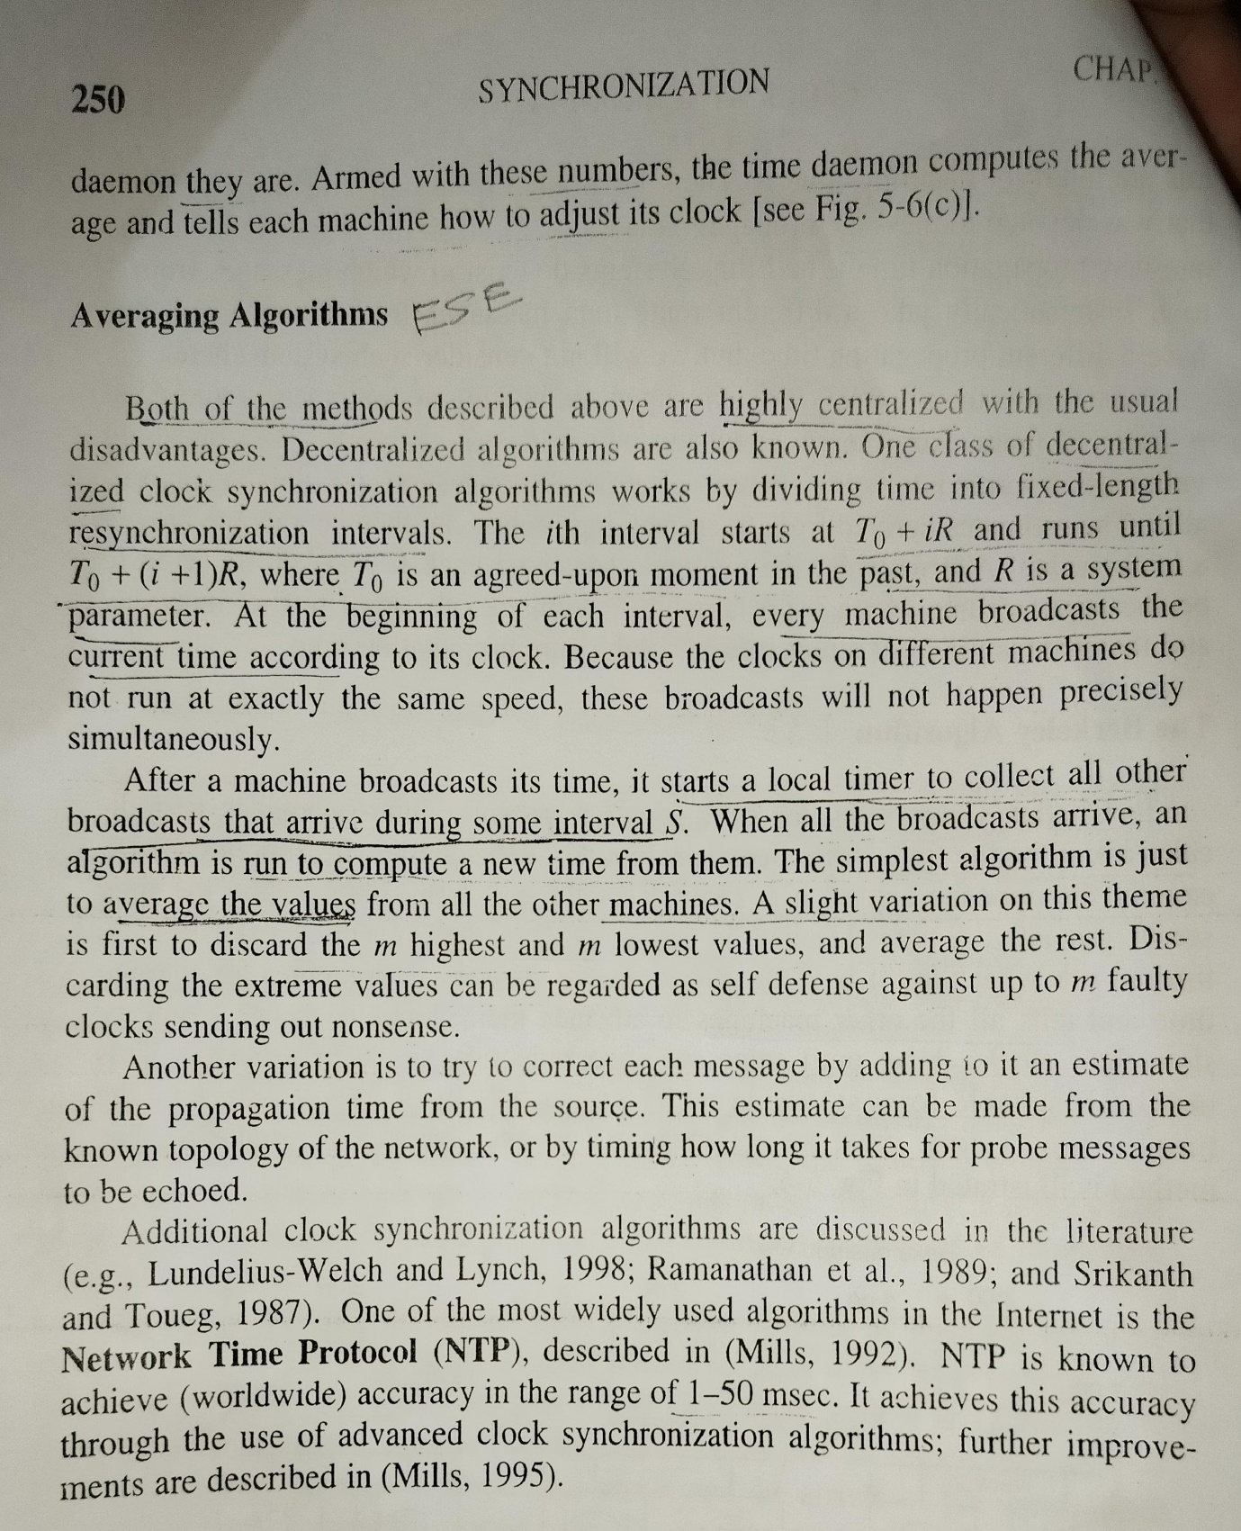

Certainly! Let’s start with **Berkeley’s Algorithm** and then discuss an averaging algorithm used for clock synchronization.

### Berkeley’s Algorithm

[Berkeley’s Algorithm is a clock synchronization technique used in distributed systems, particularly when no machine has an accurate time source or access to UTC (Universal Time Coordinated) servers](https://www.geeksforgeeks.org/berkeleys-algorithm/)[1](https://www.geeksforgeeks.org/berkeleys-algorithm/). Here’s how it works:

1. **Master Node Selection**: A master node is chosen from the network nodes, often through an election process. [This master node acts as the time coordinator](https://www.geeksforgeeks.org/berkeleys-algorithm/)[1](https://www.geeksforgeeks.org/berkeleys-algorithm/).
2. **Time Polling**: The master node periodically pings the slave nodes to fetch their local times. [This can be done using Cristian’s algorithm](https://www.geeksforgeeks.org/berkeleys-algorithm/)[1](https://www.geeksforgeeks.org/berkeleys-algorithm/).
3. [**Average Time Calculation**: The master node calculates the average time difference between the times received from the slave nodes and its own system clock](https://www.geeksforgeeks.org/berkeleys-algorithm/)[1](https://www.geeksforgeeks.org/berkeleys-algorithm/).
4. [**Time Adjustment**: The master node then adjusts its clock by the average time difference and broadcasts this adjustment to the slave nodes](https://www.geeksforgeeks.org/berkeleys-algorithm/)[1](https://www.geeksforgeeks.org/berkeleys-algorithm/).
5. **Clock Update**: Each slave node adjusts its clock by the amount received from the master node. [This helps synchronize the clocks across the network](https://www.geeksforgeeks.org/berkeleys-algorithm/)[1](https://www.geeksforgeeks.org/berkeleys-algorithm/).

#### Example:

Suppose we have three nodes with the following local times:

* Node A: 2:00 PM
* Node B: 2:05 PM
* Node C: 1:55 PM

The master node (Node A) calculates the average time difference:

* Node B is 5 minutes ahead.
* Node C is 5 minutes behind.

The average difference is (5 - 5) / 2 = 0 minutes. Node A broadcasts a message to Node B and Node C to adjust their clocks by 0 minutes, effectively synchronizing all nodes to 2:00 PM.

### Averaging Algorithm for Clock Synchronization

An averaging algorithm for clock synchronization involves each node sharing its local time with other nodes and adjusting its clock based on the average time difference. [This is a distributed approach where there is no single master node](https://www.geeksforgeeks.org/berkeleys-algorithm/)[2](https://www.geeksforgeeks.org/synchronization-in-distributed-systems/).

Here’s a simplified version of how it might work:

1. [**Local Time Sharing**: Each node sends its local time to all other nodes in the system](https://www.geeksforgeeks.org/berkeleys-algorithm/)[2](https://www.geeksforgeeks.org/synchronization-in-distributed-systems/).
2. [**Average Time Calculation**: Upon receiving all the times, each node calculates the average time difference between its own time and the times received2](https://www.geeksforgeeks.org/synchronization-in-distributed-systems/).
3. [**Clock Adjustment**: Each node then adjusts its clock by the calculated average time difference](https://www.geeksforgeeks.org/berkeleys-algorithm/)[2](https://www.geeksforgeeks.org/synchronization-in-distributed-systems/).

#### Example:

Let’s say we have three nodes with the following local times:

* Node X: 3:00 PM
* Node Y: 3:04 PM
* Node Z: 2:56 PM

Each node calculates the average time:

* Node X’s average difference: (4 - 4) / 2 = 0 minutes.
* Node Y’s average difference: (-4 + 4) / 2 = 0 minutes.
* Node Z’s average difference: (4 - 4) / 2 = 0 minutes.

All nodes adjust their clocks by 0 minutes, maintaining their original times but now with a consensus that they are synchronized.

These algorithms help maintain time consistency across distributed systems, which is crucial for coordination and consistency of operations. [For more detailed information on these algorithms, you can refer to the resources provided1](https://www.geeksforgeeks.org/berkeleys-algorithm/)[2](https://www.geeksforgeeks.org/synchronization-in-distributed-systems/)[3](https://www.mdpi.com/1424-8220/14/8/14744)[4](https://ieeexplore.ieee.org/document/9772418/).

**DEC 2022**

**Identify the various problems of replication. How to improve the performance of distributed application using replication?**

**Problems of Replication:**

1. **Consistency Challenges:**
   * Maintaining consistency across replicas can be challenging, especially in the presence of concurrent updates. Achieving consistency without introducing significant delays or compromising performance is a complex task.
2. **Concurrency Control:**
   * Coordinating concurrent updates from multiple replicas requires robust concurrency control mechanisms to prevent conflicts, race conditions, and ensure a correct and coherent view of the data.
3. **Replica Synchronization:**
   * Ensuring that all replicas are synchronized and up-to-date introduces challenges. Replication protocols must handle scenarios where some replicas may lag behind due to network delays, failures, or temporary unavailability.
4. **Fault Tolerance:**
   * While replication enhances fault tolerance, it also introduces challenges in handling failures. Detecting and recovering from replica failures without compromising availability and consistency is crucial.
5. **Network Overhead:**
   * Replicating data across a network introduces additional communication overhead. This can impact the performance of the system, especially in scenarios with high network latency or limited bandwidth.
6. **Data Access Patterns:**
   * Replication strategies must consider the access patterns of the application. In scenarios with skewed access patterns or hotspots, replicas may experience uneven loads, leading to performance bottlenecks.
7. **Load Balancing:**
   * Efficiently distributing the load among replicas to achieve optimal load balancing can be challenging. Improper load balancing may result in underutilized or overloaded replicas.
8. **Heterogeneity:**
   * In heterogeneous environments, where replicas may have different capabilities or performance characteristics, ensuring consistent performance and behavior across all replicas becomes challenging.

**Improving Performance with Replication:**

1. **Load Balancing:**
   * Use dynamic load balancing algorithms to distribute requests evenly among replicas. This helps avoid overloading some replicas while underutilizing others.
2. **Caching:**
   * Implement caching mechanisms to reduce the need for frequent accesses to replicas. Local caches can store frequently accessed data, reducing the load on replicas and improving response times.
3. **Asynchronous Replication:**
   * Consider asynchronous replication for scenarios where slight inconsistencies are acceptable. This can improve write performance by allowing the primary replica to acknowledge writes without waiting for all replicas to be updated.
4. **Consistency Levels:**
   * Adjust the consistency levels based on application requirements. In scenarios where strong consistency is not critical, using eventual consistency or relaxed consistency models can improve performance.
5. **Partitioning:**
   * Use data partitioning strategies to distribute data across replicas in a way that aligns with access patterns. This helps in avoiding hotspots and ensures a more balanced distribution of workload.
6. **Parallel Processing:**
   * Exploit parallel processing capabilities by allowing replicas to handle requests independently whenever possible. This can be particularly effective in read-heavy scenarios.
7. **Failure Detection and Recovery:**
   * Implement robust failure detection mechanisms to quickly identify and recover from replica failures. This helps in maintaining system availability and reliability.
8. **Optimized Network Protocols:**
   * Use optimized network protocols and efficient data serialization formats to minimize network overhead during data replication.
9. **Quorum-based Systems:**
   * Explore quorum-based replication systems that allow for a flexible trade-off between consistency and performance. Adjusting the quorum size can impact the number of replicas that need to agree on updates.
10. **Replica Placement:**
    * Strategically place replicas in locations that minimize latency for end-users. This is especially important for applications with a geographically distributed user base.

**Compare the Cristian’s clock synchronization algorithm and Berkeley’s clock synchronization algorithm.**

**Cristian's Clock Synchronization Algorithm:**

1. **Centralized Approach:**
   * Cristian's algorithm follows a centralized approach where one server (time server) is considered authoritative for providing the correct time.
2. **Request and Response:**
   * The client sends a request to the time server, which responds with its current time.
3. **Calculation of Offset:**
   * The client calculates the time offset by half of the round-trip time (RTT) of the request. The assumption is that the time taken for the request to reach the server and the response to return is roughly equal.
4. **Synchronization:**
   * The client adjusts its local clock by applying the calculated time offset. This synchronization process assumes that network delays remain constant.
5. **Assumption:**
   * The algorithm assumes symmetric network delays, meaning that the time it takes for a message to travel from the client to the server is the same as the time it takes for the response to travel from the server to the client.

**Berkeley's Clock Synchronization Algorithm:**

1. **Distributed Approach:**
   * Berkeley's algorithm takes a distributed approach where each machine in the network periodically exchanges its local time with a coordinator (time daemon).
2. **Calculation of Time Offset:**
   * The coordinator calculates the time offset for each machine by comparing their local time with its own. The offset is the average difference between the local time of the machines and the coordinator's time.
3. **Adjustment of Local Clocks:**
   * The coordinator sends the time offset to each machine, and each machine adjusts its local clock accordingly.
4. **Regular Updates:**
   * The process is repeated at regular intervals to account for changes in clock drift or network conditions.
5. **Assumption:**
   * Berkeley's algorithm assumes that the time offset calculated for each machine remains relatively constant between synchronization intervals.

**Comparison:**

1. **Centralization vs. Distribution:**
   * Cristian's algorithm relies on a central time server, making it a centralized approach. In contrast, Berkeley's algorithm distributes the synchronization process among all machines in the network.
2. **Handling Asymmetric Delays:**
   * Cristian's algorithm assumes symmetric network delays, which may not hold true in all cases. Berkeley's algorithm can handle asymmetric delays more gracefully since it considers the average offset.
3. **Robustness:**
   * Berkeley's algorithm is often considered more robust in scenarios where machines in the network experience varying clock drifts and asymmetric delays. It provides a better average estimate of the time offset.
4. **Accuracy:**
   * Cristian's algorithm can be more accurate when network delays are relatively constant and symmetric. However, it may be sensitive to variations in network conditions.
5. **Frequency of Updates:**
   * Berkeley's algorithm can adapt to changes more frequently as it allows for periodic updates. Cristian's algorithm typically synchronizes less frequently as it relies on explicit requests.
6. **Scalability:**
   * Berkeley's algorithm may be more scalable in large networks as it distributes the synchronization process. Cristian's algorithm may face scalability challenges as it centralizes the synchronization on a single time server.

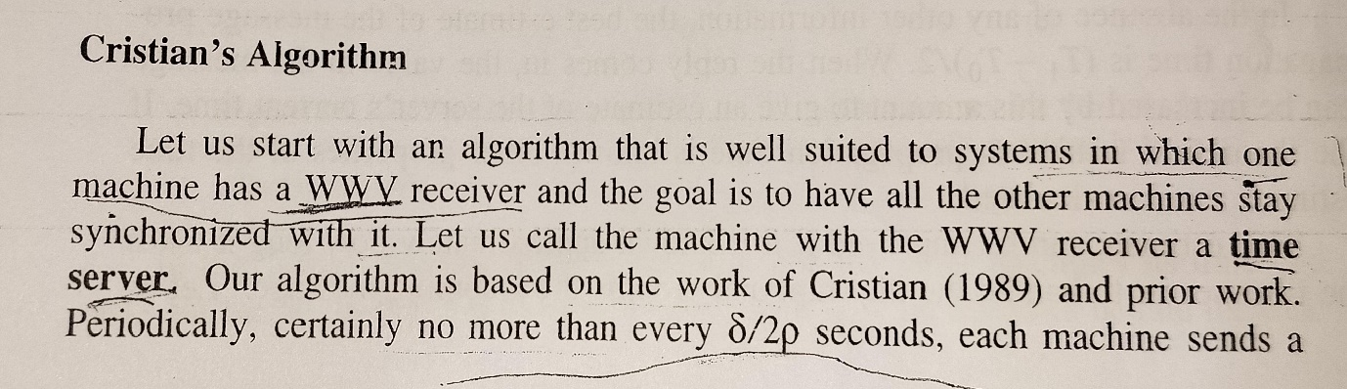

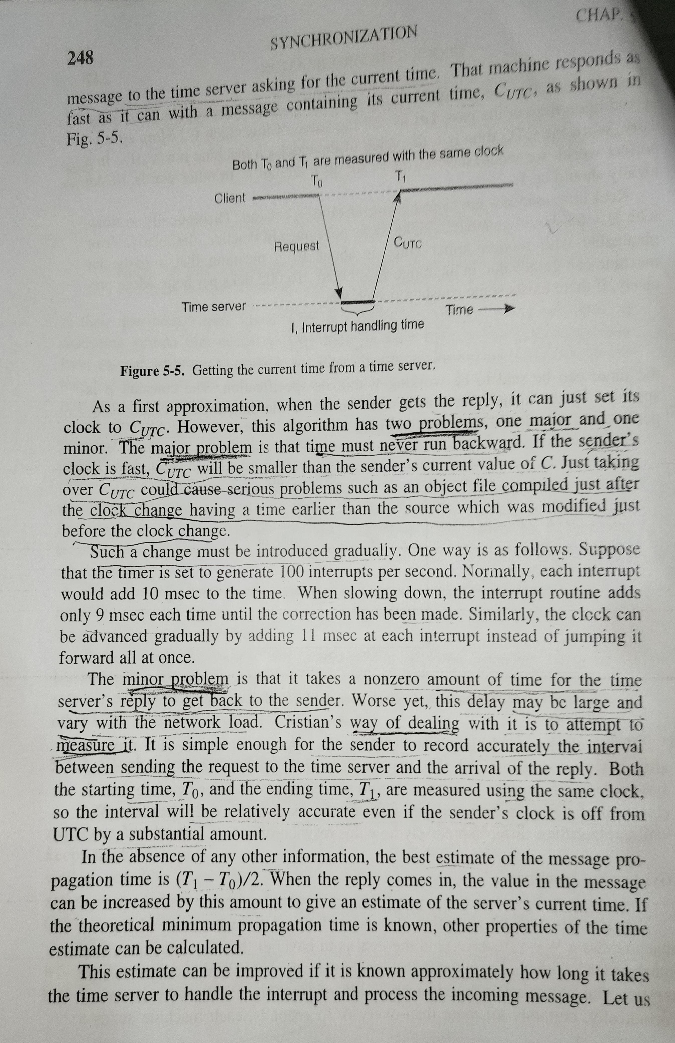

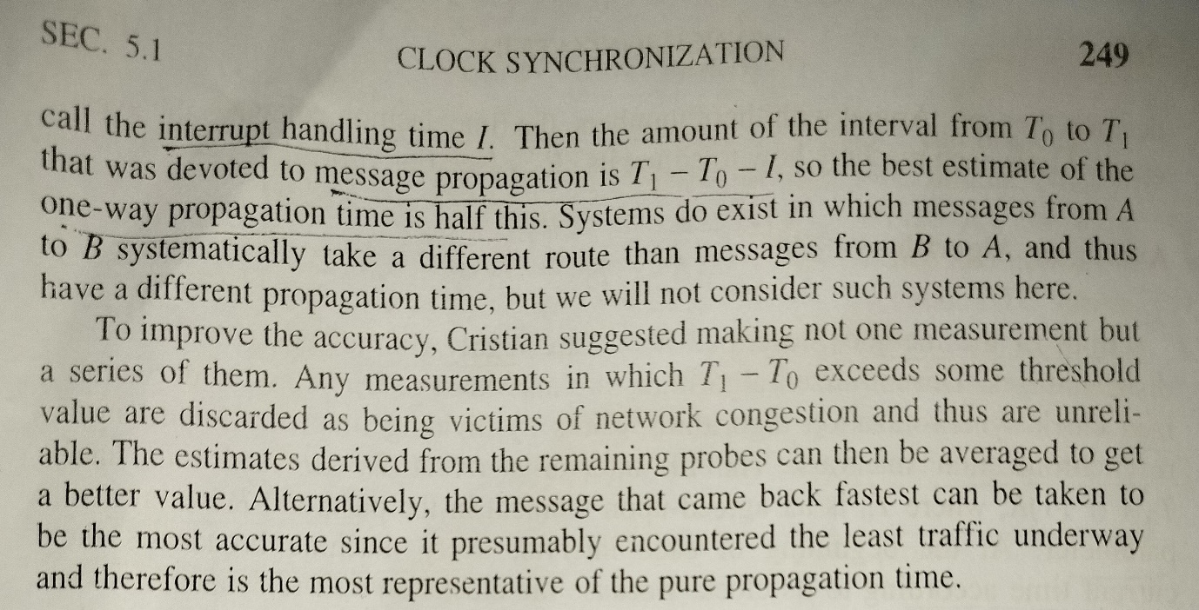





**What is RMI? Compare between static and dynamic RMI.**





**Explain the general structure of distributed system as middleware. State the any three services provided by middleware.**

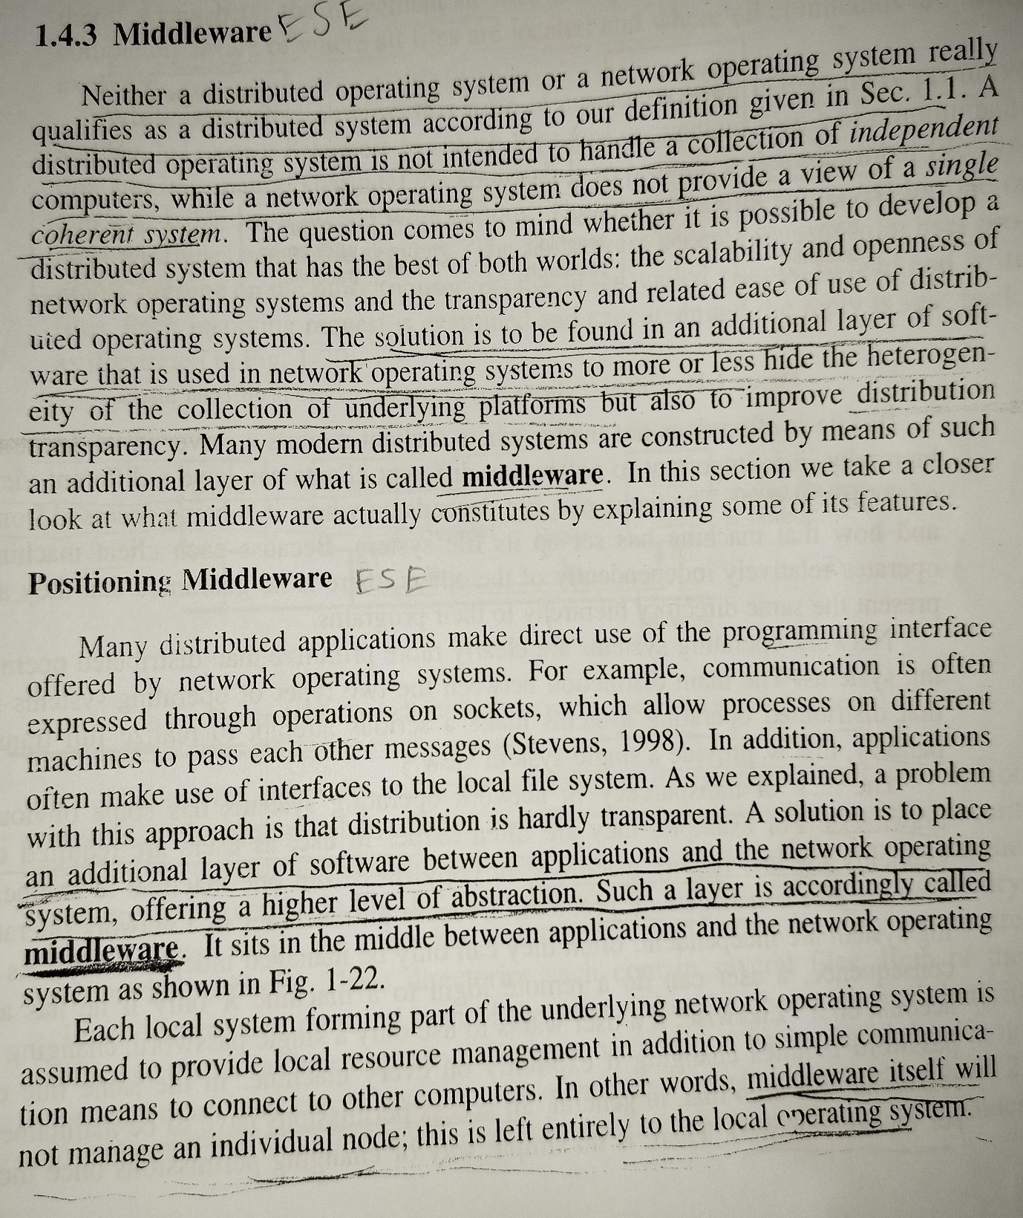

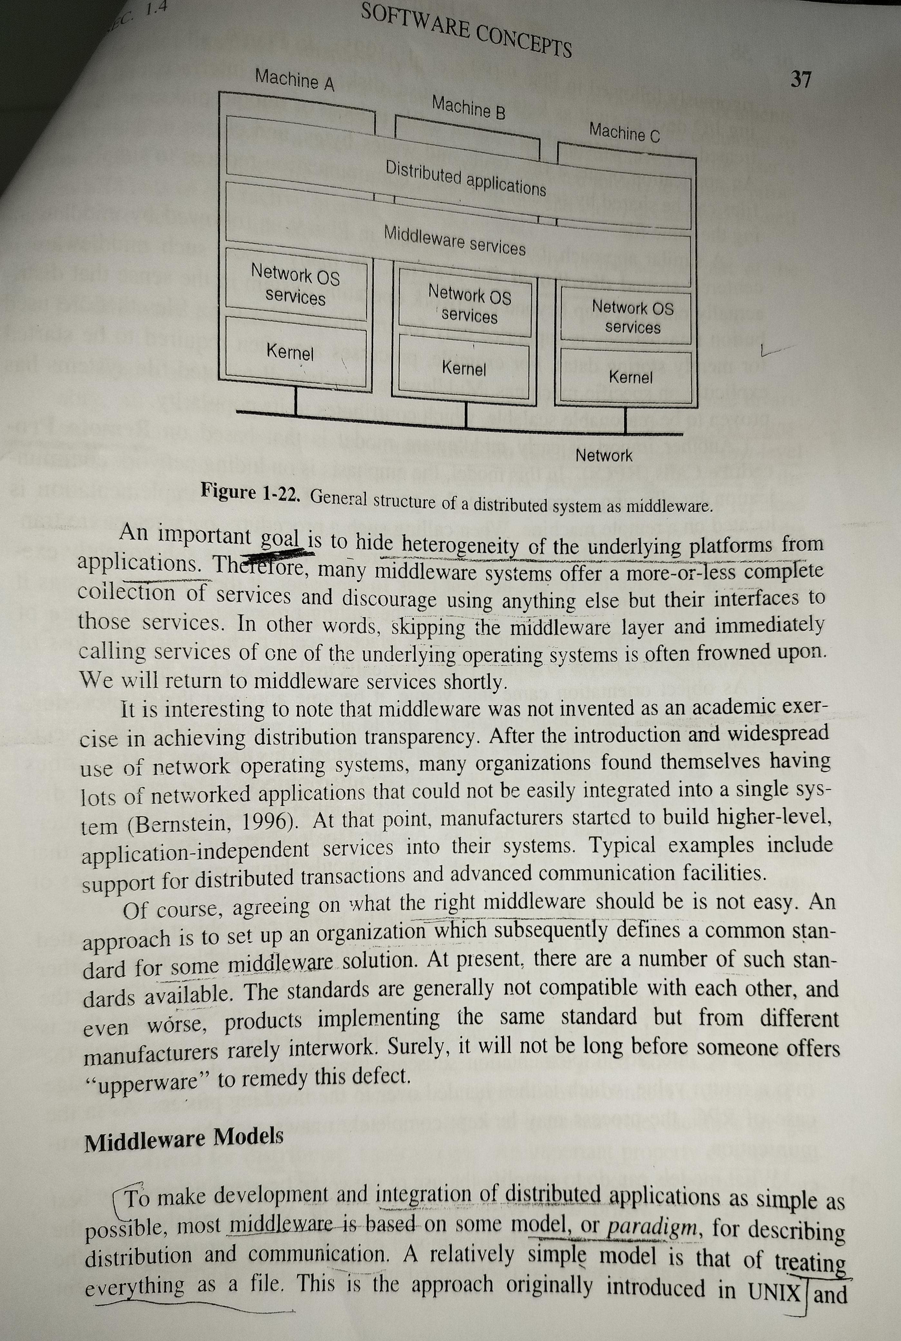

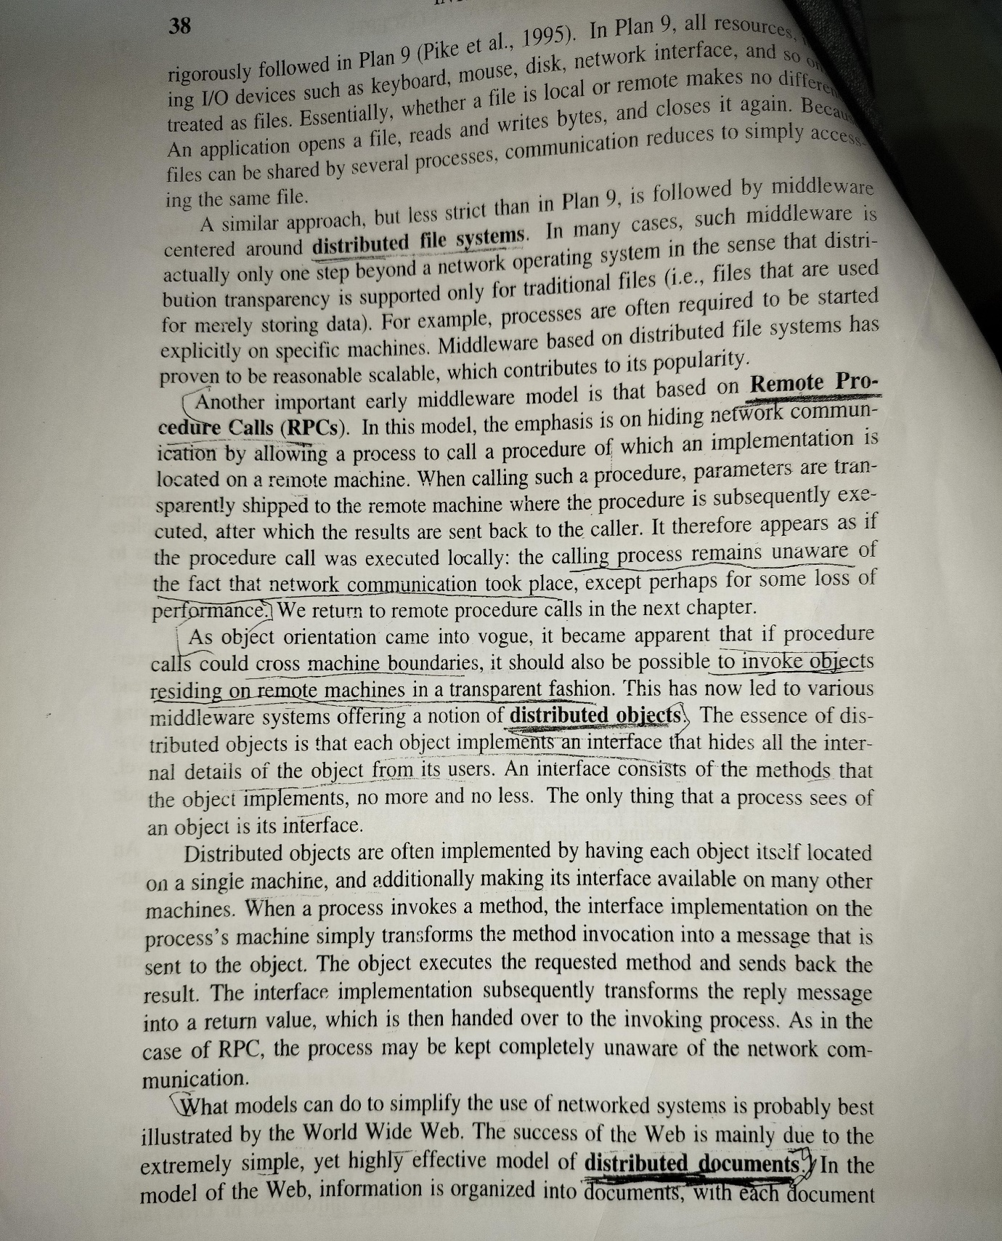

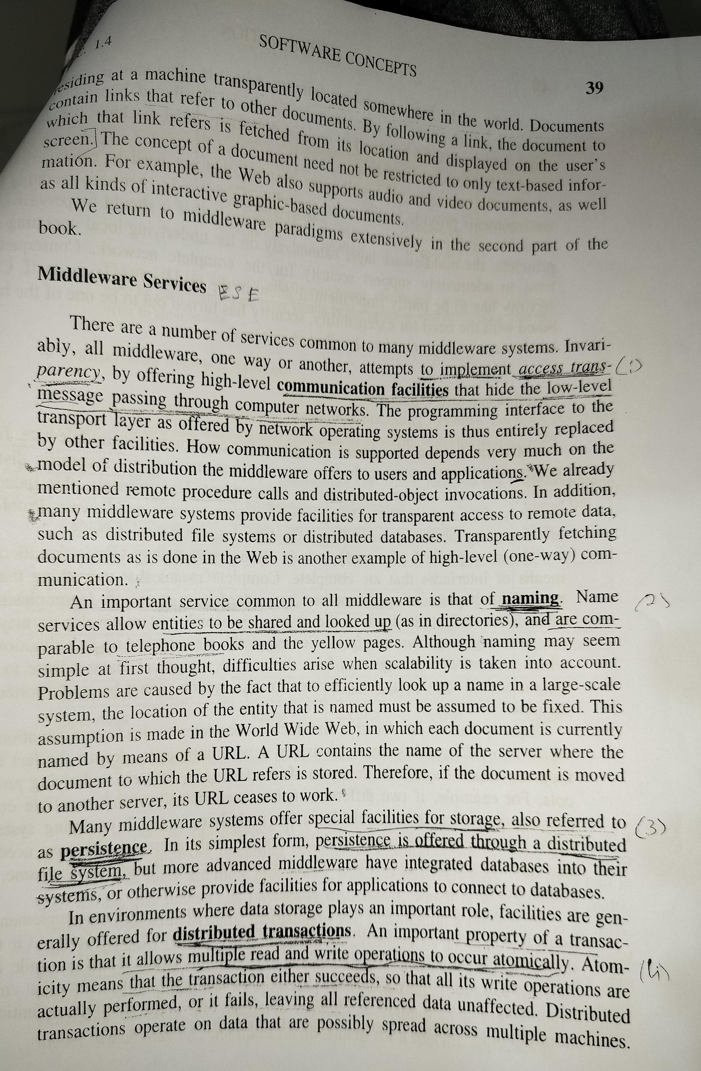

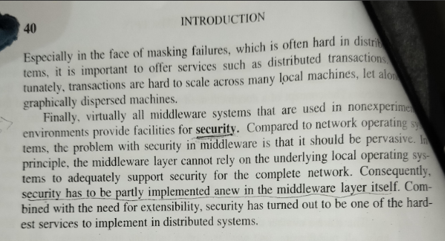

**A client makes a remote procedure call to a server. The client takes 5 milliseconds to compute the arguments for each request, and the server takes 10 milliseconds to process each request. The local operating system processing time for each send or receive operation is 0.5 milliseconds, and the network time to transmit each request or reply message is 3 milliseconds. Marshalling or unmarshalling takes 0.5 milliseconds per seconds per message. Evaluate the time taken by the client to generate and return from two requests:**

**i) if it is single threaded and**

**ii) if it has two threads that can make request concurrently on single processor.**

**Ignore the context switching time.**





**In the client server model implemented using a simple RPC mechanism, after making RPC request, a client keeps waiting until reply is received from the server for its request. It would be more efficient to allow the client to perform other jobs while the server is processing the request. Describe three mechanisms that may be used in this case to allow a client to perform other jobs while the server is processing its request.**

**Synchronous RPC with diagram 3 marks**

**Asyncronous RPC with diagram 4 marks**

**Defered RPC with diagram 3 marks**

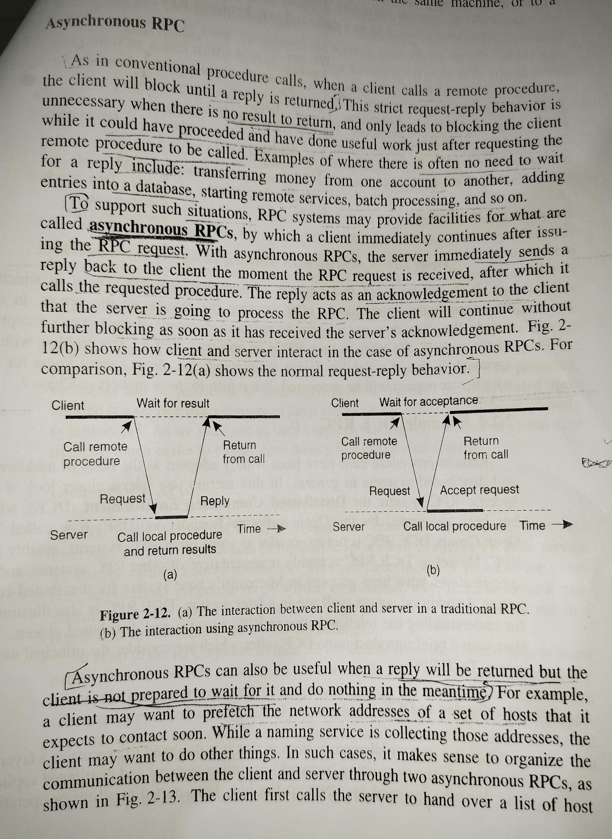

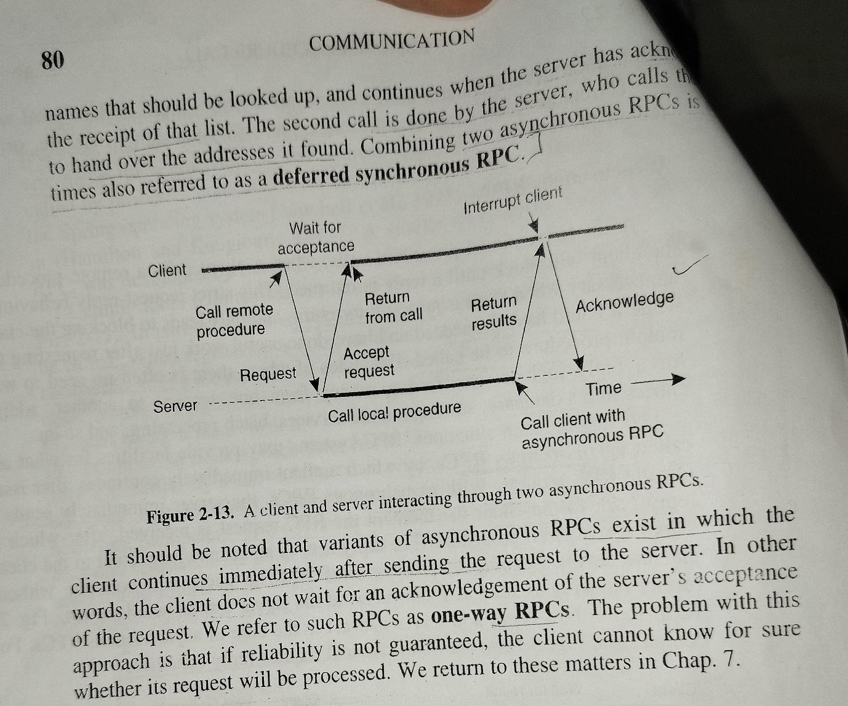

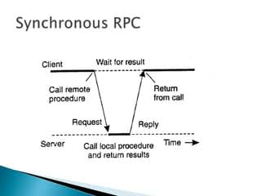

* **Definition of RPC:**
  + Software communication protocol for requesting services from a program on another computer.
  + Client-server model, where the client initiates the request, and the server provides the service.
  + Synchronous operation with the use of lightweight processes or threads for concurrent execution.
* **IDL in RPC:**
  + Interface Definition Language (IDL) describes the software component's API.
  + Acts as a bridge between machines using different operating systems and languages.
* **How RPC Works:**
  + Compilation includes a stub in the code representing the remote procedure.
  + Client runtime program contacts a name server to find the server's address.
  + Request is sent to the server through the network, and response-request protocols handle the return.
* **Execution Flow in RPC:**
  + Calling environment is suspended during the remote procedure call.
  + Procedure parameters are transferred to the remote environment for execution.
  + Results are sent back to the calling environment, and execution resumes as if from a local procedure call.
* **Example:**
  + A client program offloads a complex computation to a server using RPC.
  + RPC handles communication, execution, and result retrieval seamlessly.
* **Opinion:**
  + RPC simplifies distributed computing, abstracting network complexities.
  + Allows developers to focus on functionality rather than intricate network details.

### Asynchronous RPC

**Asynchronous RPC** allows the client to make a request and then continue with other tasks without waiting for the server’s response. The client can later check for the server’s response or be notified when it is ready. This mechanism improves efficiency by not blocking the client’s execution.

#### Diagram:

Client Asynchronous RPC Server

|------------------->| |

| |----Process----> |

| Continue work | |

| |<---Response---- |

|<-------------------| |

### Deferred Synchronous RPC

**Deferred Synchronous RPC** is a hybrid approach where the client sends a request and continues with its execution. The client defers the waiting for the server’s response to a later point in time when the result is needed. This allows the client to perform other jobs while the server processes the request.

#### Diagram:

Client Deferred Synchronous RPC Server

|------------------->| |

| |----Process----> |

| Continue work | |

| | |

| Wait for response |<---Response---- |

|<-------------------| |

These mechanisms provide different ways to handle the waiting time associated with RPCs, allowing clients to utilize their time more efficiently while waiting for server responses. [For more detailed information on these RPC mechanisms, you can refer to the resources provided1](https://www.geeksforgeeks.org/what-is-rpc-mechanism-in-distributed-system/)[2](https://learn.microsoft.com/en-us/windows/win32/rpc/asynchronous-rpc)[3](https://lass.cs.umass.edu/~shenoy/courses/spring07/lectures/Lec08.pdf).

**What actions to be taken with respect to the references to local resources when migrating the code to another machine? Justify these actions with example.**

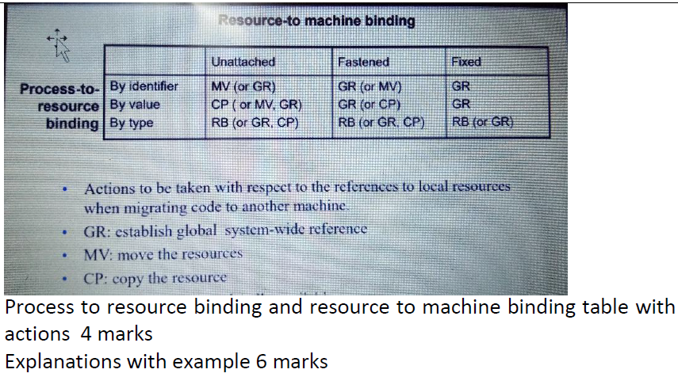

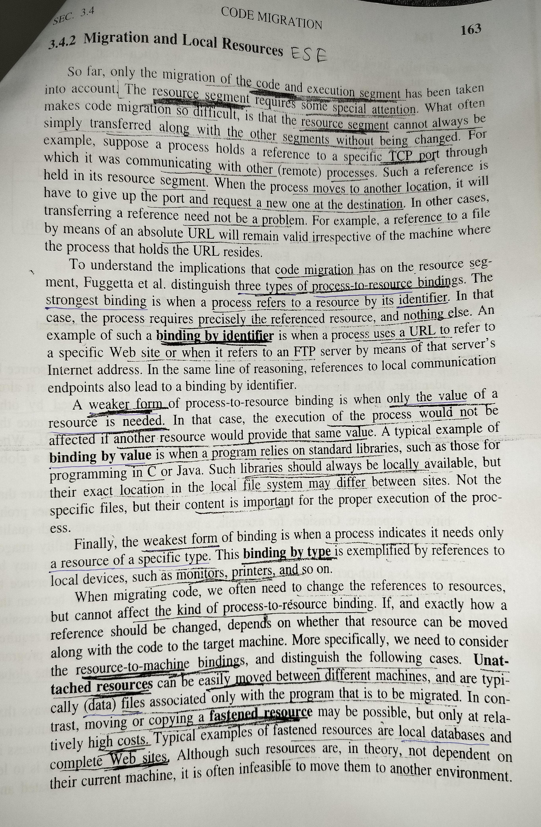

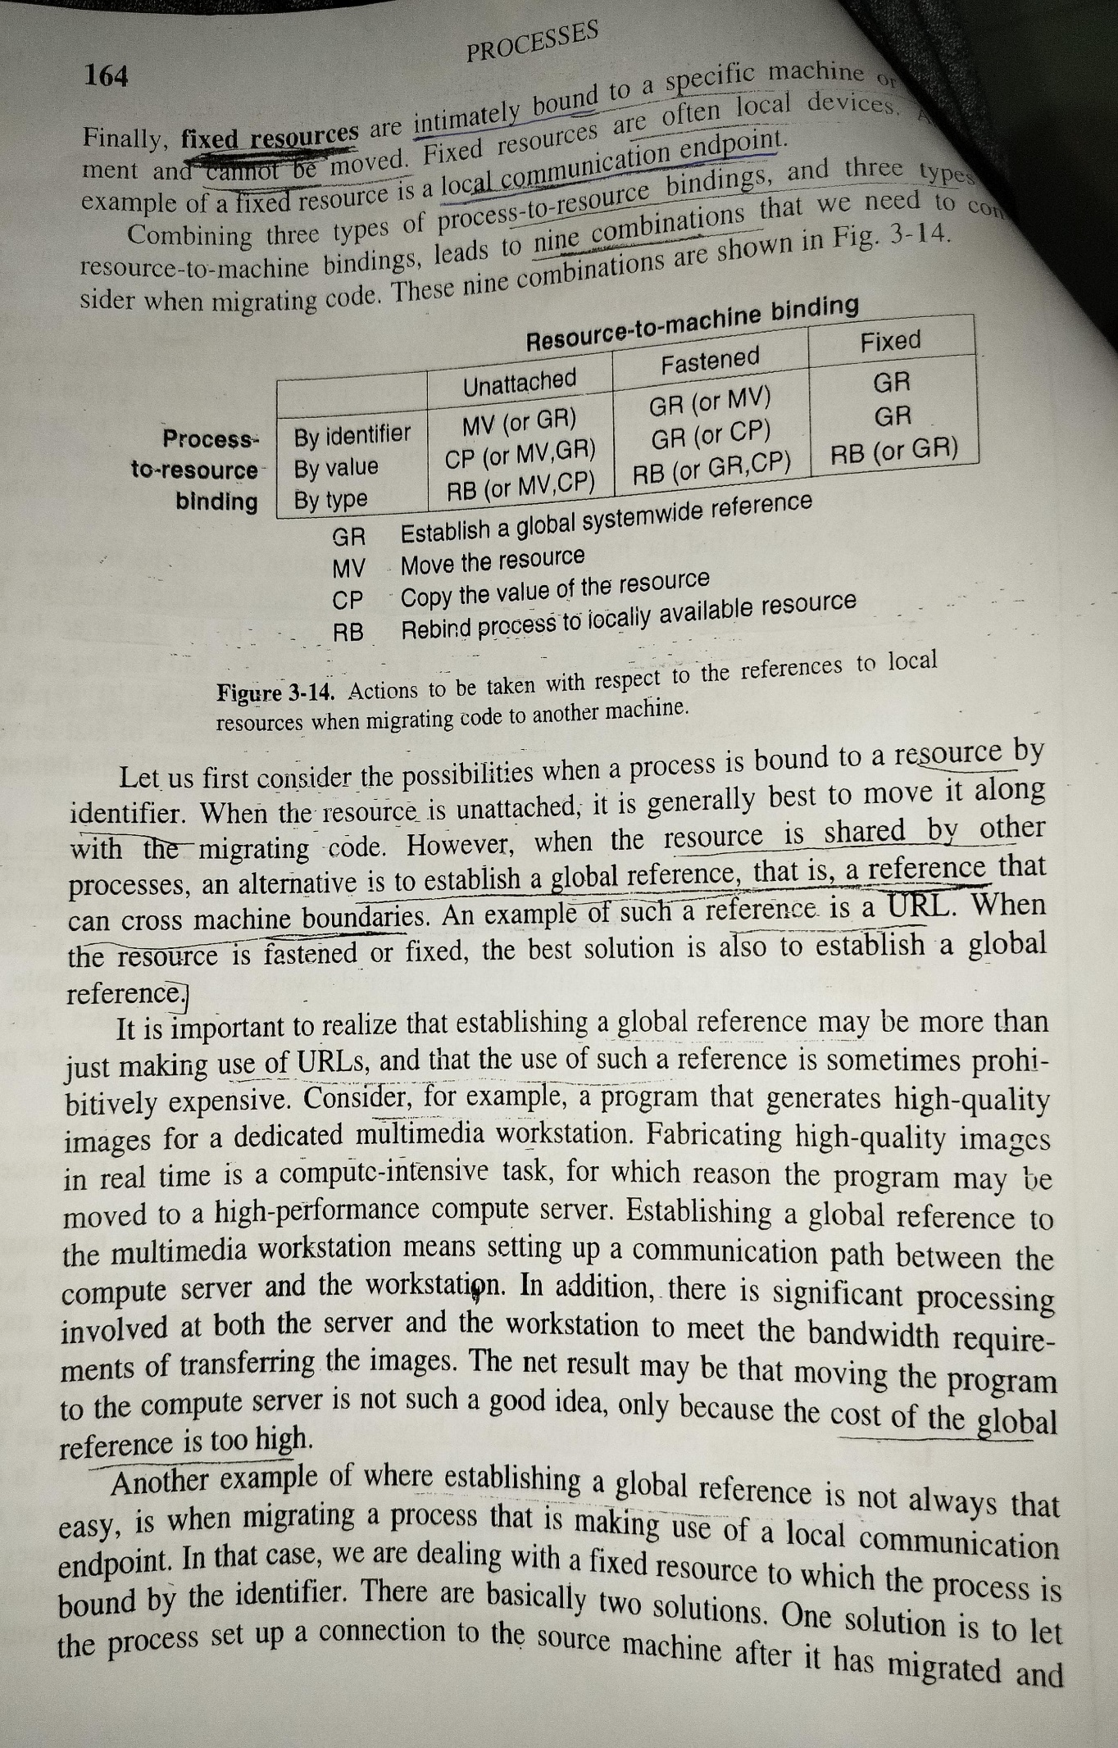

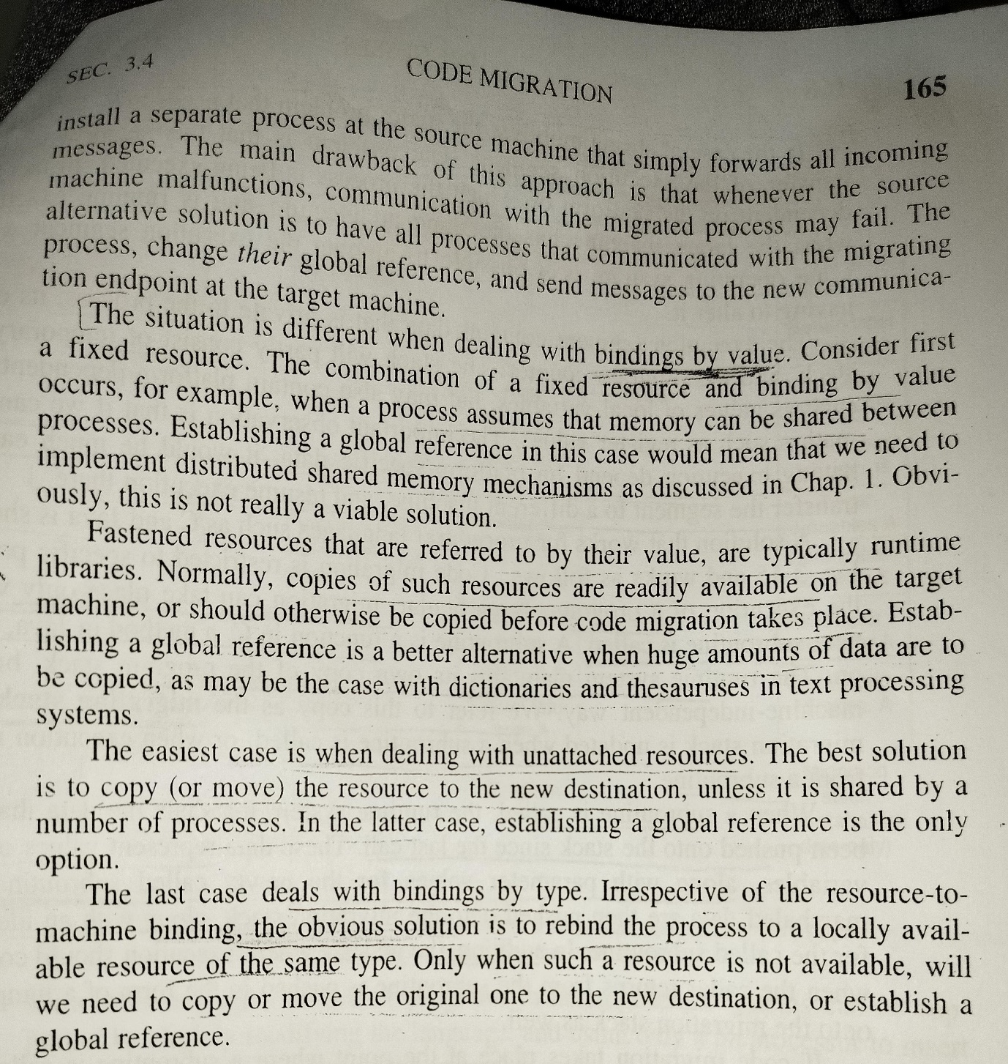

When migrating code to another machine in a distributed system, it’s essential to address the references to local resources to ensure the code functions correctly in the new environment. Here are the actions to be taken with respect to the references to local resources, along with justifications and examples:

### Actions and Justifications:

1. **Global Reference Establishment (GR)**: Establish a global system-wide reference for resources that can be accessed globally. This ensures that the migrated code can refer to resources regardless of its physical location.

**Example**: If the code interacts with a web service, update the service’s URL to a global endpoint that the migrated code can access from anywhere.

1. **Resource Movement (MV)**: Move unattached resources that are exclusively used by the program being migrated. This action is taken to maintain the integrity of the data and the functionality of the code.

**Example**: If the code relies on specific data files, these files should be moved to the new machine to ensure the code continues to operate without modification.

1. **Resource Copying (CP)**: Copy the value of resources that cannot be moved but can be duplicated. This allows the migrated code to function with a local copy of the necessary resources.

**Example**: Configuration files or libraries that are required for the code to run can be copied to the target machine.

1. **Rebinding (RB)**: Rebind process references to locally available resources for fixed resources that cannot be moved. This action is necessary to adapt the code to the new environment’s resources.

**Example**: If the code references a local printer for output, the reference should be updated to point to a printer available on the new machine’s network.

### Detailed Explanation with Examples:

* **Global Reference Establishment (GR)**: For resources like databases or APIs that are accessible over the network, the code should be updated to use the global references. This might involve changing local database connection strings to point to a globally accessible database server.

**Justification**: Using global references allows the code to remain functional and agnostic to the underlying infrastructure changes.

* **Resource Movement (MV)**: When the code relies on specific files or executables that are not tied to the original machine, these should be moved along with the code. This ensures that the dependencies of the code are met on the new machine.

**Justification**: Moving resources maintains the operational context of the code, preventing errors due to missing files or executables.

* **Resource Copying (CP)**: In cases where resources like configuration files or environment-specific data cannot be moved, creating a copy on the target machine is necessary. The code can then be adjusted to use these local copies.

**Justification**: Copying resources ensures that the code has access to the necessary data and configurations without disrupting the original system’s setup.

* **Rebinding (RB)**: For resources that are inherently local, such as printers, scanners, or other peripherals, the code must be updated to interact with the equivalent resources available on the new machine.

**Justification**: Rebinding allows the code to integrate with the new environment seamlessly, utilizing the available local resources effectively.

[By taking these actions, the migrated code can continue to function correctly and efficiently in the new environment, leveraging the available resources while maintaining its original functionality](https://cs.gmu.edu/~setia/cs707/slides/code-migration.pdf)[1](https://cs.gmu.edu/~setia/cs707/slides/code-migration.pdf)[2](https://lass.cs.umass.edu/~shenoy/courses/fall09/lectures/Lec06.pdf). [For more detailed information on code migration and handling local resources, you can refer to the resources provided1](https://cs.gmu.edu/~setia/cs707/slides/code-migration.pdf)[2](https://lass.cs.umass.edu/~shenoy/courses/fall09/lectures/Lec06.pdf). These resources will give you a comprehensive understanding of the concepts and their practical applications in real-world distributed systems.

**Suppose there are three processes A, B and C. All clock runs at the same rate but initially A’s clock reads 10,b’s clock reads 0 and C’s reads 5. At time 10 by A’s clock, A sends message to B, this message takes 4 units of time to reach B. B then waits one unit of time and then sends a message onto C which takes 2 units of time to reach C. Assuming that the system implements Lamport’s timestamps draw a picture illustrating the timestamps for the message and explain how the timestamps are obtained.**

**Diagram 4 marks**

**First message 3 marks**

**Second message 3 marks**



**What are the reasons of distributed systems are being more popular and useful?**

Distributed systems have become increasingly popular and useful for several reasons:

1. [**Resource Sharing**: They enable the sharing of hardware, software, and data resources across different locations](https://www.geeksforgeeks.org/what-is-a-distributed-system/)[1](https://www.geeksforgeeks.org/what-is-a-distributed-system/).
2. [**Scalability**: Distributed systems can easily scale to accommodate more users and resources, improving the responsiveness of the system](https://www.geeksforgeeks.org/what-is-a-distributed-system/)[1](https://www.geeksforgeeks.org/what-is-a-distributed-system/).
3. [**Fault Tolerance**: They are designed to continue operating properly even if some components fail, ensuring reliability1](https://www.geeksforgeeks.org/what-is-a-distributed-system/).
4. [**Concurrency**: Distributed systems naturally support concurrent processing, allowing multiple activities or functionalities to be performed simultaneously by separate users in different locations1](https://www.geeksforgeeks.org/what-is-a-distributed-system/).
5. [**Improved Performance**: By dividing tasks among multiple machines, distributed computing can make better use of resources and complete tasks faster, especially with large data sets2](https://itcompanies.net/blog/distributed-computing-pros-cons).
6. [**Flexibility**: They allow for more flexible system configurations and can be adapted to a wide range of applications and use cases](https://www.geeksforgeeks.org/what-is-a-distributed-system/)[3](https://www.spaceotechnologies.com/glossary/tech-terms/what-is-distributed-system/).
7. [**Cost-Effectiveness**: Distributed systems can be more cost-effective than centralized systems, as they can leverage existing infrastructure and reduce the need for expensive, high-powered machines](https://www.geeksforgeeks.org/what-is-a-distributed-system/)[2](https://itcompanies.net/blog/distributed-computing-pros-cons).
8. [**Geographical Distribution**: They support applications that are inherently distributed, such as social media platforms, where information is shared among geographically dispersed users](https://www.geeksforgeeks.org/what-is-a-distributed-system/)[1](https://www.geeksforgeeks.org/what-is-a-distributed-system/).
9. [**Transparency**: To the end-user, distributed systems appear as a single, unified system, providing a seamless experience despite the complex underlying architecture](https://www.geeksforgeeks.org/what-is-a-distributed-system/)[2](https://itcompanies.net/blog/distributed-computing-pros-cons).

[These reasons contribute to the growing trend of applications migrating to the cloud, where distributed systems offer improved performance, scalability, and fault tolerance compared to traditional centralized systems](https://www.geeksforgeeks.org/what-is-a-distributed-system/)[4](https://www.geeksforgeeks.org/distributed-systems-tutorial/). [For more detailed information on the advantages of distributed systems, you can refer to the resources provided1](https://www.geeksforgeeks.org/what-is-a-distributed-system/)[2](https://itcompanies.net/blog/distributed-computing-pros-cons)[4](https://www.geeksforgeeks.org/distributed-systems-tutorial/)[3](https://www.spaceotechnologies.com/glossary/tech-terms/what-is-distributed-system/).

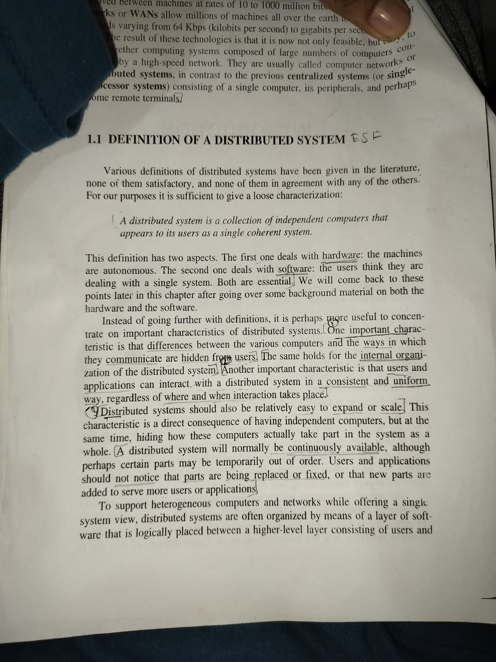

**What is client centric consistency model? The mobile user accessing different replicas of distributed database apply the eventual consistency with respect to this scenario and explain.**

**Client centric consistency model 2 marks**

**Eventual consistency with some scenario 4 marks**

**Explanation 4 marks**

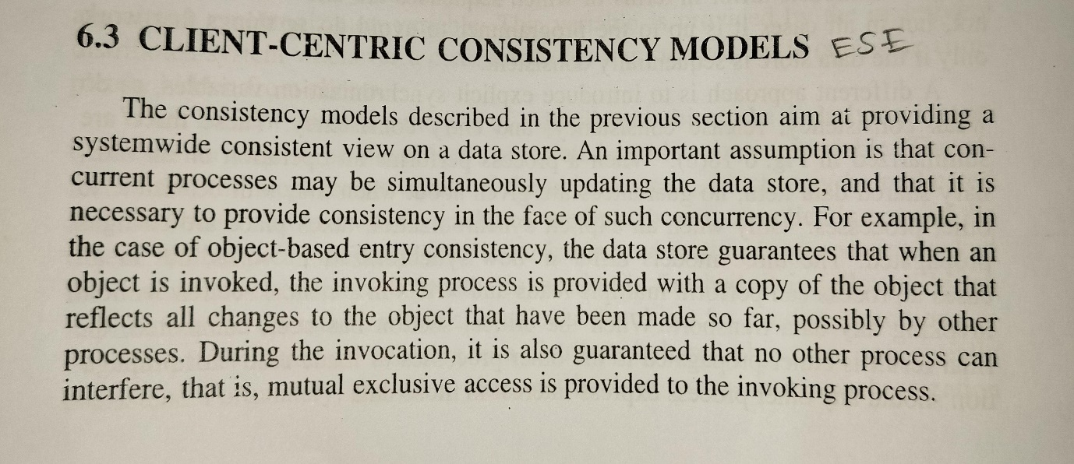

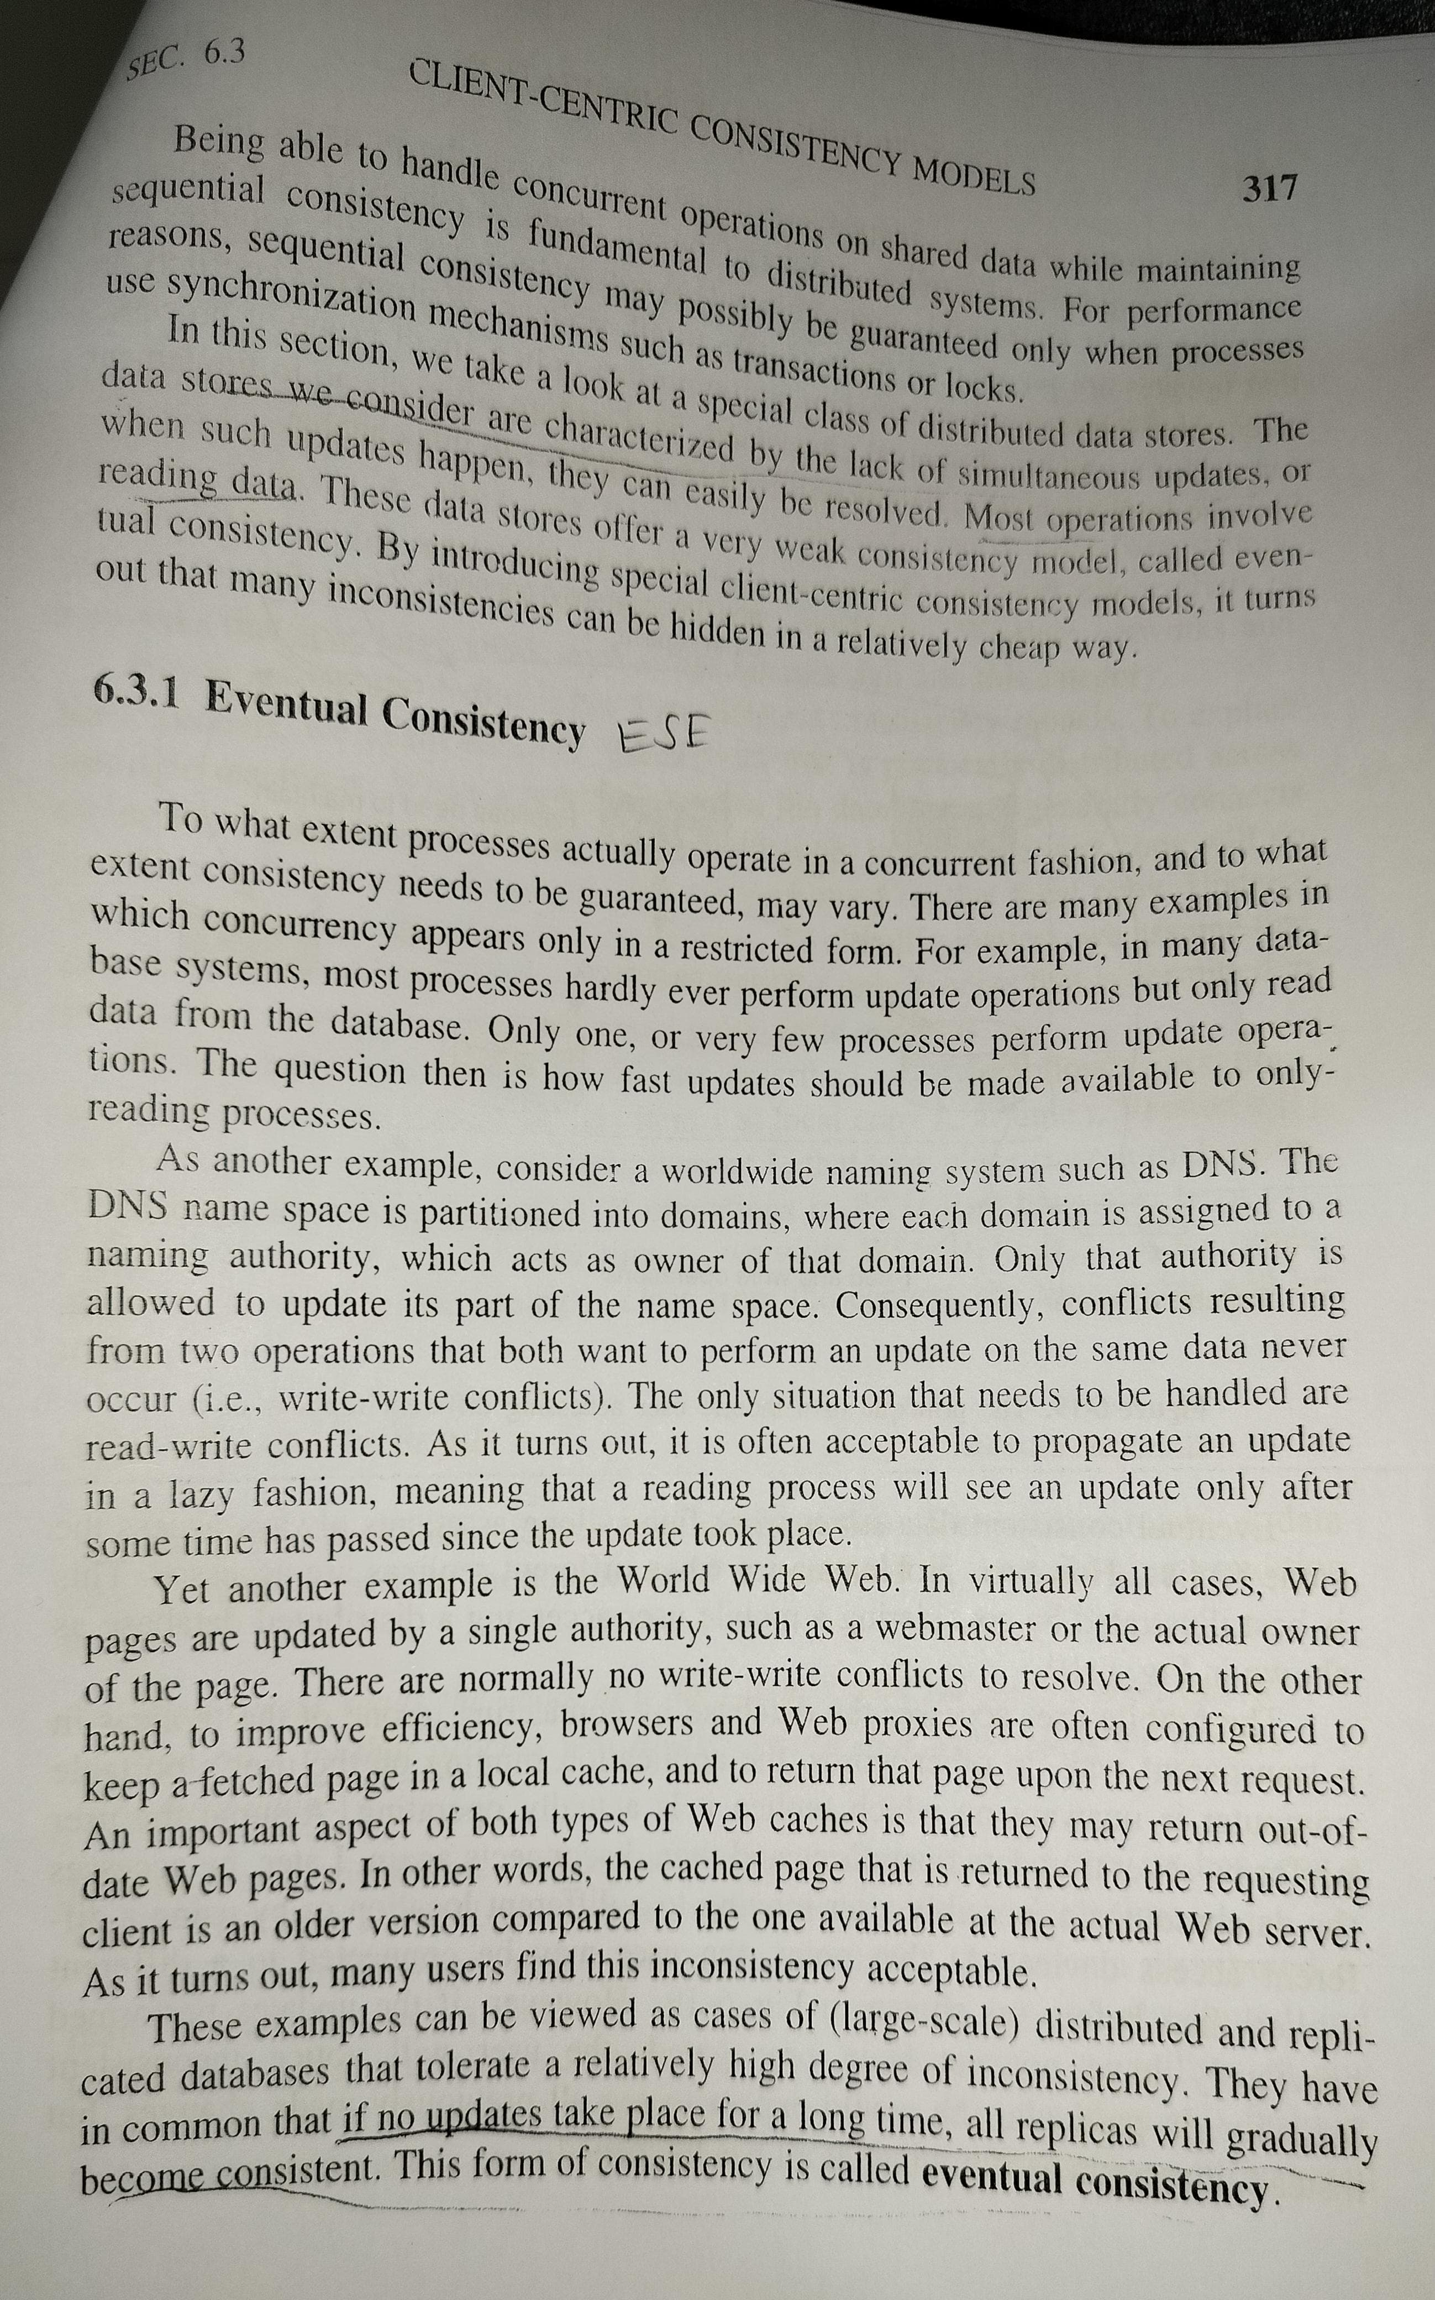

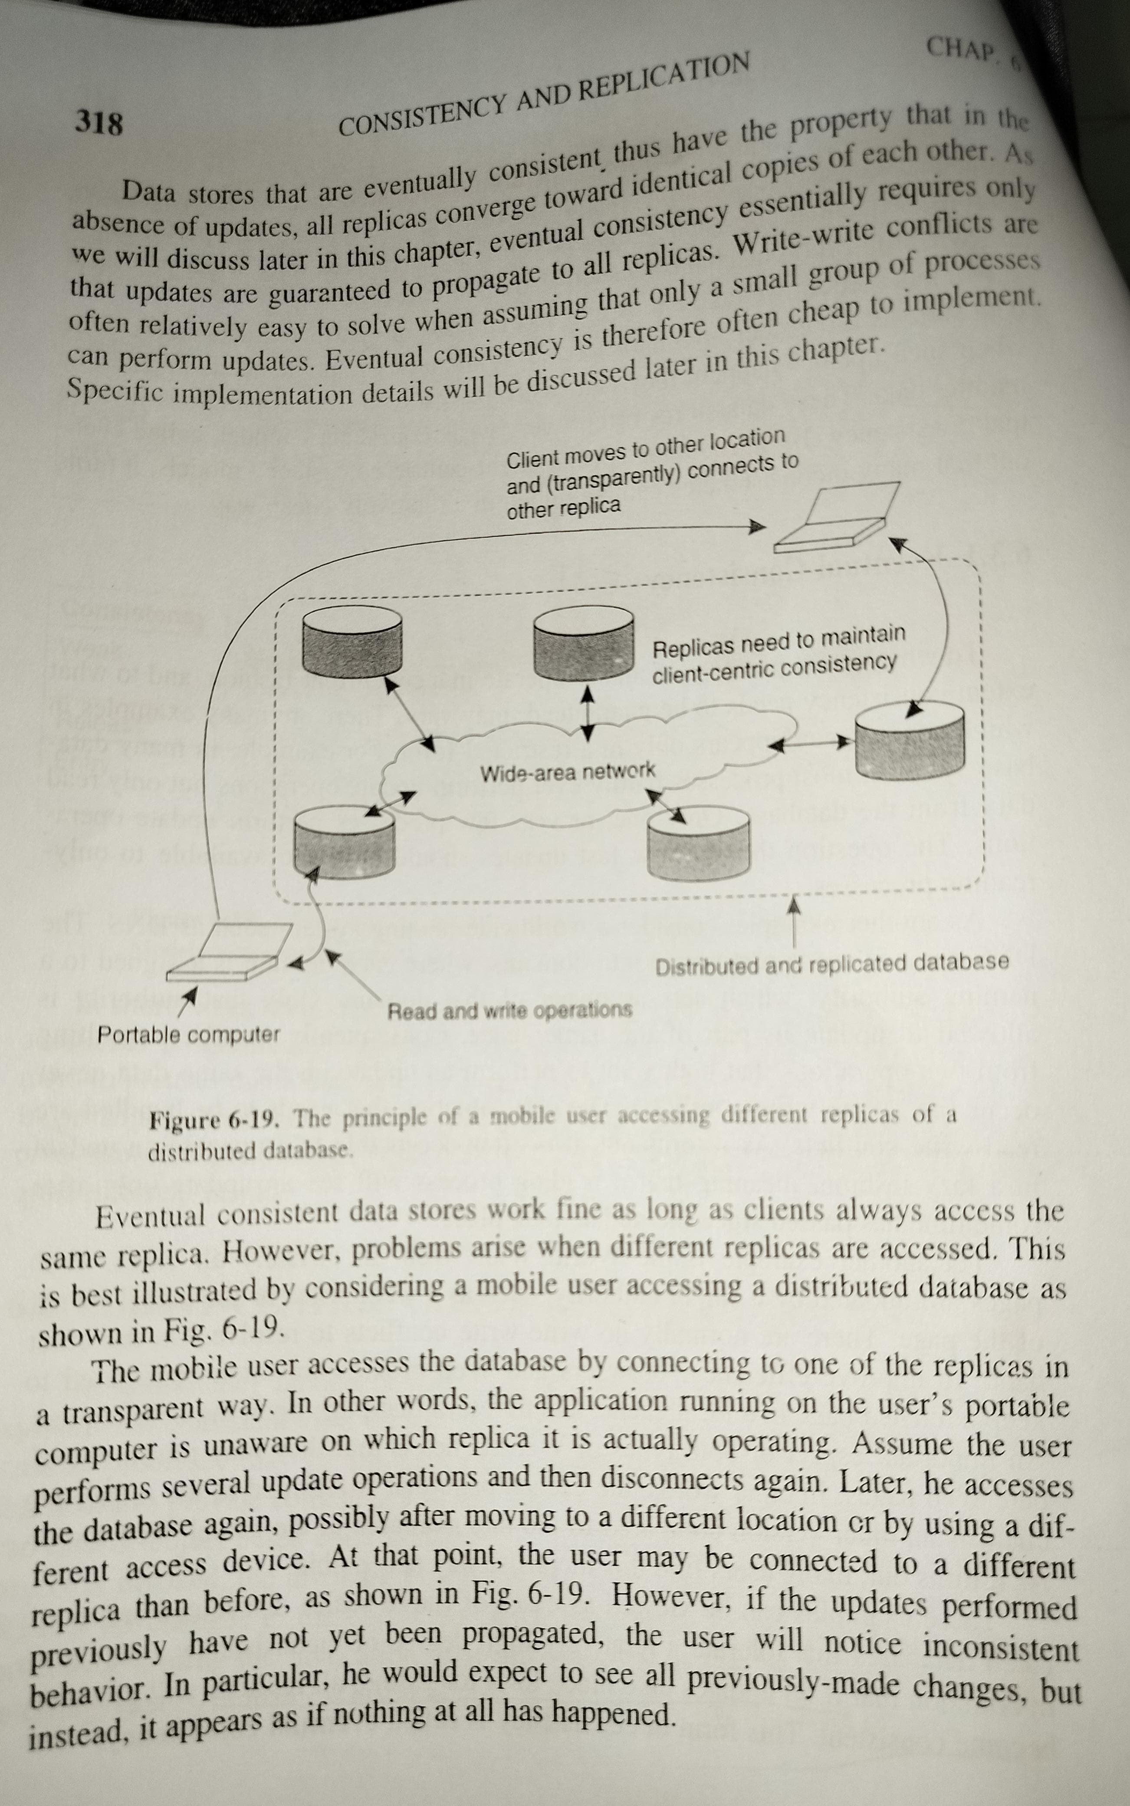

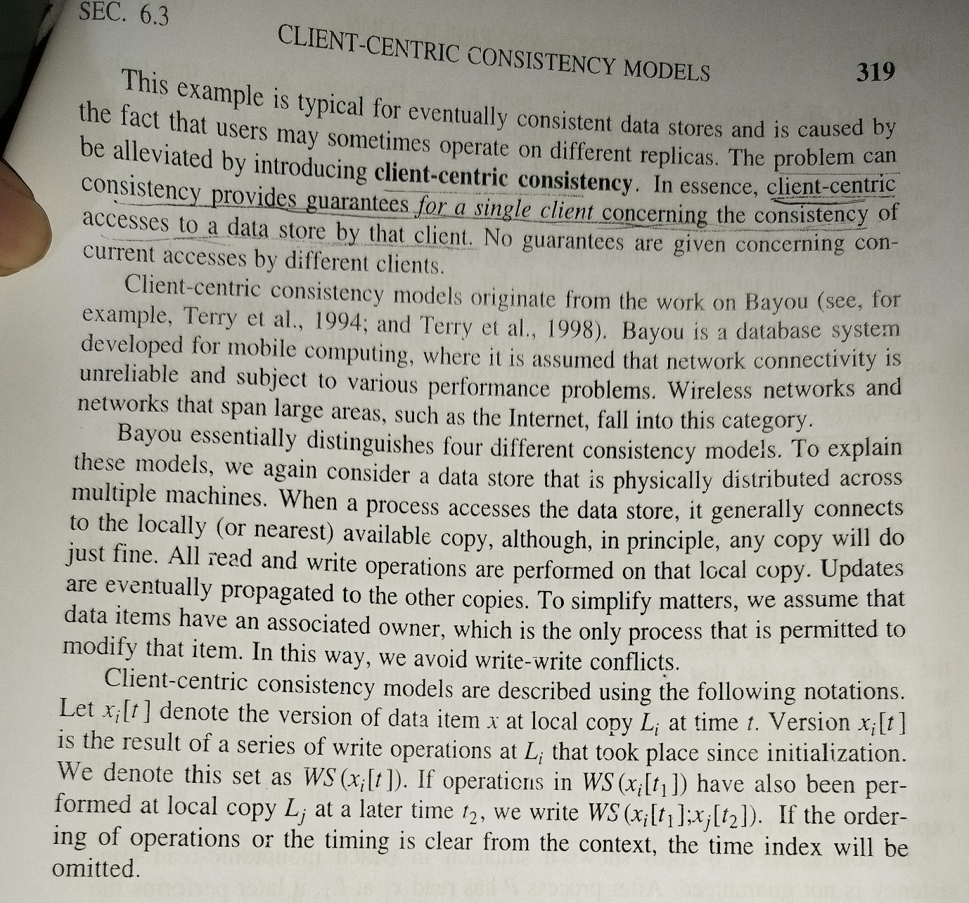

**How mutual exclusion algorithm satisfy the requirement of mutual exclusion and starvation using centralized approach and distributed approach? Give the example of centralized mutual exclusion algorithm for 3 processes and one coordinator process showing request, reply,and release messages. How it is advantages to use a timestamp for distributed mutual exclusion? Justify your answer using 4 processes with timestamp for distributed mutual exclusion.**

**Requirement of Mutual exclusion using centralized and distributed approach 2 marks**

**Centralized mutual exclusion diagram with explanation 3 marks**

**distributed mutual exclusion diagram with explanation 3 marks**

**advantages 2 marks**

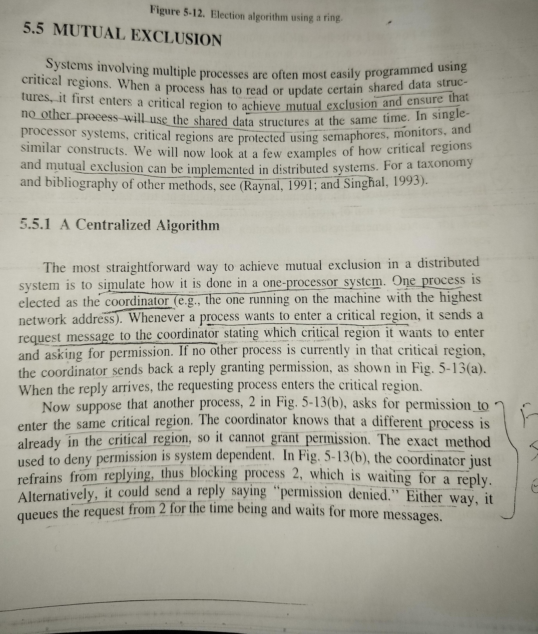

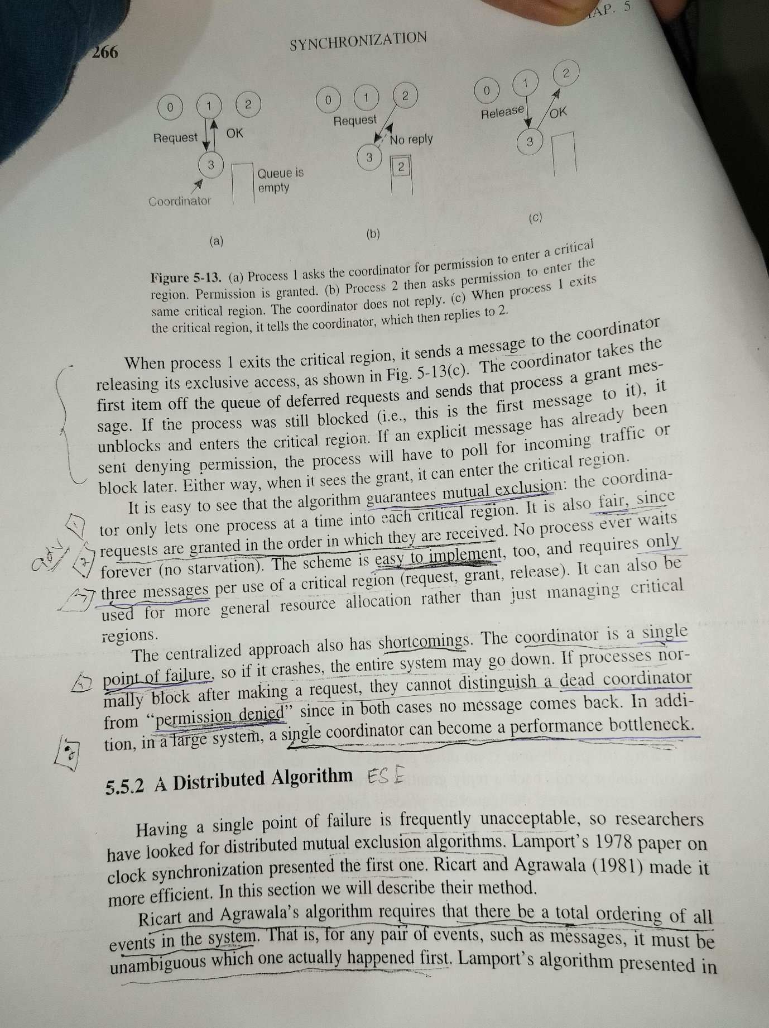

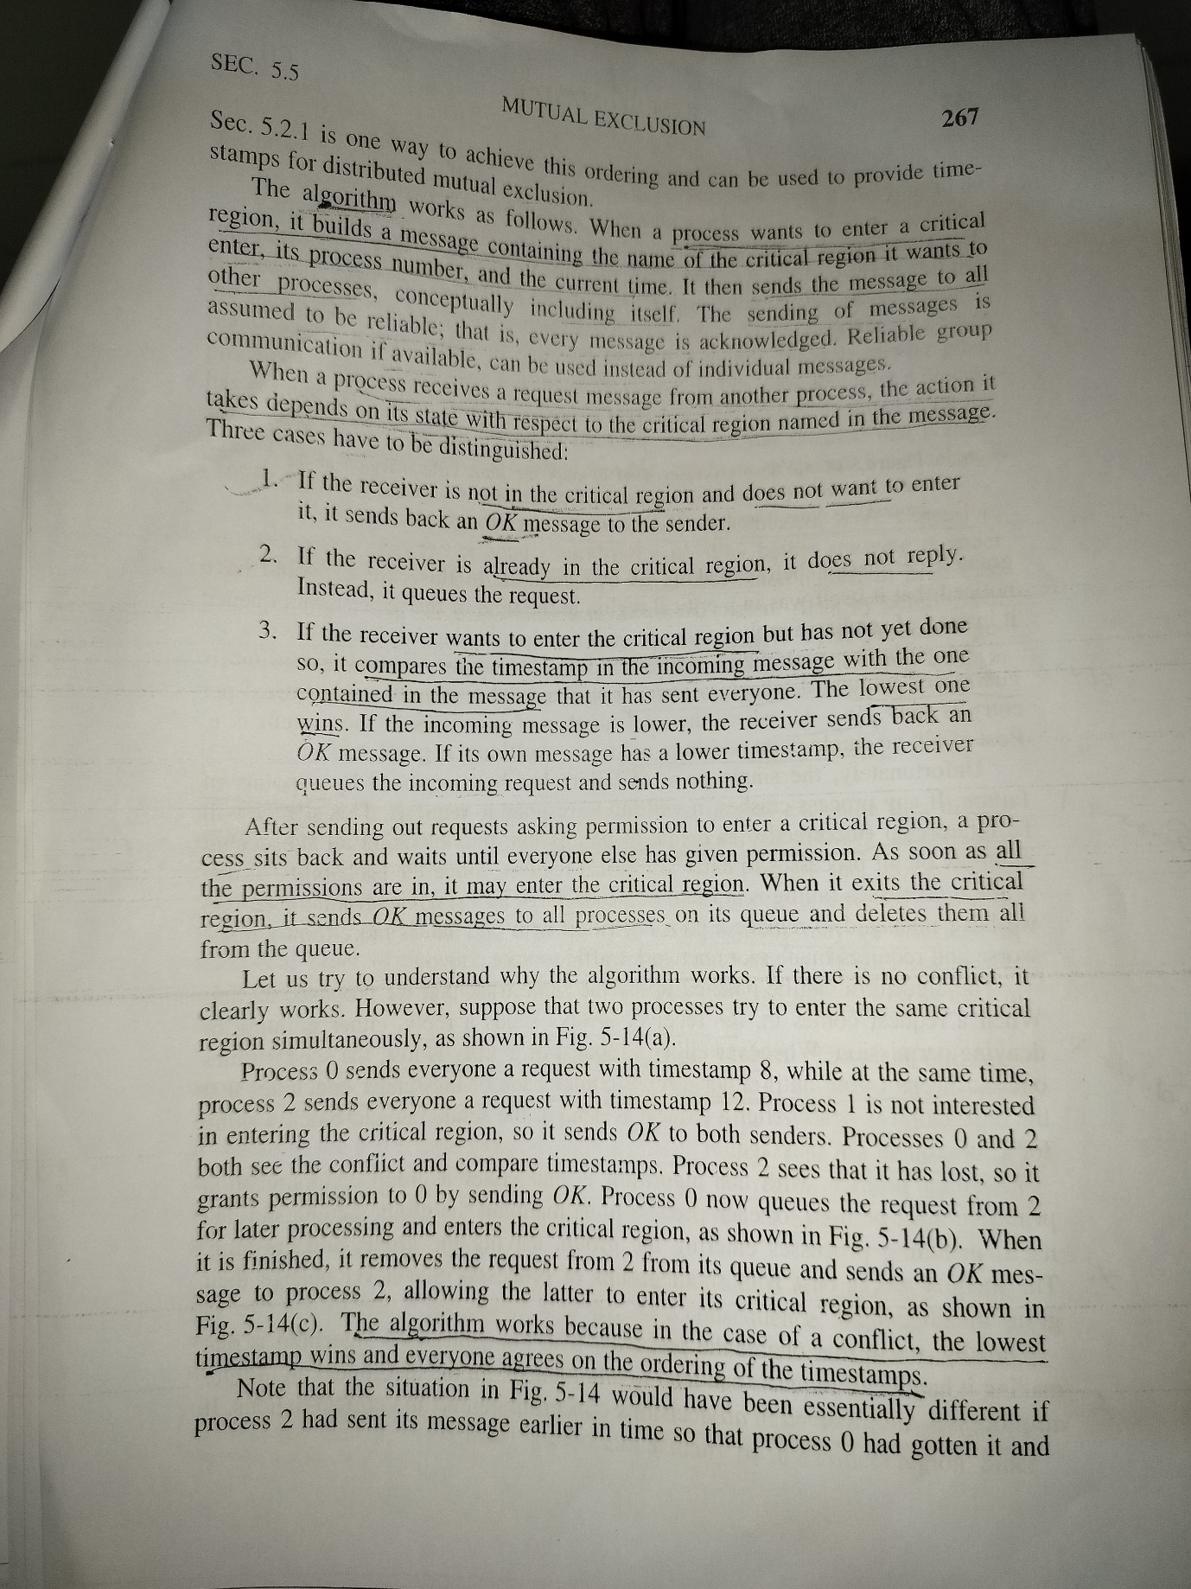

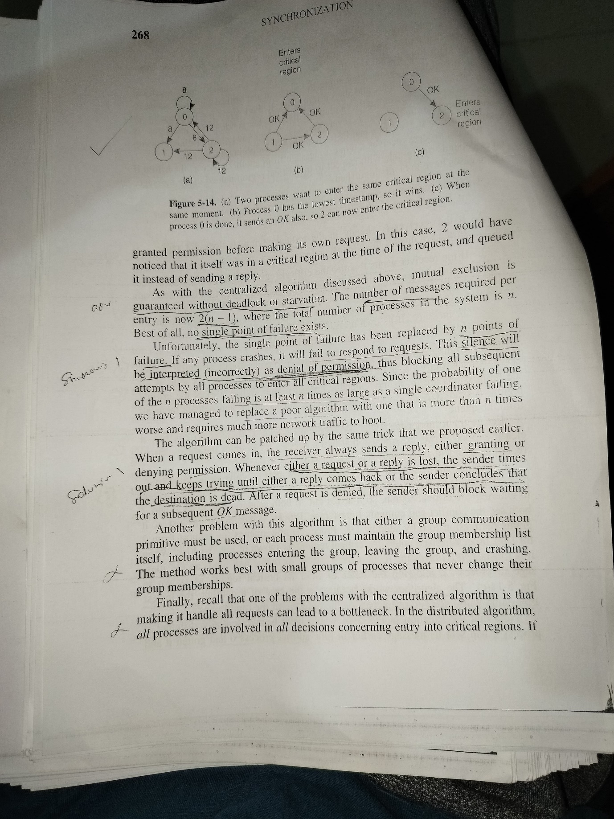

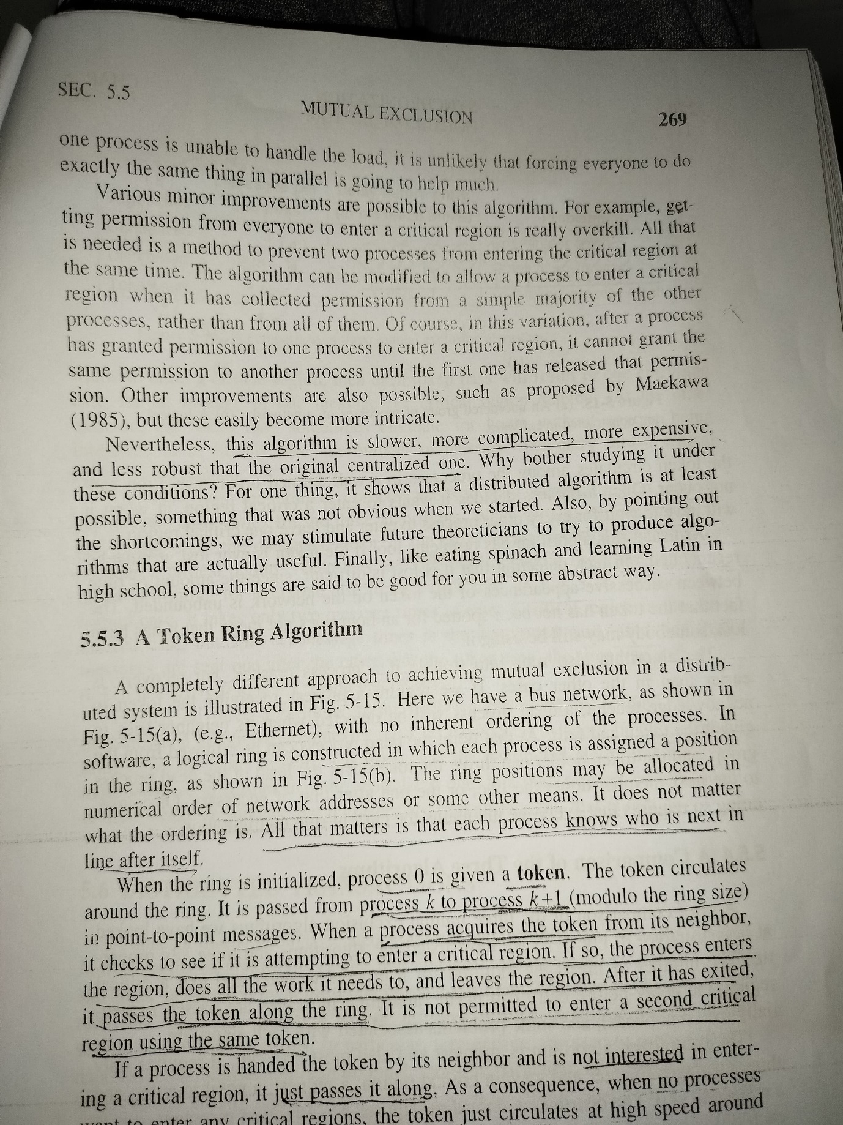

**Suppose you have decided to use the high-low policy as the process transfer policy of a load balancing algorithm for distributed system. Select the suitable method that you will use in your implementation for choosing high mark and low mark values. Do these threshold values have to be same for all processors in the system? Give reasons for your answer.**

**Threshold policy for process transfer 6 marks**

**Selecting the threshold 2 marks**

**Reasons 2 marks**

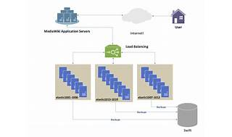

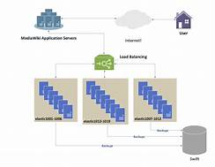

Explore

### Threshold Policy for Process Transfer

[The **high-low policy**, also known as the **double-threshold policy**, is a method used in load balancing algorithms for distributed systems to decide when to transfer processes from heavily loaded nodes to lightly loaded nodes](https://www.ques10.com/p/20526/explain-the-load-balancing-approach-in-distributed/)[1](https://www.ques10.com/p/20526/explain-the-load-balancing-approach-in-distributed/). The policy uses two threshold values:

* **High Mark**: If a node’s load exceeds this value, it attempts to transfer processes to a less loaded node.
* **Low Mark**: If a node’s load is below this value, it can accept more processes.

The goal is to maintain the system’s load between these two marks, avoiding both underutilization and overloading of nodes.

### Selecting the Threshold

When implementing the high-low policy, the method for choosing high mark and low mark values can be either **static** or **dynamic**:

* **Static Method**: Predefined threshold values are set for each node based on its processing capabilities. This method does not adapt to changes in the system’s workload.
* **Dynamic Method**: Threshold values are calculated based on the average workload and a predefined constant. This method allows the system to adapt to varying workloads and can provide better load balancing.

### Reasons for Threshold Values Variance

Threshold values **do not have to be the same** for all processors in the system. Here are the reasons:

* **Differing Capabilities**: Processors may have different computational capabilities, memory sizes, and I/O capacities. [Setting the same threshold for all would not account for these differences](https://www.ques10.com/p/20526/explain-the-load-balancing-approach-in-distributed/)[2](https://www.ques10.com/p/2565/explain-the-issues-in-designing-load-balancing-a-1/).
* **Workload Variability**: Different nodes may handle different types of workloads. Some may be more CPU-intensive, while others may be I/O-bound. Tailoring thresholds to the type of workload can improve efficiency.
* **System Dynamics**: In a dynamic system, the workload can change over time. A static, uniform threshold may not be optimal as it cannot adapt to these changes.

[By setting individualized threshold values, the load balancing algorithm can more effectively distribute the workload according to the unique characteristics and current state of each processor in the distributed system1](https://www.ques10.com/p/20526/explain-the-load-balancing-approach-in-distributed/). This approach can lead to better overall system performance and resource utilization.

**MSE OCT 22**

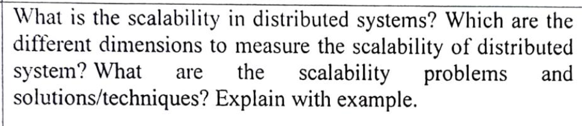

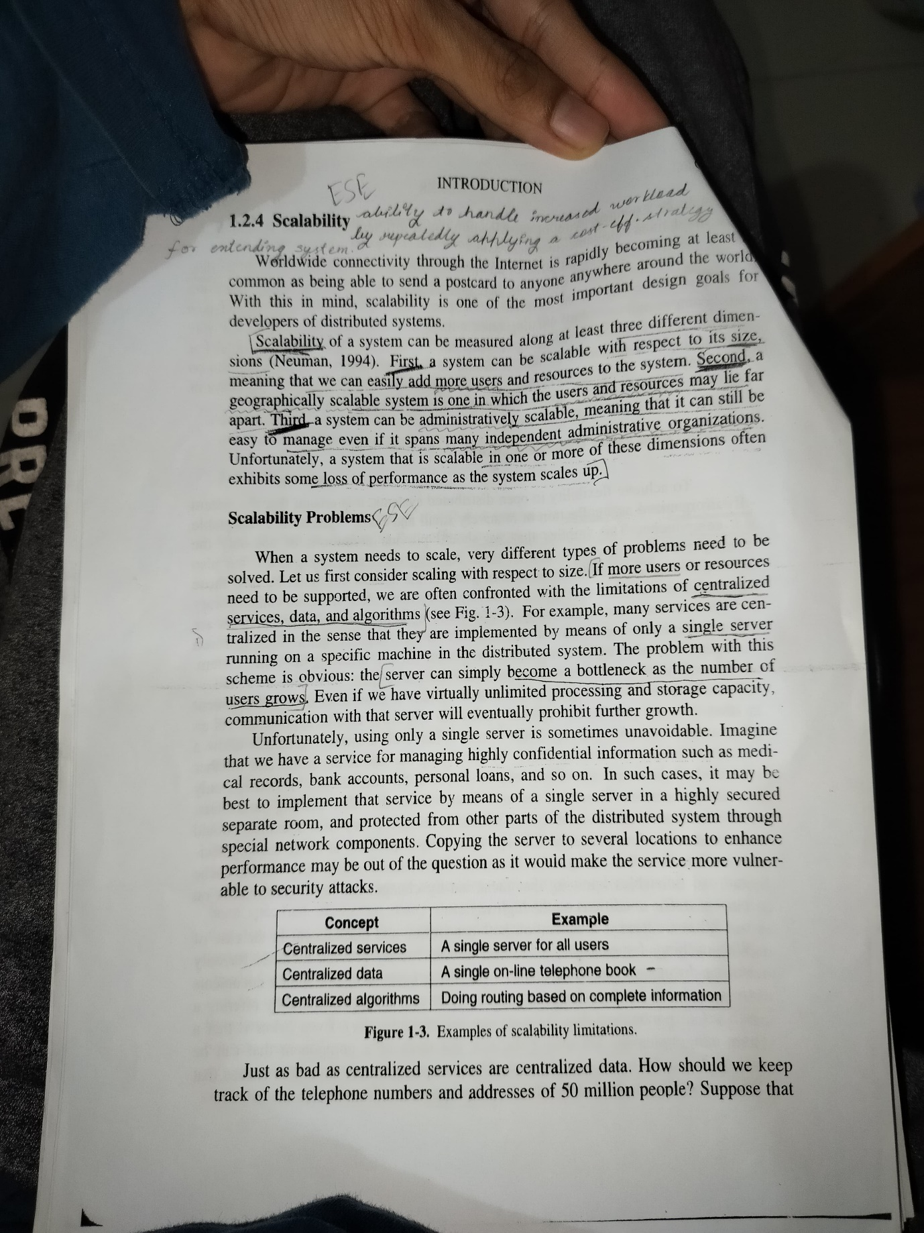

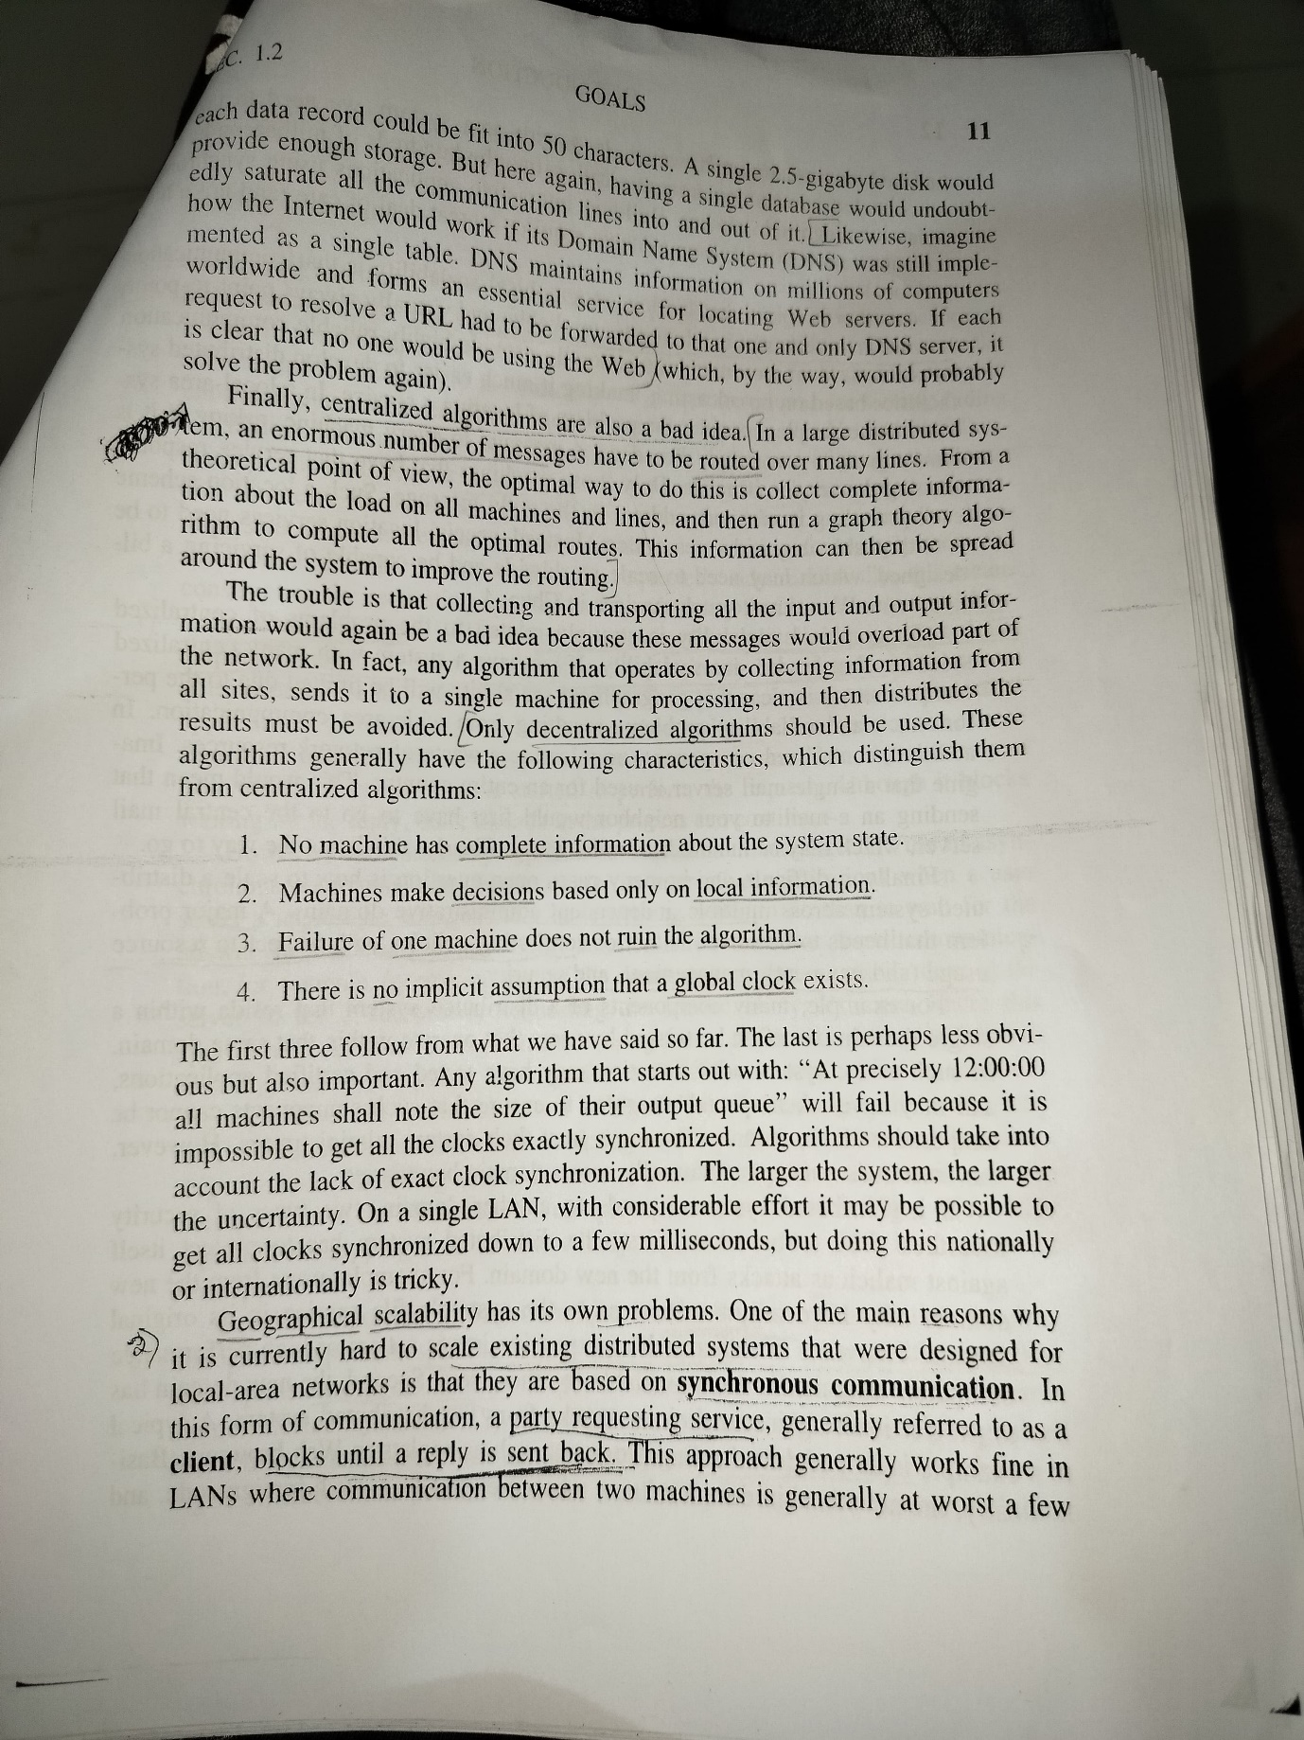

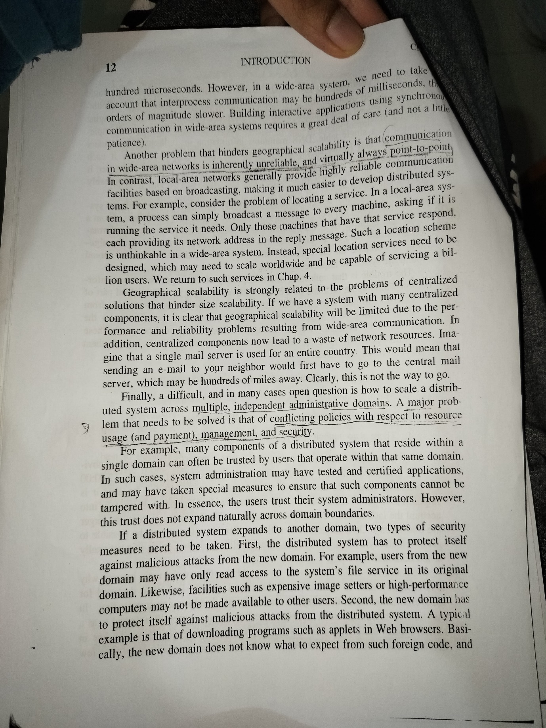 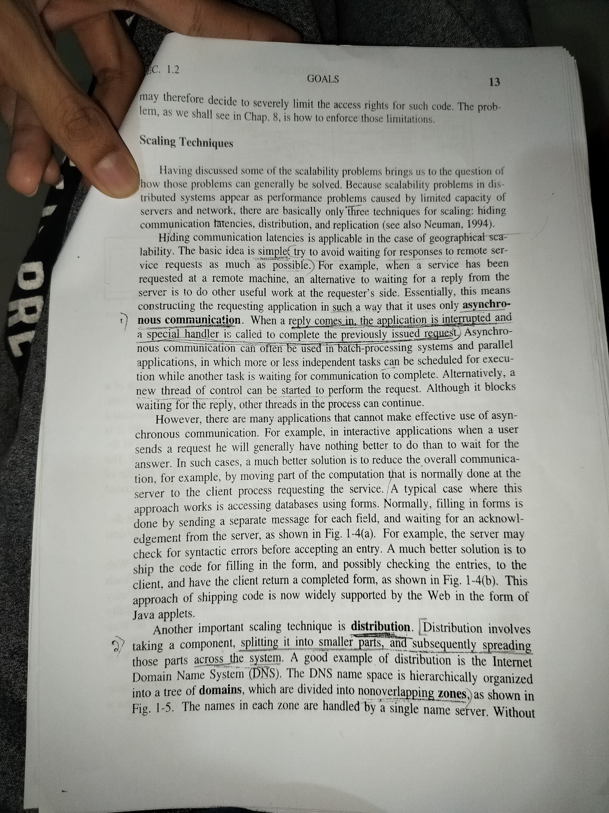 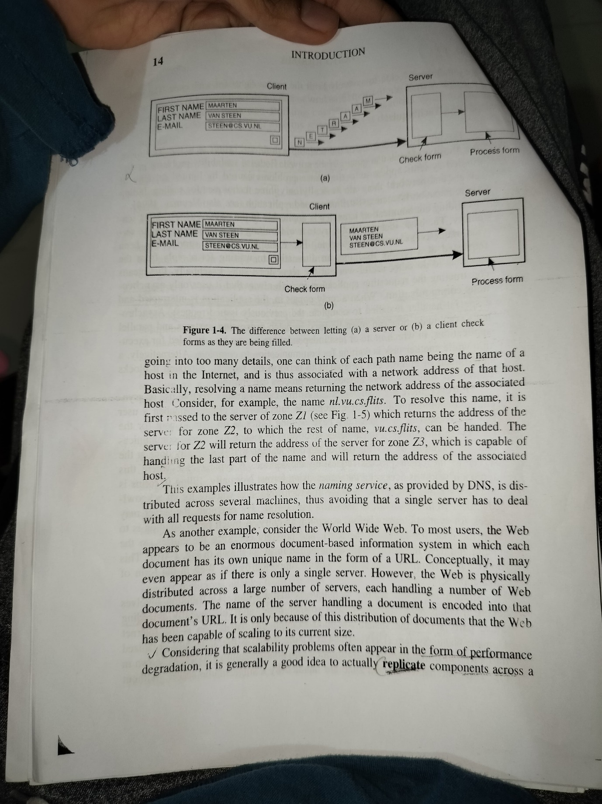 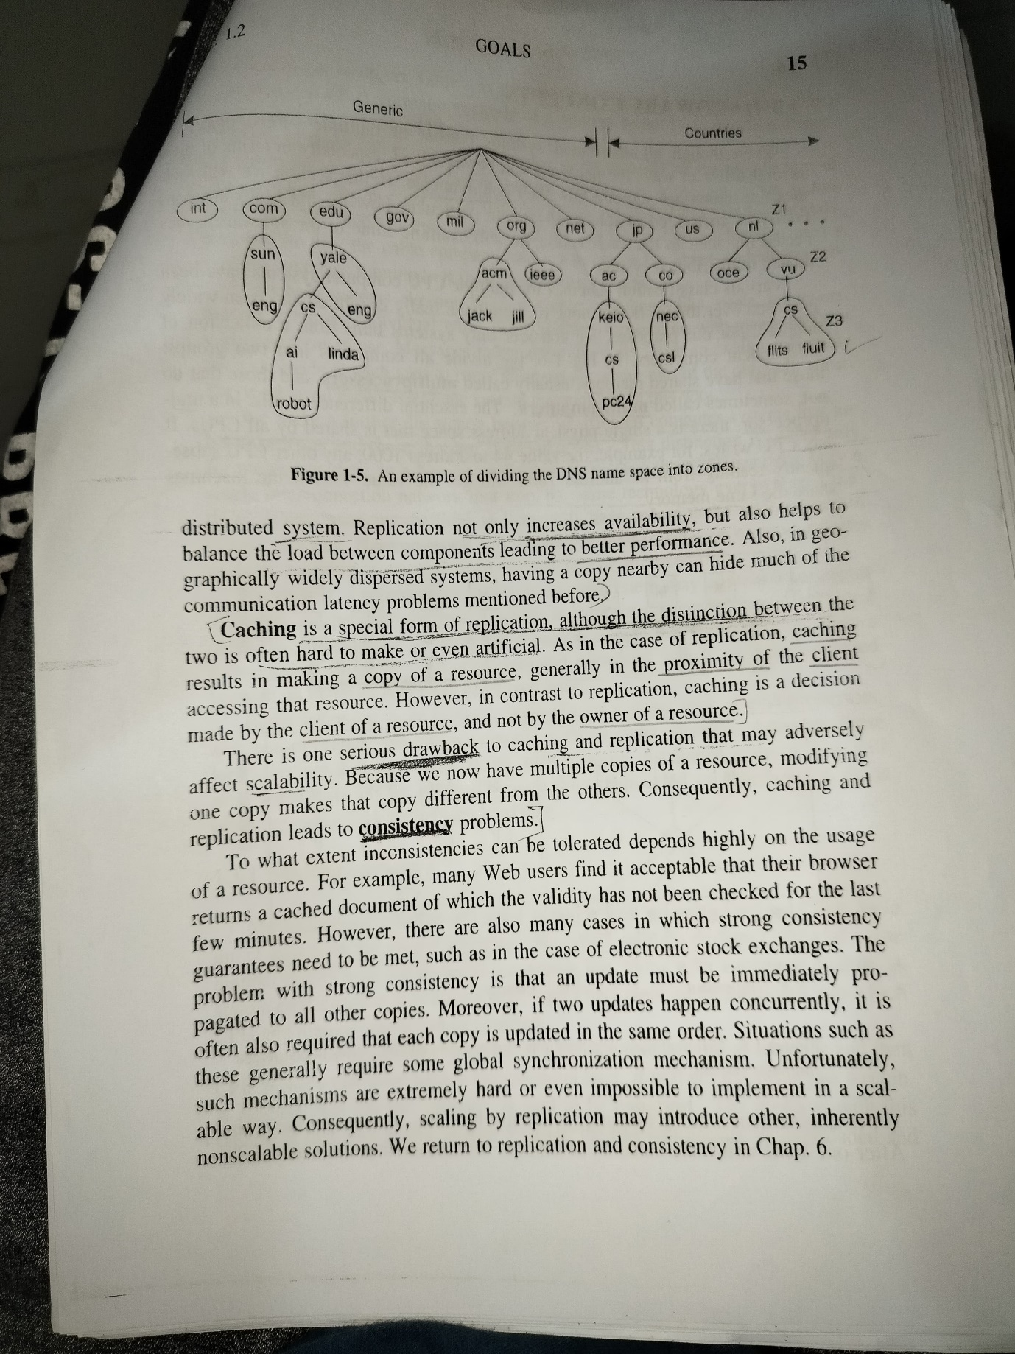

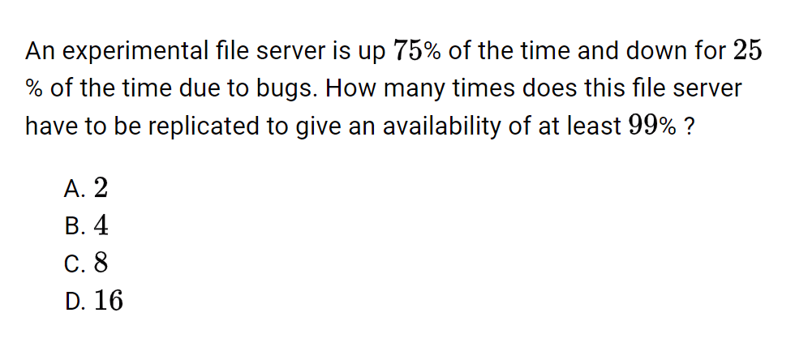

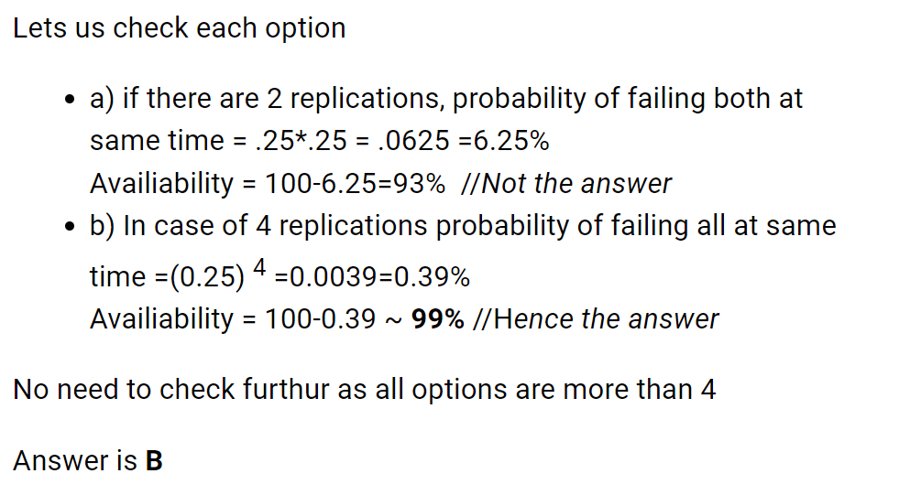

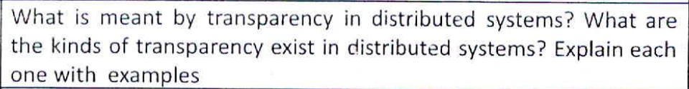

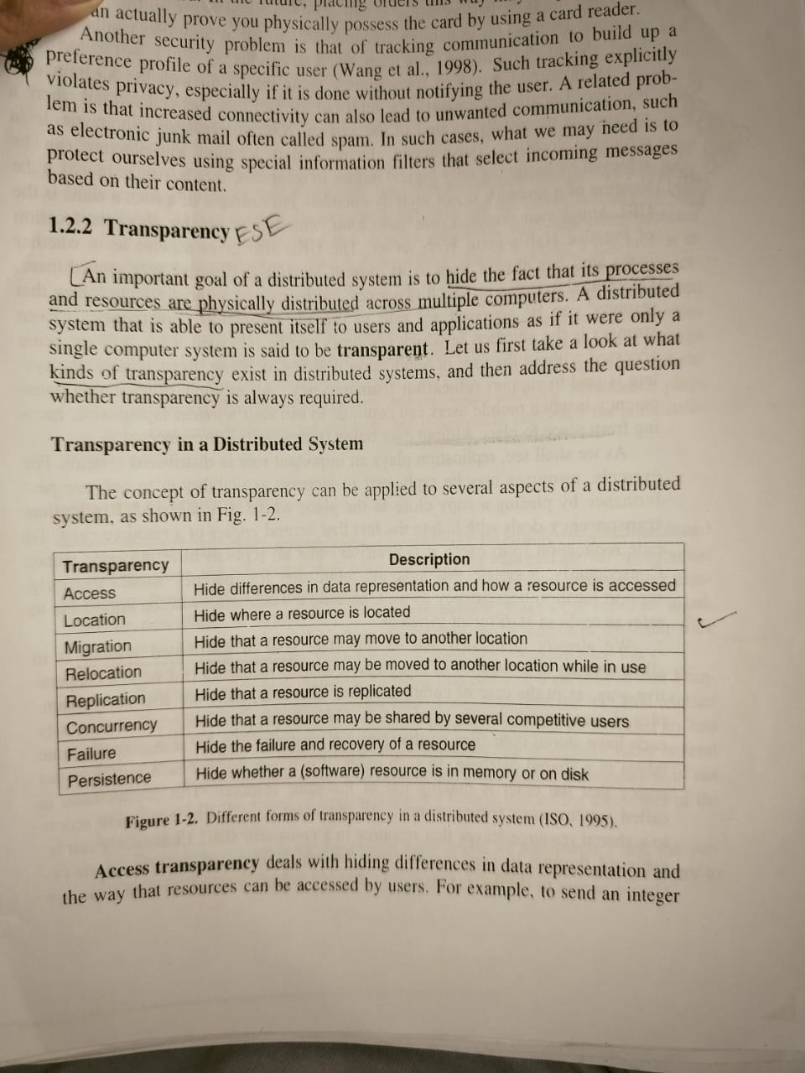

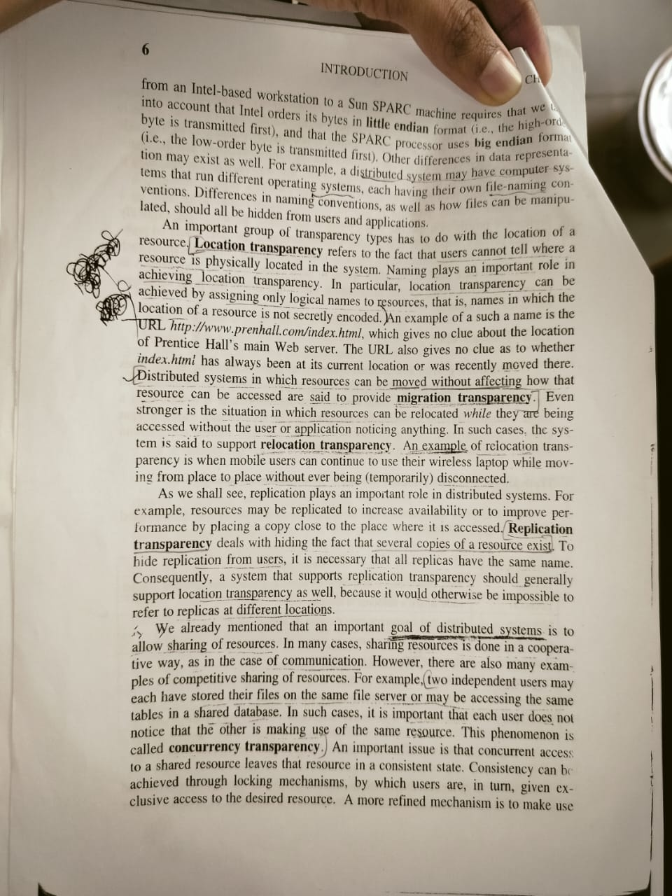

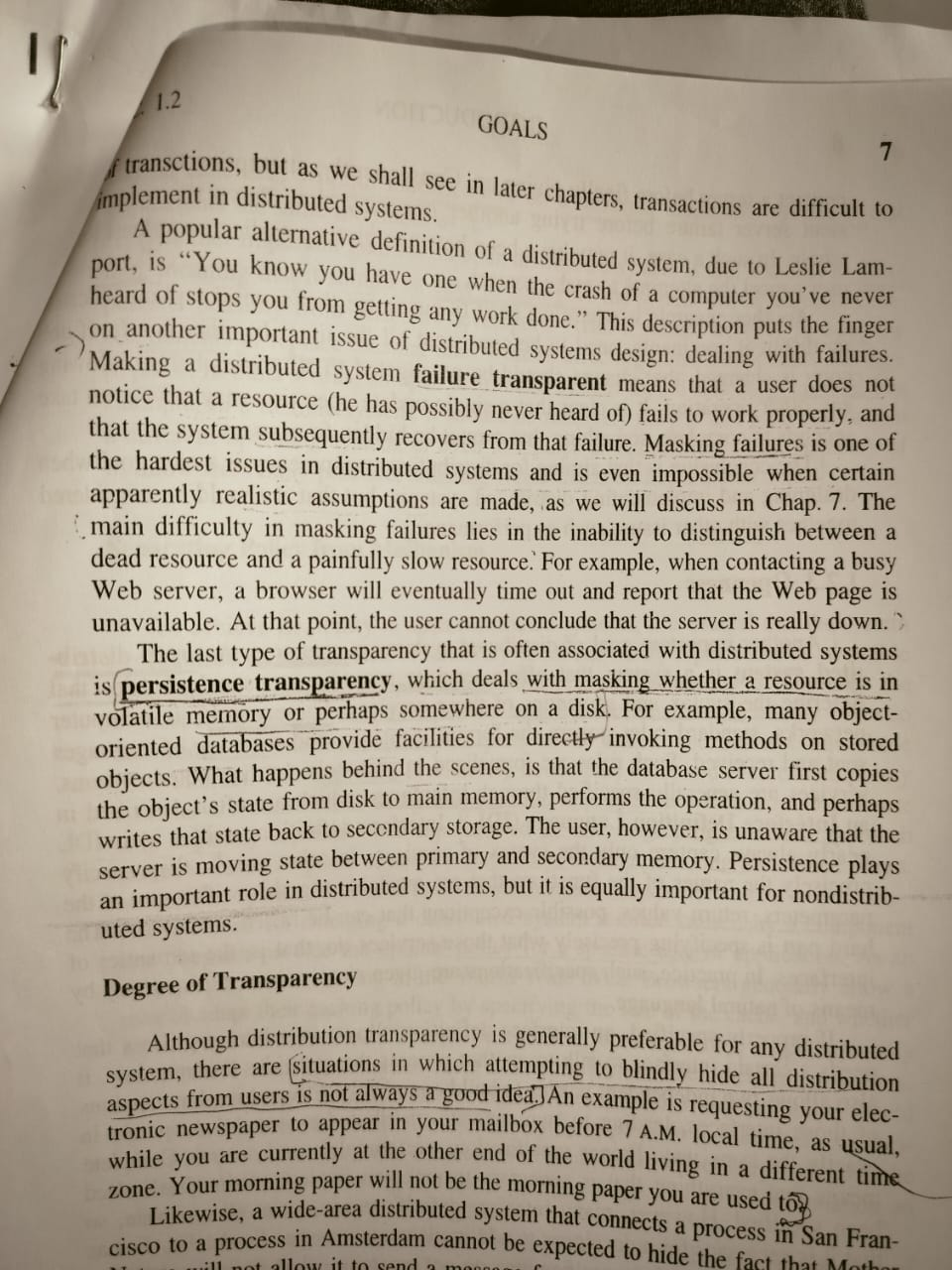

**ESE MAY 2021**

**What is a phantom deadlock? What might be the reason for**

**phantom deadlock in a distributed system? Suppose that**

**centralized deadlock detection scheme in which the transfer on**

**request method is used to transfer the information from the local**

**coordinator to the central coordinator. Give an example to show**

**that the algorithm may still detect a phantom deadlock.**

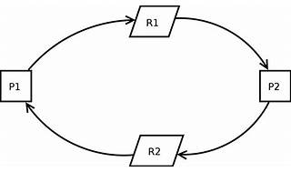

[A **phantom deadlock** in distributed systems refers to situations where multiple processes or threads get stuck and can’t move forward because of conflicts in synchronization and resource allocation1](https://www.geeksforgeeks.org/phantom-deadlock-in-distributed-system/). [This happens when different tasks are being executed at the same time, causing each process to wait for a resource that is held by another process](https://www.geeksforgeeks.org/phantom-deadlock-in-distributed-system/)[1](https://www.geeksforgeeks.org/phantom-deadlock-in-distributed-system/). [Unlike deadlocks, where resources are explicitly locked and blocked, phantom deadlocks often occur due to dependencies that are not immediately obvious1](https://www.geeksforgeeks.org/phantom-deadlock-in-distributed-system/).

[Phantom deadlocks usually happen because of a combination of factors like synchronization mechanisms, strategies for allocating resources, and the inherent complexities of distributed systems](https://www.geeksforgeeks.org/phantom-deadlock-in-distributed-system/)[1](https://www.geeksforgeeks.org/phantom-deadlock-in-distributed-system/). [In distributed systems, multiple nodes may request resources from each other such as files, locks, or data to carry out tasks1](https://www.geeksforgeeks.org/phantom-deadlock-in-distributed-system/). [Due to network delays and the asynchronous nature of communication, nodes might not receive responses to their resource requests1](https://www.geeksforgeeks.org/phantom-deadlock-in-distributed-system/). [This can lead to communication delays](https://www.geeksforgeeks.org/phantom-deadlock-in-distributed-system/)[1](https://www.geeksforgeeks.org/phantom-deadlock-in-distributed-system/). [Sometimes nodes may lack time and comprehensive information about the system’s resource allocation and utilization](https://www.geeksforgeeks.org/phantom-deadlock-in-distributed-system/)[1](https://www.geeksforgeeks.org/phantom-deadlock-in-distributed-system/). [As a result, they might misinterpret the information due to knowledge1](https://www.geeksforgeeks.org/phantom-deadlock-in-distributed-system/).

In a centralized deadlock detection scheme, one site is chosen as a control site. [This site is responsible for deadlock detection2](https://www.geeksforgeeks.org/deadlock-detection-in-distributed-systems-2/). [It has control over all resources of the system2](https://www.geeksforgeeks.org/deadlock-detection-in-distributed-systems-2/). [If a site requires a resource, it requests the control site, the control site allocates and de-allocates resources, and maintains a wait-for graph2](https://www.geeksforgeeks.org/deadlock-detection-in-distributed-systems-2/). [And at a regular interval of time, it checks the wait-for graph to detect a cycle2](https://www.geeksforgeeks.org/deadlock-detection-in-distributed-systems-2/). [If the cycle exists then it will declare the system as deadlock otherwise the system will continue working](https://www.geeksforgeeks.org/phantom-deadlock-in-distributed-system/)[2](https://www.geeksforgeeks.org/deadlock-detection-in-distributed-systems-2/).

[Let’s understand it better with an example of a phantom deadlock](https://www.geeksforgeeks.org/phantom-deadlock-in-distributed-system/)[1](https://www.geeksforgeeks.org/phantom-deadlock-in-distributed-system/). In this diagram, the arrows show the relationships of waiting. [For instance, P1 is waiting for R2, P2 is waiting for R3, and P3 is waiting for R1](https://www.geeksforgeeks.org/phantom-deadlock-in-distributed-system/)[1](https://www.geeksforgeeks.org/phantom-deadlock-in-distributed-system/). [This circular pattern suggests a deadlock1](https://www.geeksforgeeks.org/phantom-deadlock-in-distributed-system/). [However, due to the asynchronous nature of distributed systems and the delay in propagating local information, the deadlock detection algorithm might identify a deadlock that does not really exist3](https://www.edureka.co/community/17605/what-is-phantom-deadlock). [Such situations are called phantom deadlocks and they lead to unnecessary aborts3](https://www.edureka.co/community/17605/what-is-phantom-deadlock).

**Why is heterogeneity unavoidable in many distributed systems?**

**What are some of common types of incompatibilities**

**encountered in heterogeneous distributed systems? What are the**

**common issues with which the designer of a heterogeneous**

**distributed system must deal?**

[Heterogeneity is often unavoidable in distributed systems due to the diverse requirements of different applications](https://www.geeksforgeeks.org/heterogeneous-and-other-dsm-systems-distributed-systems/)[1](https://www.geeksforgeeks.org/heterogeneous-and-other-dsm-systems-distributed-systems/). [Hardware and software are generally tailored to a specific application area](https://www.geeksforgeeks.org/heterogeneous-and-other-dsm-systems-distributed-systems/)[1](https://www.geeksforgeeks.org/heterogeneous-and-other-dsm-systems-distributed-systems/). [For instance, supercomputers and multiprocessors excel at compute-intensive tasks but struggle with user interface and device I/O1](https://www.geeksforgeeks.org/heterogeneous-and-other-dsm-systems-distributed-systems/). [On the other hand, personal computers and workstations are frequently equipped with excellent user interfaces1](https://www.geeksforgeeks.org/heterogeneous-and-other-dsm-systems-distributed-systems/). [Many applications necessitate complex user interfaces, specific I/O devices, and large amounts of computational power](https://www.geeksforgeeks.org/heterogeneous-and-other-dsm-systems-distributed-systems/)[1](https://www.geeksforgeeks.org/heterogeneous-and-other-dsm-systems-distributed-systems/). [As a result, integrating diverse machines into a coherent distributed system and sharing resources among them is very desirable](https://www.geeksforgeeks.org/heterogeneous-and-other-dsm-systems-distributed-systems/)[1](https://www.geeksforgeeks.org/heterogeneous-and-other-dsm-systems-distributed-systems/).

Common types of incompatibilities encountered in heterogeneous distributed systems include:

1. [**Data Compatibility and Conversion**: Different byte-ordering and floating-point representations may be used by machines with different architectures](https://www.geeksforgeeks.org/heterogeneous-and-other-dsm-systems-distributed-systems/)[1](https://www.geeksforgeeks.org/heterogeneous-and-other-dsm-systems-distributed-systems/). [Data that is sent from one machine to another must be converted to the destination machine’s format](https://www.geeksforgeeks.org/heterogeneous-and-other-dsm-systems-distributed-systems/)[1](https://www.geeksforgeeks.org/heterogeneous-and-other-dsm-systems-distributed-systems/).
2. [**Block Size Selection**: The data transmission unit (block) must be transformed according to the data type of its contents](https://www.geeksforgeeks.org/heterogeneous-and-other-dsm-systems-distributed-systems/)[1](https://www.geeksforgeeks.org/heterogeneous-and-other-dsm-systems-distributed-systems/).

Designers of a heterogeneous distributed system must deal with several issues, including:

1. [**Heterogeneity**: This applies to the network, computer hardware, operating system, and implementation of different developers2](https://www.geeksforgeeks.org/design-issues-of-distributed-system/).
2. [**Openness**: The degree to which new resource-sharing services can be made available to the users2](https://www.geeksforgeeks.org/design-issues-of-distributed-system/).
3. [**Scalability**: The system should remain efficient even with a significant increase in the number of users and resources connected](https://www.geeksforgeeks.org/heterogeneous-and-other-dsm-systems-distributed-systems/)[2](https://www.geeksforgeeks.org/design-issues-of-distributed-system/).
4. [**Security**: The security of an information system has three components: Confidentiality, integrity, and availability](https://www.geeksforgeeks.org/heterogeneous-and-other-dsm-systems-distributed-systems/)[2](https://www.geeksforgeeks.org/design-issues-of-distributed-system/).
5. [**Failure Handling**: Corrective measures should be implemented to handle cases when some faults occur in hardware and the software program](https://www.geeksforgeeks.org/heterogeneous-and-other-dsm-systems-distributed-systems/)[2](https://www.geeksforgeeks.org/design-issues-of-distributed-system/).
6. [**Concurrency**: There is a possibility that several clients will attempt to access a shared resource at the same time2](https://www.geeksforgeeks.org/design-issues-of-distributed-system/).
7. [**Transparency**: The distributed system should be perceived as a single entity by the users or the application programmers rather than a collection of autonomous systems2](https://www.geeksforgeeks.org/design-issues-of-distributed-system/).

**A server is designed to perform simple integer arithmetic**

**operations (addition, subtraction, multiplication and division).**

**Clients interact with this server by using an RPC mechanism.**

**Describe the contents of the call and reply messages of this RPC**

**application, explaining the purpose of each component.**

[In a Remote Procedure Call (RPC) mechanism, the client and server communicate through call and reply messages1](https://www.geeksforgeeks.org/rpc-message-protocol/)[2](https://www.ibm.com/docs/en/aix/7.2?topic=call-rpc-message-protocol)[3](https://www.ibm.com/docs/en/aix/7.1?topic=call-rpc-model). Here’s a description of the contents of these messages in the context of a server performing simple integer arithmetic operations:

**Call Message:**

1. [**Transaction Identifier (xid)**: This is a unique identifier for each transaction](https://www.geeksforgeeks.org/rpc-message-protocol/)[4](https://sites.ualberta.ca/dept/chemeng/AIX-43/share/man/info/C/a_doc_lib/aixprggd/progcomc/rpc_msg.htm). [It helps in matching the reply message to the corresponding call message](https://www.geeksforgeeks.org/rpc-message-protocol/)[2](https://www.ibm.com/docs/en/aix/7.2?topic=call-rpc-message-protocol).
2. [**Message Type**: This indicates whether the message is a call or a reply](https://www.geeksforgeeks.org/rpc-message-protocol/)[4](https://sites.ualberta.ca/dept/chemeng/AIX-43/share/man/info/C/a_doc_lib/aixprggd/progcomc/rpc_msg.htm). In this case, it would be set to “CALL”.
3. **Procedure Identifier**: This specifies the procedure to be invoked on the server. For example, it could be an identifier for addition, subtraction, multiplication, or division.
4. **Procedure Parameters**: These are the parameters required for the procedure. [For arithmetic operations, these would be the integers on which the operation is to be performed1](https://www.geeksforgeeks.org/rpc-message-protocol/).

**Reply Message:**

1. [**Transaction Identifier (xid)**: This matches the xid in the call message, allowing the client to correlate the reply with the original request2](https://www.ibm.com/docs/en/aix/7.2?topic=call-rpc-message-protocol).
2. [**Message Type**: This indicates whether the message is a call or a reply](https://www.geeksforgeeks.org/rpc-message-protocol/)[4](https://sites.ualberta.ca/dept/chemeng/AIX-43/share/man/info/C/a_doc_lib/aixprggd/progcomc/rpc_msg.htm). In this case, it would be set to “REPLY”.
3. [**Reply Status**: This indicates whether the procedure was executed successfully or not1](https://www.geeksforgeeks.org/rpc-message-protocol/).
4. [**Return Values**: If the procedure was executed successfully, this contains the result of the operation](https://www.geeksforgeeks.org/rpc-message-protocol/)[1](https://www.geeksforgeeks.org/rpc-message-protocol/).

The purpose of these components is to facilitate communication between the client and the server, allowing the client to invoke procedures on the server and receive the results. [The client and server may be on different systems, possibly with different architectures and data representation types1](https://www.geeksforgeeks.org/rpc-message-protocol/). [The RPC mechanism abstracts these details, making network communication appear as if it were a local procedure call5](https://www.geeksforgeeks.org/what-is-rpc-mechanism-in-distributed-system/)[6](https://www.geeksforgeeks.org/remote-procedure-call-rpc-in-operating-system/). [This greatly simplifies the development of distributed applications6](https://www.geeksforgeeks.org/remote-procedure-call-rpc-in-operating-system/).

**How would you incorporate persistence asynchronous**

**communication into model of communication based on RMI to remote objects? In Java Remote object invocation how to pass**

**object by reference or by value give an example with**

**justification.**

[Incorporating persistent asynchronous communication into a model of communication based on Remote Method Invocation (RMI) involves a few steps1](https://lass.cs.umass.edu/~shenoy/courses/spring02/lectures/Lec05.pdf)[2](https://bing.com/search?q=persistence+asynchronous+communication+in+RMI):

1. [**Persistent Communication**: In persistent communication, messages are stored until the receiver is ready1](https://lass.cs.umass.edu/~shenoy/courses/spring02/lectures/Lec05.pdf). [This can be achieved by implementing a message queue or buffer at the sender’s end](https://lass.cs.umass.edu/~shenoy/courses/spring02/lectures/Lec05.pdf)[1](https://lass.cs.umass.edu/~shenoy/courses/spring02/lectures/Lec05.pdf). [When a message is sent, it is stored in this buffer until the receiver is ready to process it](https://lass.cs.umass.edu/~shenoy/courses/spring02/lectures/Lec05.pdf)[1](https://lass.cs.umass.edu/~shenoy/courses/spring02/lectures/Lec05.pdf).
2. [**Asynchronous Communication**: In asynchronous communication, the sender continues immediately after it has submitted the message](https://lass.cs.umass.edu/~shenoy/courses/spring02/lectures/Lec05.pdf)[1](https://lass.cs.umass.edu/~shenoy/courses/spring02/lectures/Lec05.pdf). [This can be achieved by implementing non-blocking methods or using separate threads for sending and receiving messages1](https://lass.cs.umass.edu/~shenoy/courses/spring02/lectures/Lec05.pdf).

[In Java RMI, objects can be passed either by value or by reference](https://lass.cs.umass.edu/~shenoy/courses/spring02/lectures/Lec05.pdf)[3](https://stackoverflow.com/questions/3087756/rmi-pass-by-value-or-by-reference)[4](https://stackoverflow.com/questions/11187548/is-it-possible-to-pass-by-reference-in-rmi)[5](https://coderanch.com/t/187699/certification/RMI-pass-reference)[6](https://stackoverflow.com/questions/23597427/java-rmi-pass-by-reference):

1. [**Pass by Value**: If an object does not implement the Remote interface but is Serializable, then it will be serialized and passed by value](https://lass.cs.umass.edu/~shenoy/courses/spring02/lectures/Lec05.pdf)[3](https://stackoverflow.com/questions/3087756/rmi-pass-by-value-or-by-reference). [This means a copy of the object is created and sent to the remote method](https://lass.cs.umass.edu/~shenoy/courses/spring02/lectures/Lec05.pdf)[3](https://stackoverflow.com/questions/3087756/rmi-pass-by-value-or-by-reference).
2. [**Pass by Reference**: If an object implements the Remote interface, then it will be passed by reference3](https://stackoverflow.com/questions/3087756/rmi-pass-by-value-or-by-reference). [This means a reference to the object (a stub) is sent to the remote method](https://lass.cs.umass.edu/~shenoy/courses/spring02/lectures/Lec05.pdf)[3](https://stackoverflow.com/questions/3087756/rmi-pass-by-value-or-by-reference). [Any changes made to the object through this reference will affect the original object3](https://stackoverflow.com/questions/3087756/rmi-pass-by-value-or-by-reference).

Here’s an example:

public interface MyService extends Remote {

public MyHandle createX(SomeSerializableObj param1) throws RemoteException;

}

public interface MyHandle extends Remote {

void doOne();

void doTwo();

}

[In this example, SomeSerializableObj is passed by value to the createX method, while MyHandle is passed by reference](https://lass.cs.umass.edu/~shenoy/courses/spring02/lectures/Lec05.pdf)[4](https://stackoverflow.com/questions/11187548/is-it-possible-to-pass-by-reference-in-rmi). [The createX method returns a reference to a MyHandle object, allowing the client to interact with that object on the server](https://lass.cs.umass.edu/~shenoy/courses/spring02/lectures/Lec05.pdf)[4](https://stackoverflow.com/questions/11187548/is-it-possible-to-pass-by-reference-in-rmi).

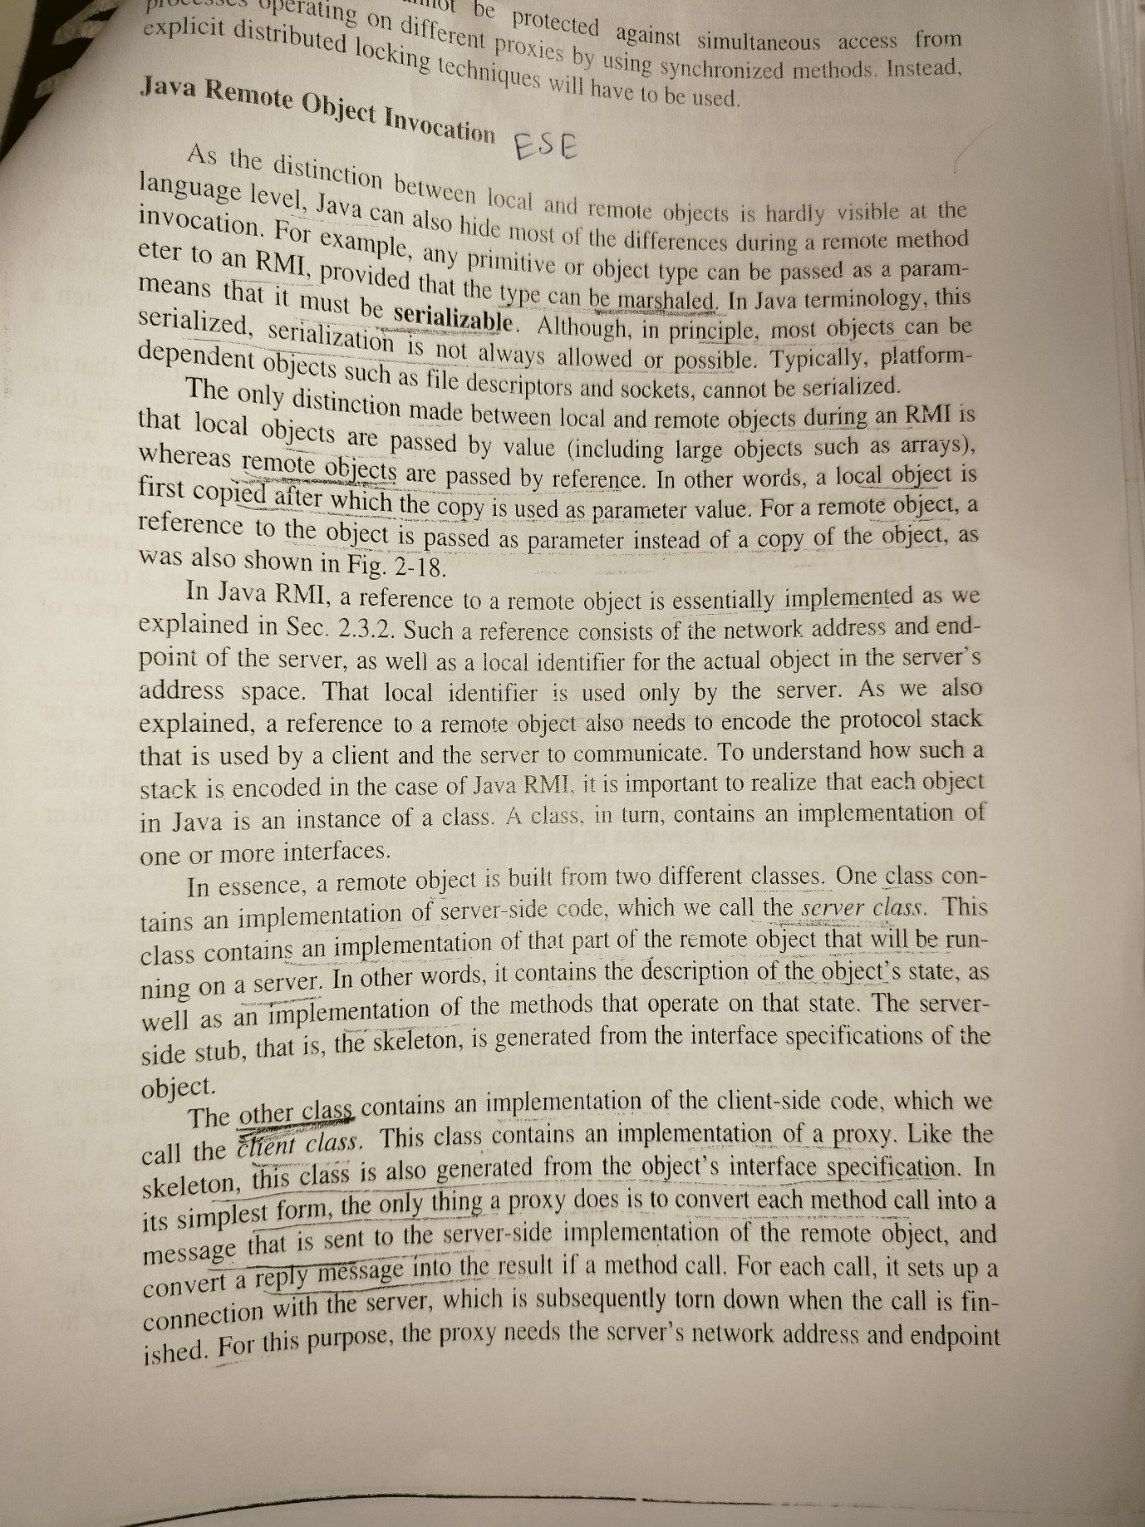

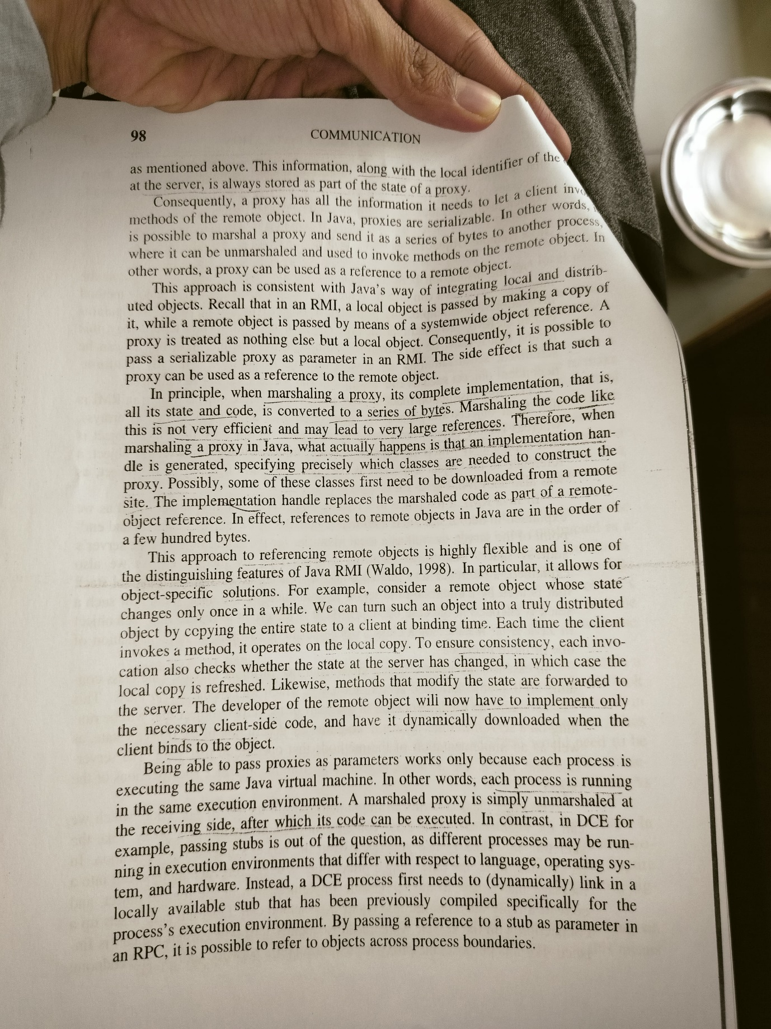

**How GIOP and IIOP used in CORBA? What is the role of**

**ORB? Give the example of interface and implementation**

**repository used in CORBA. What are the functions of interfaces**

**used in CORBA at client and server side?**

[In the Common Object Request Broker Architecture (CORBA), the General Inter-ORB Protocol (GIOP) and the Internet Inter-ORB Protocol (IIOP) play crucial roles](https://docs.oracle.com/cd/E13211_01/wle/wle42/corba/giop.pdf)[1](https://docs.oracle.com/cd/E13211_01/wle/wle42/corba/giop.pdf)[2](https://en.wikipedia.org/wiki/General_Inter-ORB_Protocol):

1. [**GIOP**: This is a general protocol that defines how Object Request Brokers (ORBs) communicate in CORBA](https://docs.oracle.com/cd/E13211_01/wle/wle42/corba/giop.pdf)[1](https://docs.oracle.com/cd/E13211_01/wle/wle42/corba/giop.pdf). [It’s designed to be simple, scalable, low-cost, and general enough to be implemented on any connection-oriented transport protocol](https://docs.oracle.com/cd/E13211_01/wle/wle42/corba/giop.pdf)[1](https://docs.oracle.com/cd/E13211_01/wle/wle42/corba/giop.pdf).
2. [**IIOP**: This is a specific implementation of GIOP for use over the Internet](https://docs.oracle.com/cd/E13211_01/wle/wle42/corba/giop.pdf)[2](https://en.wikipedia.org/wiki/General_Inter-ORB_Protocol). [It provides a mapping between GIOP messages and the TCP/IP layer](https://docs.oracle.com/cd/E13211_01/wle/wle42/corba/giop.pdf)[2](https://en.wikipedia.org/wiki/General_Inter-ORB_Protocol). [All CORBA products are required to support IIOP](https://docs.oracle.com/cd/E13211_01/wle/wle42/corba/giop.pdf)[1](https://docs.oracle.com/cd/E13211_01/wle/wle42/corba/giop.pdf).

[The **Object Request Broker (ORB)** is a key component of CORBA](https://docs.oracle.com/cd/E13211_01/wle/wle42/corba/giop.pdf)[3](https://www.corba.org/orb_basics.htm)[4](https://www.ibm.com/docs/en/integration-bus/9.0.0?topic=corba-common-object-request-broker-architecture)[5](https://www.seotrance.com/ebusiness-solutions/module6/orb-function-corba.php)[6](https://docs.oracle.com/javase/8/docs/api/org/omg/CORBA/ORB.html)[7](https://docs.oracle.com/cd/E15261_01/tuxedo/docs11gr1/tech_articles/CORBA.html). [It handles the communication, marshaling, and unmarshaling of parameters, making the process transparent for CORBA server and client applications](https://docs.oracle.com/cd/E13211_01/wle/wle42/corba/giop.pdf)[3](https://www.corba.org/orb_basics.htm). [The ORB also manages the Interface Repository, a distributed database containing IDL interface definitions](https://docs.oracle.com/cd/E13211_01/wle/wle42/corba/giop.pdf)[3](https://www.corba.org/orb_basics.htm).

[The **Interface Repository** provides persistent storage for interface definitions specified in OMG IDL](https://docs.oracle.com/cd/E13211_01/wle/wle42/corba/giop.pdf)[8](https://docs.oracle.com/cd/E13211_01/wle/wle42/corba/8IR.PDF). [It manages and provides access to a collection of object definitions](https://docs.oracle.com/cd/E13211_01/wle/wle42/corba/giop.pdf)[8](https://docs.oracle.com/cd/E13211_01/wle/wle42/corba/8IR.PDF). [The **Implementation Repository** contains information that allows the ORB to locate and activate implementations of objects](https://docs.oracle.com/cd/E13211_01/wle/wle42/corba/giop.pdf)[9](https://research.cs.queensu.ca/home/xiao/DS/node5.html).

[Interfaces in CORBA specify a software boundary between a service implementation and its clients10](https://www.ece.uvic.ca/~itraore/seng422-05/notes/arch05-9.pdf)[11](https://www.ece.uvic.ca/~itraore/seng422-06/notes/arch06-6-2.pdf). [They can involve attributes, operations, and type definitions](https://docs.oracle.com/cd/E13211_01/wle/wle42/corba/giop.pdf)[10](https://www.ece.uvic.ca/~itraore/seng422-05/notes/arch05-9.pdf)[11](https://www.ece.uvic.ca/~itraore/seng422-06/notes/arch06-6-2.pdf). [On the client side, the ORB offers services like providing interface definitions from the Interface Repository and constructing invocations for use with the Dynamic Invocation Interface](https://docs.oracle.com/cd/E13211_01/wle/wle42/corba/giop.pdf)[3](https://www.corba.org/orb_basics.htm). [On the server side, the ORB manages the activation and deactivation of objects, among other tasks](https://docs.oracle.com/cd/E13211_01/wle/wle42/corba/giop.pdf)[3](https://www.corba.org/orb_basics.htm).

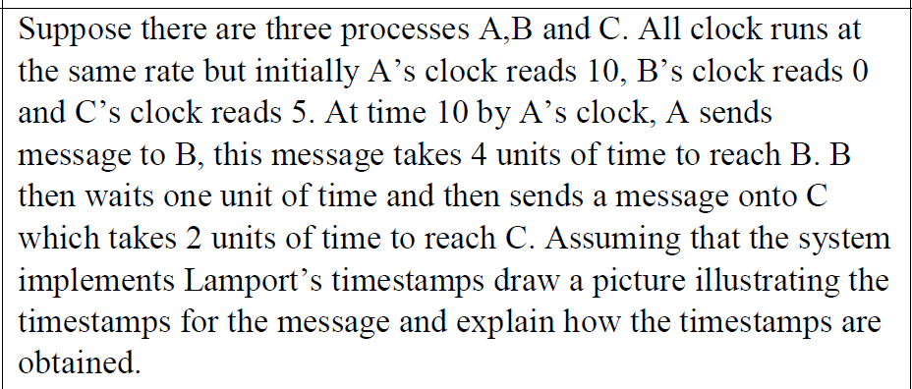

**Choose an example of an application for which causal**

**consistency is the most suitable consistency model.**

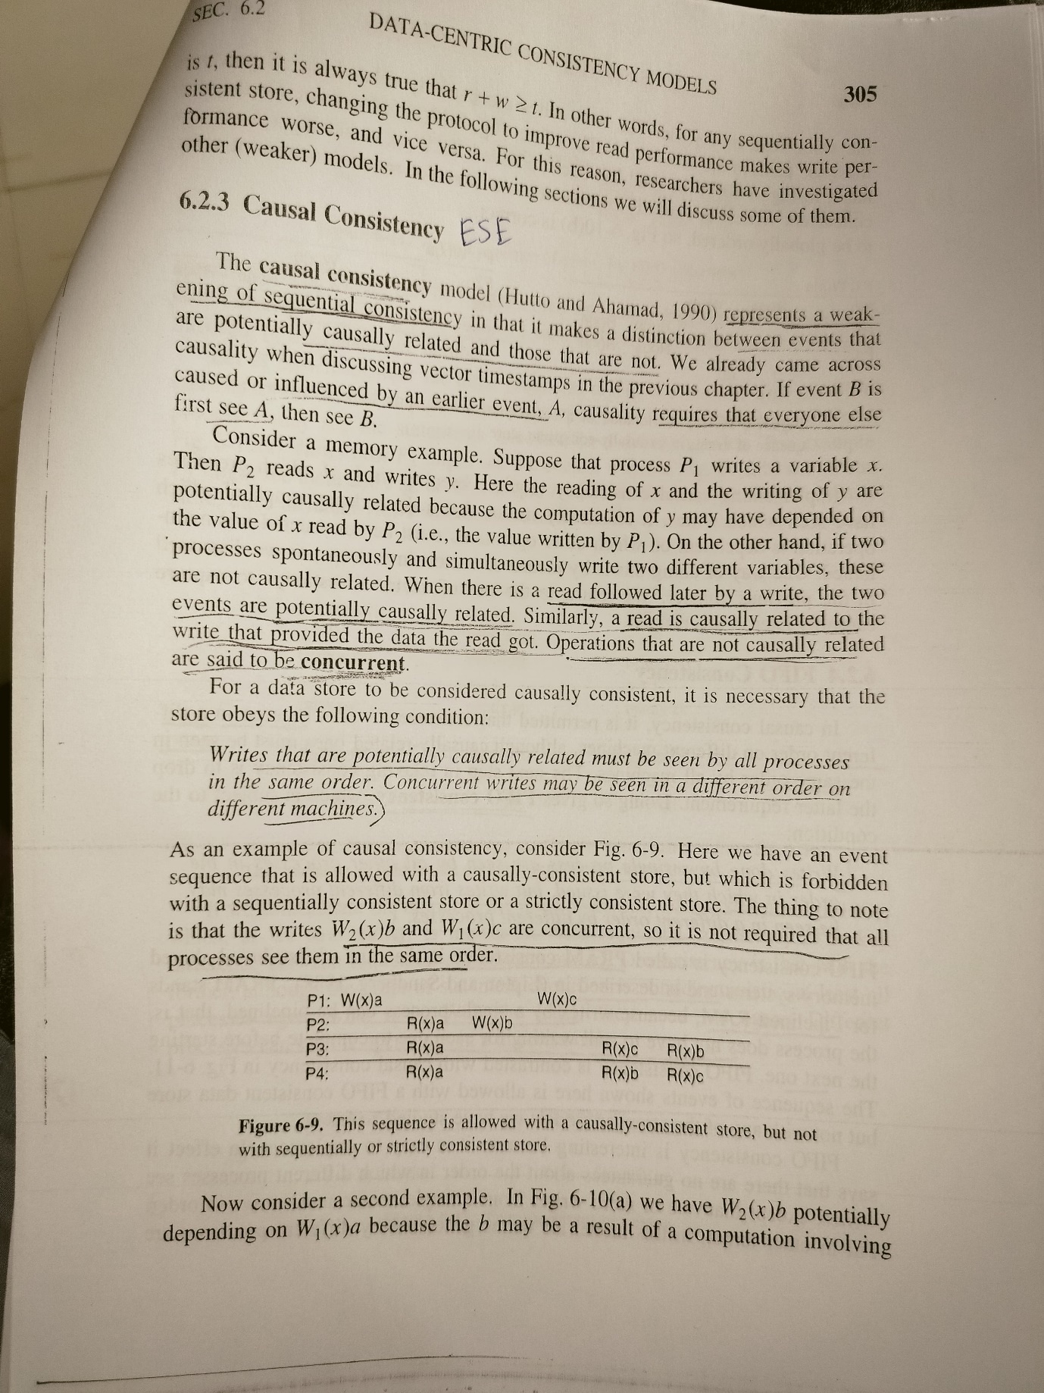

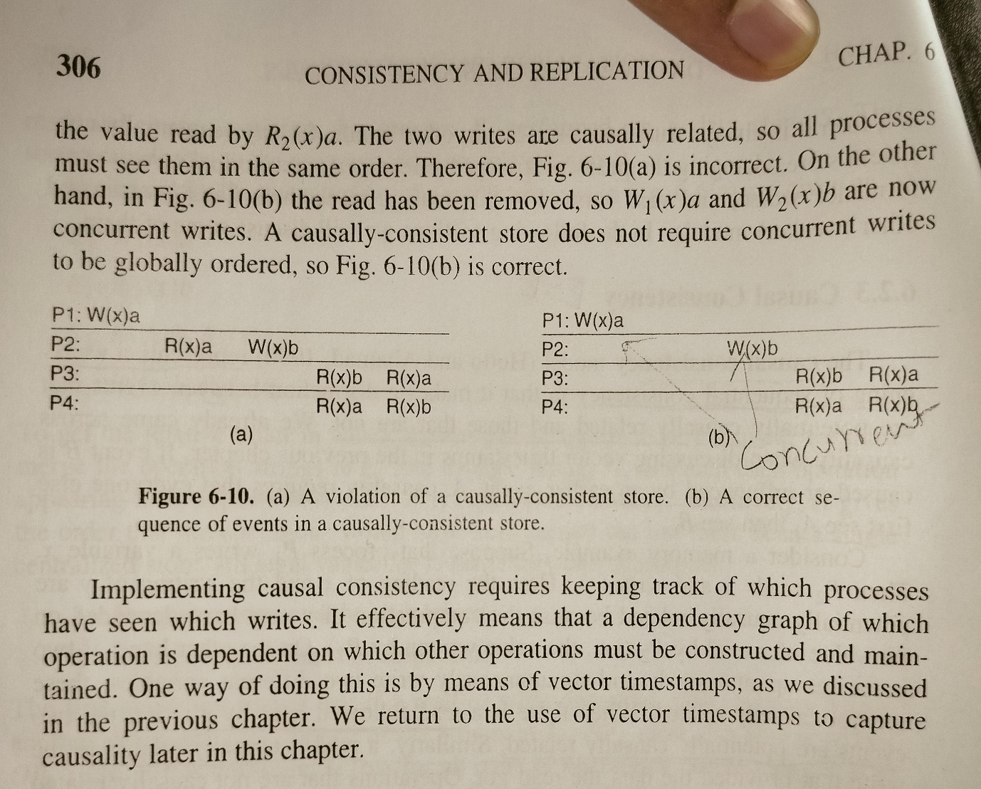

**How to construct message queuing model is used in message**

**oriented persistent communication? What is the relationship**

**between the queue level addressing and network level**

**addressing is used in message queuing system?**

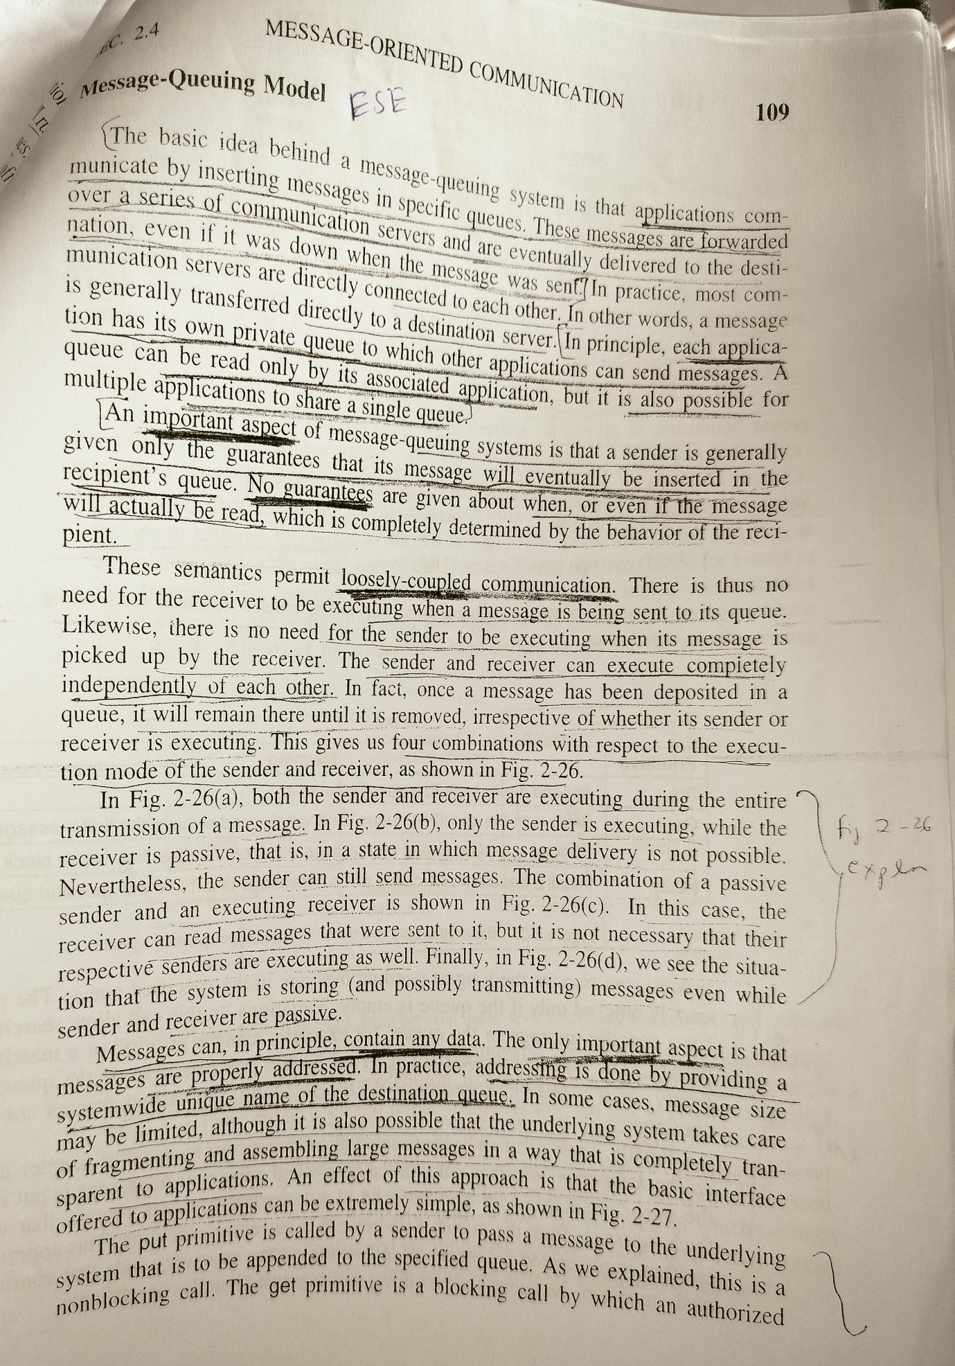

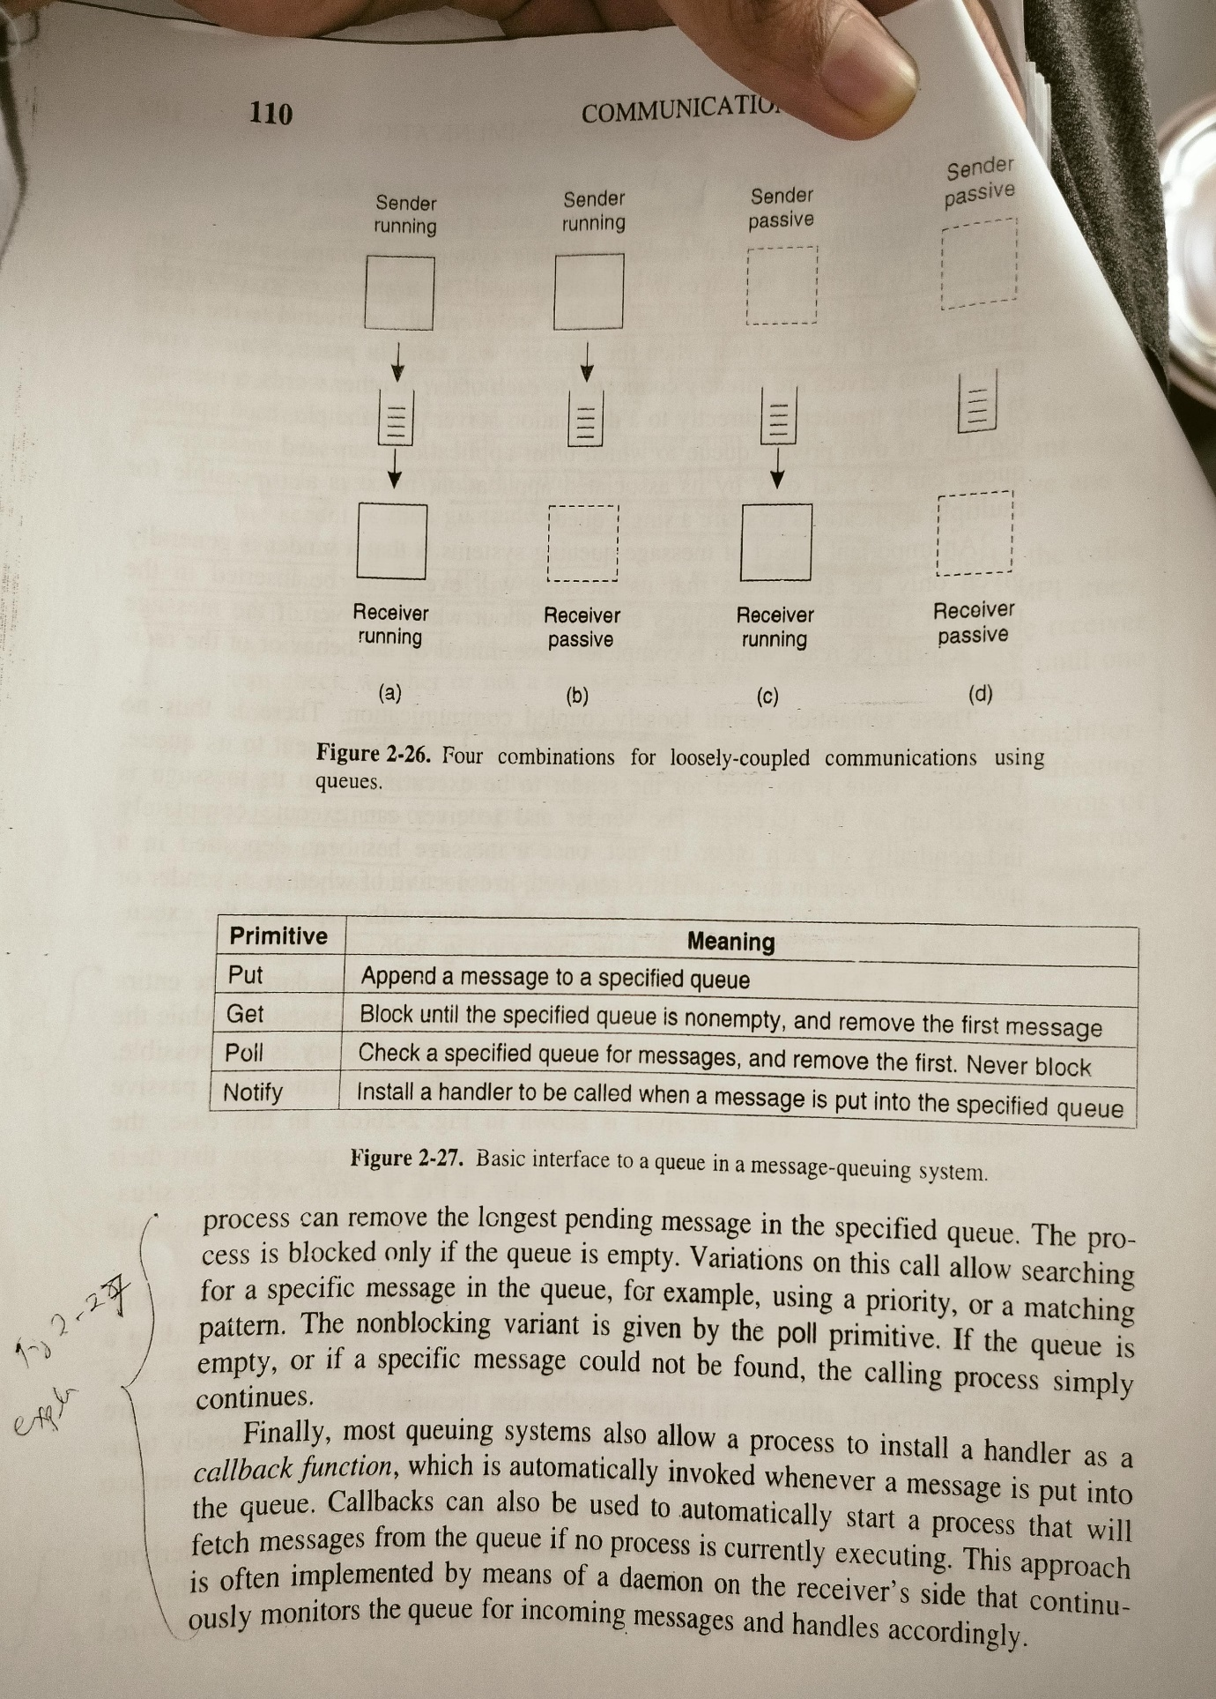

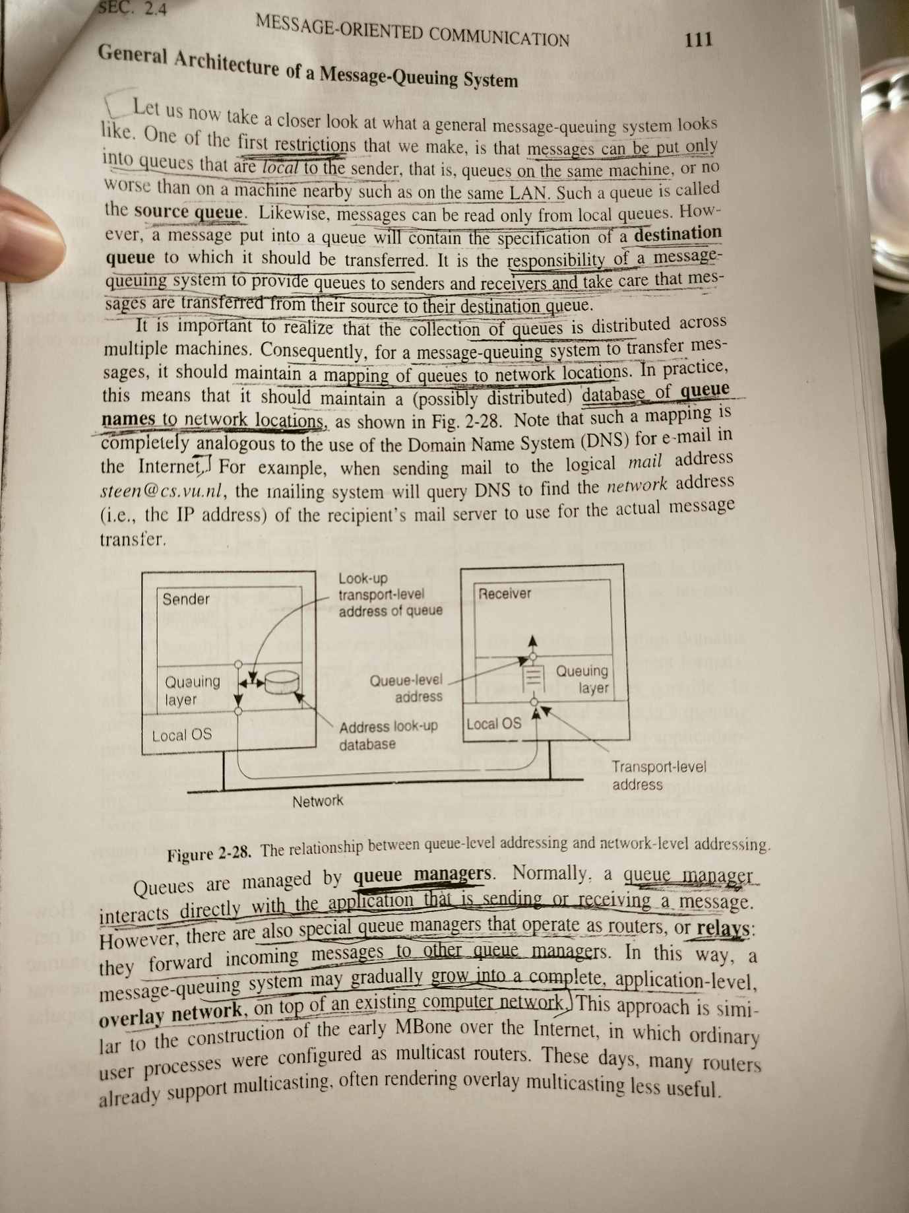

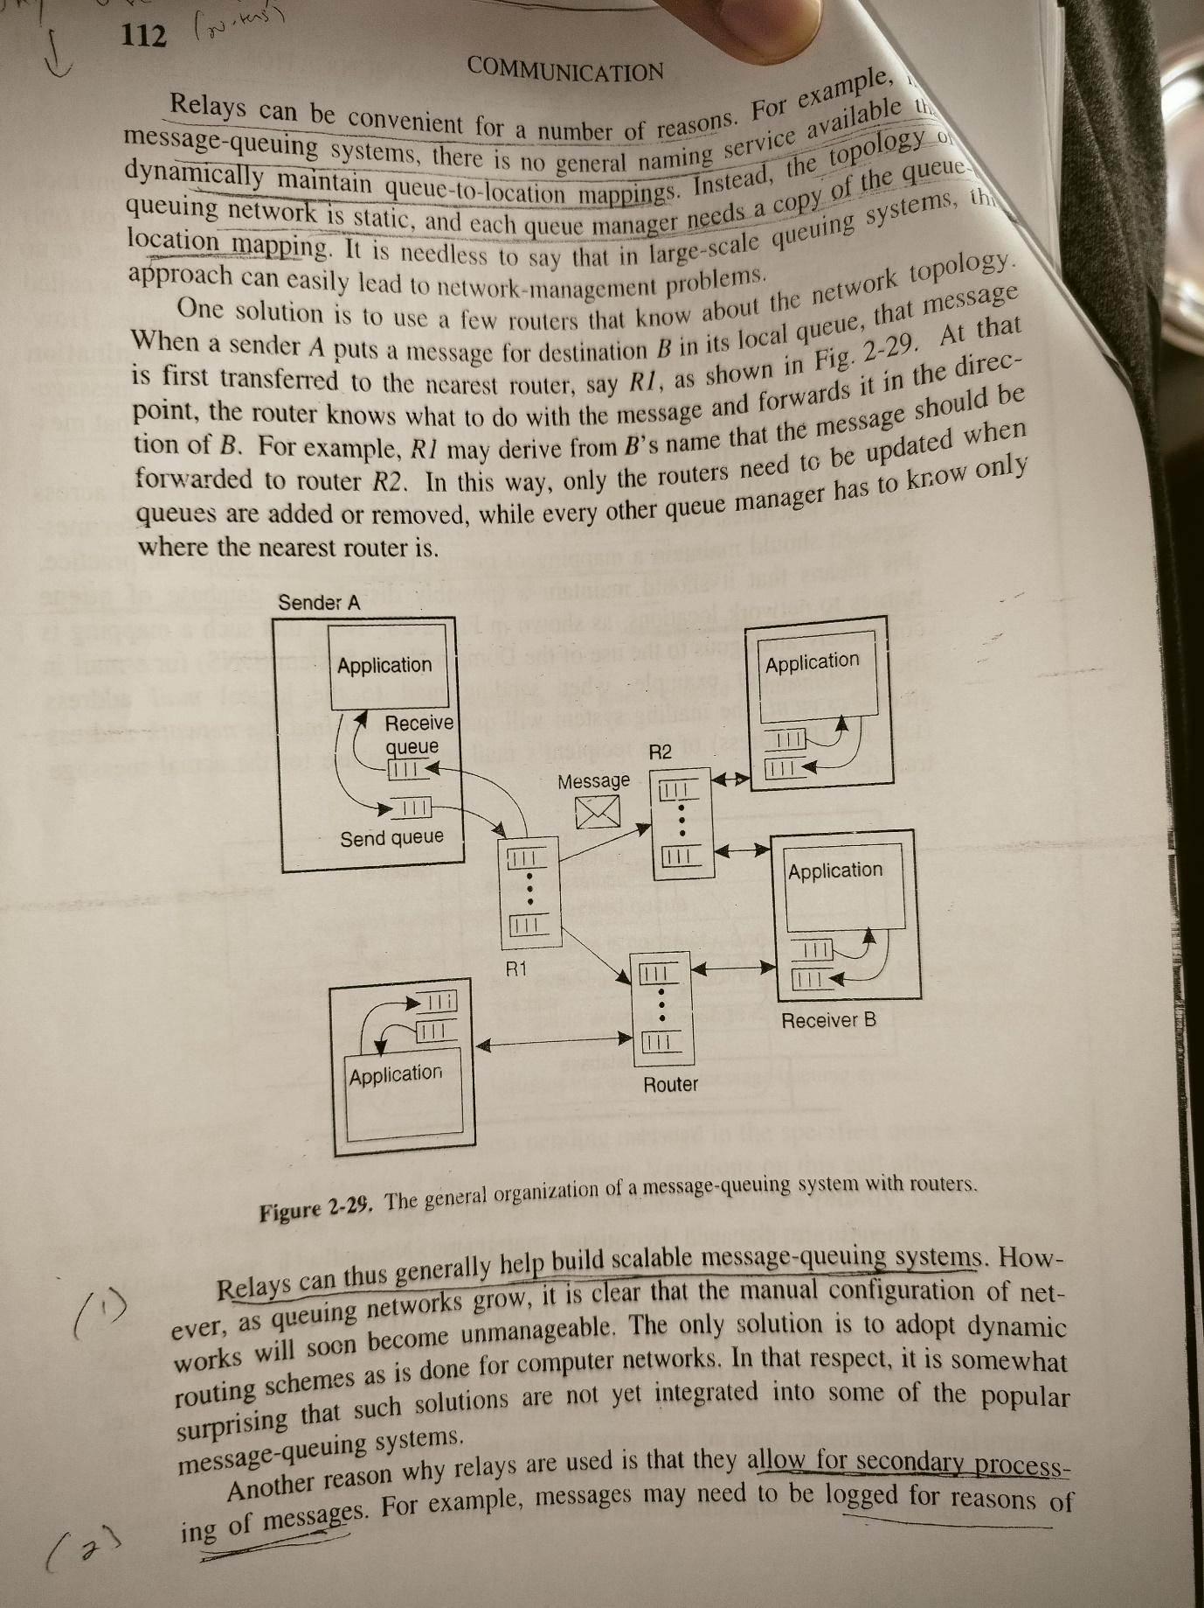

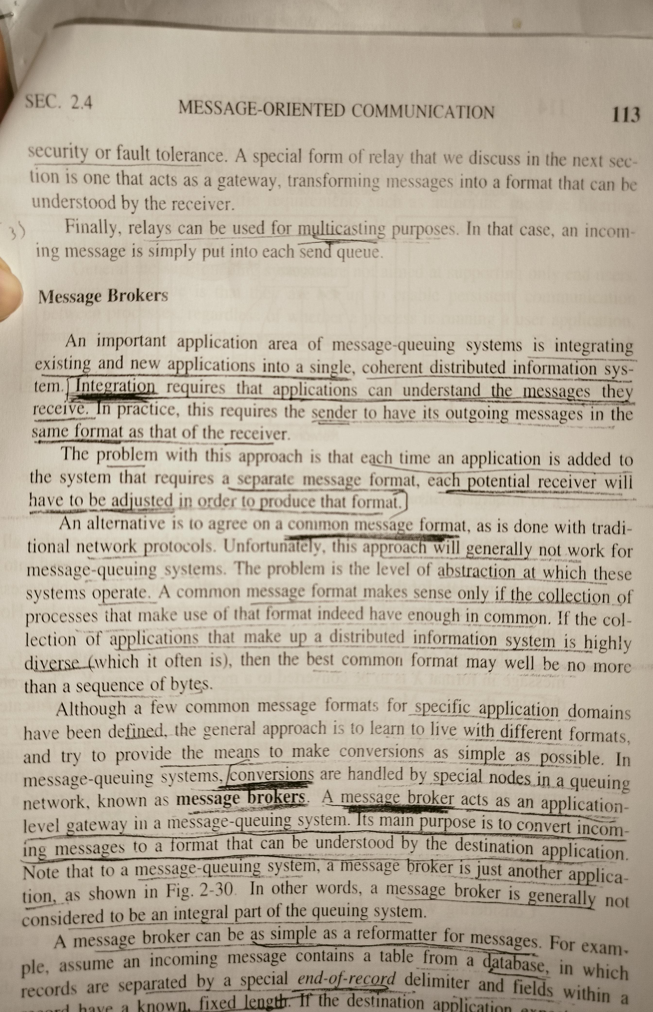

**How the code is executed on the CPU and GPU memory in**

**CUDA? How the allocating and deallocating of device memory**

**space via cudaMalloc and cudaFree takes place?**

In CUDA, the execution of code and the management of memory involve several steps:

1. [**Execution of Code**: The execution of any CUDA program involves three main steps](https://developer.nvidia.com/blog/cuda-refresher-cuda-programming-model/)[1](https://developer.nvidia.com/blog/cuda-refresher-cuda-programming-model/):
   * **Host-to-Device Transfer**: Copy the input data from host memory (CPU) to device memory (GPU).
   * **Execution**: Load the GPU program and execute it, caching data on-chip for performance.
   * **Device-to-Host Transfer**: Copy the results from device memory back to host memory.
2. **Memory Allocation and Deallocation**:
   * [**cudaMalloc**: This function is used to allocate an object in the device’s global memory2](https://engineering.purdue.edu/~smidkiff/ece563/NVidiaGPUTeachingToolkit/Mod2/Lecture-2-2-cuda-data-allocation-API.pdf). [It takes two parameters: the address of a pointer to the allocated object and the size of the allocated object in terms of bytes2](https://engineering.purdue.edu/~smidkiff/ece563/NVidiaGPUTeachingToolkit/Mod2/Lecture-2-2-cuda-data-allocation-API.pdf).
   * [**cudaFree**: This function is used to free an object from the device’s global memory2](https://engineering.purdue.edu/~smidkiff/ece563/NVidiaGPUTeachingToolkit/Mod2/Lecture-2-2-cuda-data-allocation-API.pdf).

Here is a simple example of how you might use these functions in a CUDA program:

const size_t SIZE = 900; // width and height of an image

float *abc; // Declare a pointer to a float

// Allocate memory on the GPU

cudaMalloc((void **)&abc, SIZE * SIZE * sizeof(float));

// ... Perform operations on abc ...

// Free the allocated memory

cudaFree(abc);

In this example, cudaMalloc is used to allocate a block of memory on the GPU that can hold SIZE * SIZE floats. [The cudaFree function is then used to deallocate that memory once it is no longer needed](https://developer.nvidia.com/blog/cuda-refresher-cuda-programming-model/)[3](https://stackoverflow.com/questions/7648549/allocate-memory-with-cudamalloc).

Please note that CUDA does not natively support the allocation of 2-dimensional arrays. [If you need a 2-dimensional array, you will need to either manually compute the index into a 1-dimensional array or allocate an array of pointers, each of which points to a 1-dimensional array3](https://stackoverflow.com/questions/7648549/allocate-memory-with-cudamalloc).

Remember that efficient memory management is crucial for achieving good performance in CUDA applications. Always be sure to free any memory that you allocate once you’re done using it to prevent memory leaks. Also, try to minimize data transfers between the host and the device, as these can be expensive operations.

**The process migration facility of distributed system does not**

**allow free migration of processes from one node to another but has restrictions regarding which node's processes can be**

**migrated to which other nodes of the system. What might be the**

**reasons behind imposing such a restriction? What are the action**

**to be taken with respect to the references to the local resources**

**when migrating the code to another machine?**

Process migration in a distributed system is a complex task and there could be several reasons for imposing restrictions on which node’s processes can be migrated to which other nodes:

1. [**Dynamic Load Balancing**: It allows processes to take advantage of less loaded nodes by migrating from overloaded ones1](https://www.geeksforgeeks.org/process-migration-in-distributed-system/)[2](http://helios.mm.di.uoa.gr/~costas/papers/Research_Paper.pdf).
2. [**Availability**: Processes that reside on a failure node can be migrated to other healthy nodes](https://www.geeksforgeeks.org/process-migration-in-distributed-system/)[1](https://www.geeksforgeeks.org/process-migration-in-distributed-system/)[2](http://helios.mm.di.uoa.gr/~costas/papers/Research_Paper.pdf).
3. [**System Administration**: Processes that reside on a node that is to be undergone system maintenance can be migrated to other nodes1](https://www.geeksforgeeks.org/process-migration-in-distributed-system/)[2](http://helios.mm.di.uoa.gr/~costas/papers/Research_Paper.pdf).
4. [**Data Locality**: Processes can take advantage of locality of data or other special capabilities of a particular node1](https://www.geeksforgeeks.org/process-migration-in-distributed-system/)[2](http://helios.mm.di.uoa.gr/~costas/papers/Research_Paper.pdf).
5. [**Mobility**: Processes can be migrated from a handheld device or laptop computer to a more powerful server computer before the device gets disconnected from the network2](http://helios.mm.di.uoa.gr/~costas/papers/Research_Paper.pdf).
6. [**Fault Recovery**: The mechanism to halt, transport and resume a process is technically useful to support fault recovery in mission-critical or transaction-based applications2](http://helios.mm.di.uoa.gr/~costas/papers/Research_Paper.pdf).
7. [**Node Capabilities**: Not all nodes might have the same capabilities or resources, and processes might be restricted based on the requirements of the process](https://www.geeksforgeeks.org/process-migration-in-distributed-system/)[3](http://www.gpcet.ac.in/wp-content/uploads/2018/08/Distributed-Systems-Lecturer-Notes-Latest-250-282.pdf).
8. **Refusal of Destination System**: Sometimes the destination system may refuse to accept the migration of a process to itself. If a workstation is idle, a process may have been migrated to it. [Once the workstation is active, it may be necessary to evict (recover) the migrated processes to provide adequate response time3](http://www.gpcet.ac.in/wp-content/uploads/2018/08/Distributed-Systems-Lecturer-Notes-Latest-250-282.pdf).

[These restrictions help ensure that the distributed system operates efficiently and effectively, balancing the load across nodes, preserving data locality, and maintaining system stability1](https://www.geeksforgeeks.org/process-migration-in-distributed-system/)[2](http://helios.mm.di.uoa.gr/~costas/papers/Research_Paper.pdf)[3](http://www.gpcet.ac.in/wp-content/uploads/2018/08/Distributed-Systems-Lecturer-Notes-Latest-250-282.pdf).

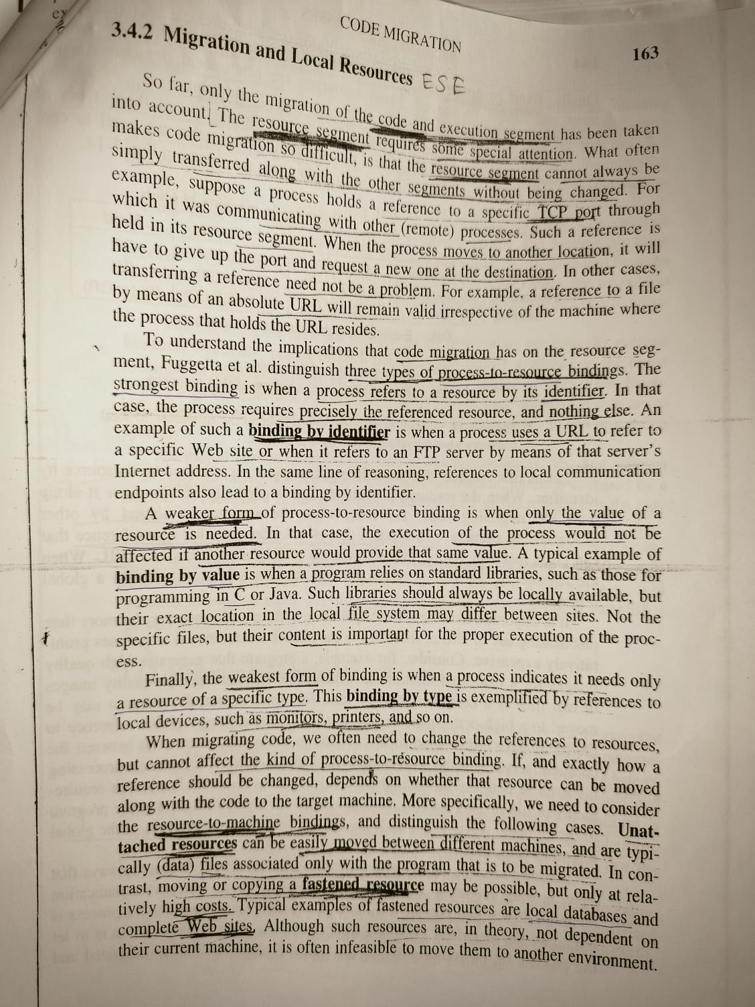

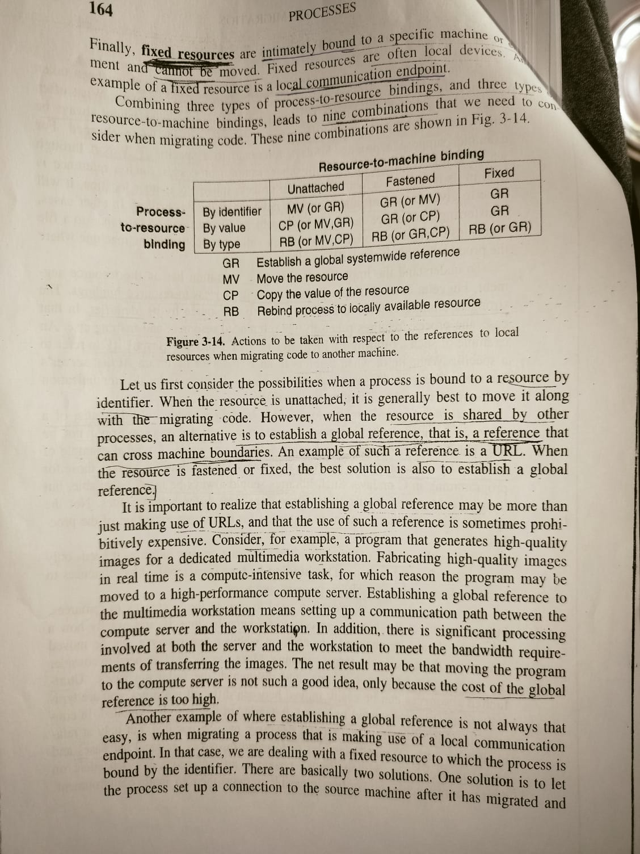

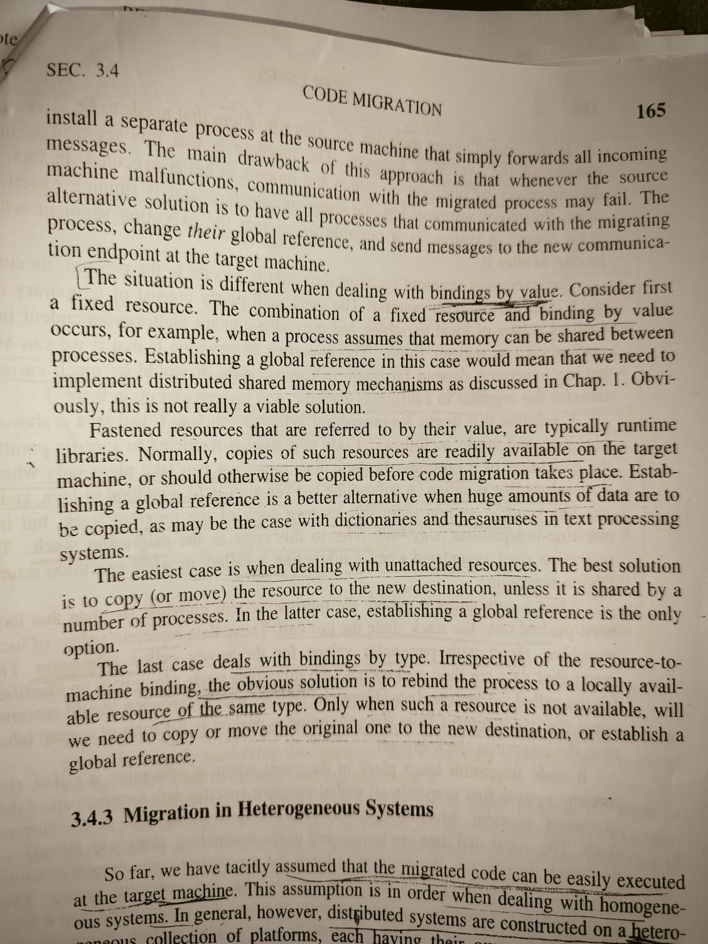

**A programmer is writing an application for release consistent**

**system. However an application needs sequential consistency to**

**produce correct results. What precautions must the programmer**

**take?**

[When writing an application for a release consistent system that needs sequential consistency, the programmer must take the following precautions1](https://en.wikipedia.org/wiki/Release_consistency):

1. [**Proper Synchronization**: The programmer must ensure that the program is properly synchronized1](https://en.wikipedia.org/wiki/Release_consistency). [This means that synchronization primitives like locks, semaphores, or monitors are used correctly to control the order of access to shared resources1](https://en.wikipedia.org/wiki/Release_consistency).
2. [**Acquire and Release Operations**: In a release consistent model, the actions of entering and leaving a critical section are classified as acquire and release1](https://en.wikipedia.org/wiki/Release_consistency). [The programmer must explicitly code these operations into the program](https://en.wikipedia.org/wiki/Release_consistency)[1](https://en.wikipedia.org/wiki/Release_consistency).
3. [**Order of Operations**: The programmer must ensure that before an access to a shared variable is performed, all previous acquires by this processor must have completed1](https://en.wikipedia.org/wiki/Release_consistency). [Similarly, before a release is performed, all previous reads and writes by this process must have completed1](https://en.wikipedia.org/wiki/Release_consistency).
4. [**Processor Consistency**: The acquire and release accesses must be processor consistent1](https://en.wikipedia.org/wiki/Release_consistency). [This means that the memory accesses performed by each processor appear in a single, sequentially consistent order2](https://www.geeksforgeeks.org/sequential-consistency-in-distributive-systems/).

[If these conditions are met and the program is properly synchronized (i.e., processors implement acquire and release properly), the results of any execution will be exactly the same as they would have been executed following sequential consistency1](https://en.wikipedia.org/wiki/Release_consistency). [In effect, accesses to shared variables are separated into atomic operation blocks by the acquire and release primitives so that races and interleaving between blocks will be prevented](https://en.wikipedia.org/wiki/Release_consistency)[1](https://en.wikipedia.org/wiki/Release_consistency).

**How would you incorporate persistence asynchronous**

**communication into model of communication based on RMI to remote objects?**

[Incorporating persistent asynchronous communication into a model of communication based on Remote Method Invocation (RMI) involves a few steps](https://lass.cs.umass.edu/~shenoy/courses/spring02/lectures/Lec05.pdf)[1](https://lass.cs.umass.edu/~shenoy/courses/spring02/lectures/Lec05.pdf)[2](https://lass.cs.umass.edu/~shenoy/courses/spring13/lectures/Lec10.pdf):

1. [**Persistent Communication**: In persistent communication, messages are stored until the receiver is ready1](https://lass.cs.umass.edu/~shenoy/courses/spring02/lectures/Lec05.pdf). [This can be achieved by implementing a message queue or buffer at the sender’s end](https://lass.cs.umass.edu/~shenoy/courses/spring02/lectures/Lec05.pdf)[1](https://lass.cs.umass.edu/~shenoy/courses/spring02/lectures/Lec05.pdf). [When a message is sent, it is stored in this buffer until the receiver is ready to process it](https://lass.cs.umass.edu/~shenoy/courses/spring02/lectures/Lec05.pdf)[1](https://lass.cs.umass.edu/~shenoy/courses/spring02/lectures/Lec05.pdf).
2. [**Asynchronous Communication**: In asynchronous communication, the sender continues immediately after it has submitted the message1](https://lass.cs.umass.edu/~shenoy/courses/spring02/lectures/Lec05.pdf). [This can be achieved by implementing non-blocking methods or using separate threads for sending and receiving messages](https://lass.cs.umass.edu/~shenoy/courses/spring02/lectures/Lec05.pdf)[1](https://lass.cs.umass.edu/~shenoy/courses/spring02/lectures/Lec05.pdf).

[In Java RMI, you could achieve this by creating a separate thread for each remote method invocation3](https://stackoverflow.com/questions/15942654/java-asynchronous-rmi). [The thread would handle the communication with the remote object, allowing the main application thread to continue executing without waiting for the remote method to complete](https://lass.cs.umass.edu/~shenoy/courses/spring02/lectures/Lec05.pdf)[3](https://stackoverflow.com/questions/15942654/java-asynchronous-rmi). [To ensure persistence, you could use a local buffer or a database to store the messages until they are processed](https://lass.cs.umass.edu/~shenoy/courses/spring02/lectures/Lec05.pdf)[1](https://lass.cs.umass.edu/~shenoy/courses/spring02/lectures/Lec05.pdf).

[However, it’s important to note that incorporating persistent asynchronous communication into RMI may require significant changes to the application’s architecture and could introduce additional complexities1](https://lass.cs.umass.edu/~shenoy/courses/spring02/lectures/Lec05.pdf)[2](https://lass.cs.umass.edu/~shenoy/courses/spring13/lectures/Lec10.pdf). [It’s also worth noting that while this approach can improve the responsiveness of the application, it may also increase the risk of data inconsistencies if not properly managed1](https://lass.cs.umass.edu/~shenoy/courses/spring02/lectures/Lec05.pdf)[2](https://lass.cs.umass.edu/~shenoy/courses/spring13/lectures/Lec10.pdf).

**ESE IT JAN 22**

**What is weak consistency model? Write down its three properties.**

**Using time diagram show the valid and invalid sequence of event.**

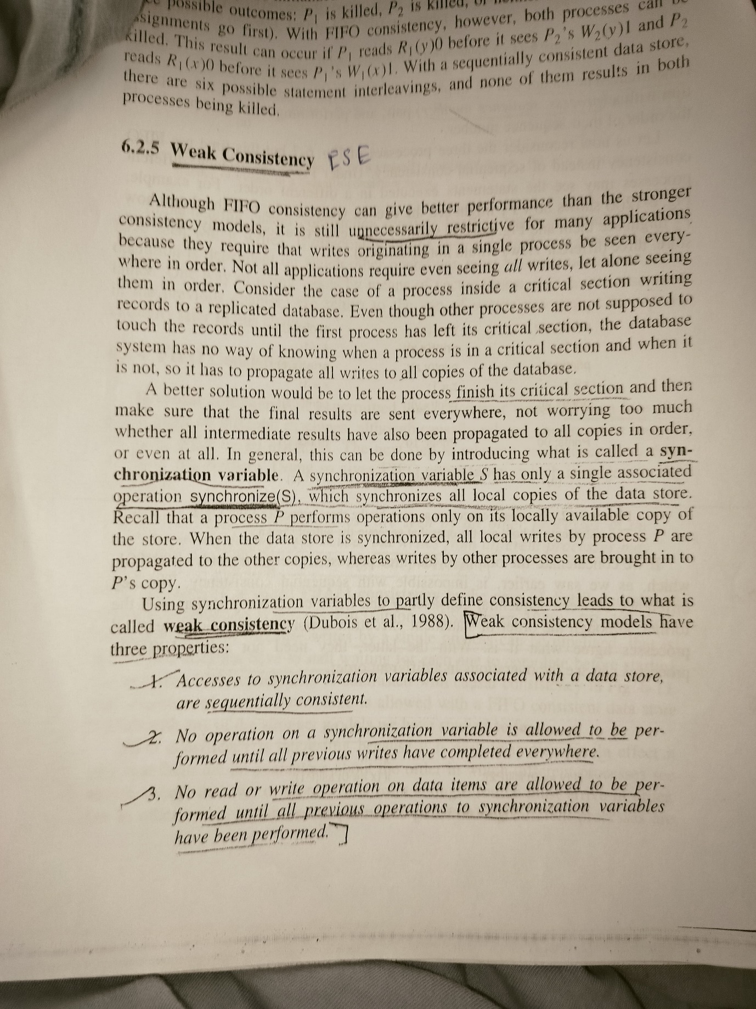

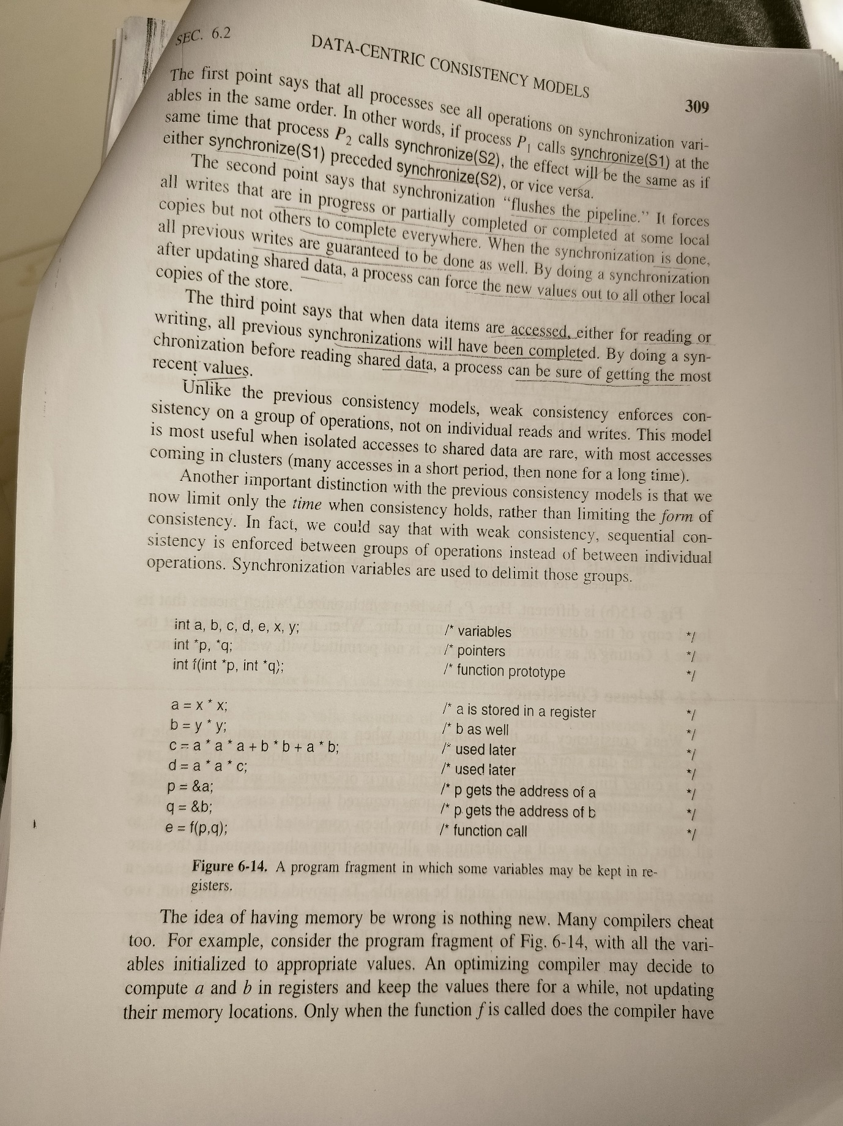

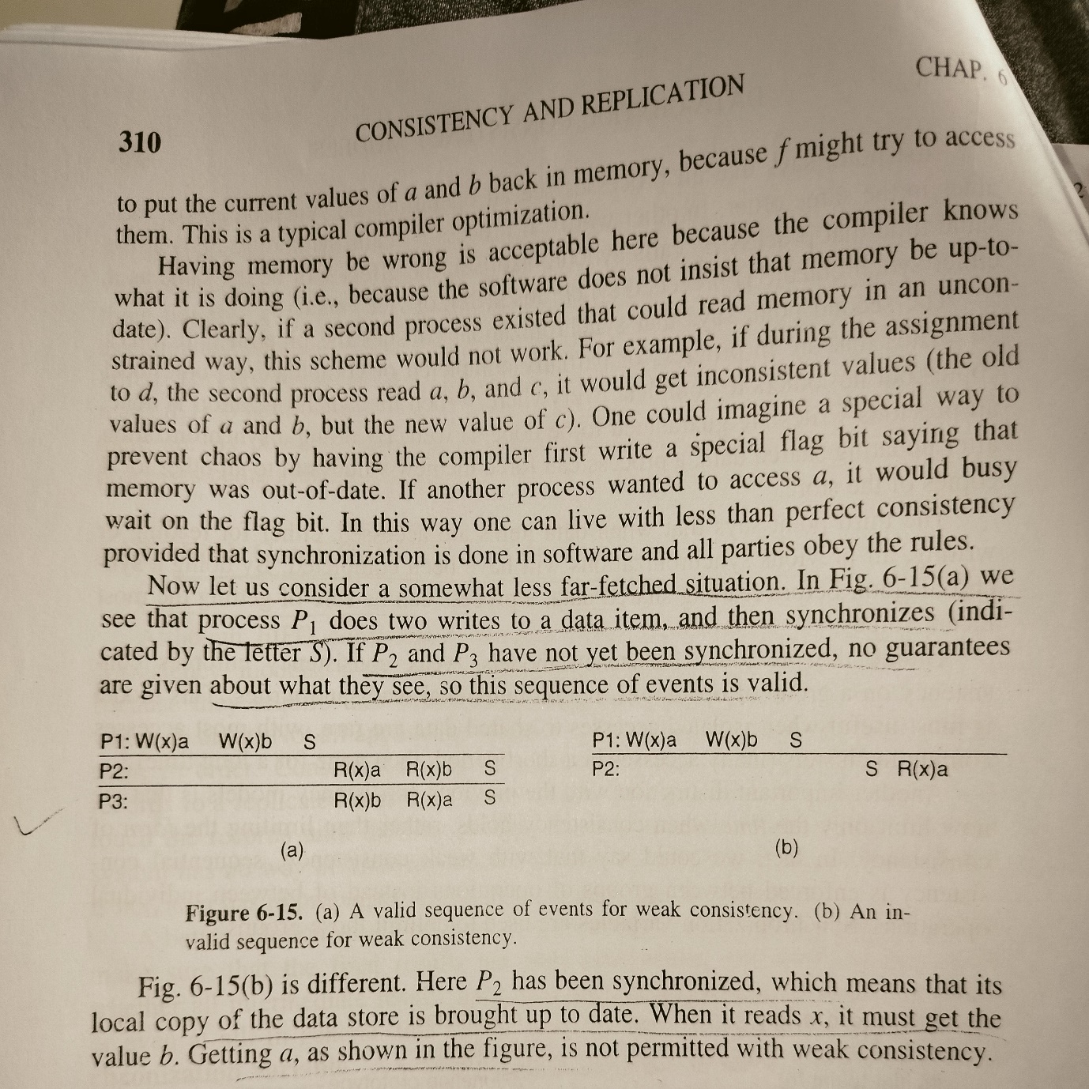

**If we can think of replicating a remote object across**

**several machine, we need to solve the problem of how to protect**

**the object against simultaneous access by multiple clients. What are**

**the two solution to this problem**

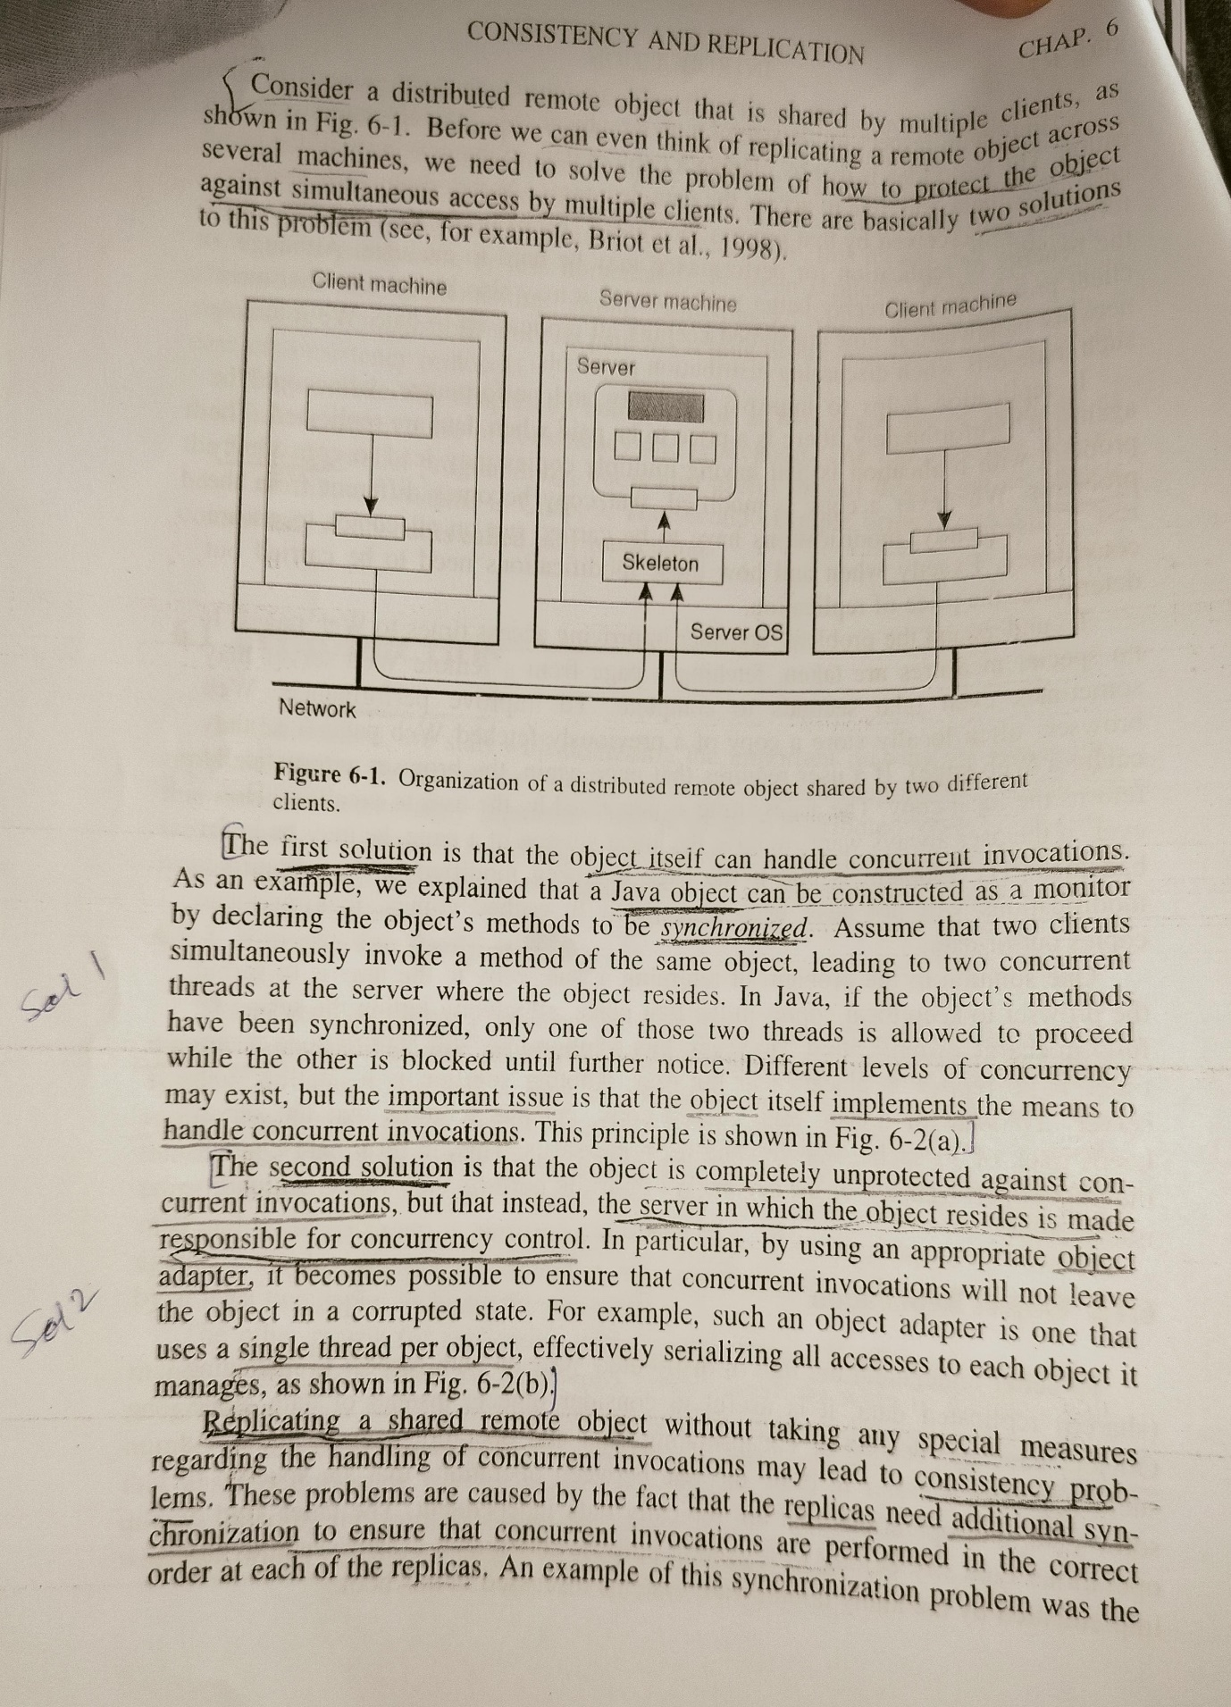

**What are the reason for replication? What are the two issues in**

**replication?**

[Replication in distributed systems is primarily used for the following reasons](https://www.geeksforgeeks.org/what-is-replication-in-distributed-system/)[1](https://www.geeksforgeeks.org/what-is-replication-in-distributed-system/)[2](https://hevodata.com/learn/data-replication-in-distributed-system/)[3](https://ioenotes.edu.np/media/2021/01/Ch-7-Part-2-Distributed-System.pdf)[4](https://pdfs.semanticscholar.org/60b4/10241ac4e68b2ea9afae7abe8f658b2d06ef.pdf)[5](https://senyosimpson.com/posts/data-replication/):

1. [**Fault Tolerance**: If a node stops working, the distributed network will still work fine due to its replicas](https://www.geeksforgeeks.org/what-is-replication-in-distributed-system/)[1](https://www.geeksforgeeks.org/what-is-replication-in-distributed-system/).
2. [**Load Sharing**: Loads on a server are shared among different replicas](https://www.geeksforgeeks.org/what-is-replication-in-distributed-system/)[1](https://www.geeksforgeeks.org/what-is-replication-in-distributed-system/).
3. **Data Availability**: It enhances the availability of the data. [If the replicas are created and data is stored near to the consumers, it would be easier and faster to fetch data1](https://www.geeksforgeeks.org/what-is-replication-in-distributed-system/).
4. [**Performance Improvement**: By having replicas, workloads can be distributed across them](https://www.geeksforgeeks.org/what-is-replication-in-distributed-system/)[5](https://senyosimpson.com/posts/data-replication/).

[However, replication also introduces two key issues](https://www.geeksforgeeks.org/what-is-replication-in-distributed-system/)[1](https://www.geeksforgeeks.org/what-is-replication-in-distributed-system/)[6](https://link.springer.com/article/10.1134/S0361768820050060)[7](https://ijcmas.com/8-5-2019/Tushar%20Kumar%20Pandey,%20et%20al.pdf)[8](https://core.ac.uk/download/pdf/31046749.pdf):

1. **Consistency Maintenance**: Keeping all replicas consistent is a major challenge. [Any change made to one replica needs to be reflected in all others](https://www.geeksforgeeks.org/what-is-replication-in-distributed-system/)[1](https://www.geeksforgeeks.org/what-is-replication-in-distributed-system/). [This can increase resource consumption and time complexity](https://www.geeksforgeeks.org/what-is-replication-in-distributed-system/)[1](https://www.geeksforgeeks.org/what-is-replication-in-distributed-system/).
2. [**Replica Placement**: Deciding where, when, and by whom replicas should be placed is a complex problem7](https://ijcmas.com/8-5-2019/Tushar%20Kumar%20Pandey,%20et%20al.pdf). [The goal of data replication solutions is to create a state close to optimal in these systems9](https://link.springer.com/article/10.1007/s11277-023-10240-7). [Therefore, there is a growing need for algorithms that determine the optimal replication configuration in the system according to the available resources9](https://link.springer.com/article/10.1007/s11277-023-10240-7).

**How Mutual Exclusion is handled in Distributed System? Compare the Centralized, Distributed and Token Ring Algorithms with respect to Message per entry/exit, Delay before entry (in message times), Problems**

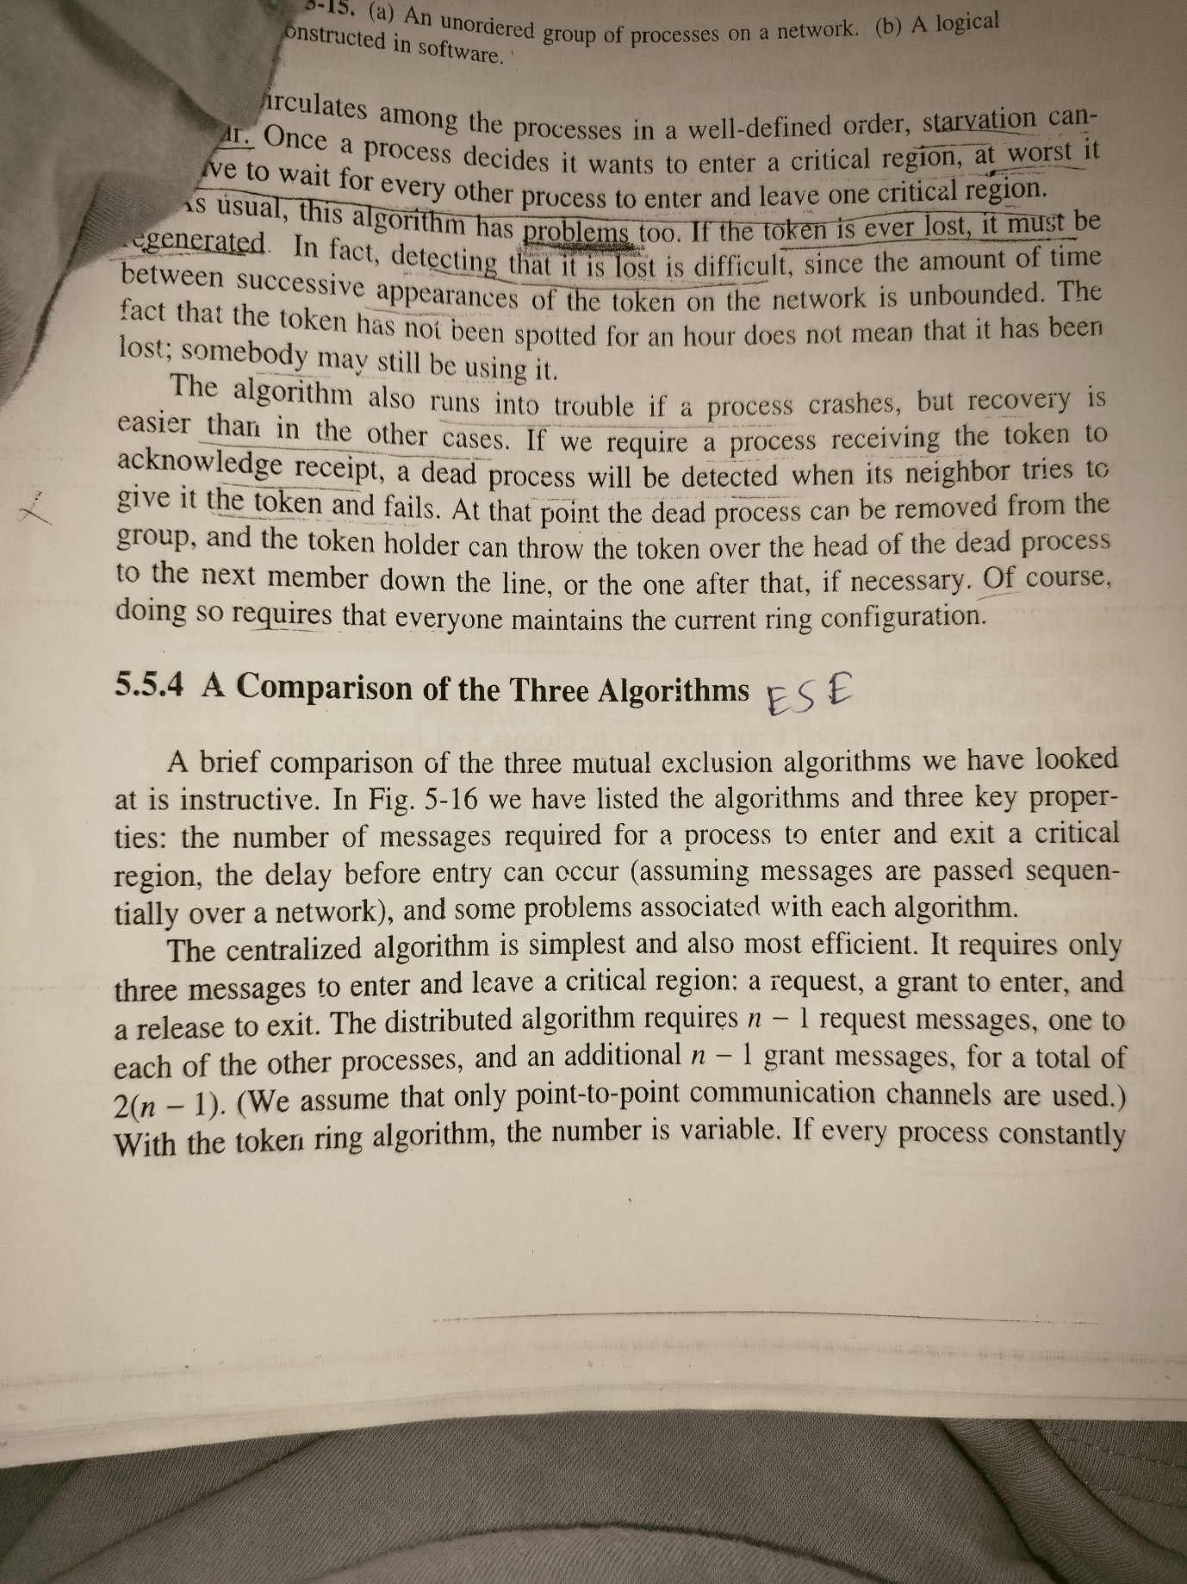

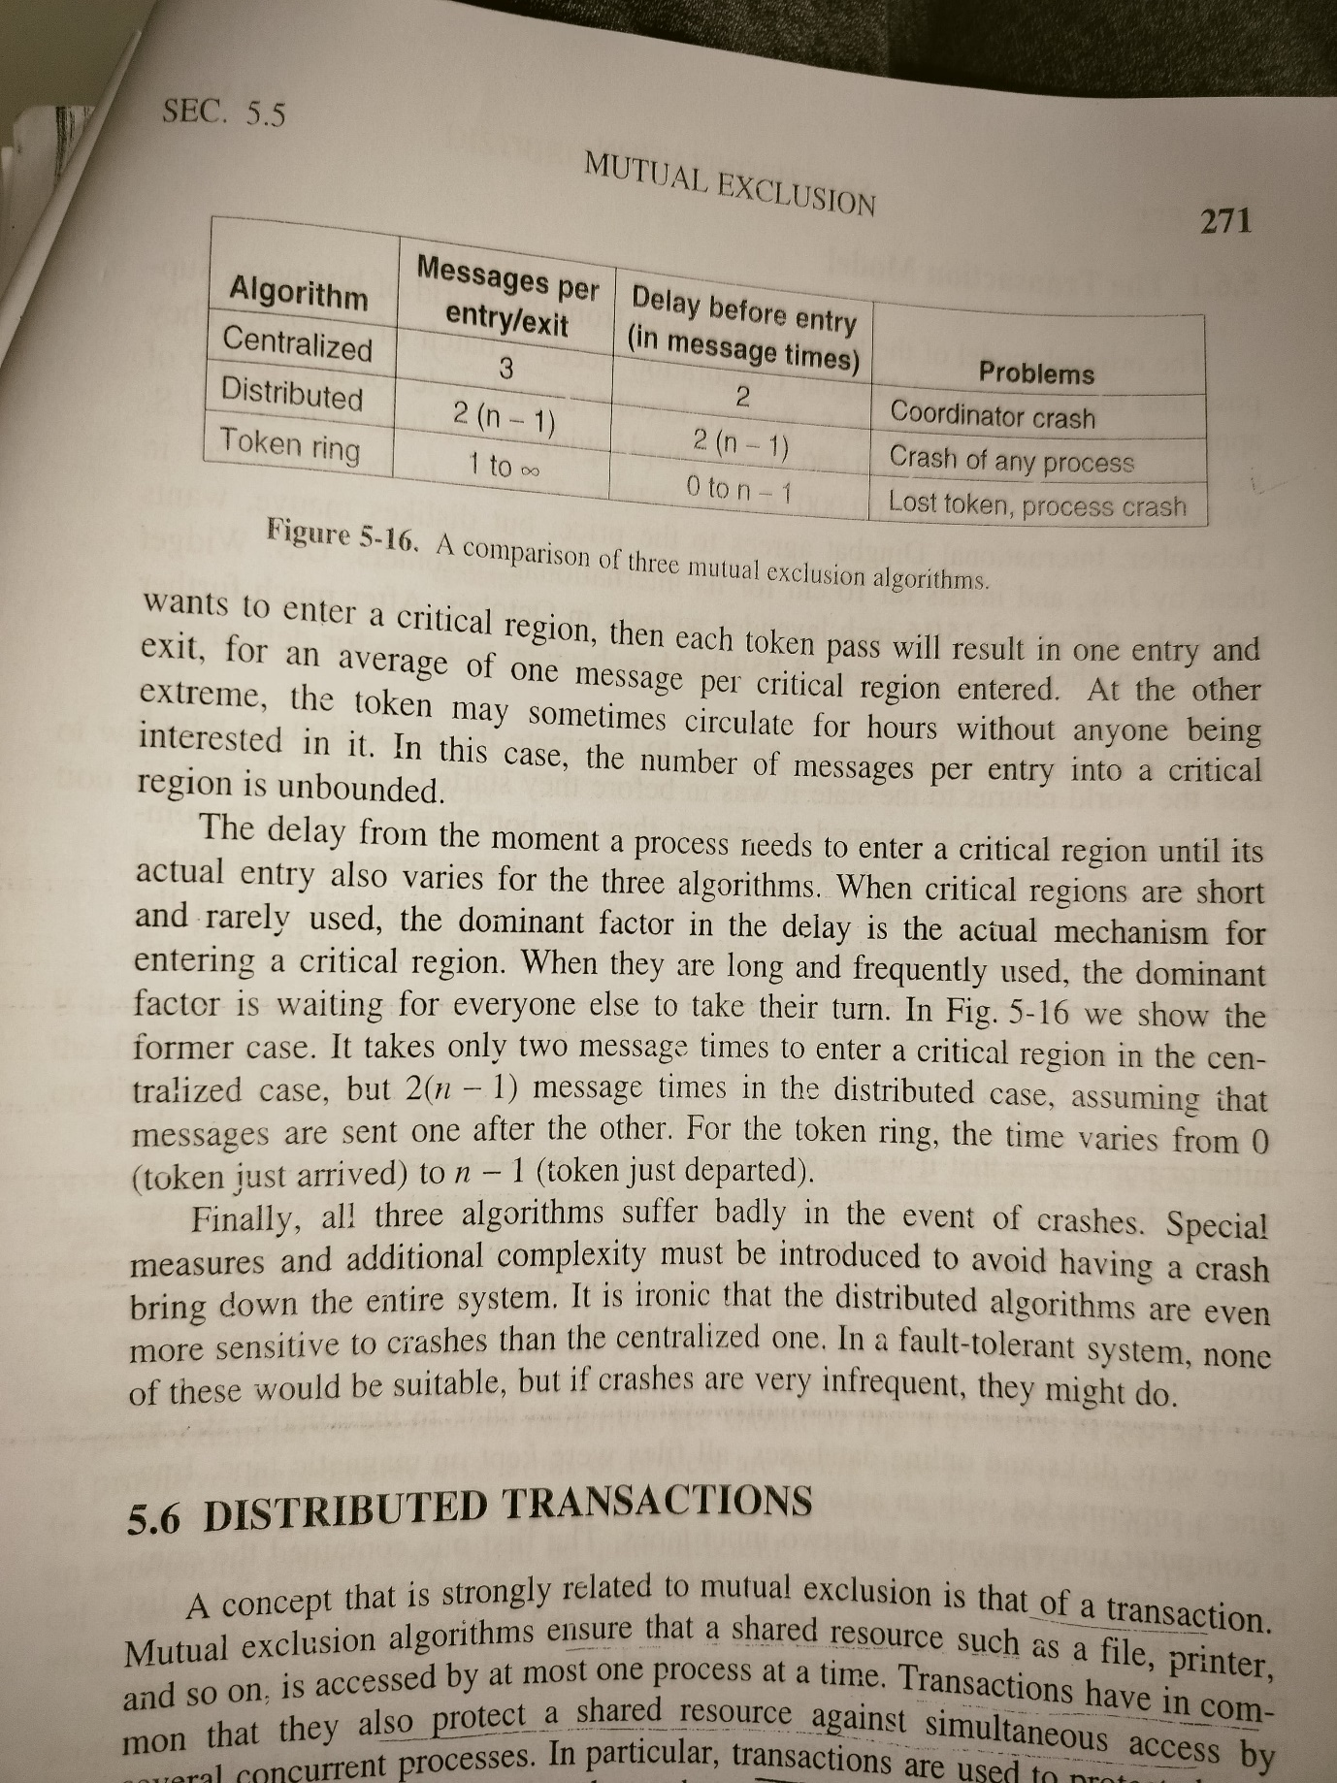

**Consider the behavior of two machines in a distributed system. Both**

**have clocks that are supposed to tick 1000 times per millisecond. One**

**of them actually does, but the other ticks only 990 times per**

**millisecond. If UTC updates come in once a minute, what is the**

**maximum clock skew that will occur?**

The clock skew can be calculated by comparing the difference in the clock rates of the two machines.

Given that one machine ticks 1000 times per millisecond (the correct rate), and the other ticks 990 times per millisecond, the difference in their rates is 10 ticks per millisecond.

Since there are 1000 milliseconds in a second and 60 seconds in a minute, the maximum clock skew that will occur before the next UTC update comes in is:

10 ticks/ms×1000 ms/s×60 s=600,000 ticks10ticks/ms×1000ms/s×60s=600,000ticks

So, the maximum clock skew that will occur is 600,000 ticks.

**Show the relation between clock time and UTC when clocks tick at**

**different rates.**

[In a distributed system, each machine has its own physical clock that ‘ticks’ based on physical processes1](https://www.cl.cam.ac.uk/teaching/1516/ConcDisSys/2016-DistributedSystems-1B-L4.pdf). [However, these clocks are imperfect and can gain or lose time over time, a process known as clock drift1](https://www.cl.cam.ac.uk/teaching/1516/ConcDisSys/2016-DistributedSystems-1B-L4.pdf). [This means that clocks can tick at different rates, creating an ever-widening gap in perceived time1](https://www.cl.cam.ac.uk/teaching/1516/ConcDisSys/2016-DistributedSystems-1B-L4.pdf).

[Coordinated Universal Time (UTC) is a time standard that is based on International Atomic Time (TAI) with leap seconds added at irregular intervals to compensate for Earth’s slowing rotation2](https://tf.nist.gov/general/pdf/1498.pdf)[3](https://www.nist.gov/pml/time-and-frequency-division/nist-time-frequently-asked-questions-faq). [UTC provides a stable reference time scale that can be used to synchronize the clocks in a distributed system2](https://tf.nist.gov/general/pdf/1498.pdf)[3](https://www.nist.gov/pml/time-and-frequency-division/nist-time-frequently-asked-questions-faq).

[When a machine’s clock ticks at a different rate than UTC, it can have positive or negative drift with respect to UTC1](https://www.cl.cam.ac.uk/teaching/1516/ConcDisSys/2016-DistributedSystems-1B-L4.pdf). [To deal with this drift, the machine needs to resynchronize periodically1](https://www.cl.cam.ac.uk/teaching/1516/ConcDisSys/2016-DistributedSystems-1B-L4.pdf). [This resynchronization can be achieved by making small adjustments to the clock’s tick rate1](https://www.cl.cam.ac.uk/teaching/1516/ConcDisSys/2016-DistributedSystems-1B-L4.pdf). [If the clock is fast, it is made to run slower until it matches UTC, and if it is slow, it is made to run faster until it matches UTC](https://www.cl.cam.ac.uk/teaching/1516/ConcDisSys/2016-DistributedSystems-1B-L4.pdf)[1](https://www.cl.cam.ac.uk/teaching/1516/ConcDisSys/2016-DistributedSystems-1B-L4.pdf).

[So, the relationship between a machine’s clock time and UTC when clocks tick at different rates is a dynamic one, with the machine’s clock time being continuously adjusted to minimize the skew with UTC1](https://www.cl.cam.ac.uk/teaching/1516/ConcDisSys/2016-DistributedSystems-1B-L4.pdf). [This process of clock synchronization aims to minimize the difference, or skew, between the machine’s clock and UTC1](https://www.cl.cam.ac.uk/teaching/1516/ConcDisSys/2016-DistributedSystems-1B-L4.pdf).

**What are reason for migrating code?**

**Describe the following**

**a) Code segment**

**b) Resource segment and**

**c) Execution segment**

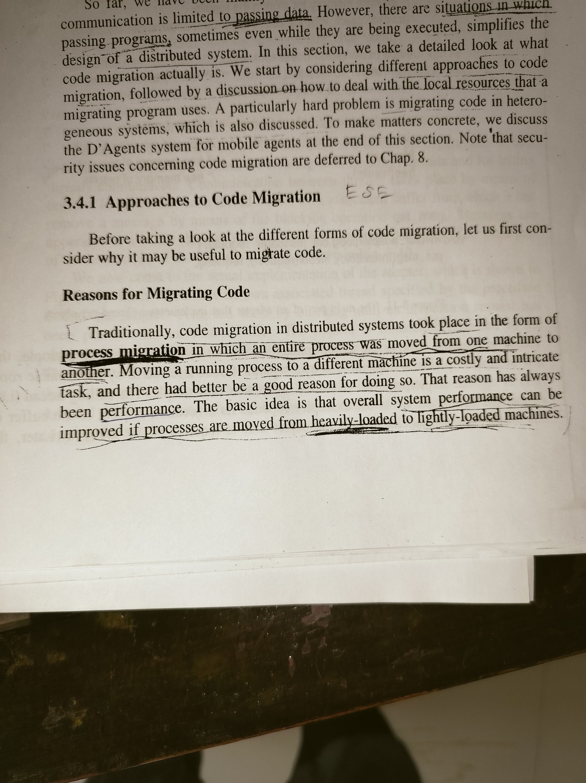

**Define**

**i Clock drift -** [Clock drift refers to several related phenomena where a clock does not run at exactly the same rate as a reference clock1](https://en.wikipedia.org/wiki/Clock_drift). [That is, after some time the clock “drifts apart” or gradually desynchronizes from the other clock1](https://en.wikipedia.org/wiki/Clock_drift). [All clocks are subject to drift, causing eventual divergence unless resynchronized1](https://en.wikipedia.org/wiki/Clock_drift).

**ii. Clock skew – When a system has n computers and all n crystals will run at slightly different rates, causing the (software) clocks gradually to get out of synchronization and give different values when read out. This difference in time values in called clock skew.**

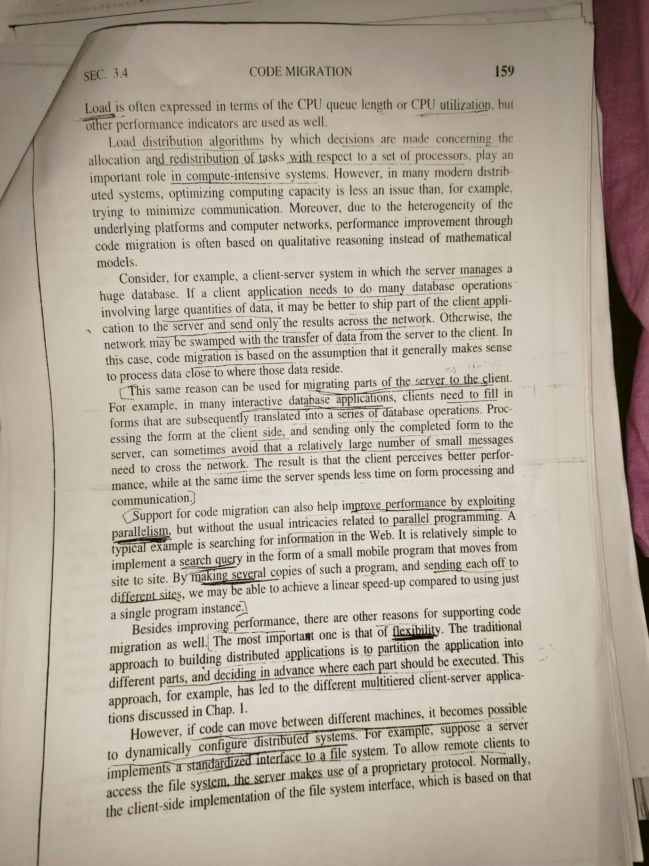

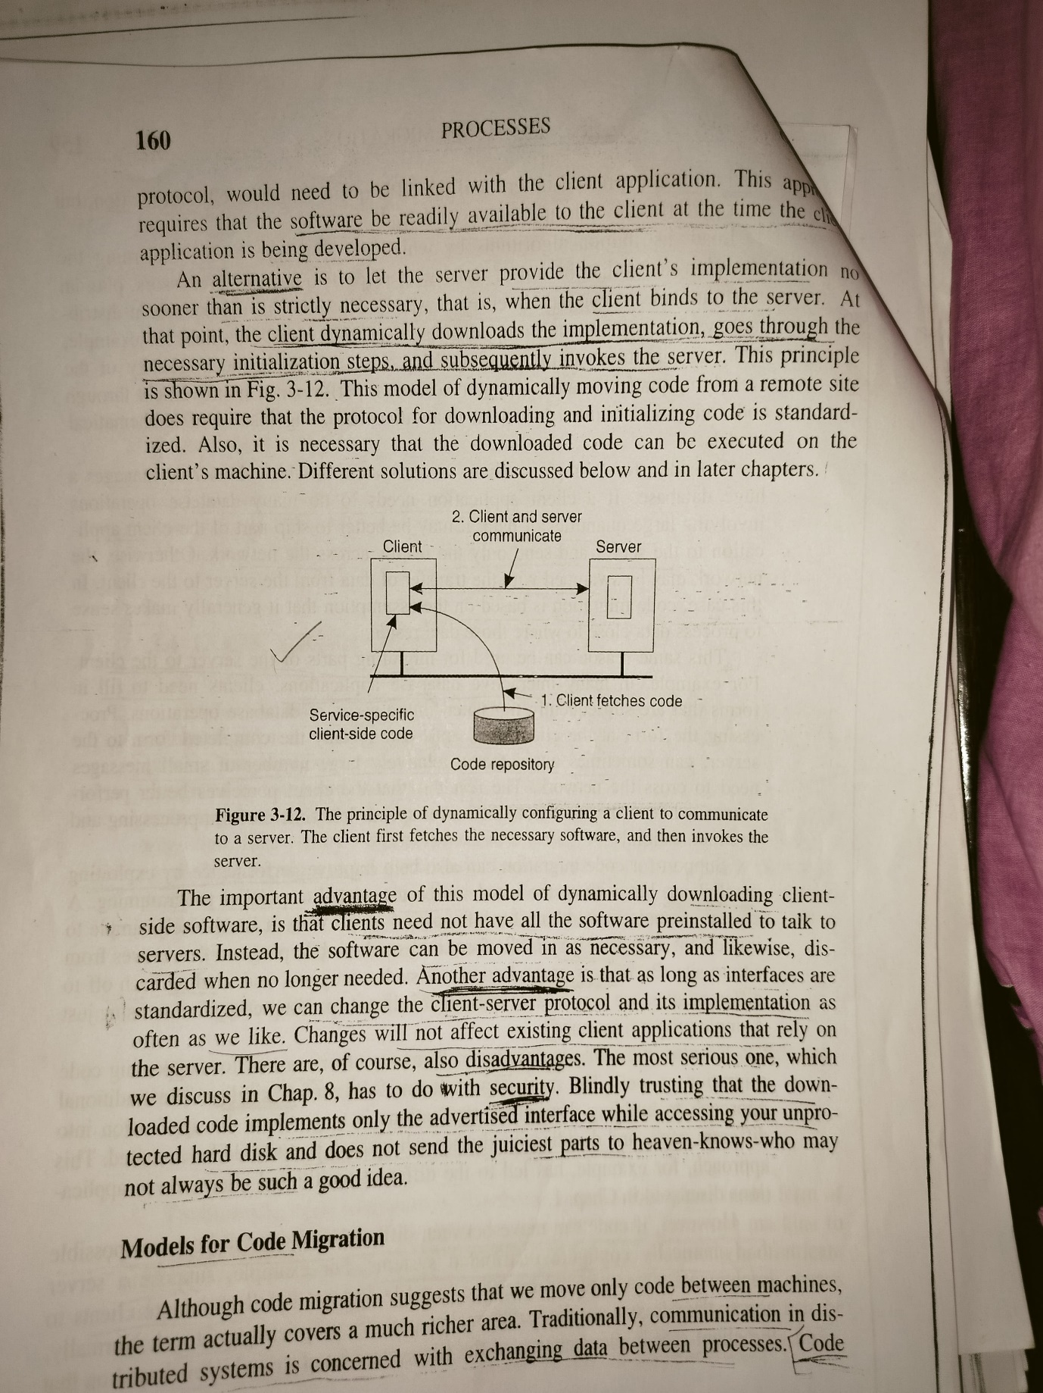

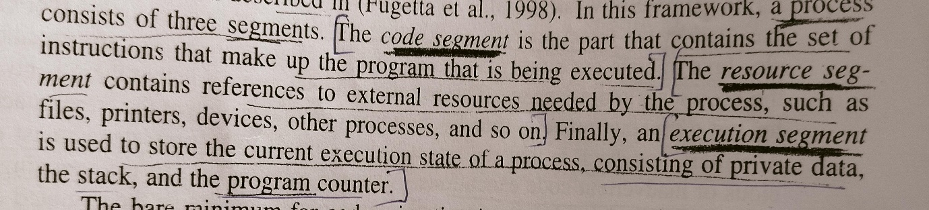

**What is group communication? Give any two key application area of group communication in distributed systems**

**What is distributed object? Draw the organization of distributed**

**object and explain its components.**

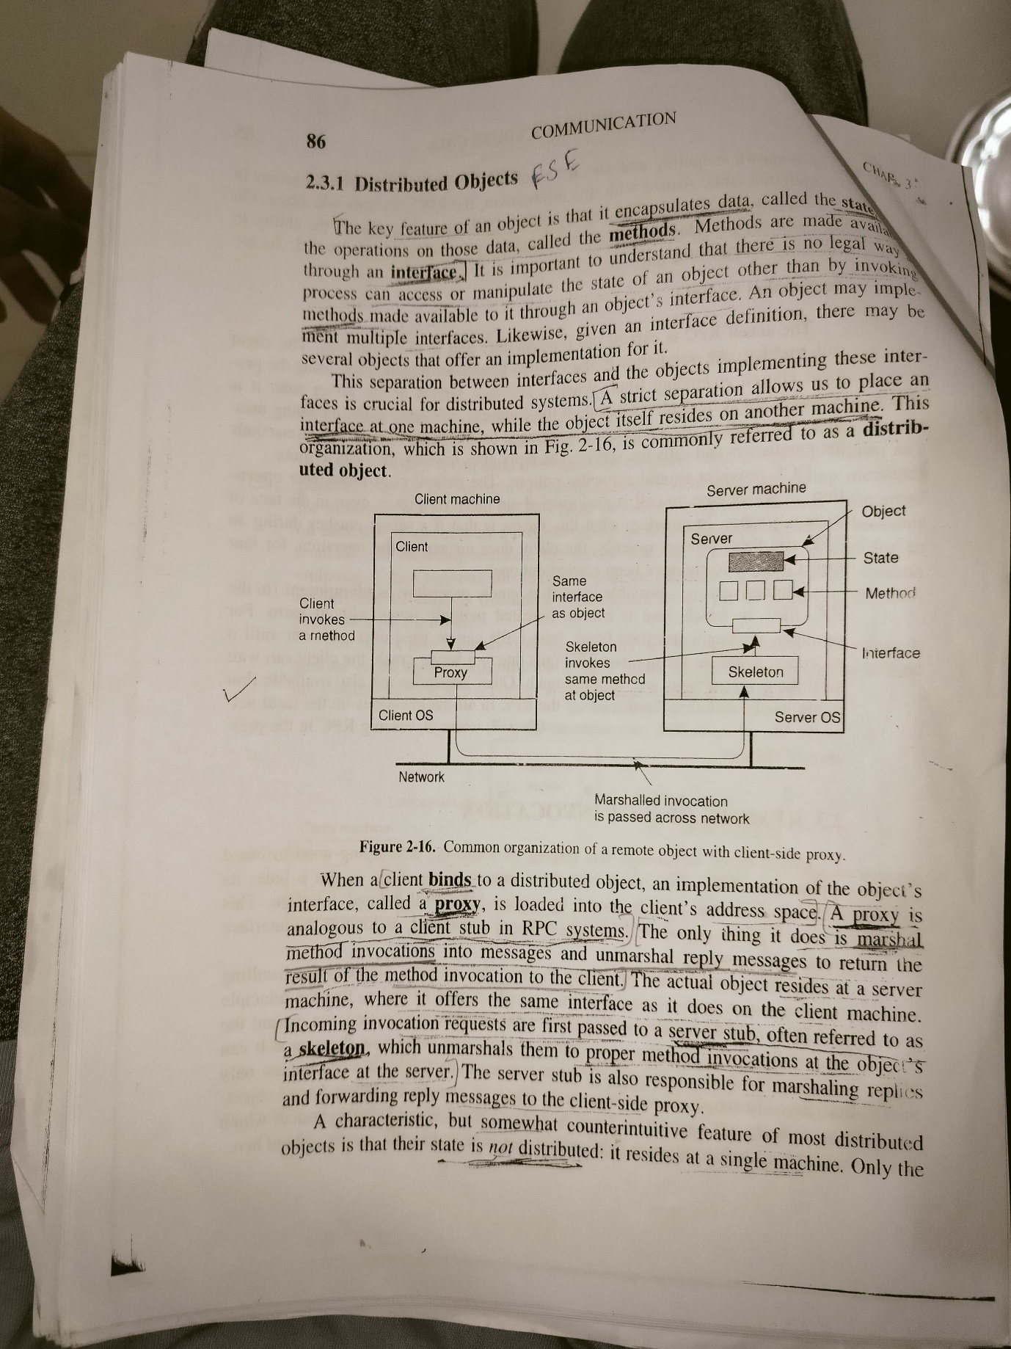

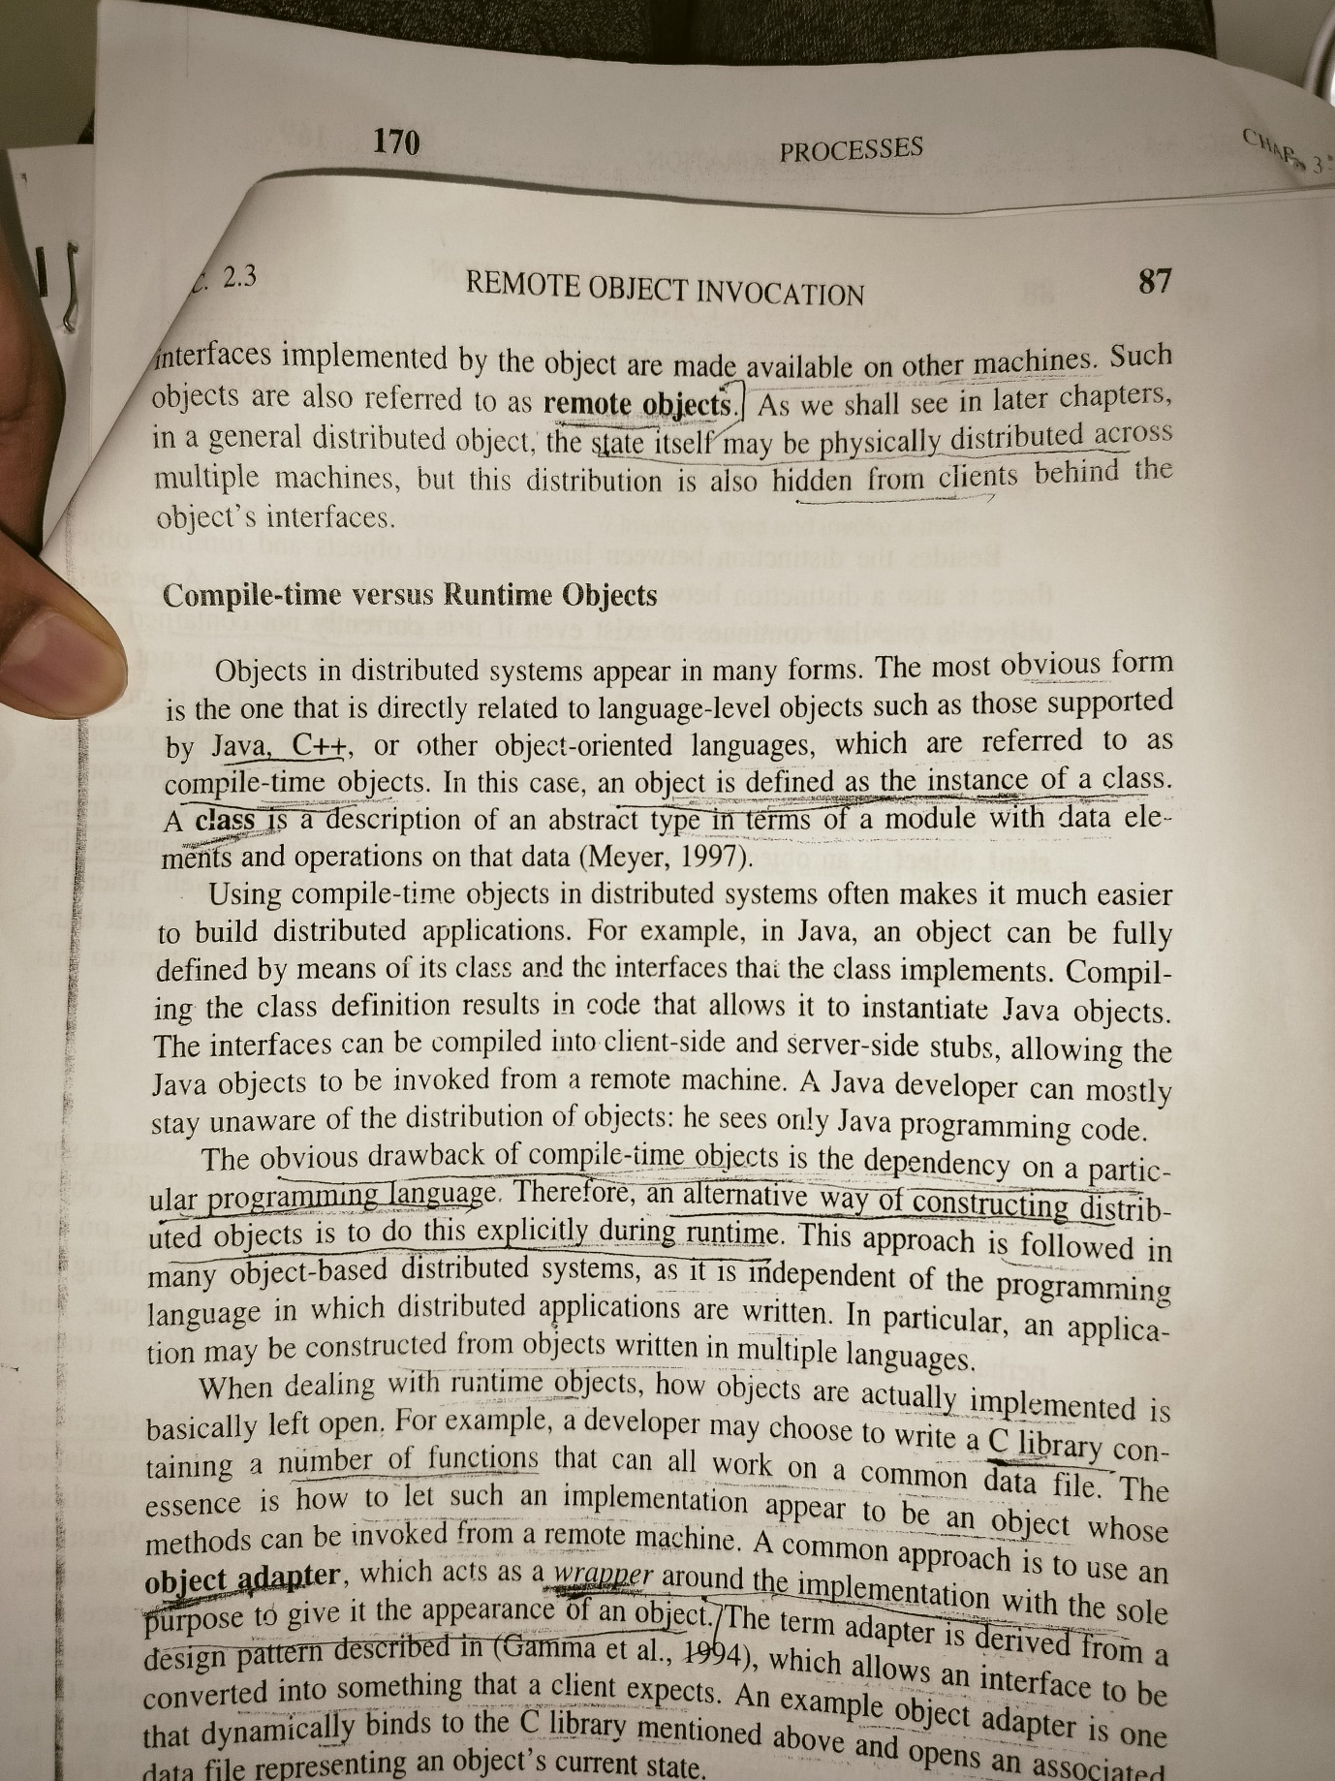

**In this problem you are to compare reading a file using a**

**single-threaded file server and a multithreaded server. It takes 15**

**msec to get a request for work, dispatch it, and do the rest of the**

**necessary processing, assuming that the data needed are in a cache**

**in main memory. If a disk operation is needed, as is the case**

**one-third of the time, an additional 75 msec is required, during**

**which time the thread sleeps. How many requests/sec can the**

**server handle if it is single threaded? If it is multithreaded**

[**https://gateoverflow.in/324493/andrew-tanenbaum-os-edition-exercise-question-17-page-no-175**](https://gateoverflow.in/324493/andrew-tanenbaum-os-edition-exercise-question-17-page-no-175)

Let’s calculate the number of requests per second a single-threaded server can handle first.

The time taken to process a request in the single-threaded server is the sum of the time taken to get a request for work, dispatch it, and do the necessary processing (15 msec), and the time taken for a disk operation, which is needed one-third of the time (75 msec * 1/3). This gives us:

Time per request=15 msec+13∗75 msec=40 msecTime per request=15 msec+31​∗75 msec=40 msec

The number of requests per second the server can handle is the reciprocal of the time per request (in seconds):

Requests per second=1Time per request=140∗10−3=25 requests/secRequests per second=Time per request1​=40∗10−31​=25 requests/sec

For a multithreaded server, the situation is a bit more complex. If we assume that the server has enough threads to handle all incoming requests simultaneously, then it can handle a disk operation (which takes 75 msec) while continuing to process other requests. Therefore, the server is not limited by the time taken for disk operations. In this case, the server can handle:

Requests per second=115∗10−3=66.67 requests/secRequests per second=15∗10−31​=66.67 requests/sec

Please note that this is a simplified analysis and actual performance can vary based on many factors such as the number of available threads, the overhead of context switching, the performance of the disk subsystem, and so on. It’s also important to note that while multithreading can increase throughput, it can also increase complexity and the potential for synchronization issues. Therefore, the decision to use a single-threaded or multithreaded server should be based on the specific requirements and constraints of your application.

**What is group communication? Give any two key application area of group communication in distributed systems**

[**Group communication** is the act of sending and receiving messages to multiple members of a group](https://www.indeed.com/career-advice/career-development/group-communication)[1](https://www.indeed.com/career-advice/career-development/group-communication)[2](https://interobservers.com/group-communication/)[3](https://www.mbaskool.com/business-concepts/marketing-and-strategy-terms/7049-group-communication.html)[4](https://www.oxfordreference.com/display/10.1093/oi/authority.20110803095909815). [In a business or distributed system environment, groups often use this type of communication to exchange ideas, determine goals, and motivate other members1](https://www.indeed.com/career-advice/career-development/group-communication)[2](https://interobservers.com/group-communication/)[3](https://www.mbaskool.com/business-concepts/marketing-and-strategy-terms/7049-group-communication.html)[4](https://www.oxfordreference.com/display/10.1093/oi/authority.20110803095909815). [The size of groups can vary, but they typically comprise at least three members and up to 20 members1](https://www.indeed.com/career-advice/career-development/group-communication)[2](https://interobservers.com/group-communication/)[3](https://www.mbaskool.com/business-concepts/marketing-and-strategy-terms/7049-group-communication.html)[4](https://www.oxfordreference.com/display/10.1093/oi/authority.20110803095909815). [When groups communicate effectively, they can share necessary information as they work to accomplish mutual goals1](https://www.indeed.com/career-advice/career-development/group-communication)[2](https://interobservers.com/group-communication/)[3](https://www.mbaskool.com/business-concepts/marketing-and-strategy-terms/7049-group-communication.html)[4](https://www.oxfordreference.com/display/10.1093/oi/authority.20110803095909815).

Key application areas of group communication in distributed systems include:

1. [**Reliable Dissemination of Information**: Group communication is used to reliably disseminate information to potentially large numbers of clients](https://www.indeed.com/career-advice/career-development/group-communication)[5](https://www.geeksforgeeks.org/group-communication-in-distributed-systems/)[6](https://www.ques10.com/p/24020/write-a-note-on-group-communication-in-distributed/). [This is particularly useful in applications where updates or notifications need to be sent to multiple recipients simultaneously](https://www.indeed.com/career-advice/career-development/group-communication)[5](https://www.geeksforgeeks.org/group-communication-in-distributed-systems/)[6](https://www.ques10.com/p/24020/write-a-note-on-group-communication-in-distributed/).
2. [**Support for Collaborative Applications**: Group communication provides the infrastructure needed for collaborative applications5](https://www.geeksforgeeks.org/group-communication-in-distributed-systems/)[6](https://www.ques10.com/p/24020/write-a-note-on-group-communication-in-distributed/). [These applications allow multiple users to work together on shared tasks, such as document editing, software development, or decision-making processes5](https://www.geeksforgeeks.org/group-communication-in-distributed-systems/)[6](https://www.ques10.com/p/24020/write-a-note-on-group-communication-in-distributed/).

**Compare Distributed OS, Network OS, and Middleware based**

**distributed systems with respective following parameters:**

**Degree of transparency**

**Same OS on all node**

**No. of copies of OS**

**Basis for communication**

**Resource management**

**vi. Scalability**

**vii. Openness**

[Here’s a comparison of Distributed Operating Systems (DOS), Network Operating Systems (NOS), and Middleware-based Distributed Systems (MDS) based on the parameters you mentioned1](https://www.geeksforgeeks.org/difference-between-network-os-and-distributed-os/)[2](https://www.javatpoint.com/network-operating-system-vs-distributed-operating-system):

| **Parameter** | **Distributed OS** | **Network OS** | **Middleware-based DS** |
| --- | --- | --- | --- |
| Degree of Transparency | [High](https://www.geeksforgeeks.org/difference-between-network-os-and-distributed-os/)[1](https://www.geeksforgeeks.org/difference-between-network-os-and-distributed-os/) | [Low](https://www.geeksforgeeks.org/difference-between-network-os-and-distributed-os/)[1](https://www.geeksforgeeks.org/difference-between-network-os-and-distributed-os/) | [Varies](https://www.geeksforgeeks.org/difference-between-network-os-and-distributed-os/)[1](https://www.geeksforgeeks.org/difference-between-network-os-and-distributed-os/) |
| Same OS on all nodes | [Yes1](https://www.geeksforgeeks.org/difference-between-network-os-and-distributed-os/) | [No](https://www.geeksforgeeks.org/difference-between-network-os-and-distributed-os/)[1](https://www.geeksforgeeks.org/difference-between-network-os-and-distributed-os/) | [No](https://www.geeksforgeeks.org/difference-between-network-os-and-distributed-os/)[1](https://www.geeksforgeeks.org/difference-between-network-os-and-distributed-os/) |
| No. of copies of OS | [One per node1](https://www.geeksforgeeks.org/difference-between-network-os-and-distributed-os/) | [One per node](https://www.geeksforgeeks.org/difference-between-network-os-and-distributed-os/)[1](https://www.geeksforgeeks.org/difference-between-network-os-and-distributed-os/) | [One per node](https://www.geeksforgeeks.org/difference-between-network-os-and-distributed-os/)[1](https://www.geeksforgeeks.org/difference-between-network-os-and-distributed-os/) |
| Basis for Communication | [Message passing and shared memory1](https://www.geeksforgeeks.org/difference-between-network-os-and-distributed-os/) | [File-based](https://www.geeksforgeeks.org/difference-between-network-os-and-distributed-os/)[1](https://www.geeksforgeeks.org/difference-between-network-os-and-distributed-os/) | [Depends on middleware](https://www.geeksforgeeks.org/difference-between-network-os-and-distributed-os/)[1](https://www.geeksforgeeks.org/difference-between-network-os-and-distributed-os/) |
| Resource Management | [Managed by the OS](https://www.geeksforgeeks.org/difference-between-network-os-and-distributed-os/)[1](https://www.geeksforgeeks.org/difference-between-network-os-and-distributed-os/) | [Managed locally at each node](https://www.geeksforgeeks.org/difference-between-network-os-and-distributed-os/)[1](https://www.geeksforgeeks.org/difference-between-network-os-and-distributed-os/) | [Depends on middleware](https://www.geeksforgeeks.org/difference-between-network-os-and-distributed-os/)[1](https://www.geeksforgeeks.org/difference-between-network-os-and-distributed-os/) |
| Scalability | [Less scalable](https://www.geeksforgeeks.org/difference-between-network-os-and-distributed-os/)[1](https://www.geeksforgeeks.org/difference-between-network-os-and-distributed-os/) | [More scalable](https://www.geeksforgeeks.org/difference-between-network-os-and-distributed-os/)[1](https://www.geeksforgeeks.org/difference-between-network-os-and-distributed-os/) | [Depends on middleware](https://www.geeksforgeeks.org/difference-between-network-os-and-distributed-os/)[1](https://www.geeksforgeeks.org/difference-between-network-os-and-distributed-os/) |
| Openness | [Varies](https://www.geeksforgeeks.org/difference-between-network-os-and-distributed-os/)[1](https://www.geeksforgeeks.org/difference-between-network-os-and-distributed-os/) | [Varies](https://www.geeksforgeeks.org/difference-between-network-os-and-distributed-os/)[1](https://www.geeksforgeeks.org/difference-between-network-os-and-distributed-os/) | [Typically high](https://www.geeksforgeeks.org/difference-between-network-os-and-distributed-os/)[1](https://www.geeksforgeeks.org/difference-between-network-os-and-distributed-os/) |

Please note that these are general characteristics and actual implementations can vary. [Also, the degree of transparency, scalability, and openness in Middleware-based Distributed Systems can greatly depend on the specific middleware used1](https://www.geeksforgeeks.org/difference-between-network-os-and-distributed-os/).

**Many networked systems are organized in terms of a back**

**office and a front office. How does organizations match with**

**the coherent view we demand for a distributed system?**

[In many networked systems, the organization is split into a **back office** and a **front office**1](https://www.pipefy.com/blog/front-office-vs-back-office/)[2](https://www.automationanywhere.com/company/blog/rpa-thought-leadership/the-difference-between-front-and-back-office)[3](https://www.numerade.com/ask/question/many-networked-systems-are-organized-in-terms-of-a-back-office-and-a-front-office-how-does-organizations-match-with-the-coherent-view-we-demand-for-a-distributed-system-26056/)[4](https://mazer.dev/en/blog/posts/what-is-the-difference-between-backoffice-and-frontoffice/)[5](http://www.dl.edi-info.ir/Distributed%20systems%20principles%20and%20paradigms.pdf). [The back office typically refers to the administrative and support functions of an organization, such as accounting, human resources, and IT1](https://www.pipefy.com/blog/front-office-vs-back-office/)[2](https://www.automationanywhere.com/company/blog/rpa-thought-leadership/the-difference-between-front-and-back-office)[3](https://www.numerade.com/ask/question/many-networked-systems-are-organized-in-terms-of-a-back-office-and-a-front-office-how-does-organizations-match-with-the-coherent-view-we-demand-for-a-distributed-system-26056/)[4](https://mazer.dev/en/blog/posts/what-is-the-difference-between-backoffice-and-frontoffice/)[5](http://www.dl.edi-info.ir/Distributed%20systems%20principles%20and%20paradigms.pdf). [The front office, on the other hand, refers to the customer-facing functions, such as sales, marketing, and customer service](https://www.pipefy.com/blog/front-office-vs-back-office/)[1](https://www.pipefy.com/blog/front-office-vs-back-office/)[2](https://www.automationanywhere.com/company/blog/rpa-thought-leadership/the-difference-between-front-and-back-office)[3](https://www.numerade.com/ask/question/many-networked-systems-are-organized-in-terms-of-a-back-office-and-a-front-office-how-does-organizations-match-with-the-coherent-view-we-demand-for-a-distributed-system-26056/)[4](https://mazer.dev/en/blog/posts/what-is-the-difference-between-backoffice-and-frontoffice/)[5](http://www.dl.edi-info.ir/Distributed%20systems%20principles%20and%20paradigms.pdf).

In a distributed system, we demand a coherent view, meaning that the system should appear to its users as a single, integrated entity, rather than a collection of independent components. This is often referred to as transparency.

The back office and front office can fit into this coherent view in the following ways:

1. **Data Consistency**: Both the back office and front office need to work with consistent data. For example, the sales data that the front office uses should be consistent with the financial data that the back office uses.
2. **Process Integration**: The processes in the back office and front office need to be integrated. For example, when a sale is made (a front office process), the inventory should be updated (a back office process).
3. **Communication**: The back office and front office need to communicate effectively. This can be facilitated by middleware, which provides a communication layer between different parts of the distributed system.

By ensuring data consistency, process integration, and effective communication, the back office and front office can both contribute to the coherent view of the distributed system.

**ESE AUG 2023**

**What are the different goals of distributed systems?**

[**https://www.ques10.com/p/2123/state-the-goals-of-distributed-system/**](https://www.ques10.com/p/2123/state-the-goals-of-distributed-system/)

**When to use vector clock? What is the difference between Lamport clock**

**and vector clock? With suitable example explain Lamport clock and vector**

**clock.**

[**Vector Clocks** are used in distributed systems to provide a causally consistent ordering of events](https://www.geeksforgeeks.org/vector-clocks-in-distributed-systems/)[1](https://www.geeksforgeeks.org/vector-clocks-in-distributed-systems/)[2](https://distributed-computing-musings.com/2023/04/vector-clocks-so-what-time-is-it/). [They are particularly useful in systems where it’s important to determine if any two arbitrarily selected events are causally dependent or concurrent](https://www.geeksforgeeks.org/vector-clocks-in-distributed-systems/)[1](https://www.geeksforgeeks.org/vector-clocks-in-distributed-systems/)[3](https://en.wikipedia.org/wiki/Vector_clock)[2](https://distributed-computing-musings.com/2023/04/vector-clocks-so-what-time-is-it/). [For example, they are often used in multi-node databases and distributed message queues](https://www.geeksforgeeks.org/vector-clocks-in-distributed-systems/)[2](https://distributed-computing-musings.com/2023/04/vector-clocks-so-what-time-is-it/).

[**Lamport Clocks** and **Vector Clocks** are both logical clocks used to order events in a distributed system](https://www.geeksforgeeks.org/vector-clocks-in-distributed-systems/)[4](https://cs.stackexchange.com/questions/101496/difference-between-lamport-timestamps-and-vector-clocks). Here are the key differences between them:

1. [**Causal Relationships**: Vector clocks can determine if any two arbitrarily selected events are causally dependent or concurrent](https://www.geeksforgeeks.org/vector-clocks-in-distributed-systems/)[4](https://cs.stackexchange.com/questions/101496/difference-between-lamport-timestamps-and-vector-clocks). [Lamport clocks cannot do this](https://www.geeksforgeeks.org/vector-clocks-in-distributed-systems/)[4](https://cs.stackexchange.com/questions/101496/difference-between-lamport-timestamps-and-vector-clocks).
2. [**Compactness**: Lamport clocks are more compact](https://www.geeksforgeeks.org/vector-clocks-in-distributed-systems/)[4](https://cs.stackexchange.com/questions/101496/difference-between-lamport-timestamps-and-vector-clocks). [Vector clocks require overhead proportional to the number of nodes](https://www.geeksforgeeks.org/vector-clocks-in-distributed-systems/)[4](https://cs.stackexchange.com/questions/101496/difference-between-lamport-timestamps-and-vector-clocks).

Now, let’s look at examples of how each of these clocks work:

[**Lamport Clock Example**](https://www.geeksforgeeks.org/vector-clocks-in-distributed-systems/)[5](https://www.geeksforgeeks.org/lamports-logical-clock/)[6](https://en.wikipedia.org/wiki/Lamport_timestamp)[7](https://pk.org/417/notes/logical-clocks.html)[8](https://blog.mattchung.me/2020/10/13/lamports-clocks-notes/)[9](https://medium.com/@dotslashbit/lamport-clocks-8f63bb094e21):

Consider two processes, P1 and P2, with events E11, E12, E13 in P1 and E21, E22, E23 in P2. The events are as follows:

* E11: P1 sends a message M1 to P2.
* E12: P1 receives a message M2 from P2.
* E13: P1 sends a message M3 to P2.

The Lamport timestamps for these events would be:

* E11: 1 (P1 sends M1)
* E21: 1 (P2 receives M1, increments its clock to max(1, 1) + 1 = 2)
* E12: 2 (P1 receives M2, increments its clock to max(2, 1) + 1 = 3)
* E13: 3 (P1 sends M3)
* E22: 2 (P2 receives M3, increments its clock to max(3, 2) + 1 = 4)
* E23: 4 (P2 has an internal event)

[**Vector Clock Example**](https://www.geeksforgeeks.org/vector-clocks-in-distributed-systems/)[1](https://www.geeksforgeeks.org/vector-clocks-in-distributed-systems/)

**Explain working of JAVA RMI with example.**

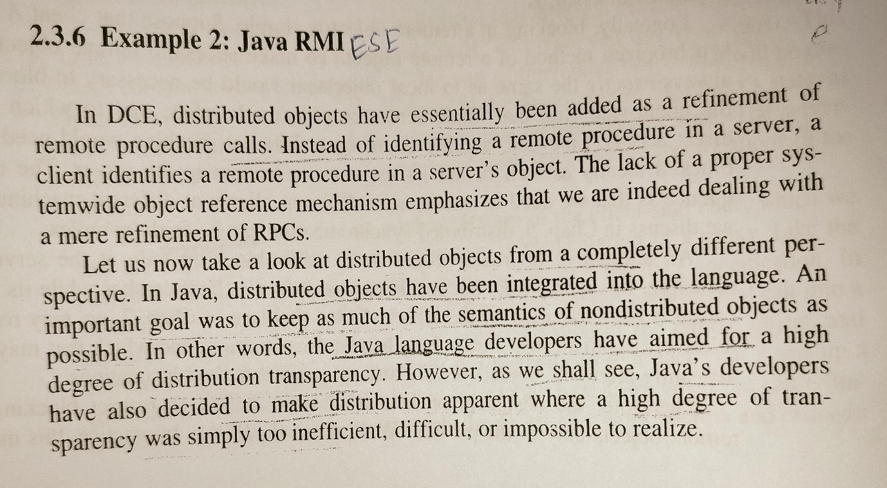

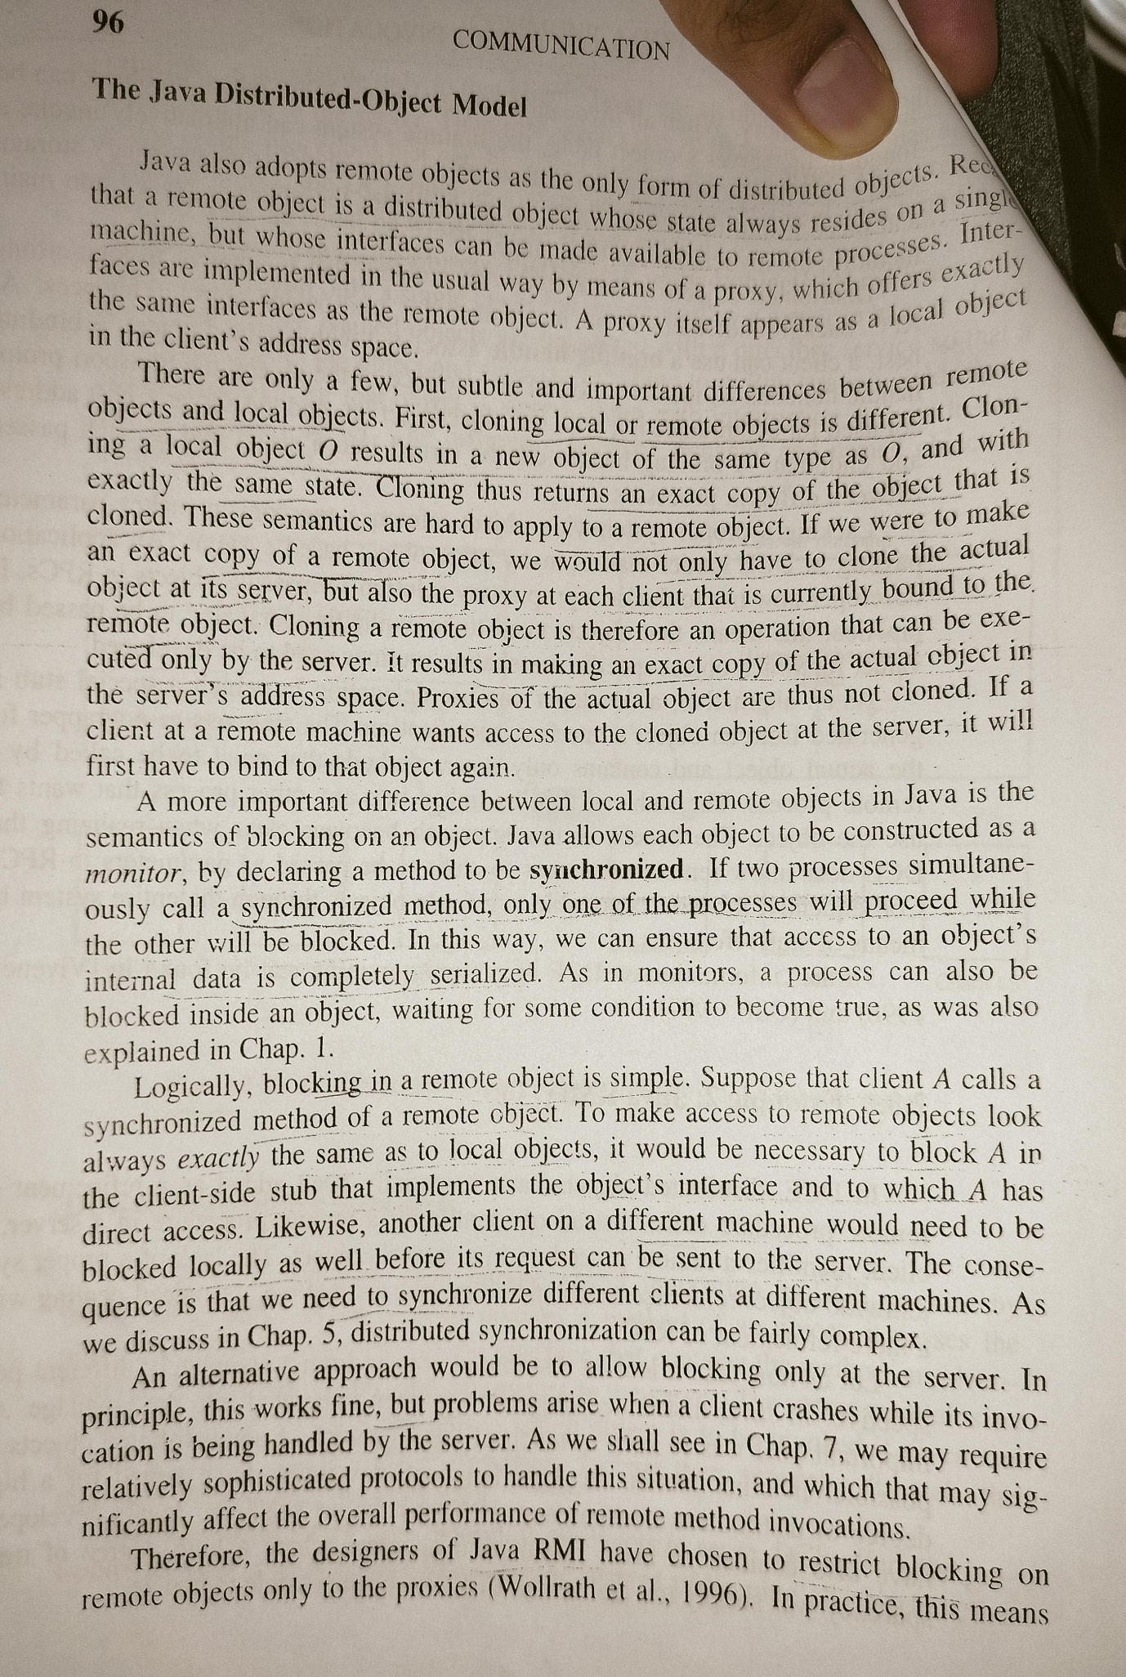

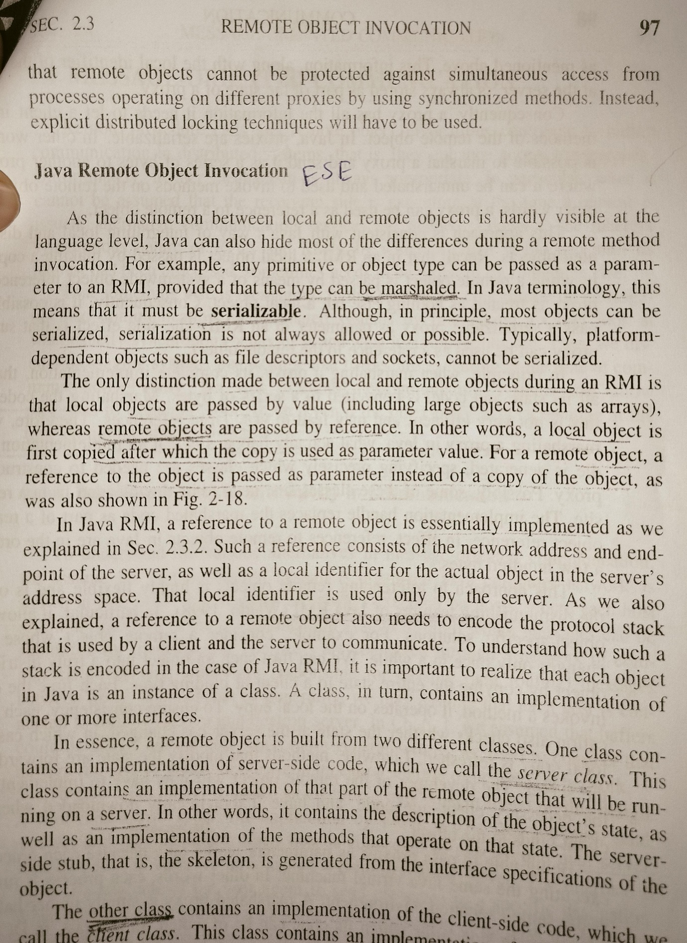

**How are the replications used in distributed systems?**

[Replication in distributed systems involves making redundant copies of resources, such as data or processes, while ensuring that all the copies are identical1](https://www.geeksforgeeks.org/what-is-replication-in-distributed-system/). [This is done to improve the reliability, fault-tolerance, and performance of the system2](https://lass.cs.umass.edu/~shenoy/courses/spring19/lectures/Lec17_notes.pdf). Here are some ways replications are used in distributed systems:

1. [**Fault Tolerance**: If a node stops working, the distributed network will still work fine due to its replicas1](https://www.geeksforgeeks.org/what-is-replication-in-distributed-system/).
2. [**Load Sharing**: Loads on a server are shared among different replicas1](https://www.geeksforgeeks.org/what-is-replication-in-distributed-system/).
3. **Data Availability**: It enhances the availability of the data. [If the replicas are created and data is stored near to the consumers, it would be easier and faster to fetch data1](https://www.geeksforgeeks.org/what-is-replication-in-distributed-system/).
4. [**Performance Improvement**: By having replicas, workloads can be distributed across them1](https://www.geeksforgeeks.org/what-is-replication-in-distributed-system/).

[There are two main types of replication strategies used in distributed systems1](https://www.geeksforgeeks.org/what-is-replication-in-distributed-system/):

* **Active Replication**: The request of the client goes to all the replicas. [It is to be made sure that every replica receives the client request in the same order else the system will get inconsistent1](https://www.geeksforgeeks.org/what-is-replication-in-distributed-system/).
* **Passive Replication**: The client request goes to the primary replica, also called the main replica. [There are more replicas that act as backup for the primary replica1](https://www.geeksforgeeks.org/what-is-replication-in-distributed-system/).

[However, replication also introduces complexity and cost of data updates3](https://link.springer.com/article/10.1134/S0361768820050060). [In many cases, data storage systems that exploit replication use relaxed consistency criteria3](https://link.springer.com/article/10.1134/S0361768820050060). [This survey describes different replication schemes and discusses several consistency models, protocols, and techniques designed to support consistency in replicated systems3](https://link.springer.com/article/10.1134/S0361768820050060).

**What are the desirable characteristics of message passing? What are the different issues in IPC by message passing? How is group communication handled in distributed systems?**

[**Desirable Characteristics of Message Passing**](https://www.geeksforgeeks.org/message-passing-model-of-process-communication/)[1](https://www.geeksforgeeks.org/message-passing-model-of-process-communication/)[2](https://www.geeksforgeeks.org/message-passing-in-distributed-system/)[3](https://www.geeksforgeeks.org/features-of-good-message-passing-in-distributed-system/)[4](https://www.tutorialspoint.com/message-passing-model-of-process-communication):

1. [**Simplicity**: Message passing systems should be easy to use and understand](https://www.geeksforgeeks.org/message-passing-model-of-process-communication/)[1](https://www.geeksforgeeks.org/message-passing-model-of-process-communication/).
2. [**Uniform Semantics**: The system should provide a consistent set of operations for sending and receiving messages](https://www.geeksforgeeks.org/message-passing-model-of-process-communication/)[1](https://www.geeksforgeeks.org/message-passing-model-of-process-communication/).
3. [**Efficiency**: The system should minimize the overhead of message passing to ensure high performance1](https://www.geeksforgeeks.org/message-passing-model-of-process-communication/).
4. [**Reliability**: The system should ensure that messages are delivered accurately and reliably1](https://www.geeksforgeeks.org/message-passing-model-of-process-communication/).
5. [**Flexibility**: The system should be adaptable to a variety of applications and use cases1](https://www.geeksforgeeks.org/message-passing-model-of-process-communication/).
6. [**Security**: The system should provide mechanisms to protect the confidentiality and integrity of messages1](https://www.geeksforgeeks.org/message-passing-model-of-process-communication/).

[**Issues in IPC by Message Passing**](https://www.geeksforgeeks.org/message-passing-model-of-process-communication/)[5](https://www.geeksforgeeks.org/issues-in-ipc-by-message-passing-in-distributed-system/)[6](https://www.geeksforgeeks.org/inter-process-communication-ipc/)[7](https://www.tutorialspoint.com/ipc-problems-caused-by-message-passing-in-a-distributed-system)[8](https://rcet.org.in/uploads/academics/rohini_81014754345.pdf)[9](https://stackoverflow.com/questions/33050646/what-are-the-problems-in-3-way-message-passing-reliable-ipc-protocol):

1. [**Sender and Receiver Identification**: Determining who is sending and receiving the message](https://www.geeksforgeeks.org/message-passing-model-of-process-communication/)[5](https://www.geeksforgeeks.org/issues-in-ipc-by-message-passing-in-distributed-system/).
2. [**Number of Receivers**: Determining whether there is a single receiver or multiple receivers](https://www.geeksforgeeks.org/message-passing-model-of-process-communication/)[5](https://www.geeksforgeeks.org/issues-in-ipc-by-message-passing-in-distributed-system/).
3. [**Guaranteed Delivery**: Ensuring that the intended recipient received the message](https://www.geeksforgeeks.org/message-passing-model-of-process-communication/)[5](https://www.geeksforgeeks.org/issues-in-ipc-by-message-passing-in-distributed-system/).
4. [**Reply Handling**: Determining whether it is required to wait for a reply from the sender](https://www.geeksforgeeks.org/message-passing-model-of-process-communication/)[5](https://www.geeksforgeeks.org/issues-in-ipc-by-message-passing-in-distributed-system/).
5. [**Failure Handling**: Handling catastrophic events such as a communication link failure or node crash](https://www.geeksforgeeks.org/message-passing-model-of-process-communication/)[5](https://www.geeksforgeeks.org/issues-in-ipc-by-message-passing-in-distributed-system/).
6. [**Buffering**: Deciding what to do with the message if the receiver is not ready to take it](https://www.geeksforgeeks.org/message-passing-model-of-process-communication/)[5](https://www.geeksforgeeks.org/issues-in-ipc-by-message-passing-in-distributed-system/).
7. [**Synchronization**: Synchronization of communicative processes is a critical issue in the communication structure](https://www.geeksforgeeks.org/message-passing-model-of-process-communication/)[5](https://www.geeksforgeeks.org/issues-in-ipc-by-message-passing-in-distributed-system/).

[**Group Communication in Distributed Systems**](https://www.geeksforgeeks.org/message-passing-model-of-process-communication/)[10](https://www.geeksforgeeks.org/group-communication-in-distributed-systems/)[11](https://rcet.org.in/uploads/academics/rohini_76674615878.pdf)[12](https://www.educative.io/answers/what-is-group-communication-in-distributed-systems):

[Group communication in distributed systems refers to the communication medium used by nodes (computers or processes) to commute information and coordinate their actions10](https://www.geeksforgeeks.org/group-communication-in-distributed-systems/). [It involves transferring and entering messages between nodes to achieve various goals such as coordination, synchronization, and data sharing](https://www.geeksforgeeks.org/message-passing-model-of-process-communication/)[10](https://www.geeksforgeeks.org/group-communication-in-distributed-systems/). [There are three types of group communication in a distributed system](https://www.geeksforgeeks.org/message-passing-model-of-process-communication/)[10](https://www.geeksforgeeks.org/group-communication-in-distributed-systems/):

1. [**Broadcast Communication**: When the host process tries to communicate with every process in a distributed system at the same time](https://www.geeksforgeeks.org/message-passing-model-of-process-communication/)[10](https://www.geeksforgeeks.org/group-communication-in-distributed-systems/).
2. [**Multicast Communication**: When the host process tries to communicate with a designated group of processes in a distributed system at the same time10](https://www.geeksforgeeks.org/group-communication-in-distributed-systems/).
3. [**Unicast Communication**: When the host process tries to communicate with a single process in a distributed system at the same time](https://www.geeksforgeeks.org/message-passing-model-of-process-communication/)[10](https://www.geeksforgeeks.org/group-communication-in-distributed-systems/).

**What is the difference between physical clock and logical clock? Explain Christians algorithm and Berkeleys algorithm with the help of example.**

**Physical Clock vs Logical Clock**:

[A **physical clock** is a physical process combined with a strategy for measuring that process to record the progression of time1](https://brainly.in/question/1981672). [For example, the revolution of the Earth measured in solar days is a physical clock](https://brainly.in/question/1981672)[1](https://brainly.in/question/1981672). [However, physical clocks are not always precise, so we can’t rely on physical time to order events2](https://yourwisdomtips.com/what-is-the-difference-between-physical-and-logical-clocks/).

[A **logical clock**, on the other hand, is a mechanism for capturing chronological and causal relationships in a distributed system](https://brainly.in/question/1981672)[3](https://www.geeksforgeeks.org/logical-clock-in-distributed-system/). [Distributed systems may have no physically synchronous global clock, so a logical clock allows global ordering on events from different processes in such systems3](https://www.geeksforgeeks.org/logical-clock-in-distributed-system/). A logical clock is not necessarily to maintain the same notion of time as a reliable watch. [Instead, it is to keep track of information pertaining to the order of events](https://brainly.in/question/1981672)[4](https://cseweb.ucsd.edu/classes/wi17/cse291-d/applications/ln/lecture4.html).

**Cristian’s Algorithm**:

[Cristian’s Algorithm is a clock synchronization algorithm used to synchronize time with a time server by client processes5](https://www.geeksforgeeks.org/cristians-algorithm/). Here’s how it works:

1. The process on the client machine sends the request for fetching clock time (time at the server) to the Clock Server at time t1.
2. The Clock Server listens to the request made by the client process and returns the response in form of clock server time.
3. [The client process fetches the response from the Clock Server at time t2 and calculates the synchronized client clock time using the formula given below](https://brainly.in/question/1981672)[5](https://www.geeksforgeeks.org/cristians-algorithm/):

TCLIENT​=TSERVER​+2(t2−t1)​

[where T_CLIENT refers to the synchronized clock time, T_SERVER refers to the clock time returned by the server, t1 refers to the time at which request was sent by the client process, and t2 refers to the time at which response was received by the client process](https://brainly.in/question/1981672)[5](https://www.geeksforgeeks.org/cristians-algorithm/).

**Berkeley’s Algorithm**:

[Berkeley’s Algorithm is a clock synchronization technique used in distributed systems](https://brainly.in/question/1981672)[6](https://www.geeksforgeeks.org/berkeleys-algorithm/). [The algorithm assumes that each machine node in the network either doesn’t have an accurate time source or doesn’t possess a UTC server](https://brainly.in/question/1981672)[6](https://www.geeksforgeeks.org/berkeleys-algorithm/). Here’s how it works:

1. An individual node is chosen as the master node from a pool node in the network. [This node is the main node in the network which acts as a master and the rest of the nodes act as slaves6](https://www.geeksforgeeks.org/berkeleys-algorithm/).
2. [Master node periodically pings slaves nodes and fetches clock time at them using Cristian’s algorithm](https://brainly.in/question/1981672)[6](https://www.geeksforgeeks.org/berkeleys-algorithm/).
3. Master node calculates the average time difference between all the clock times received and the clock time given by the master’s system clock itself. [This average time difference is added to the current time at the master’s system clock and broadcasted over the network6](https://www.geeksforgeeks.org/berkeleys-algorithm/).

**What are the difficulties are faced while using process migration over code migration? Explain code migration in heterogeneous systems with the help of example.**

[Process migration and code migration are two techniques used in distributed systems to improve performance, availability, and resource utilization1](https://www.geeksforgeeks.org/process-migration-in-distributed-system/)[2](https://cs.gmu.edu/~setia/cs707/slides/code-migration.pdf). However, they each have their own challenges:

[**Process Migration Challenges**1](https://www.geeksforgeeks.org/process-migration-in-distributed-system/):

* [**State Transfer**: The entire state of the process, including the program counter, registers, and memory, must be transferred1](https://www.geeksforgeeks.org/process-migration-in-distributed-system/).
* [**Resource Usage**: Processes may have open files, network connections, or other resources that need to be managed during migration](https://www.geeksforgeeks.org/process-migration-in-distributed-system/)[1](https://www.geeksforgeeks.org/process-migration-in-distributed-system/).
* [**Communication Overhead**: After migration, a process may need to communicate with other processes on its original node, leading to increased network traffic1](https://www.geeksforgeeks.org/process-migration-in-distributed-system/).
* [**System Heterogeneity**: Differences in system architecture, operating system, or even system configuration can make process migration more complex1](https://www.geeksforgeeks.org/process-migration-in-distributed-system/).

[**Code Migration Challenges**2](https://cs.gmu.edu/~setia/cs707/slides/code-migration.pdf):

* [**Code Transfer**: Only the code segment is typically transferred, not the entire process state2](https://cs.gmu.edu/~setia/cs707/slides/code-migration.pdf).
* [**Resource Management**: The migrated code may need to access resources that are not available on the target node2](https://cs.gmu.edu/~setia/cs707/slides/code-migration.pdf).
* [**Security**: Transferring code between nodes can have security implications, including the risk of code tampering or unauthorized access2](https://cs.gmu.edu/~setia/cs707/slides/code-migration.pdf).

[In **heterogeneous systems**, code migration can be more complex due to differences in system architecture, operating system, or programming language support2](https://cs.gmu.edu/~setia/cs707/slides/code-migration.pdf). [One approach to handle this is through the use of **intermediate language or bytecode**, which can be interpreted or compiled on different platforms2](https://cs.gmu.edu/~setia/cs707/slides/code-migration.pdf). [For example, Java applets use this approach for code migration2](https://cs.gmu.edu/~setia/cs707/slides/code-migration.pdf). [The applet’s Java bytecode is transferred over the network and executed by a Java Virtual Machine (JVM) on the target node, allowing the code to run on various types of systems2](https://cs.gmu.edu/~setia/cs707/slides/code-migration.pdf).

[Another example is the D’Agents system, a research middleware platform that supports various forms of code migration2](https://cs.gmu.edu/~setia/cs707/slides/code-migration.pdf). [An agent in D’Agents is a program that can migrate between heterogeneous platforms, and it can be written in Tcl, Scheme, or Java2](https://cs.gmu.edu/~setia/cs707/slides/code-migration.pdf). [This allows the agent to execute on a variety of systems, demonstrating how code migration can be used in a heterogeneous environment2](https://cs.gmu.edu/~setia/cs707/slides/code-migration.pdf).

**How is data centric consistency model is used in distributed systems? How consistent ordering of operations takes place in distributed systems?**

**Data-Centric Consistency Model**:

[The Data-Centric Consistency Model is a set of principles and protocols used in distributed systems to define how data is accessed and updated, ensuring that all nodes in the system agree on the state of shared data1](https://www.pickl.ai/blog/data-centric-consistency-model-in-distributed-systems/). [It primarily focuses on the consistency guarantees provided to clients regarding the data they access and manipulate1](https://www.pickl.ai/blog/data-centric-consistency-model-in-distributed-systems/). [Here are some common data-centric consistency models2](https://www.geeksforgeeks.org/consistency-model-in-distributed-system/)[1](https://www.pickl.ai/blog/data-centric-consistency-model-in-distributed-systems/):

* **Strong Consistency**: All nodes in the system agree on the order in which operations occurred. [Reads will always return the most recent version of the data, and writes will be visible to all nodes immediately after they occur2](https://www.geeksforgeeks.org/consistency-model-in-distributed-system/)[1](https://www.pickl.ai/blog/data-centric-consistency-model-in-distributed-systems/).
* [**Eventual Consistency**: Updates propagate through the system and eventually, all replicas will be consistent1](https://www.pickl.ai/blog/data-centric-consistency-model-in-distributed-systems/).
* [**Causal Consistency**: All processes see causally-related shared accesses in the same order2](https://www.geeksforgeeks.org/consistency-model-in-distributed-system/)[1](https://www.pickl.ai/blog/data-centric-consistency-model-in-distributed-systems/).
* [**Read-Your-Writes Consistency**: This ensures that a process that writes a value to some data item will always read the latest written value](https://www.pickl.ai/blog/data-centric-consistency-model-in-distributed-systems/)[1](https://www.pickl.ai/blog/data-centric-consistency-model-in-distributed-systems/).
* [**Monotonic Reads and Writes**: If a process reads the value of a data item, any successive reads on that data item by that process will always return the same or a more recent value1](https://www.pickl.ai/blog/data-centric-consistency-model-in-distributed-systems/).

**Consistent Ordering of Operations**:

[Consistency models in distributed systems refer to the guarantees provided by the system about the order in which operations appear to occur to clients](https://www.pickl.ai/blog/data-centric-consistency-model-in-distributed-systems/)[2](https://www.geeksforgeeks.org/consistency-model-in-distributed-system/). [Specifically, it determines how data is accessed and updated across multiple nodes in a distributed system, and how these updates are made available to clients2](https://www.geeksforgeeks.org/consistency-model-in-distributed-system/). [Here are some common techniques for ensuring consistent ordering of operations2](https://www.geeksforgeeks.org/consistency-model-in-distributed-system/)[3](https://www.geeksforgeeks.org/sequential-consistency-in-distributive-systems/)[4](https://www.tutorialspoint.com/event-ordering-in-distributed-system):

* [**Sequential Consistency**: The result of any execution is the same as if the read and write operations by all processes were executed in some sequential order and the operations of each individual process appear in this sequence in the order specified by its program2](https://www.geeksforgeeks.org/consistency-model-in-distributed-system/)[3](https://www.geeksforgeeks.org/sequential-consistency-in-distributive-systems/).
* **Linearizability (Strict Consistency)**: All nodes in the system agree on the order in which operations occurred. [Reads will always return the most recent version of the data, and writes will be visible to all nodes immediately after they occur2](https://www.geeksforgeeks.org/consistency-model-in-distributed-system/)[3](https://www.geeksforgeeks.org/sequential-consistency-in-distributive-systems/).
* [**Causal Consistency**: All processes see causally-related shared accesses in the same order](https://www.pickl.ai/blog/data-centric-consistency-model-in-distributed-systems/)[2](https://www.geeksforgeeks.org/consistency-model-in-distributed-system/)[3](https://www.geeksforgeeks.org/sequential-consistency-in-distributive-systems/).
* **Distributed Consensus Algorithms**: Algorithms like Paxos and Raft are used to achieve total ordering in distributed systems. [These algorithms ensure that all nodes in the system agree on the order of events by coordinating a leader node that is responsible for ordering events4](https://www.tutorialspoint.com/event-ordering-in-distributed-system).

**Why is load balancing required in distributed systems? Explain any two load balancing algorithms with examples in distributed systems.**

[**Load balancing** is a critical aspect of distributed systems as it helps optimize resource utilization, minimize response time, and ensure high availability and reliability](https://www.geeksforgeeks.org/load-balancing-approach-in-distributed-system/)[1](https://www.geeksforgeeks.org/load-balancing-approach-in-distributed-system/)[2](https://www.tutorialspoint.com/load-balancing-issues-in-distributed-system). [It involves distributing workloads across multiple computing resources to prevent any single resource from being overwhelmed](https://www.geeksforgeeks.org/load-balancing-approach-in-distributed-system/)[1](https://www.geeksforgeeks.org/load-balancing-approach-in-distributed-system/)[2](https://www.tutorialspoint.com/load-balancing-issues-in-distributed-system). [By ensuring that the workload is spread evenly among all available resources, load balancing can reduce server response time, maximize throughput, and provide a better user experience](https://www.geeksforgeeks.org/load-balancing-approach-in-distributed-system/)[1](https://www.geeksforgeeks.org/load-balancing-approach-in-distributed-system/)[2](https://www.tutorialspoint.com/load-balancing-issues-in-distributed-system).

Here are two common load balancing algorithms used in distributed systems:

1. [**Round Robin Algorithm**: This is one of the simplest methods for distributing client requests across a group of servers1](https://www.geeksforgeeks.org/load-balancing-approach-in-distributed-system/). When a request comes in, it is sent to the next server in the list. The algorithm then moves that server to the bottom of the list. [For example, if there are three servers (Server 1, Server 2, Server 3), the first request goes to Server 1, the second to Server 2, the third to Server 3, and the fourth back to Server 11](https://www.geeksforgeeks.org/load-balancing-approach-in-distributed-system/).
2. [**Least Connections Algorithm**: This algorithm directs traffic to the server with the fewest active connections](https://www.geeksforgeeks.org/load-balancing-approach-in-distributed-system/)[1](https://www.geeksforgeeks.org/load-balancing-approach-in-distributed-system/). This is useful in situations where sessions have a large variance in their processing time. [For example, if there are three servers (Server 1 with 2 connections, Server 2 with 3 connections, Server 3 with 1 connection), the next request would go to Server 3, as it has the least number of active connections](https://www.geeksforgeeks.org/load-balancing-approach-in-distributed-system/)[1](https://www.geeksforgeeks.org/load-balancing-approach-in-distributed-system/).

[Please note that the choice of load balancing algorithm depends on the specific requirements and constraints of your distributed system](https://www.geeksforgeeks.org/load-balancing-approach-in-distributed-system/)[1](https://www.geeksforgeeks.org/load-balancing-approach-in-distributed-system/).

**What is the role of middle ware in distributed systems?**

[**https://www.educative.io/answers/what-is-the-role-of-middleware-in-distributed-systems**](https://www.educative.io/answers/what-is-the-role-of-middleware-in-distributed-systems)

[In distributed systems, middleware is a software component that provides services between two or more applications and can be used by them](https://www.geeksforgeeks.org/role-of-middleware-in-distributed-system/)[1](https://www.geeksforgeeks.org/role-of-middleware-in-distributed-system/). [It sits between the application and the network](https://www.geeksforgeeks.org/role-of-middleware-in-distributed-system/)[1](https://www.geeksforgeeks.org/role-of-middleware-in-distributed-system/)[2](https://www.ibm.com/topics/middleware).

Here are some key roles of middleware in distributed systems:

1. [**Common Services**: Middleware provides common services such as authentication, authorization, compilation for best performance on particular architectures, input/output translation, and error handling](https://www.geeksforgeeks.org/role-of-middleware-in-distributed-system/)[1](https://www.geeksforgeeks.org/role-of-middleware-in-distributed-system/).
2. [**Communication**: Middleware enables one or more kinds of communication or connectivity between applications or application components in a distributed network](https://www.geeksforgeeks.org/role-of-middleware-in-distributed-system/)[2](https://www.ibm.com/topics/middleware). [It simplifies connectivity between applications, application components, and back-end data sources](https://www.geeksforgeeks.org/role-of-middleware-in-distributed-system/)[2](https://www.ibm.com/topics/middleware).
3. [**Modularization**: Middleware can be modularized from the application so it has better potential for reuse with other applications running on different platforms](https://www.geeksforgeeks.org/role-of-middleware-in-distributed-system/)[1](https://www.geeksforgeeks.org/role-of-middleware-in-distributed-system/).
4. [**Interoperability**: Middleware provides services that enable different applications and services to communicate using common messaging frameworks](https://www.geeksforgeeks.org/role-of-middleware-in-distributed-system/)[2](https://www.ibm.com/topics/middleware). [It also provides services that enable components written in multiple languages to talk with each other](https://www.geeksforgeeks.org/role-of-middleware-in-distributed-system/)[2](https://www.ibm.com/topics/middleware).
5. [**Integration**: Middleware allows organizations to implement their processes seamlessly by integrating all components of the enterprise](https://www.geeksforgeeks.org/role-of-middleware-in-distributed-system/)[1](https://www.geeksforgeeks.org/role-of-middleware-in-distributed-system/).

[Remember, there are numerous types of middleware designed for different scenarios, each having its own set of responsibilities](https://www.geeksforgeeks.org/role-of-middleware-in-distributed-system/)[1](https://www.geeksforgeeks.org/role-of-middleware-in-distributed-system/). [Therefore, it’s vital for enterprises to first identify what type of solution they require before making a purchasing decision](https://www.geeksforgeeks.org/role-of-middleware-in-distributed-system/)[1](https://www.geeksforgeeks.org/role-of-middleware-in-distributed-system/).